IMPORTANT WATER VALVE INFORMATION
As you all know, when you leave your units for any amount of time, the requirements are to turn your water off at the valve in your utility room or town house basement. Unfortunately, many of the units still have the old style gate valves (pictured below) as water shutoffs.
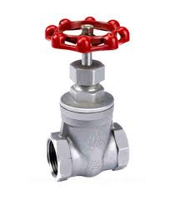
These valves tend to wear out over time and do not fully close, causing a potential disaster if there is a broken pipe or water leak.
We suggest that you replace these gate valves with Ball Valves.
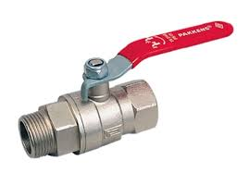
These are far safer and tend to truly shut off when the handle is perpendicular to the pipe. You should also consider installing Ball Valves for your washing machine shutoff if you don’t already have them. They can be easily shut off after each use of your washing machine to prevent a possible flood.

