Saturday & Sunday,
February 14 & 15 2026
Transfiguration of Our Lord
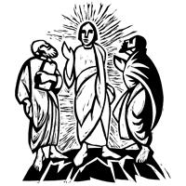
Christ Lutheran Church
“A Place Where You are Always Welcome”
Services: Saturday 5:30 pm and Sunday 10:00 am
Sunday School: 9:00 am (September- May)
600 North Main Street, Stockton, IL 61085 Office: 815-947-2033
Email: christlutheranchurch70@gmail.com http://www.christlutheranstockton.com
Ministers: ALL members of the congregation
Pastor: Rev. Chrissy Salser chrissytherev@att.net 815-988-9450
From Sundays and Seasons.com. Copyright 2017 Augsburg Fortress. All rights reserved. Reprinted by permission under Augsburg Fortress Liturgies Annual License #40643.New Revised Standard Version Bible, copyright 1989, Division of Christian Education of the National Council of the Churches of Christ in the United States of America. Used by permission. All rights reserved.
WELCOME: Thank you for joining us for worship today. We are glad you are with us. Communion will be served in the aisle or in your pew. All are welcome to share this meal. Jesus is our host and invites everyone. Those who would like to come forward, bread and wine will also be available in the front. When directed by the usher, come forward down the center aisle, Pr Chrissy will give you bread (she will be masked and wearing cloves) and then you will take a cup of wine (grape juice) from the tray. After taking communion, you will return to your seat by the side aisle. For those who are unable to come forward, communion elements can be found as you entered worship. At that part of the service, you are invited to take the bread and wine (or grape juice) when Pr. Chrissy leads. On Saturday’s offering is collected as you enter or leave worship. On Sunday we will pass the plate as a response to God’s grace. Online giving is available. Please see QR code on back of bulletin or visit our website.

Introduction: Today’s festival is a bridge between the Advent-Christmas-Epiphany cycle that comes to a close today and the Lent-Easter cycle that begins in several days. On a high mountain Jesus is revealed as God’s beloved Son, echoing the words at his baptism. This vision of glory sustains us as Jesus faces his impending death in Jerusalem. We turn this week to Ash Wednesday and our yearly baptismal journey from Lent to Easter. Some churches put aside the alleluia at the conclusion of today’s liturgy. This word of joy will be omitted during the penitential season of Lent and will be sung again at Easter.

Gathering: The Holy Spirit calls us together as the people of God.
PRELUDE
WELCOME AND ANNOUNCEMENTS

CALL TO WORSHIP: The Light of God has Come

P: People of God, arise, shine, for your light has come!

C: The light of Christ has come into the world. Immanuel. God with us. So arise, shine, for your light has come!
P: Come and see!
C: The light of God has come into our world to proclaim God’s justice and love; It has overcome the darkness and brought new life.
P: Come and follow!
C: Christ our companion has redeemed our world. He draws us into a loving family From every tribe and family and culture.
P: Go and tell!
C: The Spirit has equipped us for service. To love our neighbors as we do ourselves To bring God’s salvation to the ends of the earth.
P: Come and see, come and follow, go and tell!
C: In God’s Love the nations of the earth will put their hope.
THANKSGIVING FOR BAPTISM
P: People of God, in the baptismal waters we travel with Christ from death to life. Our past, our sin, our failure, our doubt, and our shame are drowned and gone here. C: You, O God, wash us clean
P: Our fear, our confusion, our self-righteousness, our despair—ALL are washed away by grace. C: You, O God, wash us clean.
P: Our pride, our hypocrisy, and other people’s opinions of us no longer have the power to define us. C: You, O God, give us new life.
P: The Spirit lives and moves through us now, a great and joyful mystery, so we may bring love and mercy into the world as the body of Christ.
C: You, O God, give us new life.
P: Rejoice that God has claimed us in this baptismal grace, not by our own doing or believing but by God’s mercy alone.
C: You, O God, give us new life.
P: And so, as we worship, we give thanks to God for the gracious gift of baptism that joins us together in Christ by the Spirit’s power.
C: Amen

GATHERING HYMN Shine, Jesus Shine ELW 671
(Refrain) Shine on me, shine on me Shine, Jesus, shine Fill this land with the Father's glory Blaze, Spirit, blaze Set our hearts on fire Flow, river, flow Flood the nations with grace and mercy Send forth your word Lord, and let there be light

Lord, the light of your love is shining in the midst of the darkness, shining
Jesus, Light of the world, shine upon us Set us free by the truth you now bring us (refrain)

Lord, I come to your awesome presence from the shadows into your radiance By the blood I may enter your brightness Search me, try me, consume all my darkness (refrain)

As we gaze on your kingly brightness So our faces display your likeness Ever changing from glory to glory Mirrored here may our lives tell your story Shine on me, shine on me (refrain)

GREETING:
P: The Grace of our Lord Jesus Christ, the love of God and the communion of the Holy Spirit be with you all.
C: And also with you
PRAYER OF THE DAY:
P: Let us pray together: O God, C: in the transfiguration of your Son you confirmed the mysteries of the faith by the witness of Moses and Elijah, and in the voice from the bright cloud declaring Jesus your beloved Son, you foreshadowed our adoption as your children. Make us heirs with Christ of your glory, and bring us to enjoy its fullness, through Jesus Christ, our Savior and Lord, who lives and reigns with you and the Holy Spirit, one God, now and forever. Amen.
Word: God speaks to us in scripture reading, preaching, and song.
First Reading: Exodus 24: 12-18
At Mount Sinai, Moses experienced the presence of God for forty days and forty nights. The “glory of the Lord” settled on the mountain, and on the seventh day God called out to Moses. On the mountain God gave Moses the stone tablets inscribed with the ten commandments.
¹² The Lord said to Moses, “Come up to me on the mountain and wait there; I will give you the tablets of stone, with the law and the commandment, which I have written for their instruction.” ¹³ So Moses set out with his assistant Joshua, and Moses went up onto the mountain of God. ¹⁴ To the elders he had said, “Wait here for us, until we come back to you. Look, Aaron and Hur are with you; whoever has a dispute may go to them.”
¹⁵ Then Moses went up on the mountain, and the cloud covered the mountain. ¹⁶ The glory of the Lord settled on Mount Sinai, and the cloud covered it for six days; on the seventh day he called to Moses out of the cloud. ¹⁷ Now the appearance of the glory of the Lord was like a devouring fire on the top of the mountain in the sight of the Israelites. ¹⁸ Moses entered the cloud and went up on the mountain. Moses was on the mountain for forty days and forty nights.
R: The Word of the Lord. C: Thanks be to God.

Psalm: Psalm 2
¹ Why are the nations in an uproar? Why do the peoples mutter empty threats?
² Why do the kings of the earth rise up in revolt, and the princes plot together, against the Lord and against the Lord’s anointed?
³ “Let us break their yoke,” they say; “let us cast off their bonds from us.”
⁴ God whose throne is in heaven is laughing; the Lord holds them in derision.
⁵ Then in wrath God speaks to them, and in rage fills them with terror.
⁶ “As for me, I have anointed my king upon Zion, my holy mountain.”
⁷ Let me announce the decree |of the Lord,
who said to me, “You are my son; this day have I begotten you.
⁸ Ask of me, and I will give you the nations for your inheritance
and the ends of the earth for your possession.
⁹ You shall crush them with an iron rod and shatter them like a piece of pottery.”
¹⁰ And now, you kings, be wise; be warned, you rulers of the earth.
¹¹ Submit to the | Lord with fear, and with trembling bow in worship;
¹² lest the Lord be angry, and you perish in a sudden blaze of wrath.
Happy are all who take refuge in God!
Second Reading: 2 Peter 1:16-21
At the transfiguration, God’s voice was heard, declaring Jesus to be the beloved Son. By the activity of the Holy Spirit, God’s voice continues to be heard through the word of scripture.
¹⁶ We did not follow cleverly devised myths when we made known to you the power and coming of our Lord Jesus Christ, but we had been eyewitnesses of his majesty. ¹⁷ For he received honor and glory from God the Father when that voice was conveyed to him by the Majestic Glory, saying, “This is my Son, my Beloved, with whom I am well pleased.” ¹⁸ We ourselves heard this voice come from heaven, while we were with him on the holy mountain.
¹⁹ So we have the prophetic message more fully confirmed. You will do well to be attentive to this as to a lamp shining in a dark place, until the day dawns and the morning star rises in your hearts. ²⁰ First of all you must understand this, that no prophecy of scripture is a matter of one’s own interpretation, ²¹ because no prophecy ever came by human will, but men and women moved by the Holy Spirit spoke from God.
R: The Word of the Lord. C: Thanks be to God.
GOSPEL ACCLAMATION Arise Your Light has Come ELW 314
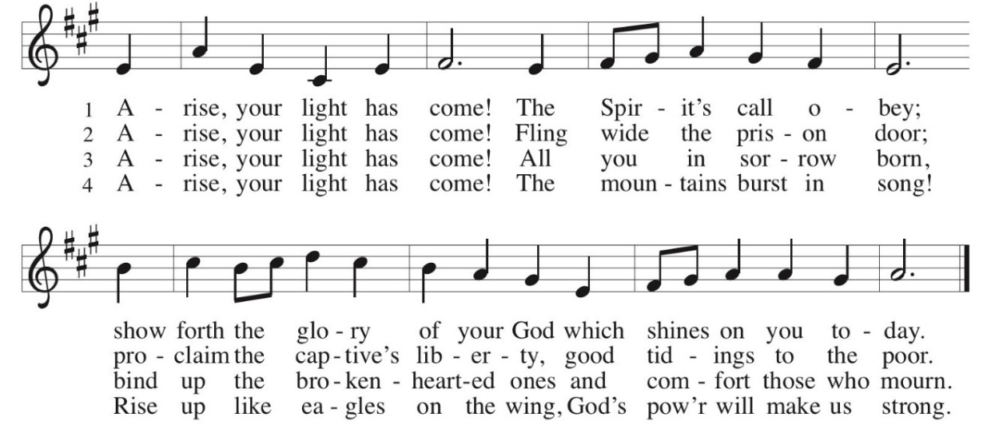
Gospel: Matthew 17:1-9

P: The Gospel according to Matthew C: Glory to you, O Lord
Shortly before he enters Jerusalem, where he will be crucified, Jesus is revealed to Peter, James, and John in a mountaintop experience of divine glory called the transfiguration.
¹ Six days later, Jesus took with him Peter and James and his brother John and led them up a high mountain, by themselves. ² And he was transfigured before them, and his face shone like the sun, and his clothes became bright as light. ³ Suddenly there appeared to them Moses and Elijah, talking with him. ⁴ Then Peter said to Jesus, “Lord, it is good for us to be here; if you wish, I will set up three tents here, one for you, one for Moses, and one for Elijah.” ⁵ While he was still speaking, suddenly a bright cloud overshadowed them, and a voice from the cloud said, “This is my Son, the Beloved; with him I am well pleased; listen to him!” ⁶ When the disciples heard this, they fell to the ground and were overcome by fear. ⁷ But Jesus came and touched them, saying, “Get up and do not be afraid.” ⁸ And when they raised their eyes, they saw no one except Jesus himself alone.
⁹ As they were coming down the mountain, Jesus ordered them, “Tell no one about the vision until after the Son of Man has been raised from the dead.”
P: The Gospel of Our Lord. C. Praise to you, O Christ.
CHILDREN’S MESSAGE
MESSAGE
HYMN OF THE DAY I Love to Tell the Story ELW 661
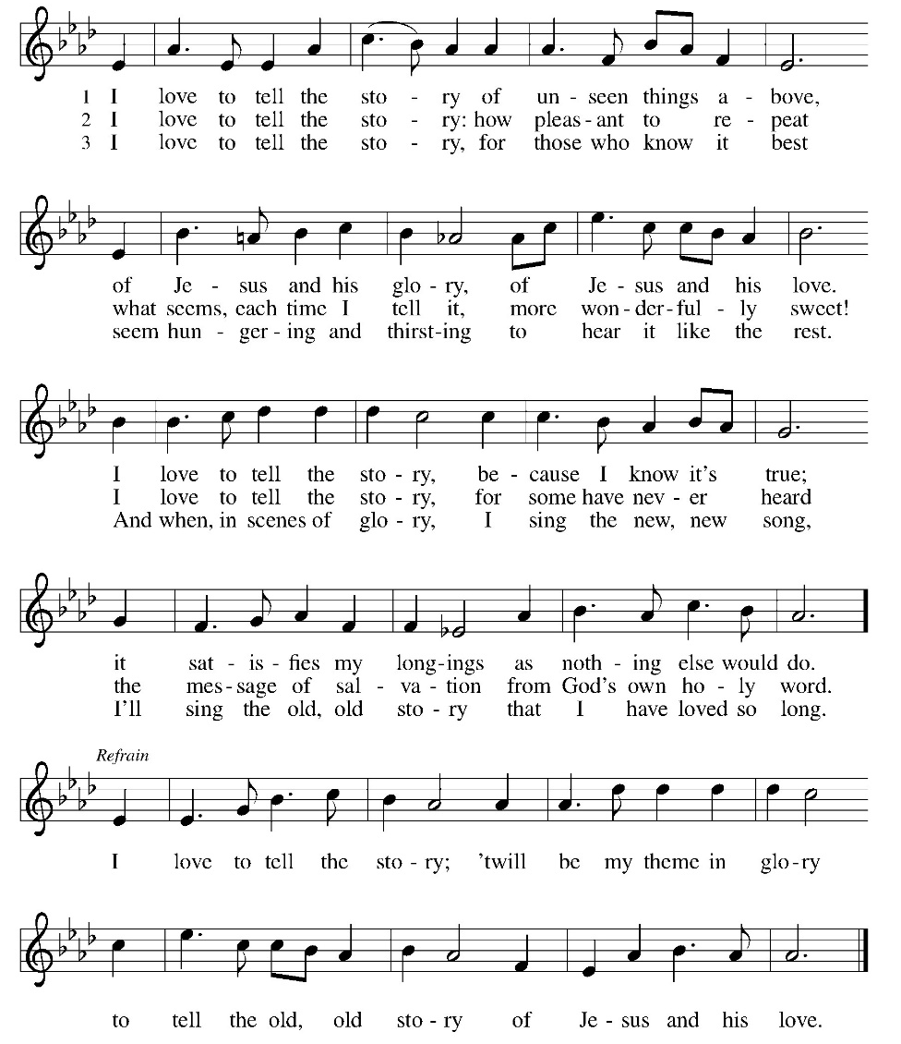
APOSTLES’ CREED:
I believe in God, the Father almighty, creator of heaven and earth.
I believe in Jesus Christ, God’s only Son, our Lord, who was conceived by the Holy Spirit, born of the virgin Mary, suffered under Pontius Pilate, was crucified, died, and was buried; he descended to the dead. On the third day he rose again; he ascended into heaven, he is seated at the right hand of the Father, and he will come to judge the living and the dead.
I believe in the Holy Spirit, the holy catholic church, the communion of saints, the forgiveness of sins, the resurrection of the body, and the life everlasting. Amen
PRAYERS OF INTERCESSION:
P: Merciful God. C: Receive our Prayer
PEACE
P: The peace of Christ be with you always.
C. And also, with you.
OFFERING: Our offering is a significant act of worship; we worship God through our giving. The ministry of this congregation is completely dependent upon your partnership and generosity. Offering is collected as you enter worship on Saturday. We will pass the offering plate on Sundays. Online giving is available.
OFFERING HYMN: This Little Light of Mine ELW 677 (Next Page)
OFFERING PRAYER:
P: Let us pray together: God of majesty, C: no eye has seen, no ear has heard what you have prepared for those who love you, yet in this meal you reveal the wideness of your mercy. Use what we have gathered to feed us with the reign of God come near, Jesus Christ, our Savior and Lord. Amen.

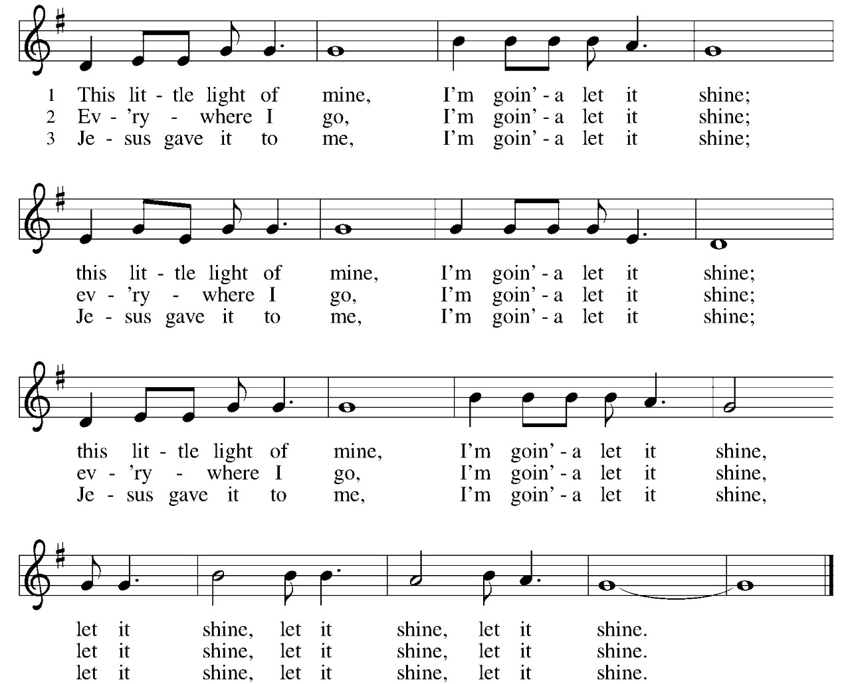

COMMUNION LITURGY:
In the night in which he was betrayed, our Lord Jesus took bread, and gave thanks, broke it and gave it to his disciples, saying: take and eat; this is my body, given for you. Do this for the remembrance of me. Again, after supper, he took the cup, gave thanks and gave it for all the drink, saying: this cup is the new covenant in my blood, shed for you and for all people for the forgiveness of sin. Do this for the remembrance of me.
THE LORD’S PRAYER:
Our Father, who art in heaven, hallowed be thy name, thy kingdom come, thy will be done on earth as it is in heaven. Give us this day our daily bread; and forgive us our trespasses, as we forgive those who trespass against us; and lead us not into temptation but deliver us from evil. For thine is the kingdom, and power, and the glory, forever and ever. Amen
INVITATION TO COMMUNION:
P: Here is the Lamb of God who takes away the sin of the world!
Come to the table; taste and see.
Please come down the center aisle, take the bread, then receive a cup (wine is dark, juice is light, return to your seats via side aisle.) Those who prefer to take communion in your pews, we will take all together after all are served.
DISTRIBUTION OF COMMUNION:
P: This is the body of Christ given for you. (All take bread).
P: This is the blood of Christ shed for you. (All take the wine).
COMMUNION HYMN: Beautiful Savior ELW 838 (next page)

TABLE BLESSING:
P: May the body and blood of our Lord Jesus Christ strengthen you and keep you in God’s grace. C: Amen.
PRAYER AFTER COMMUNION:
P: Let us pray together: Radiant God, C: we have seen your glory in the face of Jesus Christ. In the sacrament of his body and blood you have drawn us to your heart. Send us from this table with delight, that our lives may reflect the beauty of your love, and bear witness to all we have seen and heard, through Jesus Christ, our Savior and Lord. Amen.

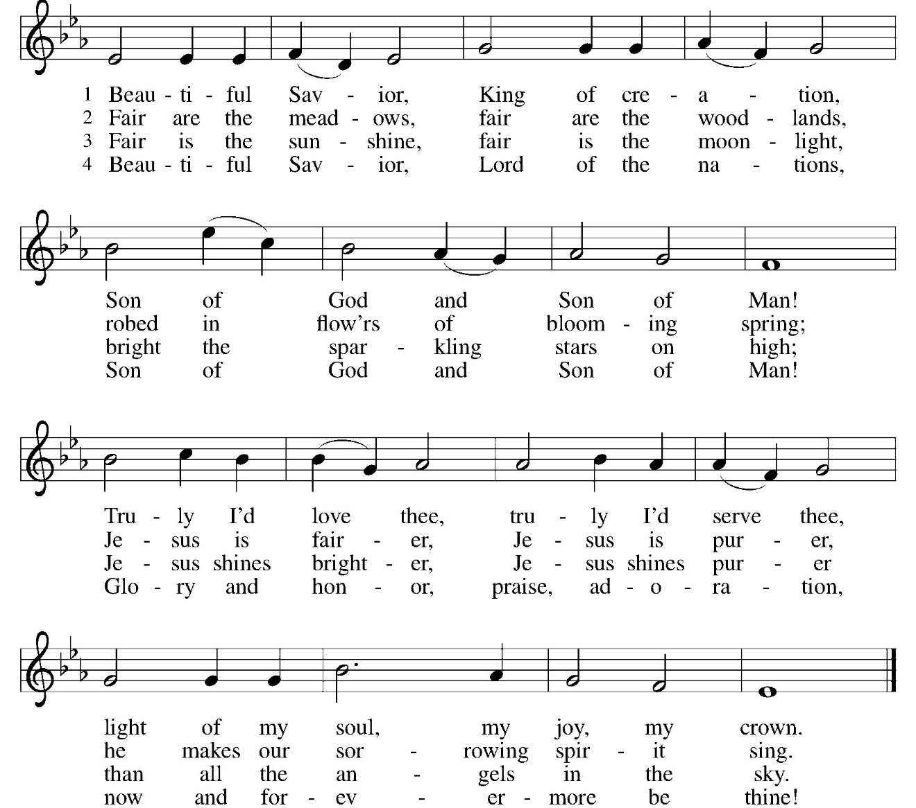

SENDING: God blesses us and sends us in mission to the world.
BLESSING:
P: May the triune God, who has put a new song in your mouth
and tuned your heart for praise ☩ bless you now and forever.
C: Amen.
SENDING HYMN We Are Marching in the light ELW 866
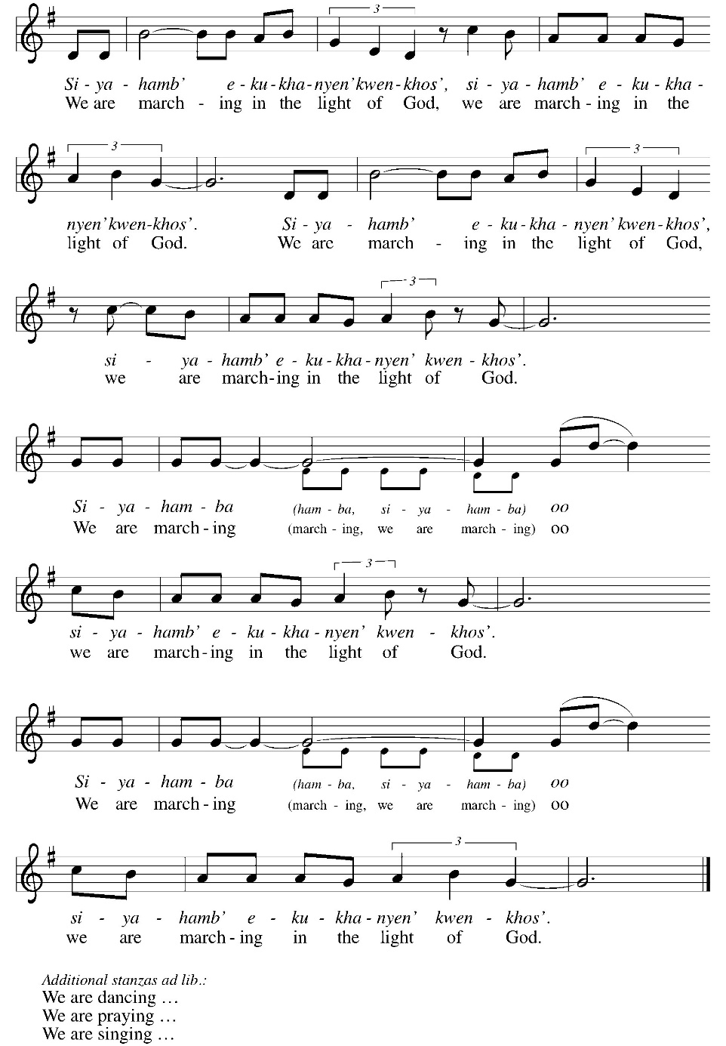
DISMISSAL:
P: Go in peace. Do justice. Love mercy.
C: Thanks be to God.
POSTLUDE
IN OUR PRAYERS TODAY: Teresa Hesselbacher, Elaine Schlicting, Darlene and Walt Steffes, Bob Schreck, Delores Wampfler, Marge and Gerald Arnold, Don & Judy Brudi, Pat Lawfer, Nancy Dittmar, Karen Dick, Angie Broshous, Grayson Raab, Larry Goebel, James Dieter, Christine Happ, Kay Hesselbacher, Mary Lou Bunker, Lillian Sefford, Cindy Kerchner, Russ Synder, Don Kunz, Johnny Blair, Jim Sullivan, John Becker To add someone to the prayer list please contact Pastor Chrissy

CELEBRATING BIRTHDAYS / ANNIVERSARIES: Crew Pfile, Grant Keys, Ken Penticoff, Kevin Schubert, Nancy Dittmar, Verla Rhyner, Karah Arnold, Jayden Hudson, Brad and Val Brudi, Bryan and Angie Broshous
ONLINE GIVING: Your gift has a big impact on our ministries and those we serve. Scan this code or visit our website to give online today
Thanks be to God for your gifts for the ministry of  Christ Lutheran Church *these numbers do not reflect online giving- only offering in worship |  |  |  | Offering/ Attendance  Sat Feb 7  Sunday Feb 8
Current Expense | $3,561.00 | Building Fund | $10.00 | Feb 7 | 28
Benevolence | $10.00 |  |  | Feb 8  Sunday School | 41  23
 |  | Total |  | Community Table | 25
  $3,581.00

January Totals: As a way to improve communication around finances, we are sharing following information: *these numbers reflect online giving contribution
January
2026
 | January | Year to date
Offerings: | $6,430 | $6,430
Expenses: | $12,667 | $12,667
Overall Gain / Loss | ($6,237) | ($6,237)

ANNOUNCEMENTS
AMAZON WISH LIST: did you know that everyday items used at the church are items you could contribute? Find our list here or on our Facebook page. Thank you! Right now items have been added for the blessing box.
THE COMMUNITY TABLE: The Community Table is an opportunity for outreach to the local community. This is a twice a month meal on the first and third Tuesday of the month at 11:30, here at Christ to gather for food, fellowship and fun, if you are interested in volunteering please talk with Janet Haas or Debbie Goebel. Join us on Tuesday February 17th. All are welcome.
CONSIDERING BECOMING A MEMBER: Have you been attending worship and participating in the life of the church for a while? Have you considered joining and becoming a member of Christ Lutheran Church? It really is easy to transfer your membership or join us. For more information, please talk to Pastor Chrissy.
READINGS FOR NEXT WEEK: Genesis 2:15-17, 3:1-7; Psalm 32; Romans 5:12-19; Matthew 4:1-11
Church Council Leadership for 2026
President: David Heller Vice President: Norm Groezinger
Secretary: Debbie Goebel Treasurer: Steve Jordan
Financial Secretary: Ken Buske Education: Leisa Hubb
Worship Team: Patsy Holland Property Team: Cory Haas
COWORKERS IN THE GOSPEL: Consider being a part of one our leadership teams. As of this month, three teams will be helping connect council and congregation as we work together to do ministry together. Three teams have formed; Worship Team, Building Team and Education Team. If you are interested in being a part of one of the teams, please see Pr Chrissy or someone on the team.
- Worship team leader is Patsy Holland -anyone who is interested in serving in any area of worship, especially baking communion bread, communion set up, serving or clean up.
- The building team will access, and address issues related to the building. Please see Cory Haas, team leader, if you would like to help out with the building.
- The Education Team over sees Confirmation, Sunday School and Vacation Bible School. Vacation Bible School is going to happen June 1-5. from 9-11:30. If you would like to be a part of the education team please see Leisa Hubb (team leader)
Upcoming Events
- February 14- 5:30 pm Worship (SAM Marty Clausen from Lanark)
- February 15- 9 am Sunday School
- February 15- 10 am Worship (Assistant to the Bishop Josh Ebner)
- February 18 – 7 am –9am Ashes and Coffee to Go Church Parking Lot
- February 18- 7 pm Worship with communion and ashes
- February 21- 8 am- Breaking Bread together – Copper Leaf Restaurant
- February 22/23 worship with communion
- March 7 - Congregation Resourcing Evening Sauk Village Community College (See insert of nisynod.com for more information-register by 2/20)
Pastor Chrissy will be taking some time off and will return to the office February 24th. I appreciate the support the congregation has expressed. I am grateful for the several leaders who have been able to lead worship during my time away. For help or pastoral care needs please call Norm Groezinger at 815-541-4808 or Jeanie at 847-721-8244. Pastor Chrissy will not be available during this time.

