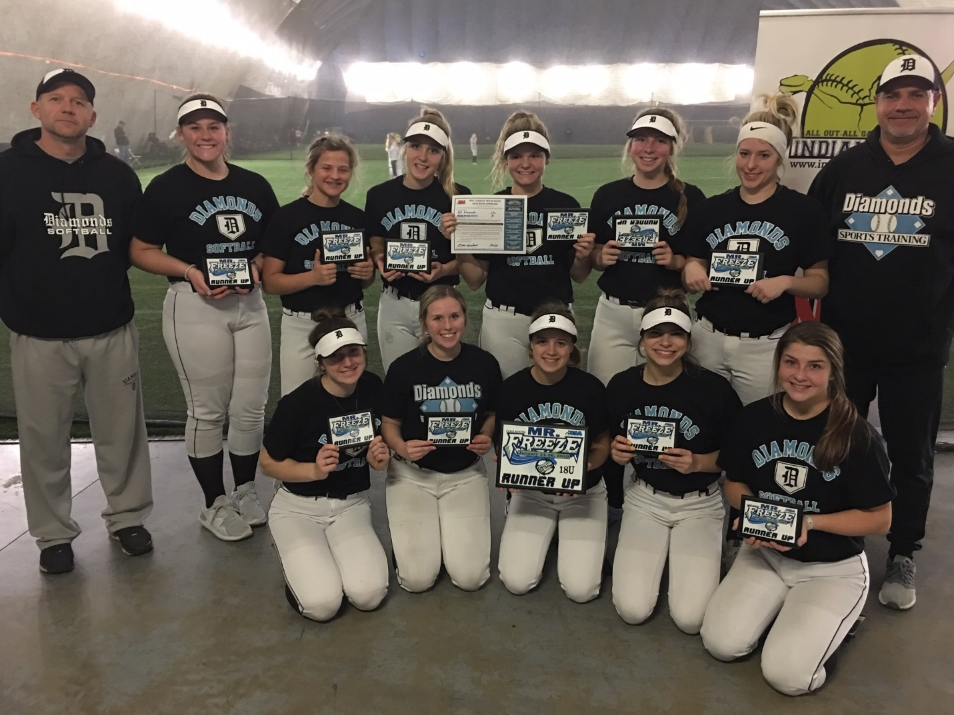
18u Runner Up GR Diamonds

