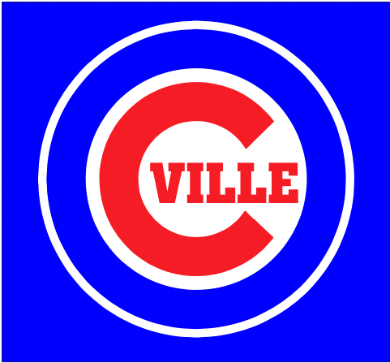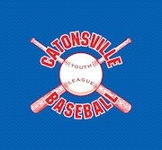

Who: Boys ages 6 -14 years old
Dates: Monday-Friday, June 24th – June 28 th 2019
Time: 8:30am-11:30am
Where: Catonsville High School
Cost: $120.00 per camper ($135 after June 10th)

WHAT: Our camp is committed to providing skills and knowledge to improve their game no matter what level they are playing at currently. We provide small group and individual instruction on hitting, pitching, fielding, and much more. Kids have an opportunity to learn skills related to specific positions.
STAFF: Our staff and counselors includes former Division I baseball players, experienced coaches from various age groups and programs from the recreational, travel, and high school levels.
Lead Instructors include:
Brian Bent: Professional Baseball Training
Neal Davis: Former CHS grad and Division 1 player
Eric Warm: CHS Head Varsity Coach
Administrator/Coaches from CYLB:Troy Stevenson, Jeff Tolton, Brian Robey, Matt Gross

Please register thru the link below:
https://go.teamsnap.com/forms/187716

Questions: jrtolton@gmail.com

