CONTINUATION OF ANNUAL TOWN MEETING
September 11, 2018
Aurora, MN

IN ATTENDANCE: (22) Jon Skelton, Craig Anttila, Edward Kippley, Jodi Knaus, Emma Shuck, Michael Kearney, Corinne Thompson, Vivian Williams, Beth Wilkes, Donna Meacham, Betty Stende, Betty Harsila, Leah Ryan, Ed Alto, William Maki, Mike Palm, Karen E., Gerry Kangas, Mike Skinner, Bill Partyka, Bonnie Partyka, Sam Wilkes

- The 2018 Continuation of the Annual Town Meeting of the Town of White was called to order by Chairman Skelton on Tuesday, September 11, 2018, at 6:00 P.M., at the Loon Lake Community Center.
- Pledge of Allegiance
- Skelton called for Nominations for Moderator
IT WAS MOVED BY THOMPSON, SUPPORTED BY BETH WILKES TO NOMINATE THOMPSON AS MODERATOR. NO OTHER NOMINATIONS. MOTION CARRIED
IT WAS MOVED BY WILLIAMS, SUPPORTED BY STENDE THAT NOMINATIONS BE CLOSED. MOTION CARRIED
Corinne Thompson took the chair as moderator.

4.) IT WAS MOVED BY PALM, SUPPORTED BY WILLIAMS TO APPROVE & ADOPT THE AGENDA AS PRESENTED. MOTION CARRIED

5.) IT WAS MOVED BY PALM, SUPPORTED BY STENDE TO SUSPEND READING & APPROVE THE MARCH 2018 ANNUAL MEETING MINTUES AS WRITTEN. MOTION CARRIED

6.) Moderator Thompson read the PowerPoint Presentation outlining the Clerk’s Report including Strategic Plan Outcomes and the 2018-2019 Budget Discussion (slides included at end of minutes). Questions were answered about the East Mesabi Water Project, Gardendale, Poplar Street, pairing and sharing ideas, the new Mesabi East School Facility, and recreation. Clarification was made on what the employee Cafeteria Plan is and signs in the road right of way. Williams would like more information on what an urban township is versus a rural township. Kearney responded. Harsila questioned how a levy increase would affect their taxes and Kippley responded. Harsila and Williams had property access questions and Kippley indicated he would talk to Public Works.

7.) Levy Discussion was held.
IT WAS MOVED BY MAKI, SUPPORTED BY WILLIAMS TO APPROVE AN INCREASE IN THE LEVY BY 2% TO BE RECEIVED IN 2019. MOTION CARRIED

8.) Accept Powerpoint Presentation & Clerk’s Report
IT WAS MOVED BY HARSILA, SUPPORTED BY WILLIAMS TO ACCEPT THE CLERK’S REPORT. MOTION CARRIED
9.) Other Business – None was discussed.
10.) IT WAS MOVED BY WILLIAMS, SUPPORTED BY STENDE TO KEEP THE 2018 CONTINUATION OF ANNUAL MEETING OPEN UNTIL THE ANNUAL TOWN MEETING ON MARCH 12, 2019. MOTION CARRIED AT 7:42 P.M.

POWERPOINT PRESENTATION SLIDES ARE ATTACHED.

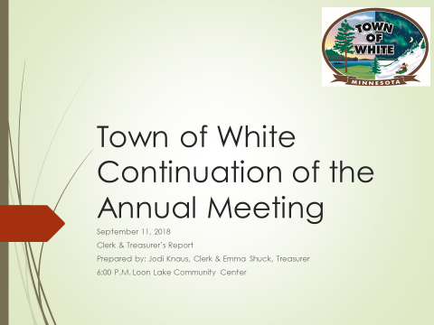

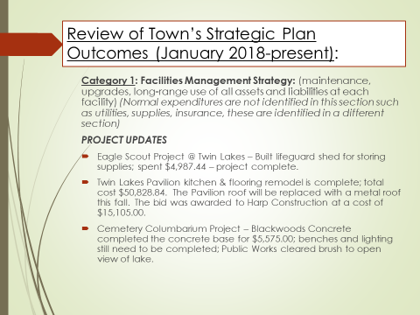

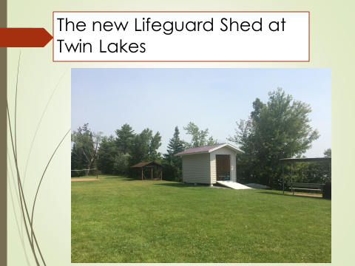

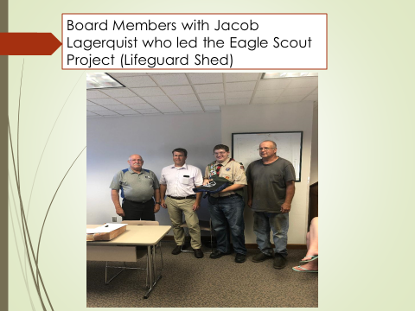

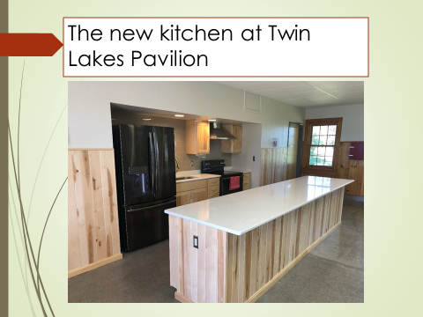

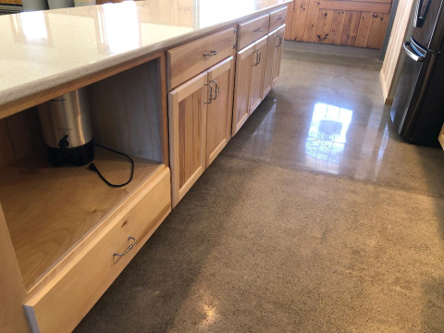

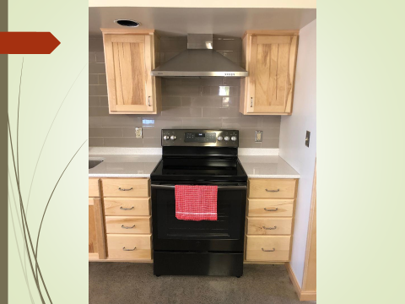

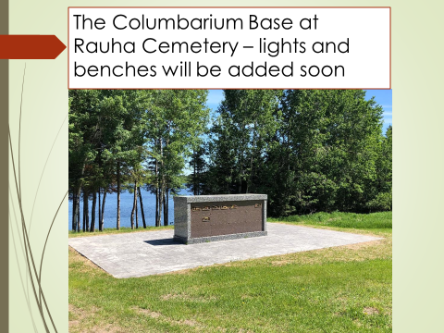

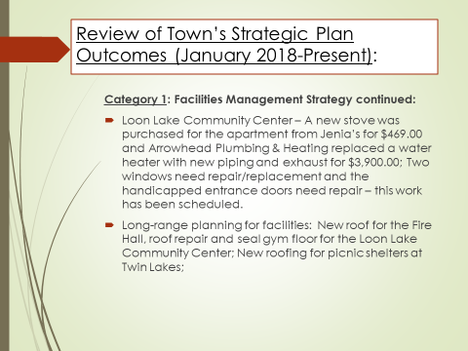

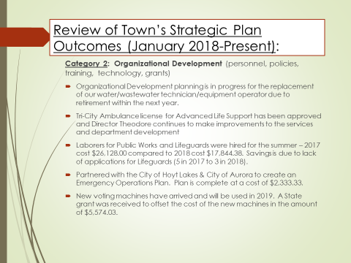

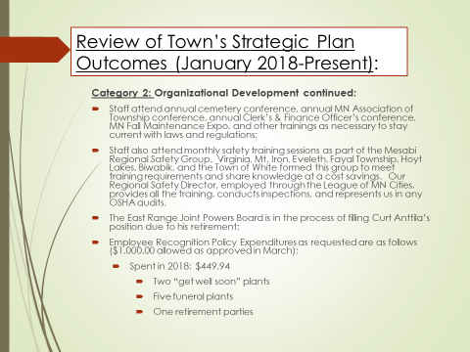

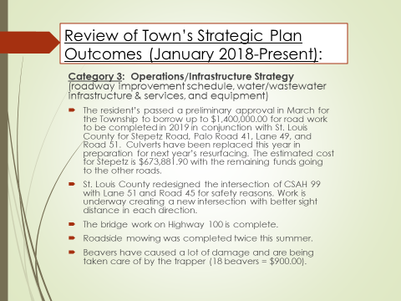

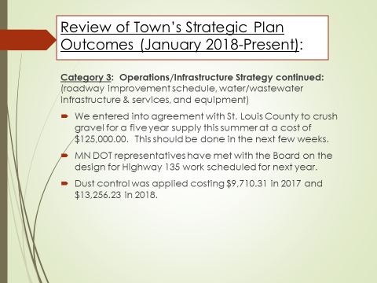

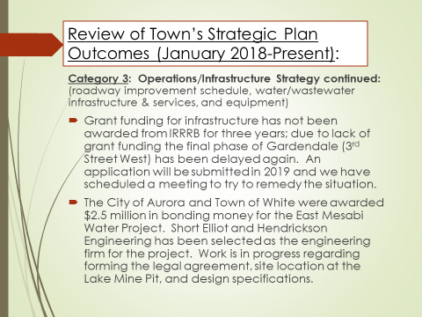

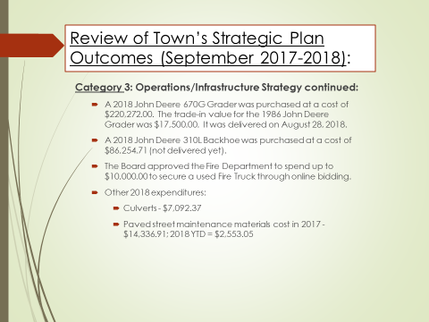

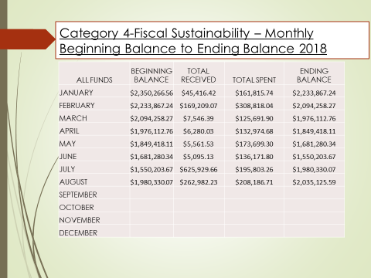

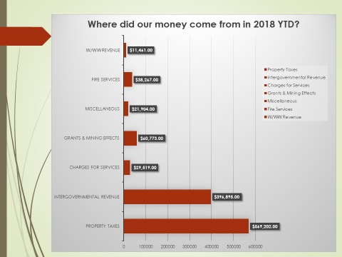

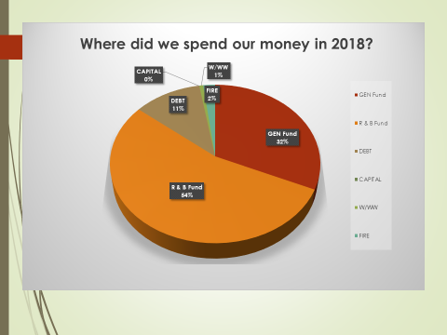

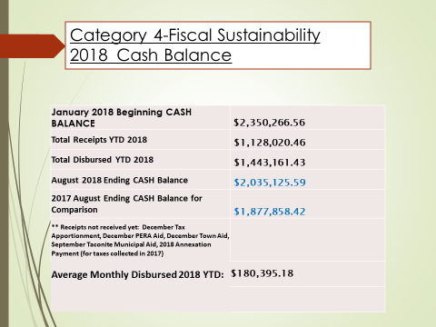

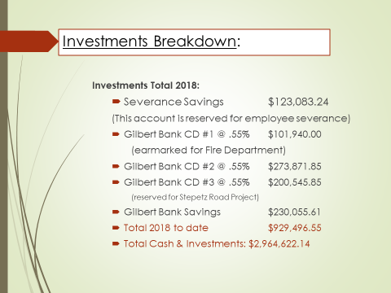

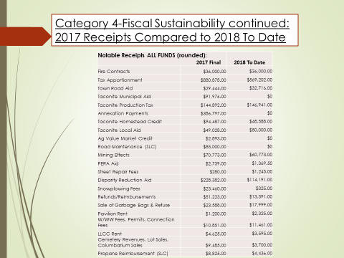

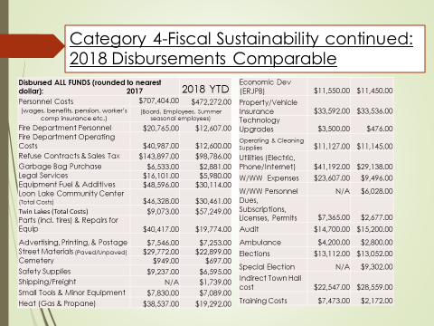

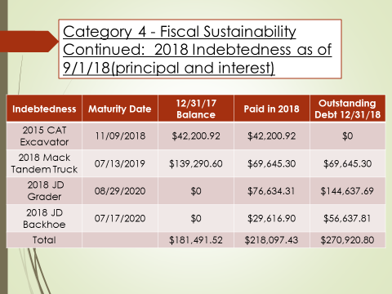

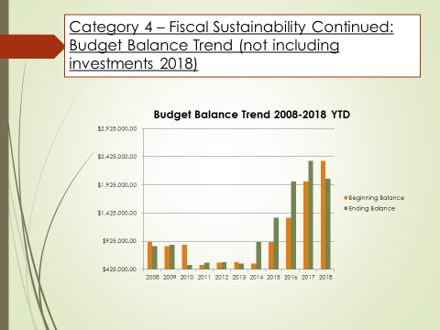

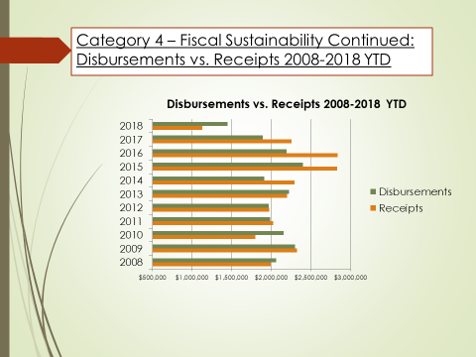

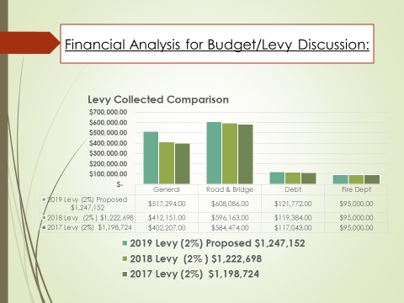

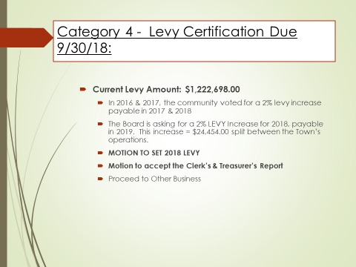

_____________________________________ _________________________________________
Jodi Knaus, Clerk Corinne Thompson, Moderator

