I believe in the Holy Spirit,
the holy catholic church,
the communion of saints,
the forgiveness of sins,
the resurrection of the body
and the life everlasting.
Amen.

PRAYERS OF INTERCESSION
V. Reconciled by God’s mercy and sustained by God’s presence, let us pray for the
world and its needs.

(A brief silence.)

A. Guide your church, O God. Accompany all Christians in this season of
repentance, and renew our faith in the riches of grace you give to us in baptism.
Hear us, O God.
C. Your mercy is great.

A. Heal this earth, O God. Satisfy the needs of every parched place, every diverse
ecosystem, every suffering creature. Though all return to dust, grant beauty and
purpose to each living thing. Hear us, O God.
C. Your mercy is great.

A. Restore the nations, O God. Let your healing spring up quickly across the world.
Give all in authority the will to loose the bonds of injustice and let any who are
oppressed go free. Hear us, O God.
C. Your mercy is great.

A. Deliver your people, O God. Comfort any whose hearts are rent by grief, uphold
any who are sick, bring food to those who hunger, and give housing to all without
shelter. Hear us, O God.
C. Your mercy is great.

A. Bless this assembly, O God. Reconcile us to one another and to you. Strengthen
our resolve to fast from evil, open our hands in sharing, and quicken our prayer.
Hear us, O God.
C. Your mercy is great.

A. Hold us forever, O God. We thank you for all who now know their treasure in
heaven, and for (Martin Luther and) all who on earth proclaimed your abounding,
steadfast love. Hear us, O God.
C. Your mercy is great.

(Here other intercessions may be offered.)

V. Watch over all of us who are worried and suffering, and especially those whose
names we now say aloud or hold within our hearts (pause). Hear us, O God.
C. Your mercy is great.

V. Receive our prayers, O God, through Jesus Christ, our strength and salvation.
C. Amen.

SHARING OF THE PEACE
V. May the peace of the Lord be with you always.
C. And also with you.
V. Now, let us share God’s Peace with one another.



(Please respect your neighbor if they desire to still only offer a peace sign or wave.)

(Following the Sharing of the Peace, we invite you to be seated.)

OFFERING
V. We now worship God with our tithes and offerings, wine and bread for use in holy
communion, and monetary gifts to support our ministry for service in God’s name.
Our Ushers will be around to your pews to pass the Offering Plates.

(Ushers come forward to get the Offering Plates from the Assistant.)

(Vicar and Assistant prepare the Altar for Communion.)

OFFERING SONG
(We invite you to sing along.)
Worship & Praise
156—What Have We to Offer?
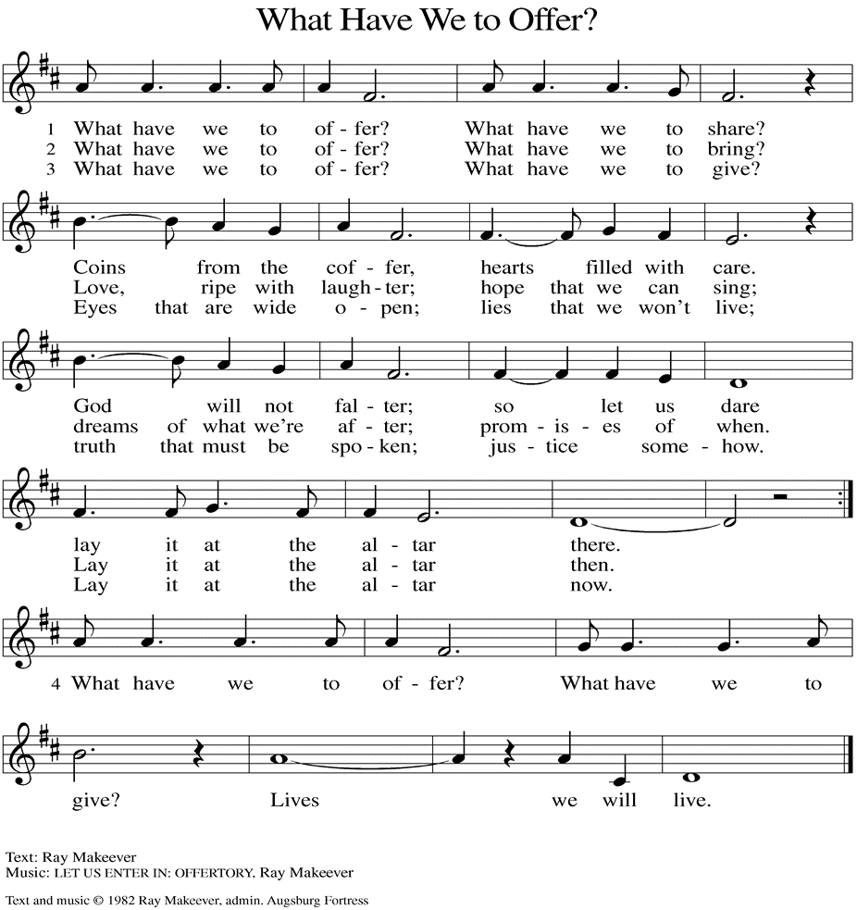
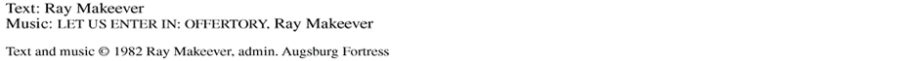

(Usher(s) brings the Tithes and Offerings up front to the Assistant.)
19“Do not store up for yourselves treasures on earth, where moth and rust
consume and where thieves break in and steal; 20but store up for yourselves
treasures in heaven, where neither moth nor rust consumes and where thieves
do not break in and steal. 21For where your treasure is, there your heart will be
also.”

V. This is the Gospel of the Lord,
C. Glory and Praise to You, Lord Jesus Christ.

(We invite you to be seated.)

SERMON
(Delivered by Vicar Vince Piekarski.)

(Following the Sermon, we invite you to stand as you are able.)

HYMN OF THE DAY
(We invite you to sing along.)
Lutheran Book of Worship—Green Book
482—When I Survey the Wondrous Cross

APOSTLES’ CREED
V. God has made us his people through our Baptism into Christ. Living together in
trust and hope let us confess our faith together using the Apostles’ Creed.
C. I believe in God, the Father almighty,
creator of heaven and earth.

I believe in Jesus Christ, God’s only Son, our Lord,
who was conceived by the Holy Spirit,
born of the Virgin Mary,
suffered under Pontius Pilate,
was crucified, died, and was buried;
he descended to the dead.
On the third day he rose again;
he ascended into heaven,
he is seated at the right hand of the Father,
and he will come to judge the living and the dead.

R. This is the Word of the Lord.
C. Thanks be to God.

V. I invite you to stand as you are able, and I invite you to announce the Gospel
Acclamation with me.

GOSPEL ACCLAMATION
C. Return to the Lord, your God, who is gracious and merciful, slow to anger,
and abounding in steadfast love. (Joel 2:13)

GOSPEL READING
In the Sermon on the Mount, Jesus commends almsgiving, prayer, and fasting,
but emphasizes that spiritual devotion must not be done for show.

V. The Holy Gospel According to Matthew, the 6th chapter. (Verses 1-6, 16-21).
C. Glory to you, O Lord.

V. [Jesus said to the disciples:] 1“Beware of practicing your piety before others in
order to be seen by them; for then you have no reward from your Father in
heaven.

2“So whenever you give alms, do not sound a trumpet before you, as the
hypocrites do in the synagogues and in the streets, so that they may be praised
by others. Truly I tell you, they have received their reward. 3But when you give
alms, do not let your left hand know what your right hand is doing, 4so that your
alms may be done in secret; and your Father who sees in secret will reward you.

5“And whenever you pray, do not be like the hypocrites; for they love to stand
and pray in the synagogues and at the street corners, so that they may be seen
by others. Truly I tell you, they have received their reward. 6But whenever you
pray, go into your room and shut the door and pray to your Father who is in
secret; and your Father who sees in secret will reward you.

16“And whenever you fast, do not look dismal, like the hypocrites, for they
disfigure their faces so as to show others that they are fasting. Truly I tell you,
they have received their reward. 17But when you fast, put oil on your head and
wash your face, 18so that your fasting may be seen not by others but by your
Father who is in secret; and your Father who sees in secret will reward you.

V. We invite you to stand as you are able.

OFFERING PRAYER
V. Let us pray,
O God, maker of heaven and earth,
your steadfast love embraces all creation.
You send rain and sunshine to nourish the earth
and bring forth its bounty.
Through these gifts of bread and wine,
draw us into the death and life of your Son,
who calls us to bear witness to his saving work.
We ask this in Jesus’ name.
C. Amen.

GREAT THANKSGIVING
V. The Lord be with you.
C. And also with you.

V. Lift up your hearts.
C. We lift them to the Lord.

V. Let us give thanks to the Lord our God.
C. It is right to give him thanks and praise.

V. It is indeed right and salutary that we should at all times and in all places offer
thanks and praise to you, O Lord, holy Father, through Christ our Lord; who rose
beyond the bounds of death and, as he promised, poured out your Spirit of life
and power upon the chosen disciples. At this the whole earth exults in boundless
joy. And so, with the Church on earth and the hosts of heaven, we praise your
name and join their unending hymn:

SANCTUS
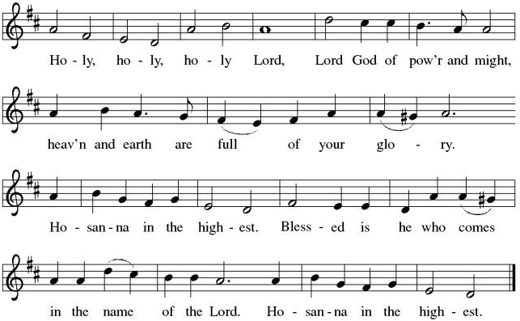

THE EUCHARISTIC PRAYER
V. Blessed are you, Lord of heaven and earth, in mercy for our fallen world you gave
your only Son, that all those who believe in Him should not perish, but have
eternal life. We give thanks to you for the salvation you have prepared for us
through Jesus Christ. Send now your Holy Spirit into our hearts that we may
receive our Lord with a living faith as He comes to us in His holy supper.
C. Amen. Come, Lord Jesus.

V. In the night in which he was betrayed our Lord Jesus took bread,
he gave thanks; broke it, and gave it to his disciples, saying:
Take and eat; this is my body, given for you.
Do this for the remembrance of me.

V. Again, after supper, He took the cup, he gave thanks,
and gave it for all to drink, saying:
This cup is the new covenant in my blood,
shed for you and for all people for the forgiveness of sin.
Do this for the remembrance of me.

R. 13Let me teach your ways to offenders,
and sinners shall be restored to you.
14Rescue me from bloodshed, O God of my salvation,
and my tongue shall sing of your righteousness.
15O Lord, open my lips,
and my mouth shall proclaim your praise.
16For you take no delight in sacrifice, or I would give it.
You are not pleased with burnt offering.
17The sacrifice of God is a troubled spirit;
a troubled and broken heart, O God, you will not despise.
C. Have mercy on me, O God, according to your steadfast love. (Ps. 51:1)

SECOND READING
The ministry of the gospel endures many challenges and hardships. Through this
ministry, God’s reconciling activity in the death of Christ reaches into the depths
of our lives to bring us into a right relationship with God. In this way, God accepts
us into the reality of divine salvation.

R. Our Second Reading is from the 5th and 6th Chapters of 2nd Corinthians
(5:20b—6:10).

R. 20bWe entreat you on behalf of Christ, be reconciled to God. 21For our sake he
made him to be sin who knew no sin, so that in him we might become the
righteousness of God.

6:1As we work together with him, we urge you also not to accept the grace of
God in vain. 2For he says,
“At an acceptable time I have listened to you,
and on a day of salvation I have helped you.”
See, now is the acceptable time; see, now is the day of salvation! 3We are
putting no obstacle in anyone’s way, so that no fault may be found with our
ministry, 4but as servants of God we have commended ourselves in every way:
through great endurance, in afflictions, hardships, calamities, 5beatings,
imprisonments, riots, labors, sleepless nights, hunger; 6by purity, knowledge,
patience, kindness, holiness of spirit, genuine love, 7truthful speech, and the
power of God; with the weapons of righteousness for the right hand and for the
left; 8in honor and dishonor, in ill repute and good repute. We are treated as
impostors, and yet are true; 9as unknown, and yet are well known; as dying, and
see—we are alive; as punished, and yet not killed; 10as sorrowful, yet always
rejoicing; as poor, yet making many rich; as having nothing, and yet possessing
everything.
Why should it be said among the peoples,
‘Where is their God?’ ”

R. This is the Word of the Lord.
C. Thanks be to God.

PSALM
R. Our Responsorial Psalm is from the 51st Psalm (Verses 1-17).
C. Have mercy on me, O God, according to your steadfast love. (Ps. 51:1)

R. 1Have mercy on me, O God, according to your steadfast love;
in your great compassion blot out my offenses.
2Wash me through and through from my wickedness,
and cleanse me from my sin.
3For I know my offenses,
and my sin is ever before me.
4Against you only have I sinned and done what is evil in your sight;
so you are justified when you speak and right in your judgment.
C. Have mercy on me, O God, according to your steadfast love. (Ps. 51:1)

R. 5Indeed, I was born steeped in wickedness,
a sinner from my mother’s womb.
6Indeed, you delight in truth deep within me,
and would have me know wisdom deep within.
7Remove my sins with hyssop, and I shall be clean;
wash me, and I shall be purer than snow.
8Let me hear joy and gladness;
that the body you have broken may rejoice.
C. Have mercy on me, O God, according to your steadfast love. (Ps. 51:1)

R. 9Hide your face from my sins,
and blot out all my wickedness.
10Create in me a clean heart, O God,
and renew a right spirit within me.
11Cast me not away from your presence,
and take not your Holy Spirit from me.
12Restore to me the joy of your salvation
and sustain me with your bountiful Spirit.
C. Have mercy on me, O God, according to your steadfast love. (Ps. 51:1)

THE LORD’S PRAYER
(We ring the bell throughout the Lord’s Prayer at all services to
invite those in the community to join in praying the Lord’s Prayer.)
V. May we now join with one another and pray together as Jesus has taught us.
C. Our Father, who art in heaven, hallowed be thy name, thy kingdom come,
thy will be done, on earth as it is in heaven. Give us this day our daily
bread; and forgive us our trespasses, as we forgive those who trespass
against us; and lead us not into temptation, but deliver us from evil. For
thine is the kingdom, and the power, and the glory, forever and ever.
Amen.

LAMB OF GOD

(We invite you to be seated.)

HOLY COMMUNION
V. Communion here is pretty simple, and all who are baptized and believe in Jesus
Christ are welcome at the table.

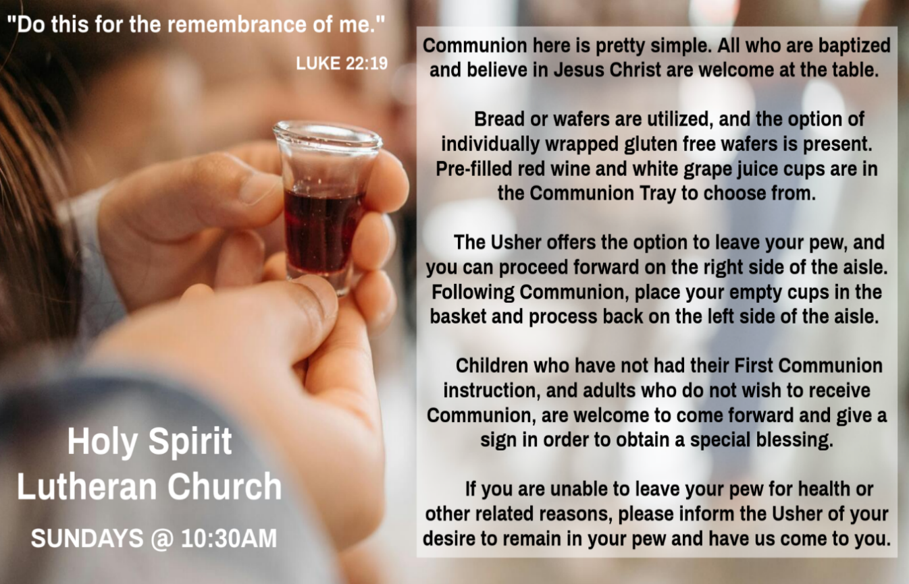

INVITATION TO COMMUNION
V. Come to the table.
Feast on God’s goodness and mercy.
C. Amen.

(Distribution of Holy Communion)

COMMUNION HYMN
(Please enjoy various music offered by our Organist during your
quiet time, prayer, and reflection following Holy Communion.)

(Vicar and Assistant remove Communion Vessels from the Altar.)

V. We invite you to stand as you are able.

POST COMMUNION BLESSING
V. May the body and blood of our Lord Jesus Christ strengthen us and keep us
always in His grace.
C. Amen.
R. 1 Blow the trumpet in Zion;
sound the alarm on my holy mountain!
Let all the inhabitants of the land tremble,
for the day of the Lord is coming, it is near—
2 a day of darkness and gloom,
a day of clouds and thick darkness!
Like blackness spread upon the mountains,
a great and powerful army comes;
their like has never been from of old,
nor will be again after them
in ages to come.

12 Yet even now, says the Lord,
return to me with all your heart,
with fasting, with weeping, and with mourning;
13 rend your hearts and not your clothing.
Return to the Lord your God,
for he is gracious and merciful,
slow to anger, abounding in steadfast love,
and relenting from punishment.
14 Who knows whether he will not turn and relent
and leave a blessing behind him,
a grain offering and a drink offering
for the Lord your God?

15 Blow the trumpet in Zion;
consecrate a fast;
call a solemn assembly;
16 gather the people.
Consecrate the congregation;
assemble the aged;
gather the children,
even infants at the breast.
Let the bridegroom leave his room
and the bride her canopy.

17 Between the vestibule and the altar,
let the priests, the ministers of the Lord, weep.
Let them say, “Spare your people, O Lord,
and do not make your heritage a mockery,
a byword among the nations.
IMPOSITION OF ASHES
V. Ash Wednesday does indeed mark the beginning of our preparation for the
renewal of our hearts, minds and spirits. Ashes are an extra-ordinary rich symbol,
rooted in Jewish/Christian tradition. They suggest judgement and God’s
condemnation of sin, and our total dependence upon God for life. The words
used at their imposition are God’s word to Adam, “Remember that you are dust,
and to dust you shall return” …. reminding us of our mortality. Moreover, ashes
also suggest cleansing and renewal. They were once used as a cleansing agent
in the absence of soap. So, ashes tell of both death and renewal.

V. If you can, please leave your pew and proceed forward on the right side of the
aisle to the steps between the Communion Rail for the Imposition of Ashes.
Please process back on the left side of the aisle as you return to your pew and be
seated.

If you are unable to leave your pew for health or other related reasons, please
raise your hand after everyone comes forward and have us come to you.

(This moment will be silent as we come forward and focus on the beginning of Lent.)

V. “Remember that you are dust, and to dust you shall return.” (Ecclesiastes 3:20)

(After everyone has received ashes please repeat after me.)

V. Accomplish in us, O God, the work of your salvation,
C. that we may show forth your glory in the world.
V. By the Cross and Passion of Your Son, our Saavior,
C. bring us with all Your saints to the joy of His resurrection.
V. Almighty God have mercy on us, forgive us all our sins through our Lord Jesus
Christ, strengthen us in all goodness, and by the power of the Holy Spirit keep us
in eternal life.
C. Amen.

FIRST READING
Because of the coming Day of the Lord, the prophet Joel calls the people to a
community lament. The repentant community reminds God of his gracious
character and asks God to spare the people, lest the nations doubt God’s power
to save.

R. Our First Reading is from the 2nd Chapter of Joel (Verses 1-2, 12-17).
POST COMMUNION CANTICLE
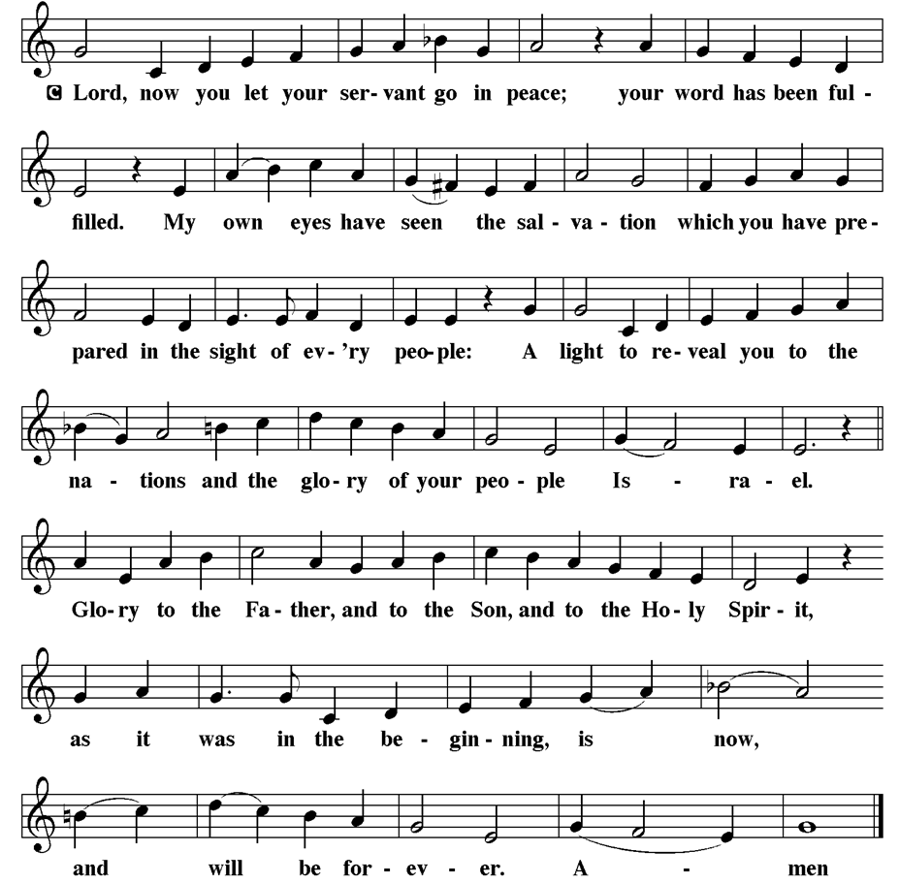

PRAYER AFTER COMMUNION
A. Let us pray,
God of our salvation,
we give you thanks for this meal that restores our souls,
reconciles us to you, and strengthens us for the journey.
Through the body and blood of your Son,
may we become Christ’s body in the world,
bearing witness to your love for all creation,
through Jesus Christ, our Savior and Lord.
C. Amen.

BLESSING
V. Receive the blessing of the holy Trinity:
God, who calls all things into existence,
Jesus Christ, who redeems us,
and the Holy Spirit, whose breath sustains creation,
☩ bless you now and always.
C. Amen.

SENDING HYMN
(We invite you to sing along.)
With One Voice—Blue Book
776—Be Thou My Vision

(Assistant extinguishes the Altar Candles half way through the Sending Hymn.)

(Vicar processes out once the Altar Candles have been extinguished.)

DISMISSAL
A. Go in peace. Believe the good news.
C. Thanks be to God.

POSTLUDE
(Music offered by our Organist as we depart following our Worship Service.)
Take My Life and Let It Be

LICENSES & EXPIRATION DATES
Worship Service Content is used via permission through Augsburg Fortress Liturgies Annual License #SB144368. The next Subscription Renewal Date is 2/28/2026.
Our Hymns and Worship Music are used via permission through CCLI One
License #11327166. The next Subscription Renewal Date is 1/31/2027.

KYRIE
V. In peace, let us pray to the Lord.
C. Lord, have mercy.

V. For the peace from above, and for our salvation, let us pray to the Lord.
C. Lord, have mercy.

V. For the peace of the whole world, for the well-being of the church of God,
and for the unity of all, let us pray to the Lord.
C. Lord, have mercy.

V. For this holy house, and for all who offer here their worship and praise,
let us pray to the Lord.
C. Lord, have mercy.

V. Help, save, comfort, and defend us, gracious Lord.
C. Amen.

PRAYER OF THE DAY
V. The Lord be with you.
C. And also with you.

V. Let us pray,
Almighty and ever-living God, you hate nothing you have made, and you forgive
the sins of all who are penitent. Create in us new and honest hearts, so that, truly
repenting of our sins, we may receive from you, the God of all mercy, full pardon
and forgiveness through your Son, Jesus Christ, our Savior and Lord, who lives
and reigns with you and the Holy Spirit, one God, now and forever.
C. Amen.

INVITATION TO LENT
V. As disciples of Jesus, we are called to a discipline that contends against evil and
resists whatever leads us away from the love of God and neighbor. I invite you,
therefore, to the disciplines of Lent – self-examination and repentance, prayer
and fasting, sacrificial giving and works of love – strengthened by the gifts of
word and sacrament. Let us continue our journey through these forty days to the
great Three Days of Jesus’ death and resurrection.

V. For desiring self-reliance instead of hungering for your word:
Gracious God,
C. have mercy on us according to your steadfast love.
V. For failing to recognize your coming reign,
and for hindering the work of the Spirit: Gracious God,
C. have mercy on us according to your steadfast love.
V. For drawing from the well of self-serving ambition,
and for disdaining the living water Christ offers: Gracious God,
C. have mercy on us according to your steadfast love.
V. For disregarding voices from the margin,
and for distrusting signs of your healing and hope in the world:
Gracious God,
C. have mercy on us according to your steadfast love.
V. For dwelling in tombs of self-pity and discontent,
and for disregarding Christ’s call to come forth to life:
Gracious God,
C. have mercy on us according to your steadfast love.

V. God’s steadfast love, grace, and forgiveness abound.
Through faith, the free gift of God,
you have been clothed in the righteousness of Christ.
In the name of ☩ Jesus Christ, your sins are forgiven.
The Spirit of the One who raised Christ from the dead
dwells in you,
pours God’s love into your hearts,
and gives you life and peace.
C. Amen.

GATHERING HYMN
(We invite you to sing along.)
Lutheran Book of Worship—Green Book
296—Just as I Am, without One Plea

APOSTOLIC GREETING
V. May the grace of our Lord Jesus Christ, the love of God,
and the communion of the Holy Spirit be with you all.
C. And also with you.

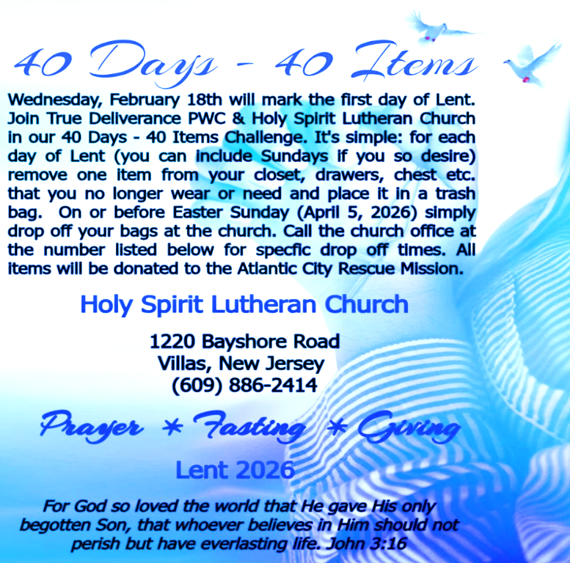

WHAT IS THE EVANGELICAL LUTHERAN CHURCH IN AMERICA?
The ELCA was formed in 1987 by the merger of three Lutheran Church bodies –
the ALC (American Lutheran Church), the LCA (Lutheran Church in America), and the AELC (Association of Evangelical Lutheran Churches). Learn more at elca.org.


The New Jersey Synod is a geographical grouping of Evangelical Lutheran Church in America (ELCA) congregations that share the mission and ministry of the Church on the New Jersey territory. It is one of 65 synods in the ELCA. The NJ Synod is comprised of 143 congregations, which include over 45,000 baptized members.

VICAR APPOINTMENT ON MARCH 19TH, 2023
A Memorandum of Understanding on the Matter of Pastoral Appointment
In Theological Education for Emerging Ministries (TEEM) Candidacy
TO: Congregation Council, Holy Spirit Lutheran Church, Villas
FROM: The Rev. Tracie L. Bartholomew, Bishop, New Jersey Synod

Dear Brother and Sisters in Christ,
This memorandum is in support of your discussions with Vincent Piekarski as pastor of Holy Spirit, Villas. Because this is not the usual pattern for completing the educational and candidacy requirements for ordination, it is my hope that this memorandum will both provide guidelines and engage in conversation with those who are invested in this process.

I would say at the outset that because Vincent is an outstanding candidate for the Ministry of Word and Sacrament, we will all want to do whatever is necessary to assure that his placement serves the mission of the church in the best possible fashion.

The following notes reflect my own understanding of this matter:
(1) The appointment for Vincent will begin on April 1, 2023. At this time, Vincent
will assume all responsibilities of a regularly called pastor, including presiding at
the Sacrament of Holy Communion and Baptism at Holy Spirit, Villas.
(2) A pastoral appointment in the TEEM process is an option for completing
seminary educational requirements and the steps of the candidacy process.
Upon completion of the candidacy process and seminary education, the
candidate may receive and accept a call to ordained ministry from the
congregation where the appointment is being served.
(3) This appointment is jointly supervised by the Office of the Bishop and the TEEM
pastor’s seminary. A mentoring relationship with a local pastor is required for the
length of this appointment.
(4) The synod of candidacy origin will be responsible for the approval process.
(5) Upon approval for ordination, the congregation would be expected to extend a
call to the pastoral appointee.
(6) Compensation for the TEEM pastor will be according to the guidelines of the New
Jersey Synod. All normal forms of compensation should be in place for the term
of the appointment, including stipulation that base salary and housing shall be in
accord with synod guidelines for first call at time of ordination.
(7) The ELCA Portico benefit plan for lay persons in full-time church service should
be used for the pastoral appointee up to the time of ordination, whereupon the
benefit package is to be converted to the plan for ELCA clergy.

CONFERENCE CALL CHECK-IN, WELCOME, & ANNOUNCEMENTS
(Vicar (V), Assistant (A), Reader (R), and Congregation (C).)

INTRODUCTION
A. On Ash Wednesday we begin our forty-day journey toward Easter with a day of
fasting and repentance. Marking our foreheads with dust, we acknowledge that
we die and return to the earth. At the same time, the dust traces the life-giving
cross indelibly marked on our foreheads at baptism. While we journey through
Lent to return to God, we have already been reconciled to God through Christ.
We humbly pray for God to make our hearts clean while we rejoice that “now is
the day of salvation.” Returning to our baptismal call, we more intentionally bear
the fruits of mercy and justice in the world.

PRELUDE
(Music offered by our Organist at the start of our Worship Service.)
I Have Decided to Follow Jesus

CHIMES
(Music offered by our Organist at the start of our Worship Service.)
I Surrender All

V. We invite you to stand as you are able.

CONFESSION & FORGIVENESS
(All may make the sign of the cross, the sign that is marked at baptism.)
V. Blessed be the holy Trinity, ☩ one God,
who forgives all our sin,
whose mercy endures forever.
C. Amen.

V. Let us confess our sin before God, who removes our guilt
and blots out all offenses.

(Silence is kept for reflection.)

V. Gracious God,
C. have mercy on us according to your steadfast love.
V. For seeking worldly delights that deceive us and dishonor you:
Gracious God,
C. have mercy on us according to your steadfast love.

We, the Evangelical Lutheran Church of the Holy Spirit, are People of God, who
are called by the Holy Spirit to pray, worship, joyfully proclaim Jesus Christ,
and compassionately witness and serve others in Christian Love.


We are glad that you joined us for Worship today! Thank you for enriching our time together! We would like to get to know you better, and for you to get to know us better too. Brochures, welcome gifts, prayer shawls, Bibles, and other items are available throughout the church. We would be happy to show you around and share about our ministries. Please do not hesitate to speak up and ask questions.
Also, please make sure you sign-in on our clipboard on the podium in the lobby.


Our Worship Services are conducted in coordination with our Conference Call.
Join us at 657-390-7423 or 701-802-5170, with access code 8221190#.
You may need to dial 1 first depending on your phone plan. After logging in please announce your name and feel free to talk with others until we get started.


SANCTUARY CANDLE FOR FEBRUARY
Given to the Glory of God & In Memory of JAMES P. ROONEY
by Del McKenna & Children.
ALTAR CANDLES FOR FEBRUARY
Given to the Glory of God & In Memory of CLAIRE MILLER
by Jean, Phil, & Bob Zimmerman.
(8) A decision for Pastoral Appointment is made with the agreement of a synod and
its candidacy committee, and the ELCA, normally represented by the regional
staff person of each in consultation with the seminary and its Director for
Contextual Education.
(9) Pastoral Appointment in a TEEM Candidacy is an option that is to serve the
mission of the Church in a particular and vital way and is not to be viewed or
used as a means to circumvent the normal candidacy process and/or first call
placement process.

In the specific case of Vincent, the New Jersey Synod remains responsible for the candidacy and approval process, and has agreed to this proposal for Appointment at Holy Spirit, Villas.

Continued blessings to both Holy Spirit and Vincent Piekarski as you embark on this journey of mutual ministry. As partners in ministry, we walk with you and rejoice in this new relationship.

VICAR VINCE’S DAY OF REST
A day of rest can have physical, mental, and spiritual benefits. “Mittwoch,” German for mid-week, or Wednesday, is the day that Vicar Vince will use to recharge and do some other things. Please do not hesitate to reach out if there is an emergency!

VICE PASTOR UPDATE
Pastor William Hodgetts continues to attend our Church Council Meetings
and provides Supervision and Support to Vicar Vince.


CHURCH STAFF & VOLUNTEERS
VICAR
Vicar Vince Piekarski
VICE PASTOR
Pastor William Hodgetts
ORGANIST & PIANIST
Carol Amundsen
CHURCH OFFICE, SUNDAY SCHOOL, & FOOD PANTRY
Heather Piekarski
CHURCH COUNCIL PRESIDENT & CHURCH PROPERTY
Wayne Rand
CHURCH COUNCIL VICE PRESIDENT & WOMEN OF THE CHURCH
Judy Brannan
CHURCH COUNCIL TREASURER
Bonnie Millard
CHURCH COUNCIL SECRETARY
Vicki Rinier


WELCOME TO
HOLY SPIRIT LUTHERAN CHURCH
A Member of the Evangelical Lutheran Church in America, New Jersey Synod
1220 Bayshore Rd., Villas, NJ 08251, 609-886-2414,
holyspiritlutheran@comcast.net, holyspiritvillas.com, facebook.com/holyspiritvillas
Vicar Vince Piekarski can be contacted at any time for conversation or prayer through call or text at 412-225-0287, or through email at vpie8282@gmail.com.
WEDNESDAY, FEBRUARY 18TH, 2026
ASH WEDNESDAY
5PM WORSHIP SERVICE WITH HOLY COMMUNION


