City of Aurora, Minnesota
Resolution No 2024-10

BE IT RESOLVED that the City of Aurora is hereby applying to the Minnesota Public Facilities Authority for a loan from the Clean Water Revolving Fund/Drinking Revolving Fund for improvements to its municipal wastewater treatment system/drinking water system as described in the loan application.
BE IT FURTHER RESOLVED that the City of Aurora estimates the loan amount to be up to $12,000,000 or the as-bid cost of the project.

BE IT FURTHER RESOLVED that the City of Aurora adopts the following rate structure for its water enterprise to account for repayment of this loan, with allocating additional cash reserves as needed to remain balanced:

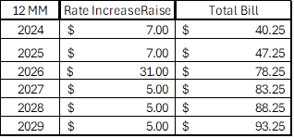
BE IT FURTHER RESOLVED that the City of Aurora has the legal authority to apply for the loan, and the financial, technical, and managerial capacity to repay the loan and ensure proper construction, operation and maintenance of the project for its design life.
I CERTIFY THAT the above resolution was adopted by the City of Aurora on February 1st, 2024
Signed: |  |  |  |  |  |  |  |  |  |  |  |  |  |  | Witnessed:
Name: |  |  |  |  |  |  |  |  |  |  |  |  |  |  | Name:
Title: |  |  |  |  |  |  |  |  |  |  |  |  |  |  | Title:

