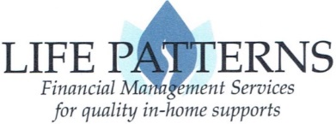
Direct Support Worker Data Sheet for Authenticare

dsw INFORMATION
Direct Support Worker Name:
Social Security Number:
Employer (participant receiving services):
Indicate services worker provides: ☐Personal Assistant Services ☐Sleep Cycle ☐Overnight Respite ☐Specialized Medical Care
Is the worker Bilingual? (yes/no)
Is the worker fluent in sign language? (yes/no)
Language Accommodation Required? (yes/no)

DISCLOSURE OF RELATIONSHIP TO HCBS WAIVER PARTICIPANT (check one)
Parent (natural or adoptive) AND Guardian of Participant**
Parent (natural or adoptive) but NOT Guardian of Participant**
Spouse of Participant
Separated spouse of Participant
Ex-spouse of Participant
Grandparent AND Guardian of Participant
Grandparent but NOT Guardian of Participant
Sibling of Participant (must be 18+ years of age) Guardian? Yes No
Child of Participant
Other family member (i.e. step-parent, foster parent, aunt/uncle, first cousin, etc.):

No family relationship

DISCLOSURE OF physical dwelling: (check one)
I live in the same physical dwelling as the Participant
I do NOT live in the same physical dwelling as the Participant

In accordance with Medicaid policies, it is the Employer’s (HCBS waiver participant or their guardian/representative) responsibility to notify the FMS provider (Life Patterns, Inc.) of any changes in the status of a Direct Support Worker. If any of the information provided on this form changes, it is the Employer’s responsibility to notify Life Patterns within 3 working days.
Signature of Direct Support Worker |  | Date

**I understand that I am a parent employed by my child in domestic service. Therefore, based on State and Federal requirements, I understand Life Patterns Inc., the FMS provider for the above named Participant/Employer, will not withhold FICA (Social Security & Medicare) from my paycheck. I further understand that I will not have Federal or State Unemployment coverage.

