YMCA After Care Enrichment  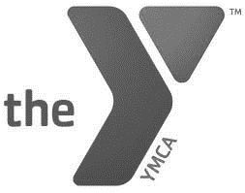  When: 3:00p.m.-6:00p.m.  Monday – Friday  Where:  - Broadmoor Elementary  - Ernest Gallet Elementary  - Green T. Lindon Elementary  - Katharine Drexel Elementary  - L. Leo Judice Elementary  - Milton Elementary  - Myrtle Place Elementary  - S. J. Montgomery Elementary  - Truman Early Childhood Education Center(see Truman Flier for more information!)  What: After School Enrichment boasts a safe, friendly environment for all participants. Children are greeted by our staff of LPSS Certified Teachers and University students and given snack before starting with homework time. Those who finish early have the opportunity to read A.R. Books and take A.R. tests. Outdoor play commences around 4:00 p.m. where children are encouraged to get active and socialize! |  |  | FeeS:  Registration: $70 for the first child, $50 each add. Child  Weekly:  $42 for the first child, $30 for each add. Child  Teacher Discount (for parents employed by LPSS): $25 per child, no registration fee  1 Day Fee: $10 per child  2 Day Fee: $20 per child  3 or more days: Full Weekly Rate  For More Info Contact:  Phyllis Weaver,  Sr. Program Director  Phyllis@theyofacadiana.com  Monet David,  Program Director  Monet@theyofacadiana.com  YMCA of Acadiana  800 E. Farrell Road  Lafayette, LA  70508  P:(337) 993-9622  F:(337) 993-9632

