SEASONAL REMINDERS

If fall is here, can winter be far behind? Here are some things we’d like to remind you about.
Irrigation Systems

Standard rule of thumb is to discontinue use of irrigation systems on or about October 1st. With most of the state under severe drought conditions, please consider shutting off your system sooner than later; your grass will go dormant until spring returns to NH. And don’t forget to shut down your system before it has the chance to freeze. This will save you from having to replace split hoses or broken sprinkler heads in the spring.

Parking on Constitution

For those of you who have motor homes, campers, boats, trailers, recreational vehicles, etc. parked on Constitution Road, the deadline to remove them is October 15th; after that date there should be nothing parked on the grass under the power lines. Please remember that parking of any of these types of vehicles in your driveway or in your yard is prohibited. If you are looking to obtain space in the lower storage area please call the office at 497-4440, ext. 0 and leave a message for director-at-large Jim Eddinger; he will get back to you regarding availability.
Parking on the Streets of Medvil

Parking on the streets must never interfere with emergency vehicle access or snow removal. Overnight parking is never allowed and there is no parking on the streets at any time beginning November 15th to April 15th. This can sometimes be a challenge during the holidays so please advise your guests to park in your driveway when space allows; additional cars can be parked on the pavement on Constitution Road. Shuttling friends and relatives might be a tad inconvenient, but who wants to be responsible for an ambulance or fire truck not being able to get past your house on their way to assisting one of your neighbors? Once snow has arrived, if you must move your vehicle into the street while you clear your driveway, please be aware of any emergency vehicles coming into our community and return your car or truck to your driveway immediately after you have completed removing the snow from your driveway.

Lawn Furniture

Lawn furniture may be stored in the back of your home, covered with tarps. Tarps used for this purpose will be green or brown so as not to present an eye sore to your neighbors. (See Medvil Community Rules D. Sites, #3)

INTERACTION WITH EMPLOYEES

We’ve said it many times before but from what we are being told, there are still residents who think they have special privileges when it comes to our Maintenance Team so we thought we’d address the issue again.
- The Maintenance Team are employees of Medvil Cooperative.
- Individual residents have no authority to direct their work.
- If you need something done that is the responsibility of the cooperative, you must submit a Work Request/Order.
- Do NOT stop them on the street. If they are in the truck or our golf cart it means they are working.
- Stop harassing them for something they did or did not do. Yelling and screaming at them will get you nothing but a non-interference letter and possible fines.

PLEASE WELCOME “HELPING HANDS” TO MEDVIL!
Helping Hands is a new committee with the intent of being able to offer a ‘helping hand’ to the members of our community through a volunteer network of our Medvil family. It is not a replacement or an extension of Medvil maintenance; it is exactly what the name states, a way to provide a helping hand in our community. It is not a long-term commitment, but rather a way to assist and bridge a gap when assistance is needed.

We are not ready to entertain requests for help just yet. I am looking for members who would like to become part of a network of community volunteers. If you are interested in knowing more and helping, as your time permits, I would love to hear from you.

I welcome your ideas. Some of the ideas I currently have are:
- Mowing a lawn
- Picking up groceries
- Picking up a prescription
- Teaching someone Zoom
- Assistance ordering groceries
- Walking a dog
- Feeding a cat
- Picking up mail
- Painting a shed
- Becoming a point person in your neighborhood to verify the wellbeing of a handful of your neighbors (Medvil Ambassadors welcome)
- Delivering a welcome gift to new members of our community
I realize not everyone is comfortable asking for help, however there are times when assistance could be offered at the recommendation of the board or a concerned member of our community but only if the homeowner agreed and accepted the helping hand.

Obviously, during this difficult time, we will maintain social distancing and volunteers will wear masks which I can provide.

Please reach out to me, Anita O’Brien, after 5:30pm at (603) 494-4246 or email me at akelliher38@gmail.com if you want to learn more.

Please note: this committee was voted on and sanctioned by the Board of Directors at its September 15, 2020 meeting.

FERAL CATS IN OUR COMMUNITY!
STOP FEEDING THE FERAL CATS! It draws them into our community and because they are getting food on a regular basis, they decide to stay. Which means they look for places to sleep. Which is usually under people’s homes, up under the vapor barrier, nestled in the insulation; the result being that cold air is getting to pipes which can cause them to freeze. This is not fair to your neighbors and the other residents who live in Medvil.
YES, WE TRAP CATS AND KITTENS. We act on all requests to trap cats and kittens. Medvil’s rules specify that all cats must be supervised so therefore all cats running around unsupervised must be considered feral or cats from other neighborhoods. Once a Work Request/Order is filed requesting to have a cat/kittens trapped, our Maintenance Team will place baited Have-A-Heart traps in the area where the animals have been spotted; most of the time it works but sometimes they are smart enough to avoid be trapped.
NO, WE CANNOT GIVE YOU A TRAPPED CAT OR KITTEN. Because we have no idea where these animals have come from and whether they are healthy or not, we cannot give anyone a cat or kitten that we have trapped. It is a question of safety for the homeowner and a liability issue for the community.
NO, WE DO NOT TAKE THEM TO A KILL SHELTER. Any cat or kitten we trap is taken to the Manchester Animal Shelter where they provide shelter, medical care and spay/neuter every animal that is brought to them. If you are looking for a cat or kitten, please consider reaching out to them at 603-628-3544.
OTHER NOTICES

NEW DEADLINE

The coronavirus, as you all know, has changed the way we do many things. Not all of the changes have been unfortunate. Example: our digital newsletter! Every issue we have sent by email has been followed by emails back from residents who are pleased with this new means of distribution. So, although nothing’s written in stone, for the time being we plan to continue publishing in this form—providing, as we’ve been doing, a small stack of printed copies in each mail house, for our neighbors who “don’t do computers.”

Having such a small print run has introduced another opportunity, and it’s one we predict everybody will like: a longer deadline for submissions! We’re extending the deadline by a whole week. It will now be noon of the Monday after the monthly Board Meeting.

As ever, if you can’t submit articles electronically, you may submit hard copy, but as the Reception Office is closed most of the time, slide your copy under the office door. We’ll ask our office volunteers to let us know if we need to pick up an article. You will find our submission guidelines on the last page of the newsletter.
MBW

FUNDRAISING COMMITTEE

The Monthly Pool was approved to start as of 8/1.

We currently have two residents waiting to play but are always looking for more. Please contact Irene Gagne at 622-1869 if you want to be placed on the list.
IG
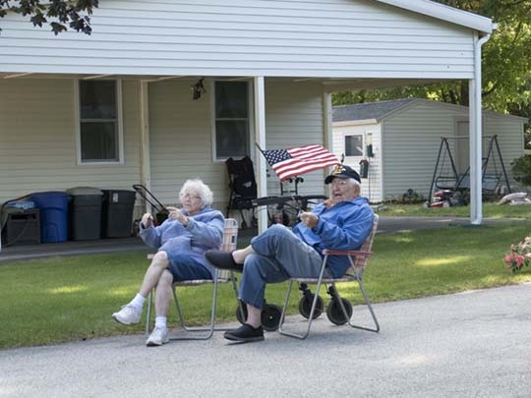
REAL ESTATE COMMITTEE

The months of September the Real Estate Committee had three pending P&S
Agreements. There have been no showings and there are currently no listings.

There have been a lot of viewings of our community both on our website as well as drive-throughs.
DK
Friendly faces + fall weather = parade fun. By Peggy Hatfield

If you are thinking of selling your home, the first
step is to fill out the Intent to Sell form. This form can be found on our website at medvilcooperative.com, filled out and sent to the office. The second step is to locate a realtor. Please consider Medvil Real Estate to help you sell your home. Sales benefit Medvil community.
CONDOLENCES

Medvil RE Committee - 497-4440 Prompt 2
Website: www.medvilcooperative.com Homes for Sale

Dorrie Kossuth, Chairperson
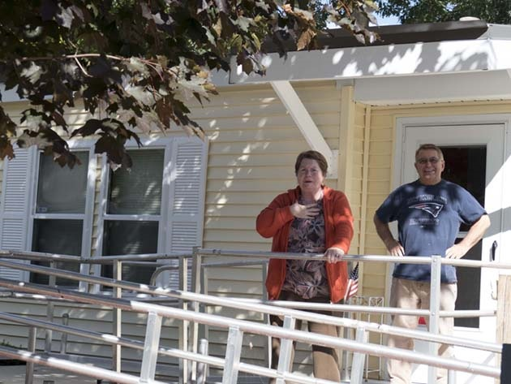
Neighbors enjoying the golf cart parade. By Peggy Hatfield
Heartfelt condolences to those who have recently lost a loved one:

- Barbara Jahn, who lost her husband, Allan

We meet them in the lives they’ve shaped. We enjoy them in the jokes and wisdom they’ve passed down. Be active in the community they’ve built. It is a way of walking with them into the future. It is a way of never losing them.

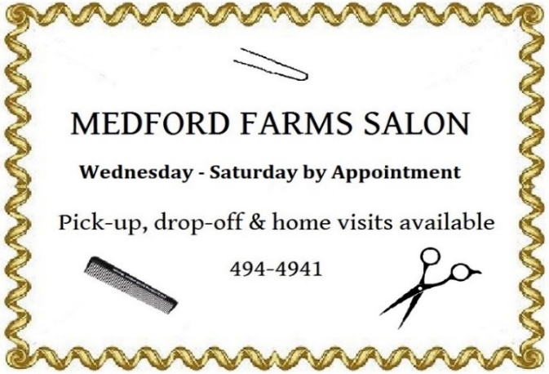
Linda Robinson, Sunshine Lady (603)851-5209
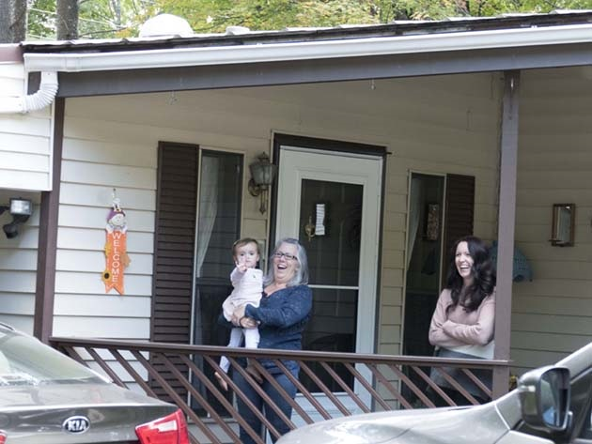
EAT LESS SALT FOR A HEALTHIER GUT. According to a study in the 6/9/20 Journal of the American Heart Association, cutting the amount of salt that women (with untreated high blood pressure) consumed over a six-week period saw the women on a low sodium diet reduce their blood pressure. They also had an increase in fatty acids, which are microbes in the gut, that also help to reduce blood pressure.
THE HEALTHY CORNER
MINUTES TO CUT CANCER RISK. In an online article from JAMA Oncology (6/18/20), people who sat less seemed to have a lower rate of fatal cancers. This was a study involving 8,002 men and women. Spending just a half hour per day doing light activity (try housework, marching in place, walking laps around the house) can reduce your cancer risk by 8% - and moderate activity like taking a walk reduced their risk by 31%. And D.X. Marquez, PhD, Professor of Nutrition at the University of Illinois, Chicago conducted a 2017 study that found older adults who exercised 150 min. per week had brighter moods and slept better.
HOW TO PERK UP FROZEN VEGETABLES. With cold weather on the way, we tend to eat more frozen vegetables - so how can we “bump” up their taste? Try tossing the still frozen veggies with a bit of vegetable oil and your favorite seasoning and then roasting them. Jen Bruning, L.D.N.,R.D.N. with the Academy of Nutrition and Dietetics also suggests stir frying or briefly steaming them and topping with low-sodium sauce - or add to soups, stews, chili or casseroles. Don’t forget to try riced cauliflower, and spiralized zucchini or butternut squash.
The fun’s not limited to one generation! By Peggy Hatfield
Courtesy of the 10/20 edition of Consumer Reports on Health
ONCE IN A BLUE MOON. . .
If you love Hallowe’en imagery, I bet you’ll be surprised to learn one of this night’s most evocative icons—bats flying across the big, bright full moon—is actually so rare it happens only once every 19 years! BUT don’t despair because this year you’ll get to see it! And it’s a “Blue Moon,” too. It won’t appear blue in the sky, though, Blue Moon is just a fancy term for a Full Moon that is the second one to happen in a given month. Well, here’s another fun fact: Because the full lunar cycle is about 29.5 days long, ANY time the Moon is technically full on Hallowe’en, it’s a Blue Moon! Because Hallowe’en is on the 31st. Here’s something else to think about: You won’t get another opportunity to see a Hallowe’en Full Moon until 2039! So best get out there and enjoy it, don’t you think?
MBW
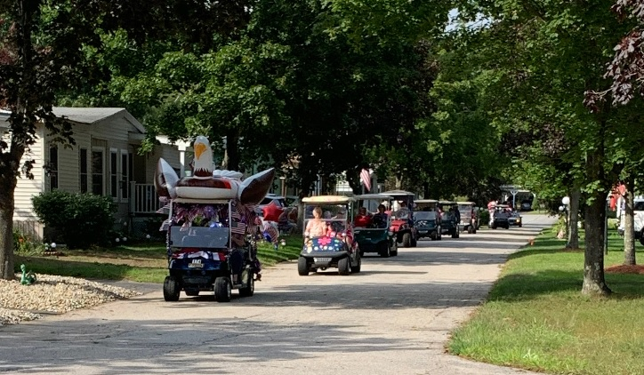

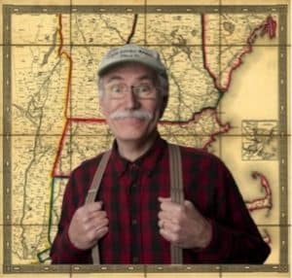
MEMBERS’ARTICLES
And here comes the parade! By Sonja Fuller
DO YOU KNOW FRED MARPLE?
By Ellyn Barnard
On 9/15/20 NH Chronicle featured one of our NH neighbors...Fred Marple. Have you met him? I have heard from a few of our Medvil neighbors who do know him. Unfortunately, I am not one of them! If you want to know a bit about Fred and his hometown of Frost Heaves, NH, I encourage you to go to Fred’s website www.fredmarple.com. He does have a few YouTube videos - Meet Frost Heaves, NH and Yoga for Yankees. Of course, as you probably know by now, Fred is a comedian and Frost Heaves, a fictional town right outside of Peterborough, is, according to Fred,
Ken Sheldon, AKA Fred Marple

made up of almost only senior citizens! You can find Fred on Facebook, too. Fred also has an “Ask Fred” column and he answers many questions from his neighbors. Here is one that someone in Frost Heaves sent in:
Dear Fred,
How do I approach my neighbor about keeping his dog from doing its business in my dooryard?
Response: I guess that depends on what kind of business it is. Lemonade stand? Investment advice? Off-brand watches? I'm all for free enterprise, but I think you're within your rights to tell Bowser to conduct his commerce in his own yard.
I hope that you will enjoy his humor - and I think that we can all use a good laugh! Enjoy!
The gaze of the eagle. . . By Sonja Fuller

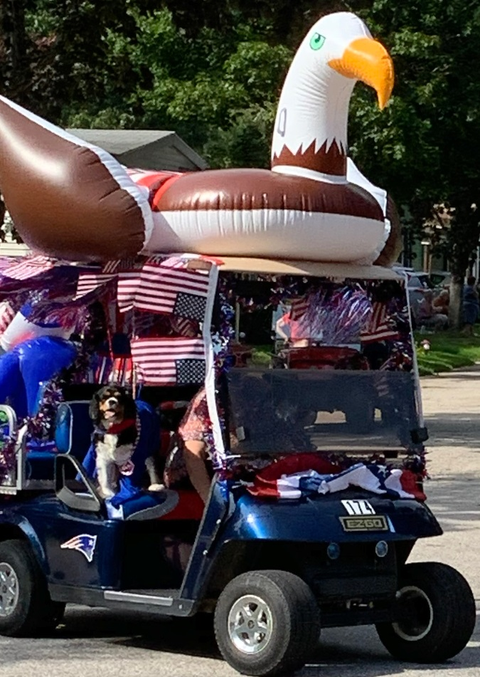
The Medvil Messenger encourages members to submit articles for consideration. Recipes, helpful hints, reminiscences, jokes, poems--please keep it upbeat and positive. Due to space considerations, original material will take precedence over reprints from other sources, including printouts of email pass-arounds. If you submit previously published material, please try to cite a source. We reserve the right to reject material that may offend, divide our community or cause political arguments. Please submit your items to our email: medvilnewsletter@comcast.net Or place a copy in the Messenger mailbox in the Reception Office in the DDC. (During our Covid-19 lockdown, you may slide it under the office door and we will ask our office volunteers to let us know that it’s there.)
Deadline for submissions is noon on the Monday after the Board Meeting. (BOD meets on the 3rd Tuesday of the month.)

Medvil Messenger Staff: Debbie Cyr and MB. Wulf

Medvil Messenger Writers this issue: Ellyn Barnard, Debbie Cyr, Irene Gagne, Linda Robinson
