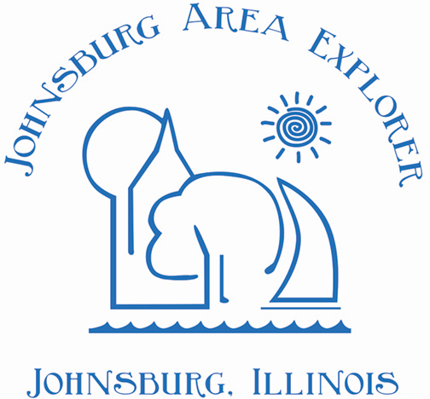
Ad copy for Passport Event
Thank you for your application to be a destination for our Passport Program. We will need the following information from you no later than March 26, 2021 for the printing of the passport book.
We’ll also need a copy of your logo.

Company Name:
Company Address:
Hours of Operation:
Phone Number:
Description of Business:
(Limit 150 characters)

Coupon information
(if offering)
Facebook
Website

Please return completed form to Donna Adams at:
donna1@paradisefinancial.biz

