4/1/2018 The Great Prince and the Time of Trouble

The Tiangong-1 Space Lab fell into the Earth's atmosphere over the South Pacific Ocean at about 8:16 PM EST on 4/1/2018. The date 4/1/2018 had some prophetic implications attached to it, as noted in the previous article, “3/31/2018 The Sign of the Descent of the Heavenly Palace on 4/1/2018”, and also below.

Michael, the Great Angelic Prince

The prophetic births of our eldest son and eldest grandson were mentioned in an article sent on 3/31/2018. Their births were on 3/31/1969 and 4/2/1999, bracketing, and calling attention to, the central date 4/1.

A reader sent an email noting that the date 9/29 is the date of the traditional Feast of St. Michael each year, and is observed in some Christian churches.

I hadn't mentioned the name of our first born son in previous articles, but his name is also Michael.

Below is a graphic that shows how the Feast of St. Michael happens to fall on both the day of the 777 point Dow Jones drop and also on the day of the launch of the Tiangong-1 (Heavenly Palace) space lab.

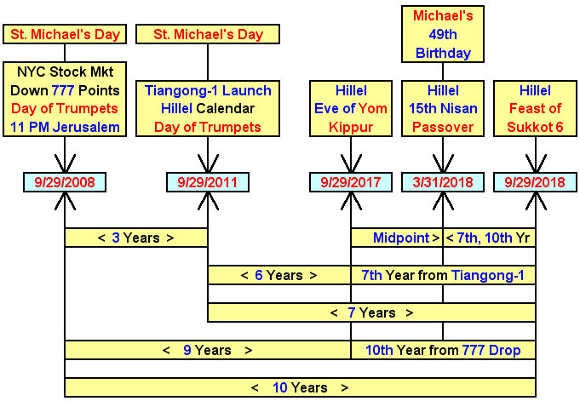
The graphic below also shows the 49th (7 x 7) birthday anniversary of our first born son, who happens to be named Michael, on Jewish Passover 3/31/2018.

Our eldest son Michael was born in Corpus Christi (Body of Christ), Texas, on 3/31/1969 at 4:45 PM CST. His birth date and time happened to be 00:45 AM 4/1/1969 in Jerusalem.

Below is a graphic depicting the events of 4/1 mentioned in previous articles with the addition of our son's Jerusalem birth time information.

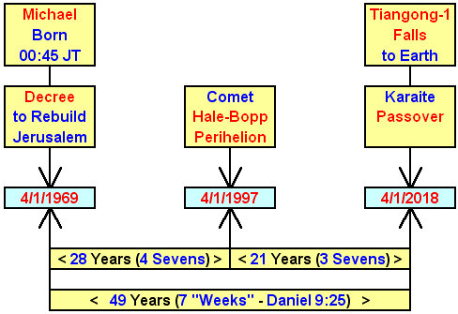

Michael the great prince is mentioned in Daniel chapter 12 below.

Daniel 12:1 And at that time shall Michael stand up, the great prince which standeth for the children of thy people: and there shall be a time of trouble, such as never was since there was a nation even to that same time: and at that time thy people shall be delivered, every one that shall be found written in the book.
2 And many of them that sleep in the dust of the earth shall awake, some to everlasting life, and some to shame and everlasting contempt.
3 And they that be wise shall shine as the brightness of the firmament; and they that turn many to righteousness as the stars for ever and ever.
4 But thou, O Daniel, shut up the words, and seal the book, even to the time of the end: many shall run to and fro, and knowledge shall be increased.

And there's another place that identifies Michael and his angels being the ones to cast Satan out of Heaven in the latter days.

Revelation 12:7 And there was war in heaven: Michael and his angels fought against the dragon; and the dragon fought and his angels,
8 And prevailed not; neither was their place found any more in heaven.
9 And the great dragon was cast out, that old serpent, called the Devil, and Satan, which deceiveth the whole world: he was cast out into the earth, and his angels were cast out with him.

The grapics above indicate an timely relationship between the name "Michael", symbolic of Michael the great angelic prince, and the two "drop events", one concerning the economy dropping 777 points and the other concerning an object (Tiangong-1) dropping to the Earth.

It may be that Michael the great prince will come to earth to rescue Daniel's people. Daniel 12:2 above indicates a resurrection event, which might accompany a "Rapture" type event.

It also might be that Satan will drop to earth, being cast out by Michael and his angelic army, and wreak havoc and destruction everywhere.

I'm not sure what all of the information above means right now, but it exists, and we will definitely find what relevance it might have as we live on into the future.

