Inspection by the Invasive Species Program
Division of Ecological Resources
Minnesota Department of Natural Resources

Lake: Rush DOW Number: 71-147 Date of inspection: 2009 April 16

County: Sherburne Observer[s]: Dan Swanson

Time - On Water: 1210 Off water: 1530

Type of inspection: Delineation of curly-leaf for a treatment – part of a Pilot project

Author[s] of report: Dan Swanson Date of report: 21 Apr 2009

Overall: The curly-leaf pondweed that I surveyed on April 16, 2009, was sparse to common at the sites it was found. The water surface temperature was 52.7 degrees F. (1230 PM).

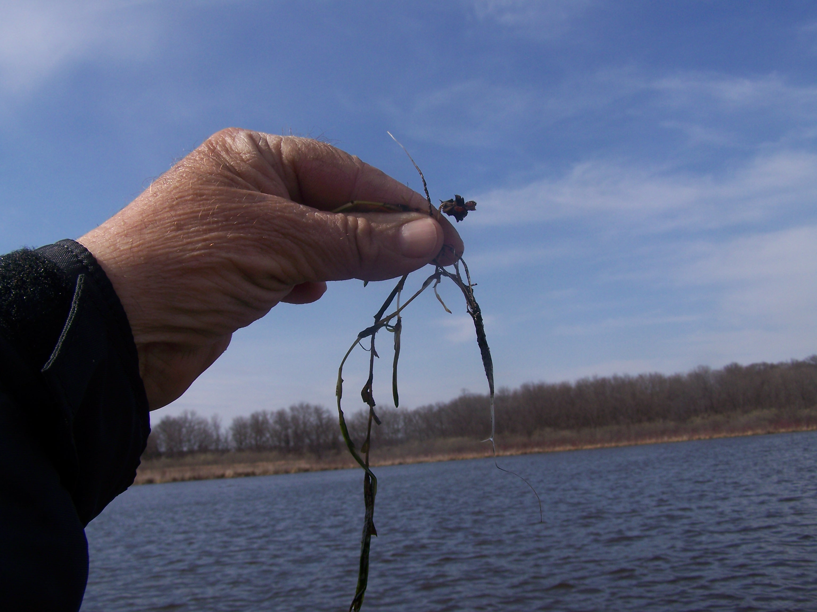

Photo 1: Curly-leaf pondweed sampled on north shore of Rush Lake on April 16, 2009.

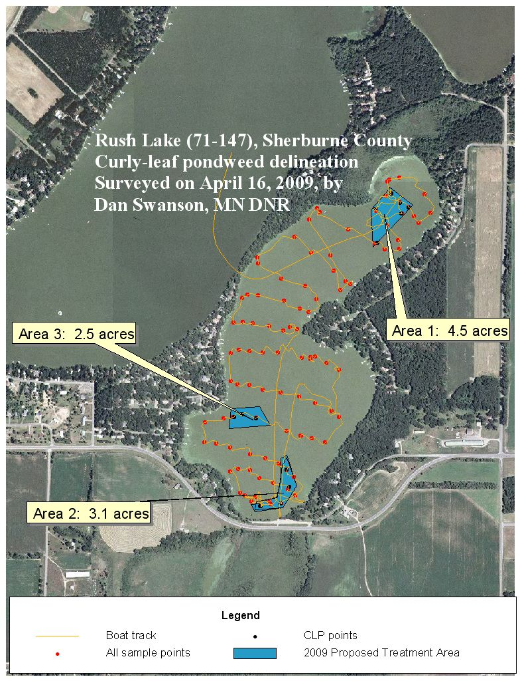

Figure 1. Aerial photo of Rush Lake on which are marked the track of the boat (orange line) and the waypoints where curly-leaf pondweed was found (black dots).

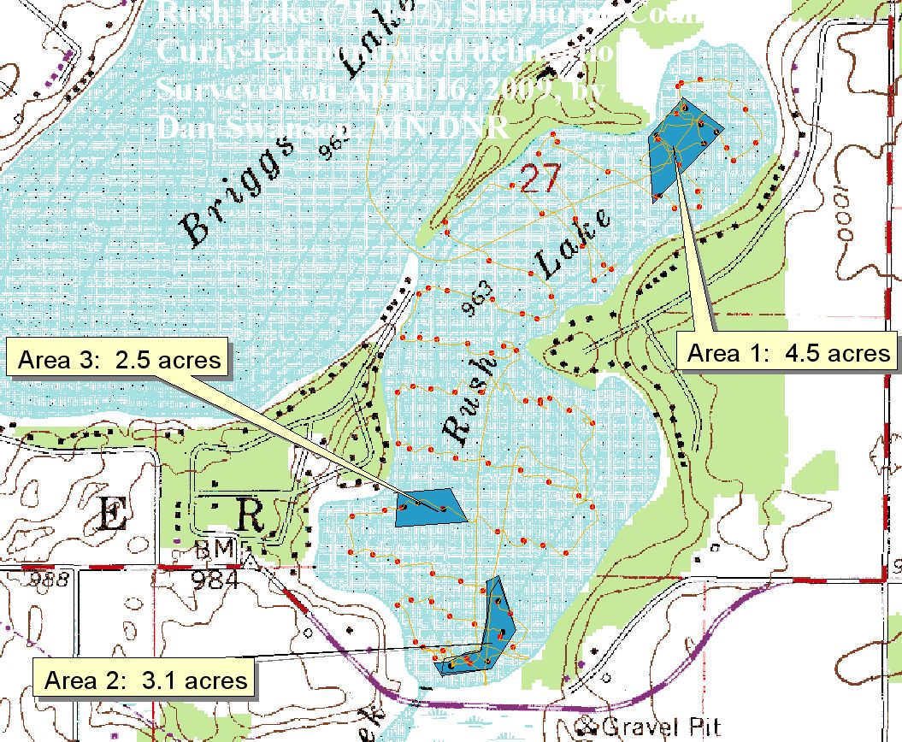

Figure 2. Quad of Rush Lake with contours on which are marked the track of the boat (orange line) and the waypoints where curly-leaf pondweed was found (black dots).

Table 1. Recommendations for individual areas on Rush Lake regarding applications for permits to allow treatment and applications for grants to support control of Curly-leaf pondweed.

Area | Waypoints | Acres proposed | Observations | Recommend that treatment be allowed | Recommend reimbursement
1 |  | 4.5 acres |  | Yes | Yes
2 |  | 3.1 acres |  | Yes | Yes
3 |  | 2.5 acres |  | Yes | Yes

GPS Yes: __X_

Locations of file[s]: D:\Dan's_Data\Lake Data\Rush-Julia Lakes\Rush lake 2009

