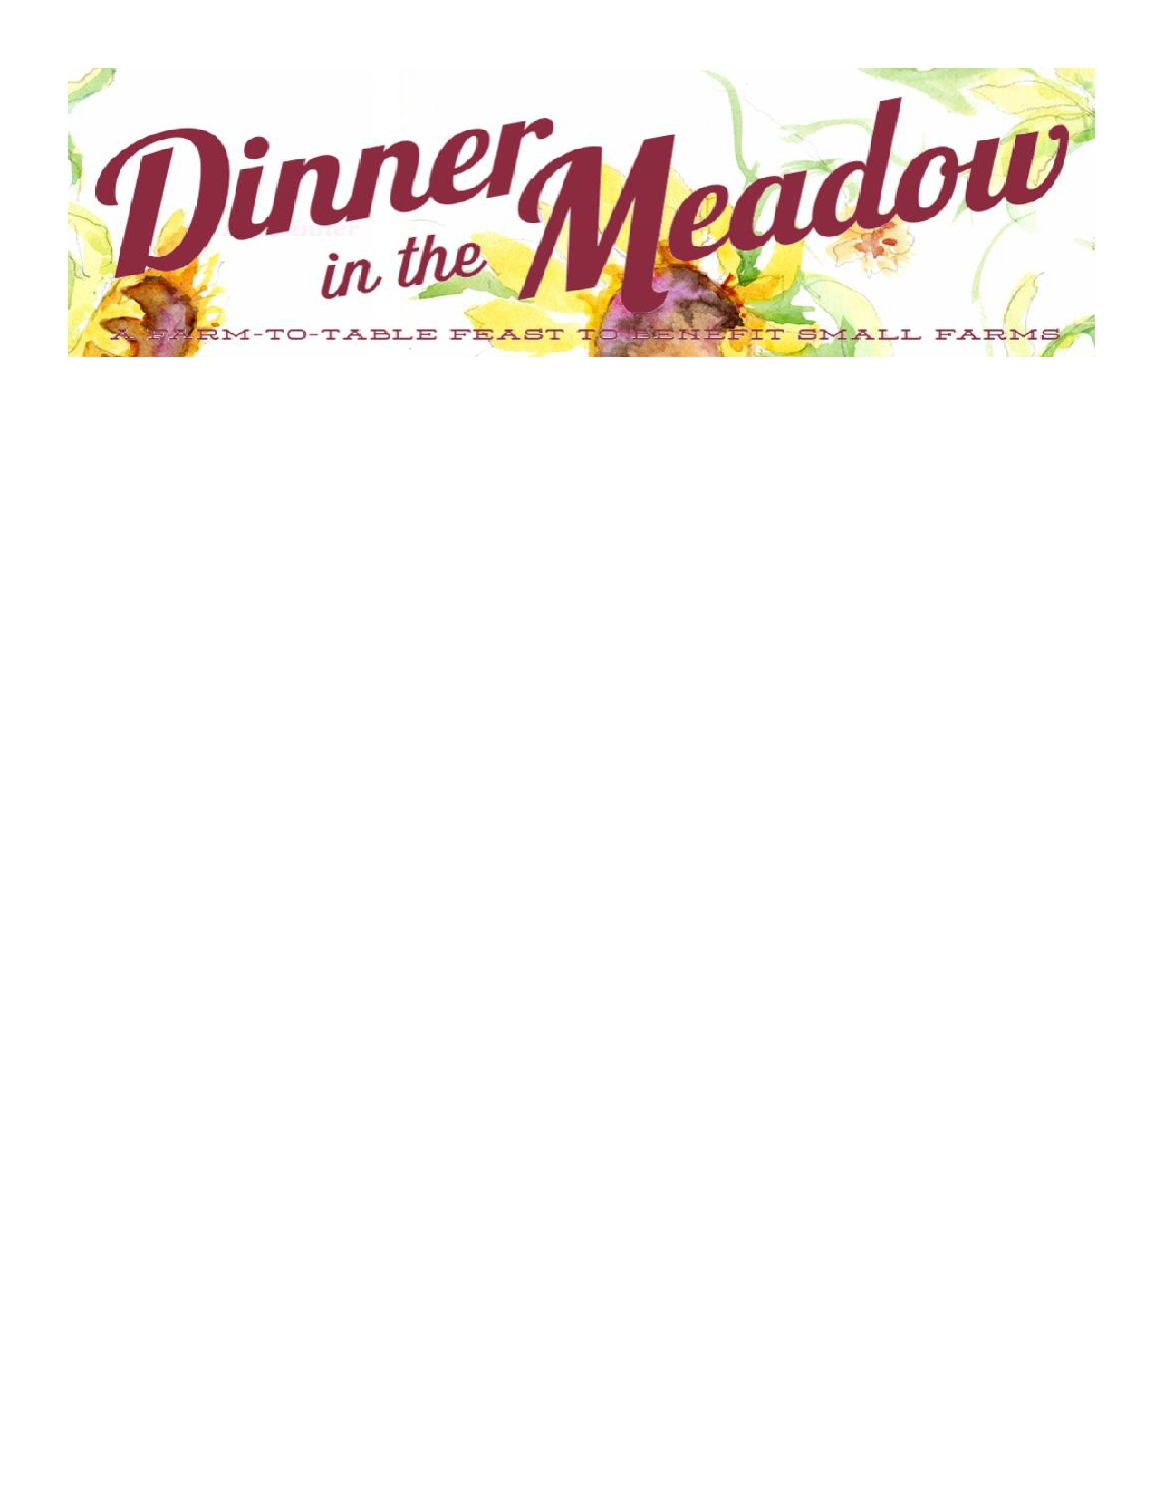
Sunflower $5000 8 Tickets (1 Table)
Table Top Signage
Logo in Program
Recognition on Social Media and at Event

Rose

Zinnia

Marigold

Cosmos

$2500

$1000

$500

$250

8 Tickets (1 Table) Table Top Signage
Logo in Program
Recognition on Social Media

8 Tickets (1 Table) Table Top Signage
Logo in Program

4 Tickets and Name in Program

2 Tickets and Name in Program

_________________________________________________________

Please make checks payable to: The Leonard-Mobley Small Farm Fund and mail with form below to:
571 Leonard Farm Road, Louisburg, NC 27596. Questions: Martha Mobley at 919-495-1305.

ORGANIZATION NAME _________________________________________________________________________
WEBSITE ____________________________________________________________________________________ SPONSORSHIP CONTACT NAME __________________________________________________________________ ADDRESS ____________________________________________________________________________________ ____________________________________________________________________________________________ EMAIL_______________________________________________________________________________________ PHONE ______________________________________________________________________________________
Thank you for supporting our small farms!

