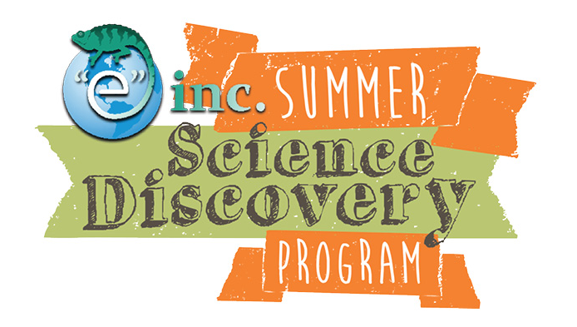

“e” inc. Photo Consent Form

Photo Release
I hereby give “e” inc. permission to use my child's picture, image or likeness in any “e” inc. literature, press release, advertisement, publication or situation that promotes the mission and philosophy of “e” inc. I understand that “e” inc. is a non-profit organization that works to increase the planet science achievements and civic participation of urban children, and that my child's picture or likeness would be used to increase “e” inc.’s capacity to serve our children and our communities.

Parent/Guardian Name (Print):___________________________________

Parent/Guardian Signature: ___________________________________

Child's Name:_______________________

Date of Signature:__________

We are very excited to begin our program and we thank you very much for allowing us to take photos of your child as a way to spread information about our work. We appreciate your support.
Sincerely,
"e" inc. staff

