Mars UP Church
Come Holy Spirit, Come
Before the Service – Speak to God!
During the Service – Let God speak to you!
After the Service – Speak to each other!

(*Please stand, if able)
Welcome and Mars Messages

Prelude

Apostles’ Creed
I believe in God the Father Almighty, Maker of heaven and earth; and in Jesus Christ His only Son our Lord; who was conceived by the Holy Ghost, born of the Virgin Mary, suffered under Pontius Pilate, was crucified, dead and buried; He descended into hell; the third day He rose again from the dead; He ascended into heaven, and sitteth on the right hand of God the Father Almighty; from thence He shall come to judge the quick and the dead. I believe in the Holy Ghost, the holy catholic church; the communion of saints; the forgiveness of sins; the resurrection of the body; and the life everlasting. Amen.

Gloria Patri
Glory be to the Father, and to the Son, and to the Holy Ghost. As it was in the beginning, is now and ever shall be,
world without end.
Amen. Amen.

The
Lord’s Prayer

Our Father,
who art in heaven,

hallowed be Thy
name,

Thy kingdom come,
Thy will be done,
on earth
as it is in heaven.

Give us this day
our daily bread;

and forgive us
our debts,
as we forgive
our debtors;

and lead us not
into temptation,
but deliver us
from evil.

For Thine
is the kingdom,
and the power,
and the glory,
forever. Amen.

The Doxology

Praise God
from whom
all blessings flow;
praise Him
all creatures
here below;
praise Him above,
ye heavenly host;
praise Father, Son,
and Holy Ghost.
Amen.

The Call to Worship
Leader: Clap your hands, all you people; shout to God
with loud songs of joy.

People: For the LORD, the Most High, is awesome, a
great king over all the earth.

Leader: God has gone up with a shout, the LORD with the
sound of a trumpet.

People: Sing praises to God, sing praises; sing praises to
our King, sing praises.

Leader: For God is the king of all the earth; sing praises
with a psalm.

People: God is king over the nations; God sits on his
holy throne.

All: We will worship God!

Pastoral Invocation

*Hymn 33
“Immortal, Invisible, God Only Wise”

Passing of the Peace

Leader: May the peace of Jesus Christ, the love of God, & the fellowship of the Holy Spirit be with you all.
People: and also with you

Children’s Chat

*Hymn 508
“Love Lifted Me”

Scripture Acts 1:1-11

Morning Message Rev. Brian Hauser
“Not Just One”

Reception of New Members
Ashley (Chamberlin) Hauser
Melissa (Proch) Wells
Peter Wells

Apostles Creed
Prayers of the People and Lord’s Prayer

Offering
*Doxology

*Offering Prayer

*Hymn 526
“The Solid Rock”

*Benediction

*Congregational Response (Everyone sings)
Blest be the tie that binds
Our hearts in Christian love
The fellowship of kindred minds
Is like that to that above.

Church Staff
Rev. Brian Hauser
Pastor
pastor@mars-up.org
724-689-3412

Ms. Jamie Daugherty
Choir Director & Organist
JamieD0714@gmail.com

Mrs. Shelly Bocheff
Administrative Assistant
marsup@mars-up.org

AV TEAM
Alma Staskiewicz, Lisa Barbour, Marie Matthews, Bill Guesman, John Ivory, Keith Nichols, Mike Bocheff, Herb Wellman

Mars United Presbyterian Church

232 Crowe Ave
PO Box 805
Mars, Pennsylvania 16046
724-625-1365
www.mars-up.org
marsup@mars-up.org

Church Office Hours:
Mon -Thurs from 9 a.m. -2:30 p.m.
Morning Worship:
10:00 am

7th Sunday of Easter

Prayer of Preparation
Lord, we come to you today with so many things on our hearts.

You call us to be in relationship of trust and love with you and you offer healing to us for those portions of our lives that are broken and injured.

Help us to be open to your mercy and healing love. For we ask this in Jesus’ Name.
AMEN.

*Postlude

Flowers are presented to the Glory of God and in honor all the veterans who served by the Staskiewicz family.

Karen Purvis would like to thank everyone for the numerous cards, well wishes and prayers during her recent illness.

MUP Session

Class of 2024 Class of 2023 Class of 2022
Alma Staskiewicz Lisa Barbour Mike Bocheff
Louise Fox Mary Ann Croop Sally Olsen
Marie Matthews Don Lewis Susan Cox
Herb Wellman Linda Lees

Clerk of Session: Herb Wellman

MUP Deacons

Class of 2024 Class of 2023 Class of 2022
Steve Martin Sharon Gibbs Jay Wilson Nancy
Marge Nicklas Carol Kopar Jenny Ivory
Pat Auld Alice Leonberg Pat Jackson

Moderator: Steve Martin

Mars United Presbyterian Church
Welcome!

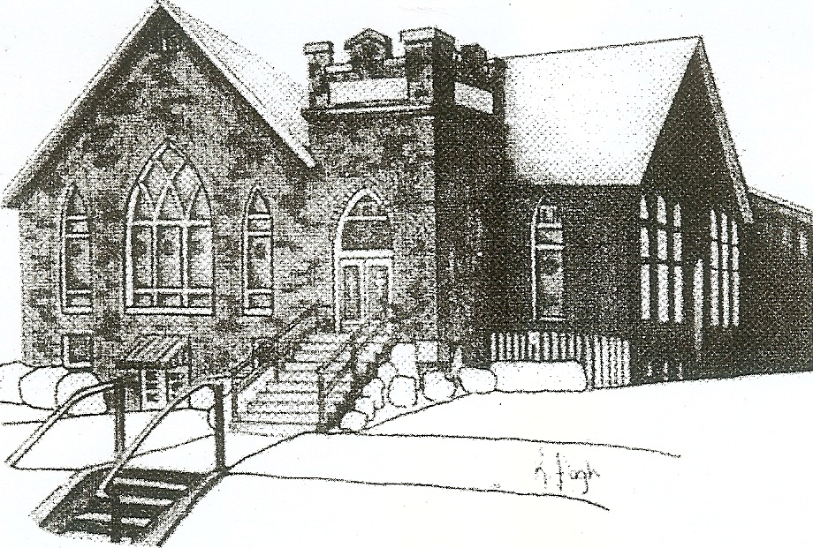
We are your hometown church: Faithful to Tradition, Loving in Fellowship, & Reaching for Tomorrow!

May 29, 2022

We welcome you and we are glad you’ve chosen to Worship with us today!

CALENDAR: May 29, 2022 – June 5, 2022

Church Office Hours: Monday -Thursday from 9 a.m. – 2:30 p.m.

Today, May 29, 2022
VOLUNTEERS☺

LAST SUNDAY’S In-House ATTENDANCE: 49

LAST SUNDAY’S OFFERING:
Operating Funds: $1707.00
Kindness Offering: $50.00
Mission: $50.00
Total: $1807.00

Tarry N Talk Hosts
Stewardship Committee
10:00 a.m. THE MORNING WORSHIP SERVICE
Monday, May 30, 2022
Memorial Day- Office Closed
Tuesday, May 31, 2022
9:00 am A team
7:00 pm AA
Wednesday, June 1, 2022
9:00 am Material Girls
Thursday, June 2, 2022
Friday, June 3, 2022
Saturday, June 4, 2022
Sunday, June 5, 2022
10:00 am THE MORNING WORSHIP SERVICE
11:15 am Deacon Meeting

Welcome to all who are Worshiping with us today!
Guests
We sincerely hope our service is a blessing to you. We ask that our guests please take a few minutes to complete one of the Connect Cards found in the pew holder.

Should you have questions regarding any aspect of our church, including membership, please contact Pastor Brian or the church office during the week at 724-625-1365. Thank you for being with us today.

PRAYER – JOYS & CONCERNS
Lou Beckwith Kennedy (Great Granddaughter of Marlene Edwards
Nancy Govan Paige Barbour (daughter of Andrew and Steph Barbour
Reid Christopher Hall (June Stirling’s nephew) Maria Elizabeth McKaveney (June Stirling’s niece)
Lindy McCartney (Lisa Barbour’s Sister) Chuck Kennedy
Patty Jackson Isabel Boynton

ANNOUNCEMENTS
Bulletins are printed Thursday mornings; let us know if you have an announcement…

GRADUATION SUNDAY Sunday, June 12th is the day chosen to honor the Graduates from High school and College. If you know of anyone who will be graduating this year, please contact the office.

VACATION BIBLE SCHOOL “MONUMENTAL” Registration for VBS is available now online at www.mars-up.org. June 26th thru June 30th 6:00 to 8:30 pm. SPECIAL OPENING SUNDAY AFTERNOON- Families join us for a HOT DOG BEAN kickoff at 5:00 pm in MUP Fellowship Hall

SAVE THE DATE Mars UP church annual picnic will be held Sunday, September 11th at Adams Township Park. We will also be celebrating Rally Day this Sunday. More Details to Follow!!

GRIEFSHARE SUMMER MEETINGS Griefshare will continue to hold one monthly meeting during the summer. Meetings will be held on June 13th, July 11th, and August 8th. The fall session will resume on September 12th at 6:30 For more information, please contact Denise @ ddemarco5@yahoo.com

COMING THIS FALL Mothers of Preschoolers (MOP) group starting at Mars UP Church. To register or questions contact church office or Ashley Hauser at 814-270-9101. More details to follow!!

