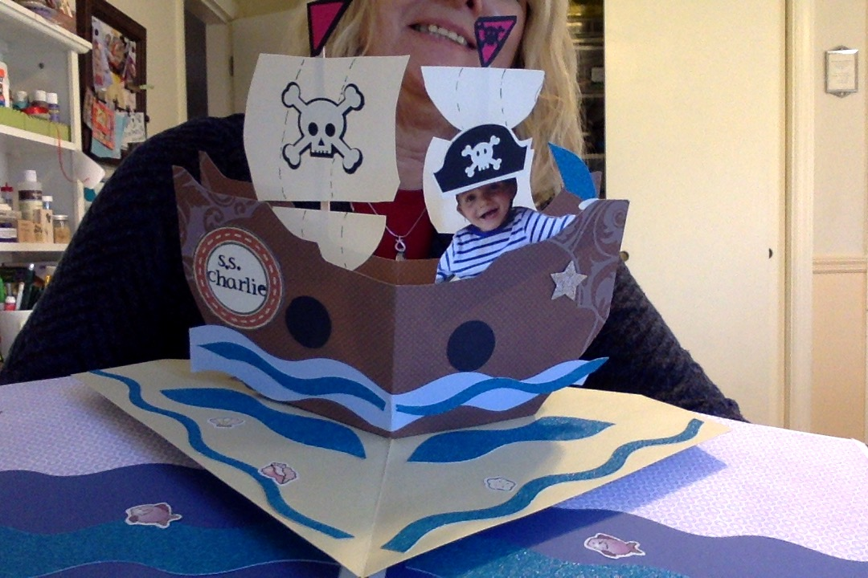
PIRATE SHIP POP UP SCRAPBOOK PAGES
Materials needed:
SHIP:
Double sided sticky tape
2 pre-cut ships from cardstock
1 6x12” white strip of cardstock for sails to trace & cut:
1 large “square” sail
1 small “square” sail
2 small semi-circle sails
2 small porthole circles or embellishments
1 precut sword
2 (12x12) blue or “water” type papers
2 (12x12) matching background papers
1 (12x12) solid cardstock for ship base
1 (12x12) solid cardstock for sails
Embellishments
Pirate hat- 2 shadow pieces- one 2 ½”white , one 2 ¼” black
Skull and crossbones- -one white 2 1/2 wide”, one black (2 3/4” wide)
Skull & crossbone—one black 1” wide
Small Black square for flags (1 ¼”)
Small Red square for flags (5/8”)
2 thin wooden coffee stirrers for flag masts
sword pattern- 2 ¼” long
Tools Needed:
Wavy cutter or tearing tool
Scissors
Glue pen/ adhesives
Scotch tape- double sided works well
Ruler

Step 1: Waves
Tack down your 2 matching background pages onto your double layout. A small print or solid will work.
Using your paper cutter, cut out four 2” strips of blue “water” paper and create one wavy edge on each using the wavy cutter or some other tool.
Cut out two more 2” strips of a different water paper and again, wave an edge on each.
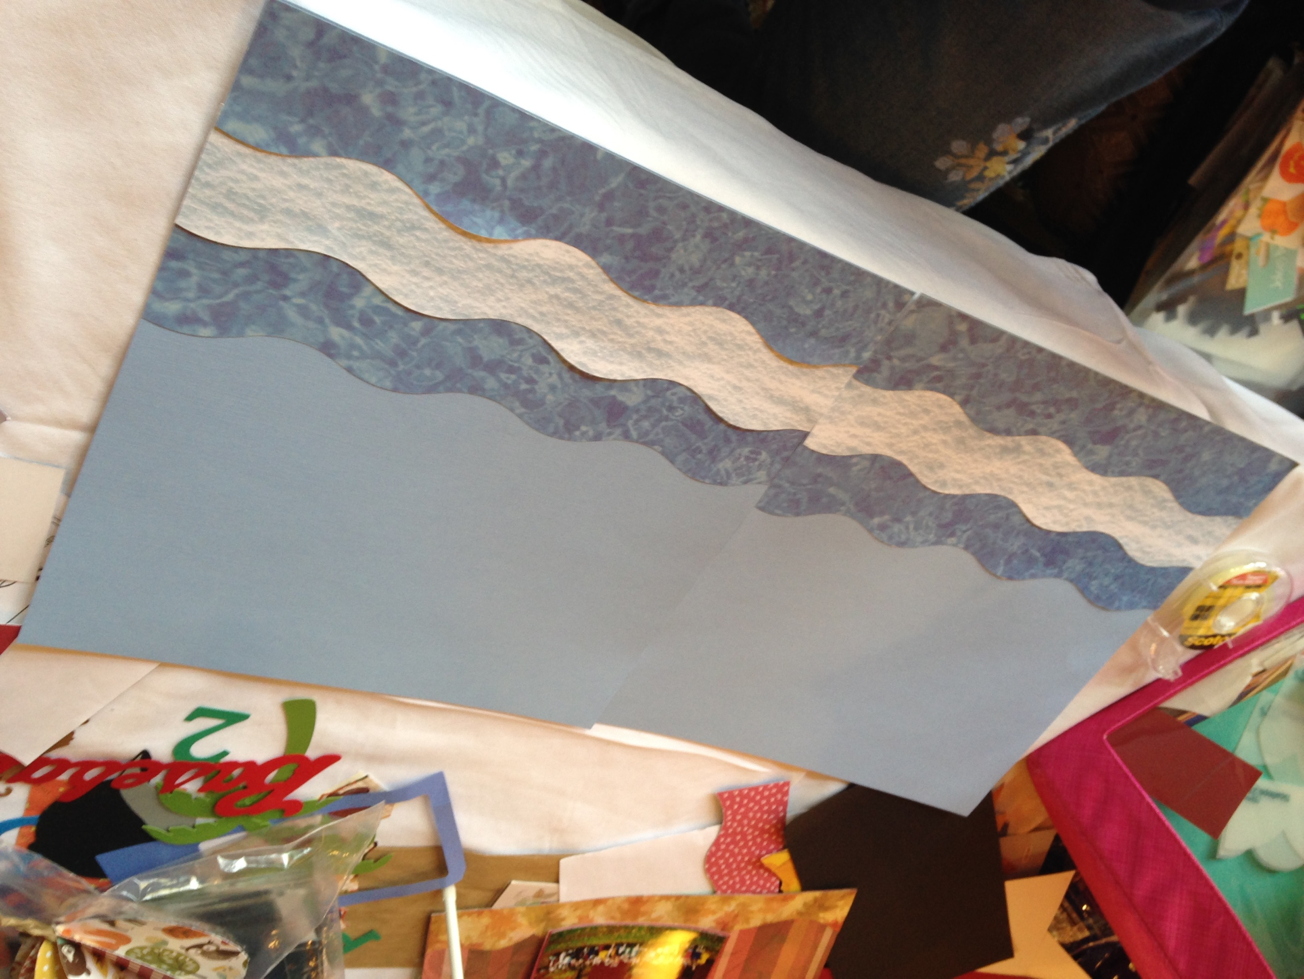
Alternate 3 strips and adhere to the bottom of each page, matching waves to each other as best you can. No waves are perfect!
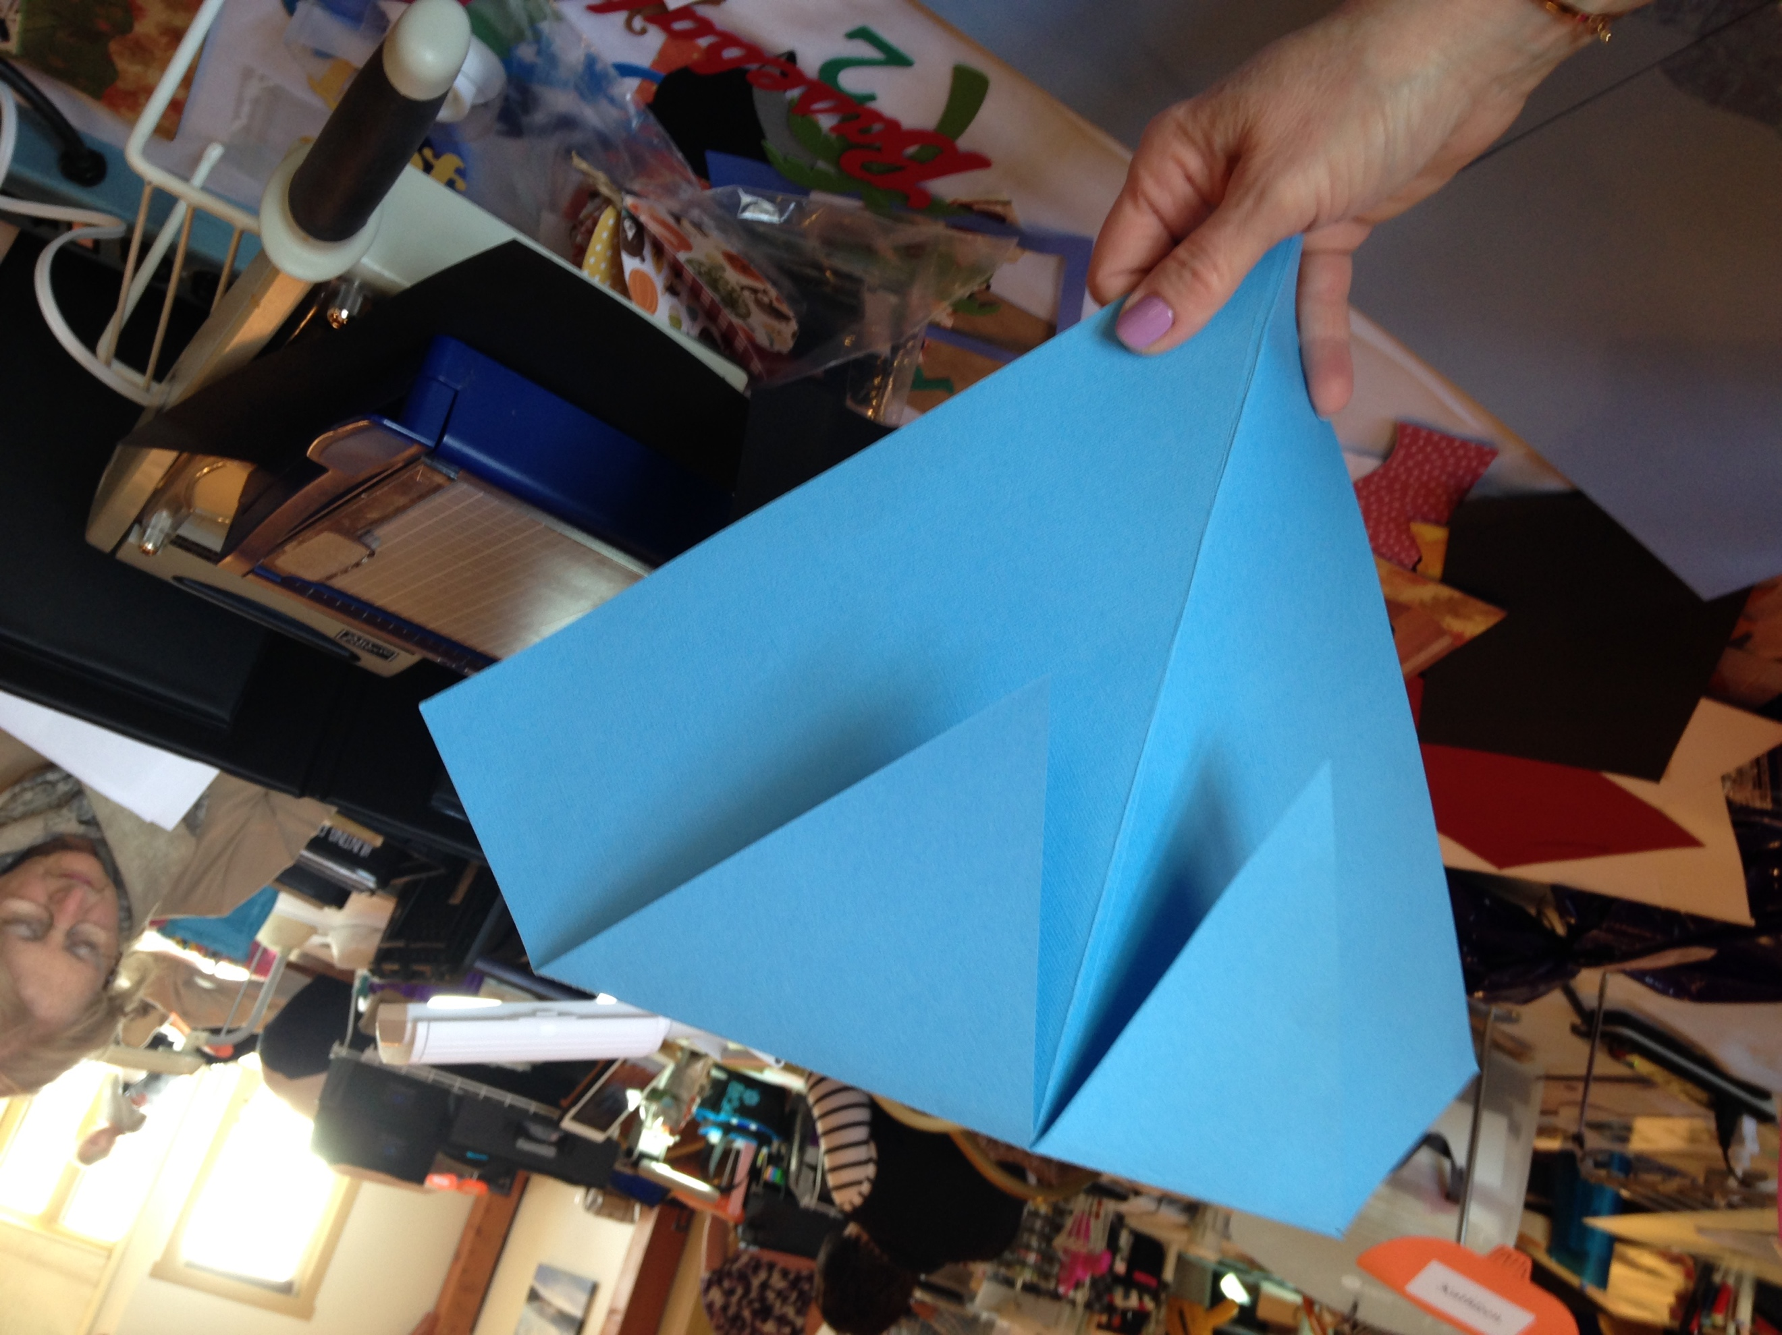
Step 2: Base
Using a scoring tool, score and crease your 12” “base” cardstock diagonally. This”base” is the triangle the ship will sit on.
Eleven inches from bottom point, score base across the width, crease, and fold over.
Cut a 1 “ triangle down the crease of this smaller triangle creating two triangular flaps.
Carefully enter and glue these flaps behind the two ocean pages, waves at the bottom and adhere into your book. Creases need to be perfectly centered where the book opens and closes.

Step 3: The ship
Carefully score and fold each ship piece in half with “good” side creases facing you.
Score the edges of your ship pieces at the bottoms by ½ “.
Fold one edge in and one edge out so the folded edges will face each other (inside the ship).
Make sure the “good” sides are facing you with creases facing you. Cut a notch in the ½” crease to allow for folding of the ships. These flaps will be secured inside the ship to help it stand up.
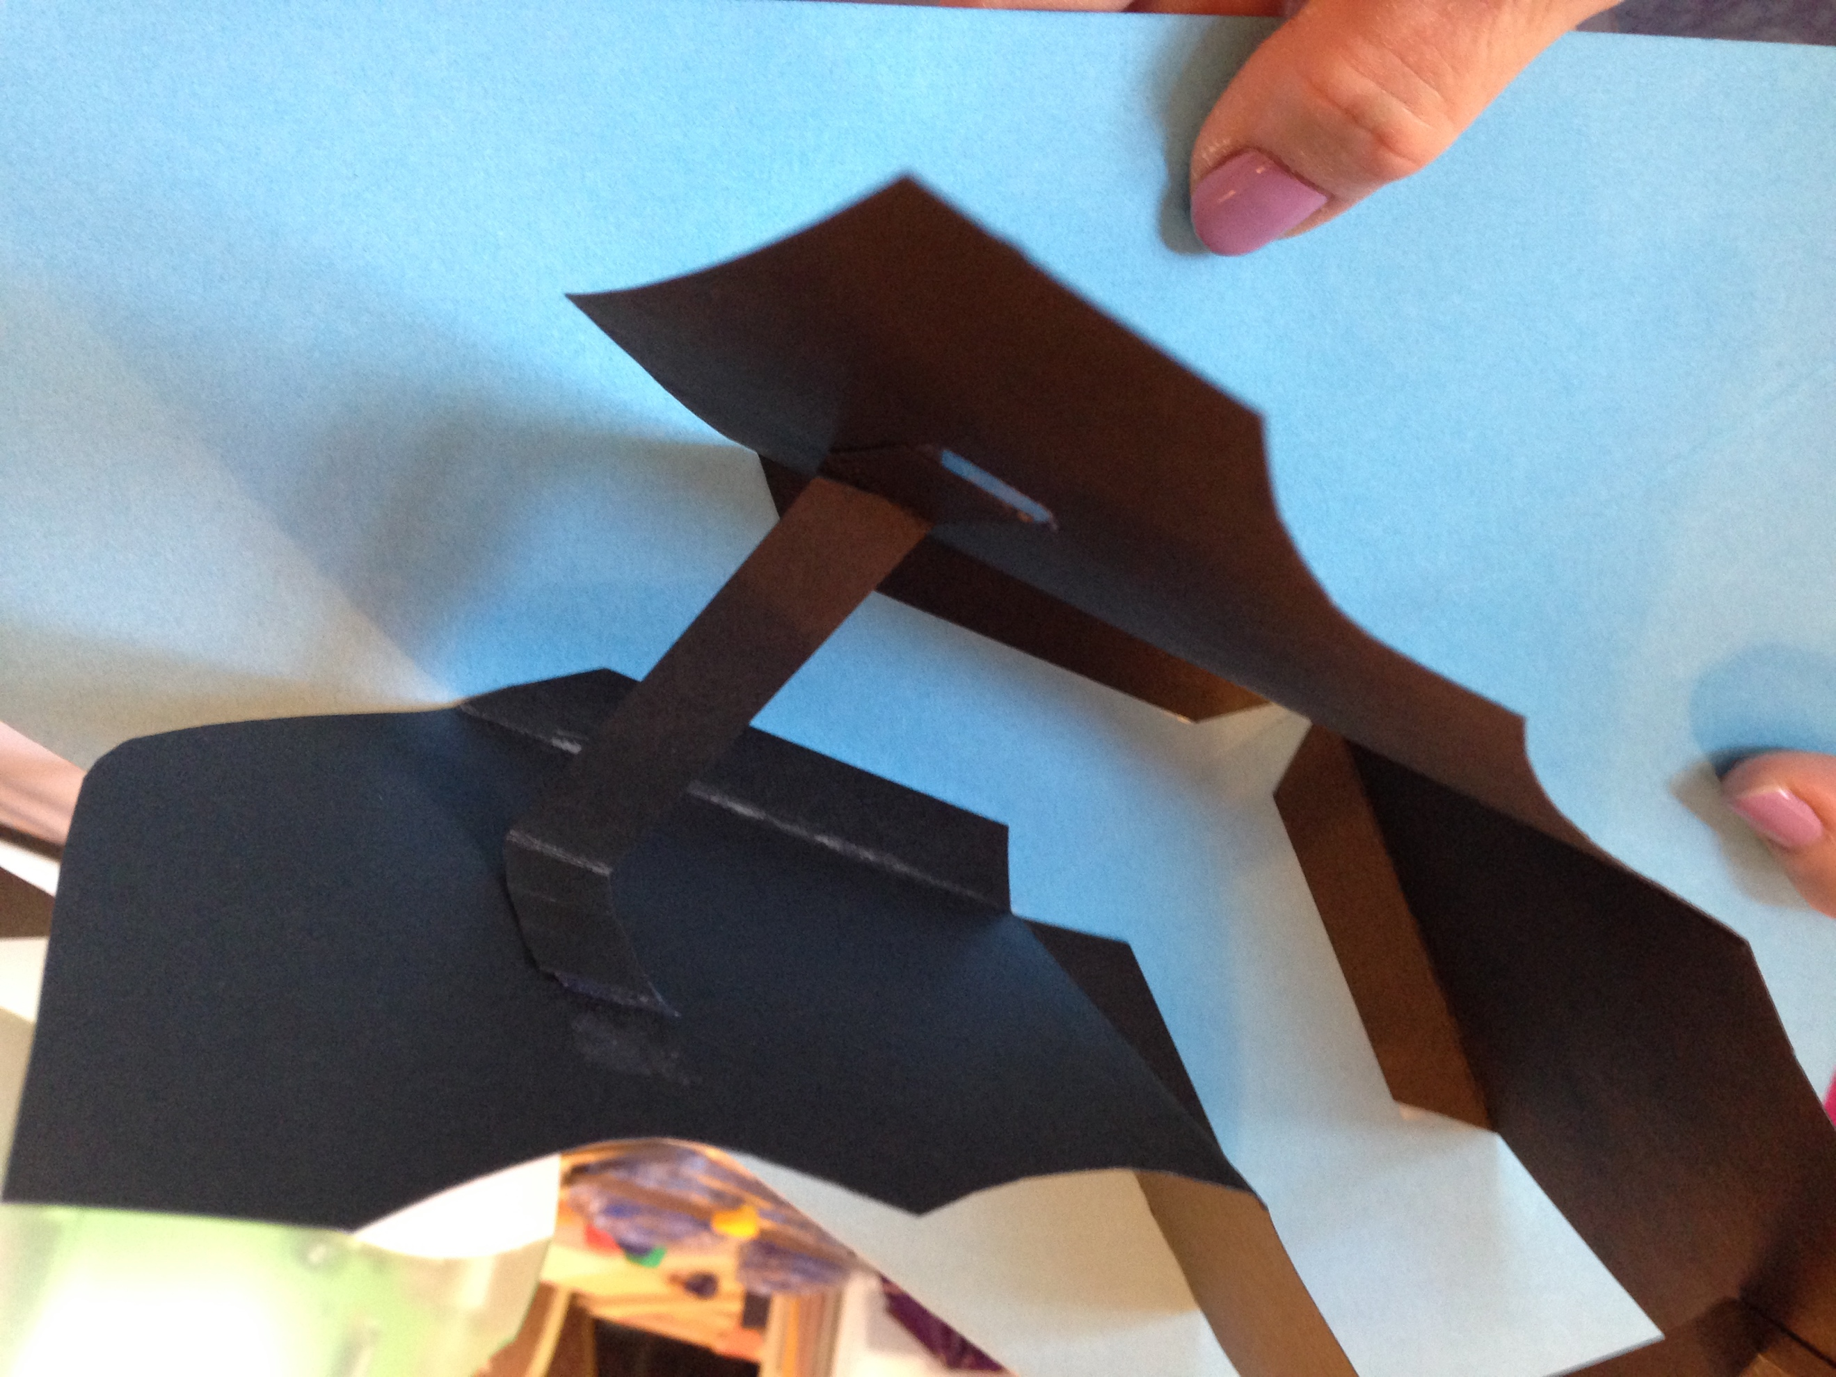

Reinforce the connection by cutting two 1 inch strips of matching cardstock that are 6” long.
Fold up 2” on each side of the strip and anchor or tape about midway on each half of your ships of the ships connecting them and adding support

Step 4: Assembling the pop up
You are now ready to anchor your ship down to the base.
Keeping the ship angled, tack ship down to base keeping it parallel to the base edges, and directly centered over the crease. Crease of base should be directly over opening where scrapbook opens. Close book to test and readjust as needed.

Step 5: Embellish!
Trace and cut out sails. Add sails, masts and embellishments as shown, making sure that the masts “clear” the book when it is folded.
Our little boy’s head is about 1 ½” wide if you’d like to add your own little “pirate”, we have included the hat!
Bon voyage!

