WELCOME TO
HOLY SPIRIT LUTHERAN CHURCH
A Member of the Evangelical Lutheran Church in America, New Jersey Synod
1220 Bayshore Rd., Villas, NJ 08251, 609-886-2414,
holyspiritlutheran@comcast.net, holyspiritvillas.com, facebook.com/holyspiritvillas
Vicar Vince Piekarski can be contacted at any time for conversation or prayer through call or text at 412-225-0287, or through email at vpie8282@gmail.com.
SUNDAY, APRIL 26TH, 2026
FOURTH SUNDAY OF EASTER
10:30AM WORSHIP SERVICE
NO HOLY COMMUNION


We, the Evangelical Lutheran Church of the Holy Spirit, are People of God, who
are called by the Holy Spirit to pray, worship, joyfully proclaim Jesus Christ,
and compassionately witness and serve others in Christian Love.


We are glad that you joined us for Worship today! Thank you for enriching our time together! We would like to get to know you better, and for you to get to know us better too. Brochures, welcome gifts, prayer shawls, Bibles, and other items are available throughout the church. We would be happy to show you around and share about our ministries. Please do not hesitate to speak up and ask questions.
Also, please make sure you sign-in on our clipboard on the podium in the lobby.


Our Worship Services are conducted in coordination with our Conference Call.
Join us at 657-390-7423 or 701-802-5170, with access code 8221190#.
You may need to dial 1 first depending on your phone plan. After logging in please announce your name and feel free to talk with others until we get started.

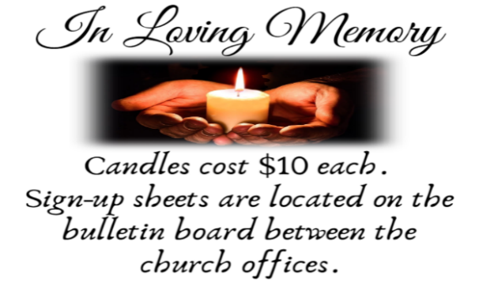
SANCTUARY CANDLE FOR APRIL
Given to the Glory of God & In Memory of
EDWARD & LINDA SCHUBERT by Vicki, Bob, Evan Rinier.
ALTAR CANDLES FOR APRIL
Given to the Glory of God & In Memory of
JOSEPH “MAC” MCKENNA & JAMES P ROONEY by Del McKenna & Children.
CONFERENCE CALL CHECK-IN, WELCOME, & ANNOUNCEMENTS
Worship Leader (WL), Assistant (A), Reader (R), and Congregation (C).

INTRODUCTION
A. Today is sometimes called “Good Shepherd Sunday.” Jesus is called the “gate” of
the sheep in today’s gospel. The risen Christ opens the way to abundant life. He
anoints our heads with oil and guides us beside the still waters of our baptism.
Each Sunday he spreads a feast before us amid the world’s violence and war.
We go forth to be signs of the resurrection and extend God’s tender care to all
creation.

PRELUDE
(Music offered by our Organist at the start of our Worship Service.)
Voluntary in D

CHIMES
(Music offered by our Organist at the start of our Worship Service.)
Amazing Grace

(We invite you to stand as you are able.)

THANKSGIVING FOR BAPTISM
(All may make the sign of the cross, the sign that is marked at baptism.)
WL. Alleluia! Christ is risen.
C. Christ is risen, indeed. Alleluia!

WL. Salvation belongs to our God who is seated on the throne and to the Lamb!
C. Amen.

WL. Let us give thanks for the gifts of baptism.

WL. Merciful God,
you are the one who was, who is, and who is to come.
You lead us beside still waters.
We thank you for the waters of creation:
morning dew, gentle rain, roaring waves.
We thank you for the waters that nourish us.
Blessed are you.
C. You guide us to springs of the water of life.

WL. Jesus Christ, you are the faithful witness
who accompanies us on our journeys.
We give you thanks for your life-giving death and resurrection.
We praise you for joining us in joy and sorrow.
Blessed are you.
C. You guide us to springs of the water of life.

WL. Holy Spirit, you anoint our head with oil and our cup overflows.
Break down barriers that divide us.
Fill us with the breath of peace.
Blessed are you.
C. You guide us to springs of the water of life.

WL. Holy One, we thank you for the gifts and grace of baptism,
and for making us a new creation.
We join with saints and angels, giving you honor and praise,
now and forever.
C. Amen.

BRIEF ORDER FOR CONFESSION AND FORGIVENESS
WL. God hears us when we cry, and draws us close in Jesus Christ. Let us return to
the one who is full of compassion.

(Silence is kept for reflection.)

WL. Fountain of living water,
C. pour out your mercy over us. Our sin is heavy, and we long to be free.
Rebuild what we have ruined and mend what we have torn. Wash us in
your cleansing flood. Make us alive in the Spirit to follow in the way of
Jesus, as healers and restorers of the world you so love. Amen.

WL. Beloved, God’s word never fails. The promise rests on grace: by the saving love
of Jesus Christ, the wisdom and power of God, ☩ your sins are forgiven, and
God remembers them no more. Journey in the way of Jesus.
C. Amen.

GATHERING HYMN
(We invite you to sing along.)
Lutheran Book of Worship—Green Book
499—Come, Thou Fount of Every Blessing

APOSTOLIC GREETING
WL. May the grace of our Lord Jesus Christ, the love of God,
and the communion of the Holy Spirit be with you all.
C. And also with you.

KYRIE
WL. In peace, let us pray to the Lord.
C. Lord, have mercy.

WL. For the peace from above, and for our salvation, let us pray to the Lord.
C. Lord, have mercy.

WL. For the peace of the whole world, for the well-being of the church of God,
and for the unity of all, let us pray to the Lord.
C. Lord, have mercy.

WL. For this holy house, and for all who offer here their worship and praise,
let us pray to the Lord.
C. Lord, have mercy.

WL. Help, save, comfort, and defend us, gracious Lord.
C. Amen.

HYMN OF PRAISE
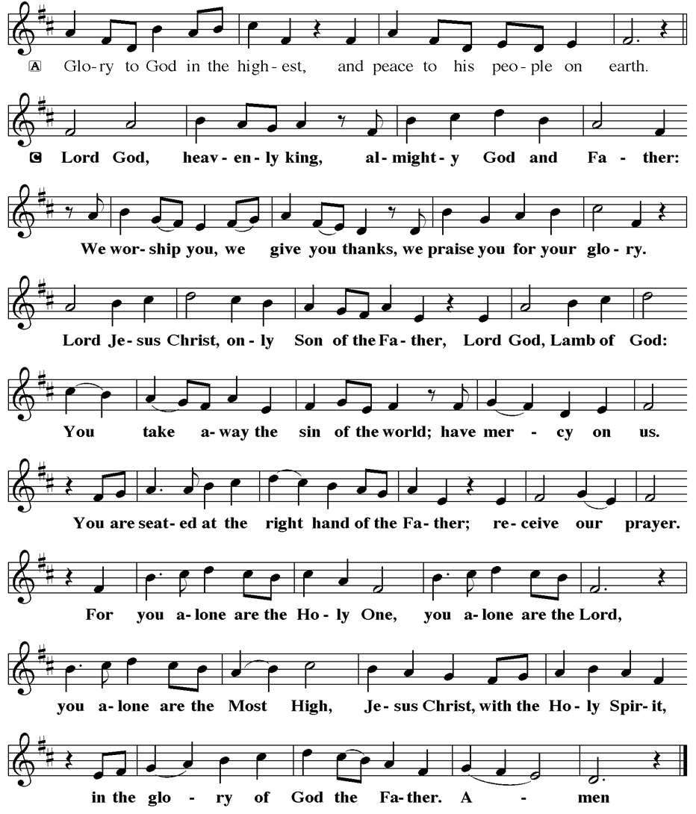
PRAYER OF THE DAY
WL. The Lord be with you.
C. And also with you.

WL. Let us pray,
O God our shepherd, you know your sheep by name and lead us to safety
through the valleys of death. Guide us by your voice, that we may walk in
certainty and security to the joyous feast prepared in your house, through Jesus
Christ, our Savior and Lord, who lives and reigns with you and the Holy Spirit,
one God, now and forever.
C. Amen.

(We invite you to be seated for our Readings and Psalm.)

FIRST READING
Today’s reading is a description of life in the community following Peter’s sermon
on the day of Pentecost, when the Spirit was poured out on God’s people. The
new community is sustained in worship and fellowship, shares what they have,
and ensures that everyone has enough.

R. Our First Reading is from Acts (Chapter 2, Verses 42-47).

R. 42 [The baptized] devoted themselves to the apostles’ teaching and fellowship, to
the breaking of bread and the prayers.

43 Awe came upon everyone because many wonders and signs were being done
through the apostles. 44 All who believed were together and had all things in
common; 45 they would sell their possessions and goods and distribute the
proceeds to all, as any had need. 46 Day by day, as they spent much time
together in the temple, they broke bread at home and ate their food with glad and
generous hearts, 47 praising God and having the goodwill of all the people. And
day by day the Lord added to their number those who were being saved.

R. This is the Word of the Lord.
C. Thanks be to God.

PSALM
R. Our Responsorial Psalm is from the 23rd Psalm.
C. The Lord is my shepherd; I shall not be in want. (Ps. 23:1)

R. 1 The Lord is my shepherd;
I shall not be in want.
2 The Lord makes me lie down in green pastures
and leads me beside still waters.
3 You restore my soul, O Lord,
and guide me along right pathways for your name’s sake.
4 Though I walk through the valley of the shadow of death, I shall fear no evil;
for you are with me; your rod and your staff, they comfort me.
C. The Lord is my shepherd; I shall not be in want. (Ps. 23:1)

R. 5 You prepare a table before me in the presence of my enemies;
you anoint my head with oil, and my cup is running over.
6 Surely goodness and mercy shall follow me all the days of my life,
and I will dwell in the house of the Lord forever.
C. The Lord is my shepherd; I shall not be in want. (Ps. 23:1)

SECOND READING
Doing the right things does not guarantee that one will not experience difficulties,
hardships, rejection, or even suffering. Here Christ is presented as the model for
our path of endurance and loyalty to God, particularly amid adversity.

R. Our Second Reading is from 1st Peter (Chapter 2, Verses 19-25).

R. 19 It is a commendable thing if, being aware of God, a person endures pain while
suffering unjustly. 20 If you endure when you are beaten for doing wrong, what
credit is that? But if you endure when you do good and suffer for it, this is a
commendable thing before God. 21 For to this you have been called, because
Christ also suffered for you, leaving you an example, so that you should follow in
his steps.
22 “He committed no sin,
and no deceit was found in his mouth.”
23 When he was abused, he did not return abuse; when he suffered, he did not
threaten, but he entrusted himself to the one who judges justly. 24 He himself
bore our sins in his body on the cross, so that, having died to sins, we might live
for righteousness; by his wounds you have been healed. 25 For you were going
astray like sheep, but now you have returned to the shepherd and guardian of
your souls.

R. This is the Word of the Lord.
C. Thanks be to God.

WL. I invite you to stand as you are able, and I invite you to announce the Gospel
Acclamation with me.

GOSPEL ACCLAMATION
C. Alleluia. Jesus says, I am the good shepherd. I know my own and my own
know me. Alleluia. (John 10:14)

GOSPEL READING
Jesus uses an image familiar to the people of his day to make a point about
spiritual leadership. Those who listen to Jesus are led to abundant life.

WL. The Holy Gospel According to John (Chapter 10, Verses 1-10).
C. Glory to you, O Lord.

WL. [Jesus said:] 1 “Very truly, I tell you, anyone who does not enter the sheepfold
by the gate but climbs in by another way is a thief and a bandit. 2 The one who
enters by the gate is the shepherd of the sheep. 3 The gatekeeper opens the
gate for him, and the sheep hear his voice. He calls his own sheep by name and
leads them out. 4 When he has brought out all his own, he goes ahead of them,
and the sheep follow him because they know his voice. 5 They will not follow a
stranger, but they will run from him because they do not know the voice of
strangers.” 6 Jesus used this figure of speech with them, but they did not
understand what he was saying to them.

7 So again Jesus said to them, “Very truly, I tell you, I am the gate for the sheep.
8 All who came before me are thieves and bandits, but the sheep did not listen
to them. 9 I am the gate. Whoever enters by me will be saved and will come in
and go out and find pasture. 10 The thief comes only to steal and kill and
destroy. I came that they may have life and have it abundantly.”

WL. This is the Gospel of the Lord,
C. Praise to you, O Christ.

SERMON
(Delivered by Chip Hand.)

(Following the Sermon, we invite you to stand as you are able.)

HYMN OF THE DAY
(We invite you to sing along.)
Lutheran Book of Worship—Green Book
481—Savior, like a Shepherd Lead Us

APOSTLES’ CREED
WL. God has made us his people through our Baptism into Christ. Living together in
trust and hope let us confess our faith together using the Apostles’ Creed.
C. I believe in God, the Father almighty,
creator of heaven and earth.

I believe in Jesus Christ, God’s only Son, our Lord,
who was conceived by the Holy Spirit,
born of the Virgin Mary,
suffered under Pontius Pilate,
was crucified, died, and was buried;
he descended to the dead.
On the third day he rose again;
he ascended into heaven,
he is seated at the right hand of the Father,
and he will come to judge the living and the dead.

I believe in the Holy Spirit,
the holy catholic church,
the communion of saints,
the forgiveness of sins,
the resurrection of the body,
and the life everlasting. Amen.

PRAYERS OF INTERCESSION
WL. Trusting in the power of Christ’s resurrection to heal and redeem our broken
world, let us pray for the needs of all creation.

(A brief silence.)

A. Shepherding God, draw all people to yourself and lead them in paths of
righteousness. Embolden your church to enter the valleys of the world and guide
us beside the still waters of your grace. We pray for military and prison chaplains
serving near and far. Merciful God,
C. receive our prayer.
A. Creator God, by the resurrection of your Son, show us your steadfast love and
instruct our hearts in your ways. Help us to revere and protect the wonders of
your creation. Merciful God,
C. receive our prayer.

A. Righteous Judge, strengthen and uphold those who work for justice and advocate
for human rights. Bring an end to oppression and save us from the temptation of
violence or vengeance. Merciful God,
C. receive our prayer.

A. Great Physician, walk with those who are grieving, and anoint those who are ill or
injured; especially:
BettyAnn Rich-White (Church Member)
Chip & Marie Hand (Church Members)
Lynn Bargstadt (Church Member)
Frank Ford (Church Member)
Carol Amundsen (Church Member)
Kim & Theresa McGinley (Church Member)
Anthony DeLuca (Church Member)
Frank Brunner (Church Member)
Paul Bowker (Church Member)
Joan Sommerman (Church Family)
Rick Lang (Church Family)
Suzie Clark (Rose Lang's Friend)
Francis Clock (Dianna DeNote’s Family)
Andrew Hudak (Rose Lang’s Friend)
Viena Murtha (Bob Fritsch’s Friend)
Sharon Waicus (Skip & Bonnie Millard's Friend)
Karen O'Brien (Paul Bowker's Friend)
Dustin Irizzary (Mary Melnicoff's Family)
The Bryan Family (Wanda Bryan's Family)
Sarah Dutton (Frank Ford's Family)
Christina McNasby (Fran Green’s Family)
Mark Stephen Dennis (Diana DeNote's Family)
Bill Lodge (Skip & Bonnie Millard's Friend)
Ron Anderson (Bill Kelly's Friend)
Bud Brearey (Judy Brannan & Mary Melnicoff's Friend)
Mary Skain (Kathy Poehler's Friend)
Robert Chaplin (Mary Melnicoff's Friend)
Jack Wieckouski (Theresa & Kim McGinley's Family)
Carolyn Santarpio (Bob Fritsch's Friend)
Harry (Judy Brannan's Friend)
Michael Hart (Diana DeNote's Friend)
Rocco Leonard DeNote (Diana DeNote's Family)
Sherri Lynn (Bob Fritsch's Friend)
John Bannco (Bob Fritsch's Friend)
Nancy Pazarinie (Bob Fritsch's Family)
Jane & Paul Eiben (Rose Lang's Friend)
Denny Papst (Rose Lang’s Friend)
Mike & Alice Rhoades (Rose Lang’s Friends)
Helen Ehlers (Judy Brannan's Friend)
Leanne Bueth (Joan Kilcoyne's Family)
Janett MacFarlane (Carol Amundsen's Friend)
Thish Kelly (Theresa & Kim McGinley's Family)
Scott Levin (Rose Lang's Friend)
Alice Ann Dennis (Diana DeNote's Family)
Nancy Taylor (Ted & Diane Bell's Family)
​​​​​ Santa Isabel Lutheran Church (Elizabeth, NJ)
Messiah Lutheran Church (Oakland, NJ)
Joyce Thompson (TDPWC Member)
Barbara Paynter (Leon Stitt’s Family)
Bob Poole (Kathy Poehler's Family)
David Smith (Heather & Vicar Vince Piekarski’s Family)
Barbara Hoitink (Lucas & Sabrina Munson's Family)
Kathy Raynor (Philomena Noak & Mary Melnicoff’s Friend)
Jordan (Carol Amundsen's Friend)
Ann Wieckouski (Theresa & Kim McGinley's Family)
Rich (Kim McGinley's Friend)
Amy Johnson (Ted Bell's Sister)
Theresa Dolan (Joan Kilcoyne's Family)
Sandy Bloomberg (Judy Brannan's Family)
Simon (Carol Amundsen's Family)
Bill Ransing & Family (Frank Ford’s Friends)
Barbara Brosius (Philomena Noak's Friend)
Barbara Schmiedel (Bob Fritsch's Family)
Cathy Bell (Ted & Diane Bell's Family)
Linda Stonelake (Kathy & Butch Poehler's Friend)
Anne Pfaff (Bonnie Millard & Vicki Rinier's Friend)
Anna Perez (Bob Fritsch's Family)
Ann Duhadway (Community Member)
Louise Helmes (Wayne & Eleanor Rand's Family)
Marion & Ernie Rink (Fran Green's Friends)
Paul Rand (Wayne & Eleanor Rand's Family)
Dr. Ed. Tinney (Bonnie & Skip Millard's Friend)
Tommy Mieluchowski (Philomena Noak's Friend)
Phyliss Mulvaney (Leon Stitt's Friend)
Ron Halbruner (Kathy & Butch Poehler's Friend)
Joe (Carol Amundsen's Friend)
Robin (Carol Amundsen's Friend)
Jeremy Pochatko (Vicar Vince Piekarski's Friend)
Olivia Holland (Bonnie & Skip Millard's Friend)
Kenzo (Philomena Noak's Friend)
Jake Burks (Mary Melnicoff's Friend)
(Additional Names Added Prior to the Worship Service.)
A. Restore them to health of body, mind, and spirit. Merciful God,
C. receive our prayer.

A. Good Shepherd, continually seek us out as lambs of your flock, and form us into a
community where all are honored and cared for. Spread a feast before us and fill
our cups to overflowing. Merciful God,
C. receive our prayer.

A. Living God, we praise you for the saints who have died in faith and now dwell in
your love. At our end, bring us, with them, to our heavenly home. Merciful God,
C. receive our prayer.

(Here other intercessions may be offered.)

WL. Watch over all of us who are worried and suffering, and especially those whose
names we now say aloud or hold within our hearts (brief pause). Merciful God,
C. receive our prayer.

WL. God of resurrection power, use us and these prayers to proclaim the good news
of new life to all the world, through Jesus Christ, our risen Savior.
C. Amen.

SHARING OF THE PEACE
WL. May the peace of the Lord be with you always.
C. And also with you.
WL. Now, let us share God’s Peace with one another.



(Please respect your neighbor if they desire to still only offer a peace sign or wave.)

(Following the Sharing of the Peace, we invite you to be seated.)

OFFERING
WL. We now worship God with our tithes and offerings, monetary gifts to support our
ministry for service in God’s name. Our Ushers will be around to your pews to
pass the Offering Plates.

(Ushers come forward to get the Offering Plates from the Assistant.)

OFFERING SONG
(We invite you to sing along.)
Worship & Praise
156—What Have We to Offer?
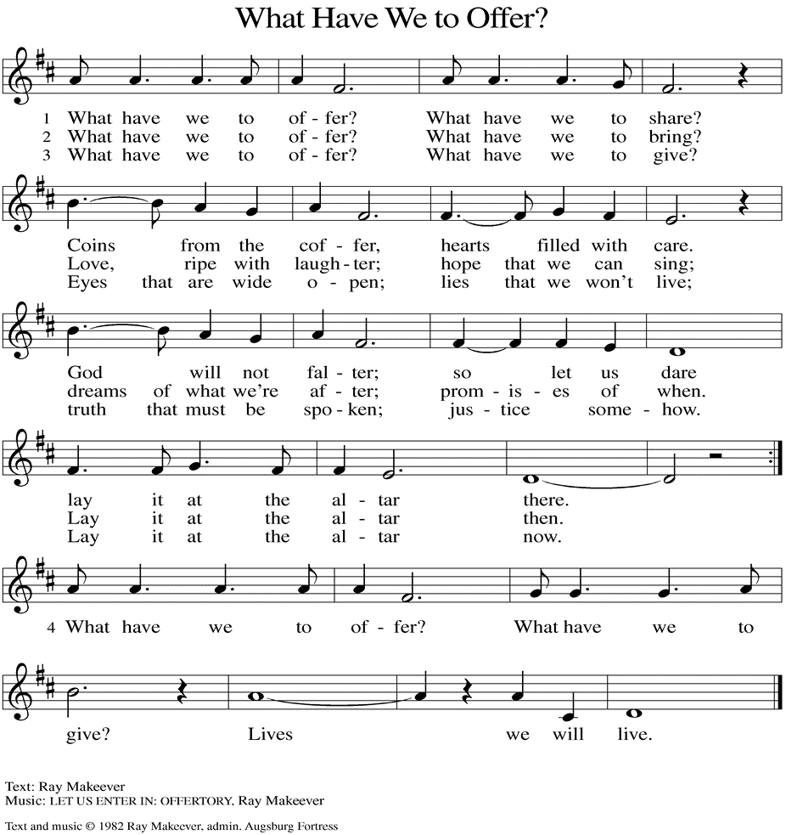
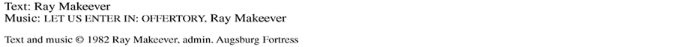

(Usher(s) brings the Tithes and Offerings up front to the Assistant.)
WL. We invite you to stand as you are able.

OFFERING PRAYER
WL. Let us pray,
Merciful God,
accept the fruits of our labor, gathered to give you glory.
You have set a table before us, a glimpse of that great day
when we will hunger and thirst no more.
Nourish us with the body and blood of Jesus,
that goodness and mercy may follow us
and bless the world you love.
In the name of Jesus,
C. Amen.

THE LORD’S PRAYER
(We ring the bell throughout the Lord’s Prayer at all services to
invite those in the community to join in praying the Lord’s Prayer.)
WL. May we now join with one another and pray together as Jesus has taught us.
C. Our Father, who art in heaven, hallowed be thy name, thy kingdom come,
thy will be done, on earth as it is in heaven. Give us this day our daily
bread; and forgive us our trespasses, as we forgive those who trespass
against us; and lead us not into temptation, but deliver us from evil. For
thine is the kingdom, and the power, and the glory, forever and ever.
Amen.

BLESSING
WL. God Almighty, who is the beginning and the end,
Jesus Christ, the firstborn of the dead,
and the Spirit, our advocate and peace,
☩ bless you now and forever.
C. Amen.

SENDING HYMN
(We invite you to sing along.)
With One Voice—Blue Book
780—What a Fellowship, What a Joy Divine

(Assistant extinguishes only the Altar Candles half way through the Sending Hymn.)

(The Paschal Candle remains lit.)
(Worship Leader processes out once the Altar Candles have been extinguished.)

(We invite you to be seated.)

BIRTHDAYS, ANNIVERSARIES, & ANNOUNCEMENTS
(Offered by Assistant and Congregation.)

ANNIVERSARY
2nd Wayne & Eleanor Rand

DISMISSAL
A. Go in peace. Praise the Lord. Alleluia!
C. Thanks be to God. Alleluia!

POSTLUDE
(Music offered by our Organist as we depart following our Worship Service.)
The Heavens Are Telling

LICENSES & EXPIRATION DATES
Worship Service Content is used via permission through Augsburg Fortress Liturgies Annual License #SB144368. The next Subscription Renewal Date is 2/28/2027.
Our Hymns and Worship Music are used via permission through CCLI One
License #11327166. The next Subscription Renewal Date is 1/31/2027.

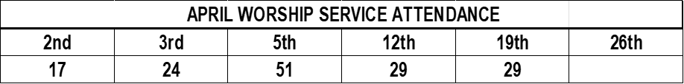


CONFIRMATION & SUNDAY SCHOOL
“Here We Stand” allows our young folks to go through a 2-year process focusing on the Bible and Luther’s Small Catechism. Classes are on Sundays from 9-10AM.

SPECIAL PREACHER
Chip Hand is looking forward to Preaching TODAY, April 26th, as Vicar Vince is back in Pittsburgh for a few days for the NFL Draft and some vacation time. Please be aware that there will not be Holy Communion TODAY as a result.

WORSHIP MINISTRY
The most important thing we do each week is gather together as God's people to Worship. God is the center and focus of everything we do. Participating in Worship is active, as Liturgy means the work and actions of the people gathered. Everything we do during the week to prepare for Worship, and everything we do as we Assist in leading Worship is important. We are thankful for all the wonderful work being done. If you have questions, or are interested in any position, reach out to Vicar Vince.
Sign-up sheets are located on the bulletin board between the church offices.

FOOD PANTRY
Open every Thursday, and the last Saturday of every month, from 10AM to 1PM. 88 people were served in March and 328 people have been served in 2026. Donations can be dropped in the outdoor drop-box, in the money jug in the back of the Church, mailed into the Church Office, or placed in the Offering Plate. Volunteers are needed. Sign-up sheets are located on the bulletin board between the church offices. If you have questions or need training see Heather, Vicar Vince, or Bonnie.
A special thank you goes out to all who donate, pray, and help in any way!

Thursday, 4/30 | Thursday, 5/7 | Thursday, 5/14
Theresa, Kim, & Bob | Garnet & Joe R. | Garnet & Joe R.
COMMUNITY FOOD DONATIONS, DELIVERIES, & MORE
North Cape May Acme provides us with Expiring, Recently Expired, and Slightly Damaged Food and Items. Kathy delivers on Saturdays in the community, brings items to church and the food pantry, and to the Branches Outreach in Rio Grande.

BULLETIN ENTRY DEADLINE
The Bulletin is printed on Thursdays during Church Office Hours. Changes need to be submitted to Vicar Vince no later than Thursday by 4PM. Thank you!

CHURCH OFFICE HOURS
Open Thursdays from 6PM to 8PM. It is open to serve the Congregation, the Community, and to handle the business of the Church. Feel free to stop in to talk, pick-up or drop off something, pray in the Sanctuary, or for whatever reason.

DONATION STATION
Get on the train and place all purchased items in the specified project donation bins located on the counter by the front doors. See Heather for more information.


WOMEN OF THE CHURCH
Their next meeting is on Monday, May 4th, at 6PM. New members are always invited and welcome to attend! Contact Judy for more information.

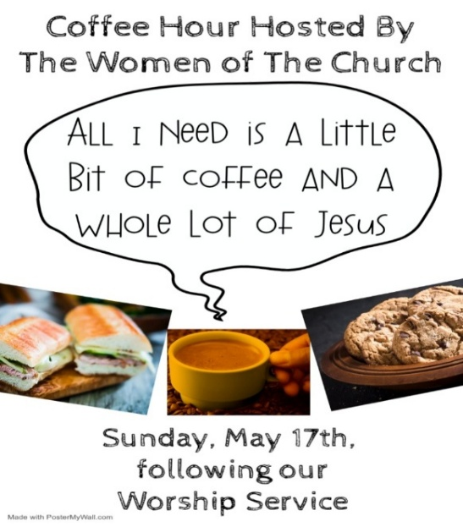
CHURCH COUNCIL
Share your comments, concerns, questions, or joys with one of our Church Council Members who can bring them back to our meetings. Visitors are always welcome to attend and listen to what is going on in and around the church. Join us In- Person or on our Conference Call at our next Meeting on Tuesday, May 19th, at 6PM.


Our NJ Synod Assembly will be on Saturday, May 30th, 2026. Wayne & Judy are attending with Vicar Vince. Please keep them and the Assembly in your prayers.


Confirmation is a journey of faith filled with new questions and answers, new discoveries, new relationships, new responsibilities, and new possibilities. Clearly confirmation is intended to be a milestone, not a destination; it is not graduation! Rather, Confirmation is a tool that equips for the life-long process of living out Christian identity. Traditionally we would be celebrating Confirmation on Pentecost Sunday. However, due to it falling on Memorial Day Weekend, and the schedules of our young folks, we will be moving it to Sunday, June 14th, during our 10:30AM Worship Service. Please come out and join Caylee Thomas and Robert Thomas on this special day and celebrate with them at the Coffee Hour afterwards.


Have you been attending our church for a while? Have you just recently returned to church after being away for a bit? Maybe you transitioned from another church, or just started to recently attend our church. We are glad to have you, and would love to have you as a member of our Congregation. We are looking forward to
having new member classes in the near future. Please stay posted.
Feel free to ask Vicar Vince any questions or for more information as well.
NEWSLETTER
Collect information, stories, pictures, and reports for our next publication. Everything needs submitted to Vicar Vince in-person or via email at vpie8282@gmail.com.

CHURCH DIRECTORY
2026 Church Directories are by the Church Office on the bookshelves. We continue keeping it updated, but we undoubtedly miss a few changes or have made a few errors. Please inform the Church Office of updates or changes to keep us up to date.

TITHES, OFFERINGS, & ENVELOPES
We worship God with our tithes and offerings. We hear in scripture, “Each of you must give as you have made up your mind, not reluctantly or under compulsion, for God loves a cheerful giver.” (2 Corinthians 9:7) Envelopes can be dropped in the offering plate, mailed to the church, or dropped in the locked mailbox. Thanks for your support in the mission of our church, its ministries, the NJ Synod, etc!

SPACE AVAILABLE
​​​​​Interested in utilizing our Fellowship Hall for a Party or Event? There is a suggested $50 refundable security deposit, and it is $250 for facility use. No alcohol or games of chance permitted due to ELCA policy. Please contact Vicar Vince for more info.

ED GREEN CAPITAL IMPROVEMENT FUND
We continue to raise money for any unforeseen costs or repairs. We are currently exploring a new Annual Fundraising opportunity where we will be handing out coffee cans to raise money at home. We also have the donation bin in the back of the church. Thanks for your continued prayers, support, and donations!

NEW SPLIT UNITS INSTALLED IN THE SANCTUARY
What a blessing it was to have Pete Meehan install our new Split Air & Heat Units in the Sanctuary. We utilized money from our ED GREEN Capital Improvement Fund to pay for a portion of this cost, as it was not a budgeted expense for the year. At this time, we are looking to refund that Fund and are running at a deficit of $3,692.08. Please consider donating to help bring this budget back into the positive.

HOME COMMUNION MINISTRY
A Minister is available if you have a loved one, or if you desire services. We look forward in sharing the Word and Holy Communion! Please inform Vicar Vince, Kathy, or the Church Office so plans can be made for visits.

PRAYER SHAWL MINISTRY
Prayer Shawls, Lap Quilts, Scarves, and other items have been made with love. Blessed items are located in the Narthex, and are free for anyone. Members of the group continue working at home on new stitches and patterns. We are blessed to be able to continue collecting new items. We have a donation station of yarn and other items located in the Narthex. You can find some new supplies for your next creation!

PRAYER LIST
Our Prayer List continues to lengthen and we realize the important need for prayers and healing. Sometimes the unfortunate result is that someone has passed away, and the words “The Family & Friends of” appear before someone’s name. However, sometimes we forget names are still on the list and their health has improved and they can be removed. Please share various stories as we continue to pray for strength and healing. Names can be added or removed from the list on the clipboard in the Narthex prior to the Worship Service, by calling the church office, or addressing it on the Conference Call. Please let us know the relation to the person(s) you listed so we can be more mindful with our prayers.

BAPTISM
We are a church whose unity is in Jesus Christ, who gathers us around word and water, wine and bread. Baptism is a significant part of our faith journey as we come from the baptismal waters to live a new life as children of God. Our baptism sets us out on a lifelong journey that is characterized by our relationship to God, our relationship to our faith community, our relationships in our community and the wider world. Living our baptismal covenant means living a life of growth in the faith practices of discipleship. Please see Vicar Vince for more information.

FIRST COMMUNION
Although no particular age for first communion is prescribed by The Use of the Means of Grace, one guideline is offered. Because admission to the Sacrament is by invitation of the Lord to the baptized, "baptized children begin to commune on a regular basis at a time determined through mutual conversation that includes the pastor/vicar, the child, and the parents or sponsors involved, within the accepted practices of the congregation.” Each congregation is encouraged to ask the question of readiness for first communion, establish their own policies regarding age and practice, and accompany that practice with catechesis appropriate to the age of the communicant. If anyone has questions, please see Vicar Vince.

LIBRARY
New books are added to our library from time to time. Several are borrowed and read and exchanged. Who knows, you might find one particularly interesting and share that with someone. Reading is a great way to pass spare time, learn, and explore. You may find some fresh ideas for prayer, ways to grow more spiritually, ways to grow closer to God, or some opportunities to understand our faith more. We have an extended library located in Vicar Vince’s office. There are Bibles of various translations, books from his personal collection, books inherited from Pastor Leah, movies, past Bible Study Curriculums, and more. Come check things out.

JERSEY JOTTINGS & NJ SYNOD APP
There is a weekly e-newsletter connecting our synod together with weekly prayer, upcoming events, synod and churchwide activities, mission stories, congregational activities, & more. Download the app or sign up at www.njsynod.org/stay-connected.

FAVORITE HYMNS
Carol is willing to play some of your favorite hymns for the Prelude & Postlude each Sunday during our Worship Service. Feel free to let her know of your suggestions.

VICE PASTOR UPDATE
Pastor William Hodgetts continues to attend our Church Council Meetings
and provides Supervision and Support to Vicar Vince.

VICAR APPOINTMENT ON MARCH 19TH, 2023
A Memorandum of Understanding on the Matter of Pastoral Appointment
In Theological Education for Emerging Ministries (TEEM) Candidacy
TO: Congregation Council, Holy Spirit Lutheran Church, Villas
FROM: The Rev. Tracie L. Bartholomew, Bishop, New Jersey Synod

Dear Brother and Sisters in Christ,
This memorandum is in support of your discussions with Vincent Piekarski as pastor of Holy Spirit, Villas. Because this is not the usual pattern for completing the educational and candidacy requirements for ordination, it is my hope that this memorandum will both provide guidelines and engage in conversation with those who are invested in this process.

I would say at the outset that because Vincent is an outstanding candidate for the Ministry of Word and Sacrament, we will all want to do whatever is necessary to assure that his placement serves the mission of the church in the best possible fashion.

The following notes reflect my own understanding of this matter:
(1) The appointment for Vincent will begin on April 1, 2023. At this time, Vincent
will assume all responsibilities of a regularly called pastor, including presiding at
the Sacrament of Holy Communion and Baptism at Holy Spirit, Villas.
(2) A pastoral appointment in the TEEM process is an option for completing
seminary educational requirements and the steps of the candidacy process.
Upon completion of the candidacy process and seminary education, the
candidate may receive and accept a call to ordained ministry from the
congregation where the appointment is being served.
(3) This appointment is jointly supervised by the Office of the Bishop and the TEEM
pastor’s seminary. A mentoring relationship with a local pastor is required for the
length of this appointment.
(4) The synod of candidacy origin will be responsible for the approval process.
(5) Upon approval for ordination, the congregation would be expected to extend a
call to the pastoral appointee.
(6) Compensation for the TEEM pastor will be according to the guidelines of the New
Jersey Synod. All normal forms of compensation should be in place for the term
of the appointment, including stipulation that base salary and housing shall be in
accord with synod guidelines for first call at time of ordination.
(7) The ELCA Portico benefit plan for lay persons in full-time church service should
be used for the pastoral appointee up to the time of ordination, whereupon the
benefit package is to be converted to the plan for ELCA clergy.

(8) A decision for Pastoral Appointment is made with the agreement of a synod and
its candidacy committee, and the ELCA, normally represented by the regional
staff person of each in consultation with the seminary and its Director for
Contextual Education.
(9) Pastoral Appointment in a TEEM Candidacy is an option that is to serve the
mission of the Church in a particular and vital way and is not to be viewed or
used as a means to circumvent the normal candidacy process and/or first call
placement process.

In the specific case of Vincent, the New Jersey Synod remains responsible for the candidacy and approval process, and has agreed to this proposal for Appointment at Holy Spirit, Villas.

Continued blessings to both Holy Spirit and Vincent Piekarski as you embark on this journey of mutual ministry. As partners in ministry, we walk with you and rejoice in this new relationship.


VICAR VINCE’S DAY OF REST
A day of rest can have physical, mental, and spiritual benefits. “Mittwoch,” German for mid-week, or Wednesday, is the day that Vicar Vince will use to recharge and do some other things. Please do not hesitate to reach out if there is an emergency!

2026 FINANCIAL STANDING
MARCH INCOME | $7,024.00
MARCH SPENDING | $8,797.52
MARCH GAIN OR (LOSS) | ($1,773.52)
2026 INCOME | $18,504.00
2026 SPENDING | $20,921.59
2026 GAIN OR (LOSS) | ($2,417.59)
ED GREEN CAPITAL IMPROVEMENT FUND | ($3,692.08)
FOOD PANTRY FUND (SOCIAL MINISTRY) | $13,381.23
CD | $26,665.08

WHAT IS THE EVANGELICAL LUTHERAN CHURCH IN AMERICA?
The ELCA was formed in 1987 by the merger of three Lutheran Church bodies –
the ALC (American Lutheran Church), the LCA (Lutheran Church in America), and the AELC (Association of Evangelical Lutheran Churches). Learn more at elca.org.


The New Jersey Synod is a geographical grouping of Evangelical Lutheran Church in America (ELCA) congregations that share the mission and ministry of the Church on the New Jersey territory. It is one of 65 synods in the ELCA. The NJ Synod is comprised of 143 congregations, which include over 45,000 baptized members.

TRUE DELIVERANCE PRAISE & WORSHIP CENTER
TDPWC utilizes our facilities from 1-4PM on Sundays. TDPWC hosts or assists with other events. TDPWC hosts a Prayer Line on Mondays, Wednesdays, & Fridays at 5PM on the Conference Call 1-657-390-7957; & Bible Study on Thursdays at 6:30PM on Zoom. See Rev. Brooks for more information.

ADDITIONAL OFFERINGS FROM OUR FRIENDS & NEIGHBORS
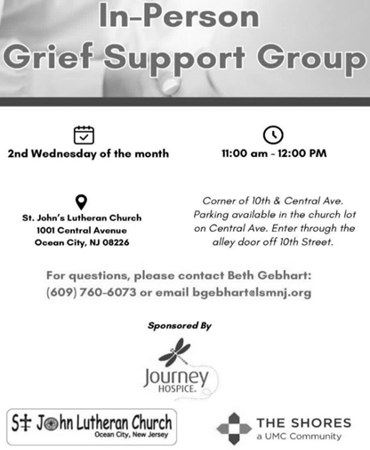
JUST FRIENDS
The group promotes a spirit of fellowship among adults 50 years and older. Bring your own lunch, beverages and deserts are provided. Everyone is welcome. The group meets in Our Lady Star of The Sea Parish Hall on the last Wednesday of the month from 12Noon to 2PM from September through May. For information, please call Martine Simonis 609-884-5312 x 110.

CHURCH STAFF & VOLUNTEERS
VICAR
Vicar Vince Piekarski
VICE PASTOR
Pastor William Hodgetts
ORGANIST & PIANIST
Carol Amundsen
CHURCH OFFICE, SUNDAY SCHOOL, & FOOD PANTRY
Heather Piekarski
CHURCH COUNCIL PRESIDENT & CHURCH PROPERTY
Wayne Rand
CHURCH COUNCIL VICE PRESIDENT & WOMEN OF THE CHURCH
Judy Brannan
CHURCH COUNCIL TREASURER
Bonnie Millard
CHURCH COUNCIL SECRETARY
Vicki Rinier



