Saturday & Sunday,
March 14 & March 15, 2026
Fourth Sunday of Lent

Christ Lutheran Church
“A Place Where You are Always Welcome”
Services: Saturday 5:30 pm and Sunday 10:00 am
Sunday School: 9:00 am (September- May)
600 North Main Street, Stockton, IL 61085 Office: 815-947-2033
Email: christlutheranchurch70@gmail.com http://www.christlutheranstockton.com
Ministers: ALL members of the congregation
Pastor: Rev. Chrissy Salser chrissytherev@att.net 815-988-9450
From Sundays and Seasons.com. Copyright 2017 Augsburg Fortress. All rights reserved. Reprinted by permission under Augsburg Fortress Liturgies Annual License #40643.New Revised Standard Version Bible, copyright 1989, Division of Christian Education of the National Council of the Churches of Christ in the United States of America. Used by permission. All rights reserved.
WELCOME: Thank you for joining us for worship today. We are glad you are with us. Communion will be served in the aisle or in your pew. All are welcome to share this meal. Jesus is our host and invites everyone. Those who would like to come forward, bread and wine will also be available in the front. When directed by the usher, come forward down the center aisle, Pr Chrissy will give you bread (she will be masked and wearing cloves) and then you will take a cup of wine (grape juice) from the tray. After taking communion, you will return to your seat by the side aisle. For those who are unable to come forward, communion elements can be found as you entered worship. At that part of the service, you are invited to take the bread and wine (or grape juice) when Pr. Chrissy leads. On Saturday’s offering is collected as you enter or leave worship. On Sunday we will pass the plate as a response to God’s grace. Online giving is available. Please see QR code on back of bulletin or visit our website.

Introduction: Baptism is sometimes called enlightenment. The gospel for this Sunday is the story of the man born blind healed by Christ. “I was blind, now I see,” declares the man. In baptism God opens our eyes to see the truth of who we are: God’s beloved children. As David was anointed king of Israel, in baptism God anoints our head with oil, and calls us to bear witness to the light of Christ in our daily lives.

Gathering: The Holy Spirit calls us together as the people of God.
PRELUDE
WELCOME AND ANNOUNCEMENTS
THANKSGIVING FOR BAPTISM
P: People of God, in the baptismal waters we travel with Christ from death to life. Our past, our sin, our failure, our doubt, and our shame are drowned and gone here.
C: You, O God, wash us clean
P: Our fear, our confusion, our self-righteousness, our despair—ALL are washed away by grace.
C: You, O God, wash us clean.
P: Our pride, our hypocrisy, and other people’s opinions of us no longer have the power to define us.
C: You, O God, give us new life.
P: The Spirit lives and moves through us now, a great and joyful mystery, so we may bring love and mercy into the world as the body of Christ.
C: You, O God, give us new life.
P: Rejoice that God has claimed us in this baptismal grace, not by our own doing or believing but by God’s mercy alone.
C: You, O God, give us new life.
P: And so, as we worship, we give thanks to God for the gracious gift of baptism that joins us together in Christ by the Spirit’s power. C: Amen

GATHERING HYMN Beautiful Things ACS 925 (next page)

GREETING:
P: The Grace of our Lord Jesus Christ, the love of God and the communion of the Holy Spirit be with you all.
C: And also with you
PRAYER OF THE DAY:
P: Bend your ear to our prayers, Lord Christ, and come among us. By your gracious life and death for us, bring light into the darkness of our hearts, and anoint us with your Spirit, for you live and reign with the Father and the Holy Spirit, one God, now and forever. Amen.

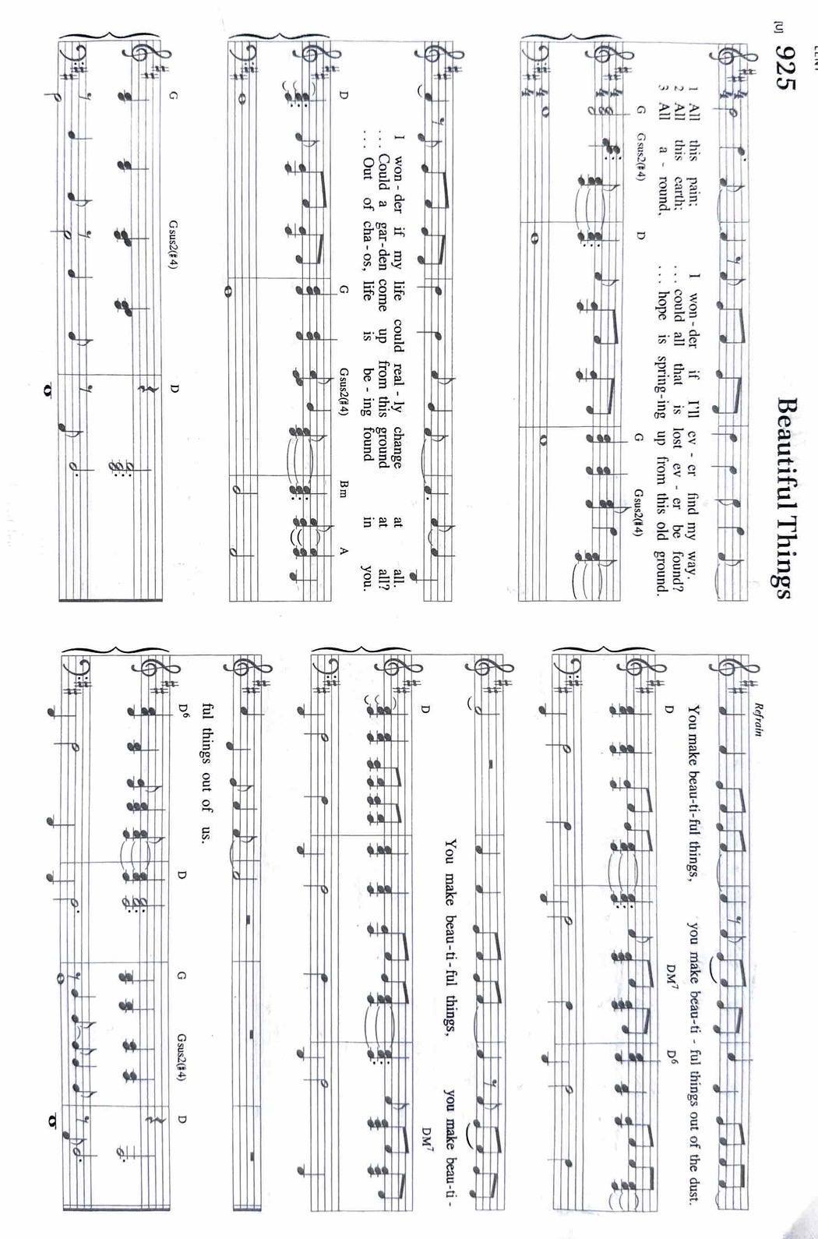
Word: God speaks to us in scripture reading, preaching, and song.

First Reading: Samuel 16:1-13
Samuel anointed David even though he was the eighth-oldest son of Jesse and did not match his brothers in height or other physical characteristics. With the anointing came endowment with the Spirit of the Lord, designating David as the Lord’s chosen successor to Saul.
¹ The Lord said to Samuel, “How long will you grieve over Saul? I have rejected him from being king over Israel. Fill your horn with oil and set out; I will send you to Jesse the Bethlehemite, for I have provided for myself a king among his sons.” ² Samuel said, “How can I go? If Saul hears of it, he will kill me.” And the Lord said, “Take a heifer with you and say, ‘I have come to sacrifice to the Lord.’ ³ Invite Jesse to the sacrifice, and I will show you what you shall do, and you shall anoint for me the one whom I name to you.” ⁴ Samuel did what the Lord commanded and came to Bethlehem. The elders of the city came to meet him trembling and said, “Do you come peaceably?” ⁵ He said, “Peaceably. I have come to sacrifice to the Lord; sanctify yourselves and come with me to the sacrifice.” And he sanctified Jesse and his sons and invited them to the sacrifice.
⁶ When they came, he looked on Eliab and thought, “Surely his anointed is now before the Lord.” ⁷ But the Lord said to Samuel, “Do not look on his appearance or on the height of his stature, because I have rejected him, for the Lord does not see as mortals see; they look on the outward appearance, but the Lord looks on the heart.” ⁸ Then Jesse called Abinadab and made him pass before Samuel. He said, “Neither has the Lord chosen this one.” ⁹ Then Jesse made Shammah pass by. And he said, “Neither has the Lord chosen this one.” ¹⁰ Jesse made seven of his sons pass before Samuel, and Samuel said to Jesse, “The Lord has not chosen any of these.” ¹¹ Samuel said to Jesse, “Are all your sons here?” And he said, “There remains yet the youngest, but he is keeping the sheep.” And Samuel said to Jesse, “Send and bring him, for we will not sit down until he comes here.”
¹² He sent and brought him in. Now he was ruddy and had beautiful eyes and was handsome. The Lord said, “Rise and anoint him, for this is the one.” ¹³ Then Samuel took the horn of oil and anointed him in the presence of his brothers, and the spirit of the Lord came mightily upon David from that day forward. Samuel then set out and went to Ramah.
R: The Word of the Lord. C: Thanks be to God.

Psalm: Psalm 23
¹ The Lord is my shepherd; I shall not be in want.
² The Lord makes me lie down in green pastures and leads me beside still waters.
³ You restore my soul, O Lord, and guide me along right pathways for your name’s sake.
⁴ Though I walk through the valley of the shadow of death, I shall fear no evil; for you are with me; your rod and your staff, they comfort me.
⁵ You prepare a table before me in the presence of my enemies; you anoint my head with oil, and my cup is running over.
⁶ Surely goodness and mercy shall follow me all the days of my life,
and I will dwell in the house of the Lord forever.
Second Reading: Ephesians 5: 8-14
Because we now live in the divine light which is Jesus Christ, we conduct our lives in ways that reflect the light of Christ, so that our activity is truly pleasing to God.
⁸ Once you were darkness, but now in the Lord you are light. Walk as children of light, ⁹ for the fruit of the light is found in all that is good and right and true. ¹⁰ Try to find out what is pleasing to the Lord. ¹¹ Take no part in the unfruitful works of darkness; rather, expose them. ¹² For it is shameful even to mention what such people do secretly, ¹³ but everything exposed by the light becomes visible, ¹⁴ for everything that becomes visible is light. Therefore it says, “Sleeper, awake! Rise from the dead, and Christ will shine on you.”
R: The Word of the Lord. C: Thanks be to God.
GOSPEL ACCLAMATION Restore to Us ELW 328
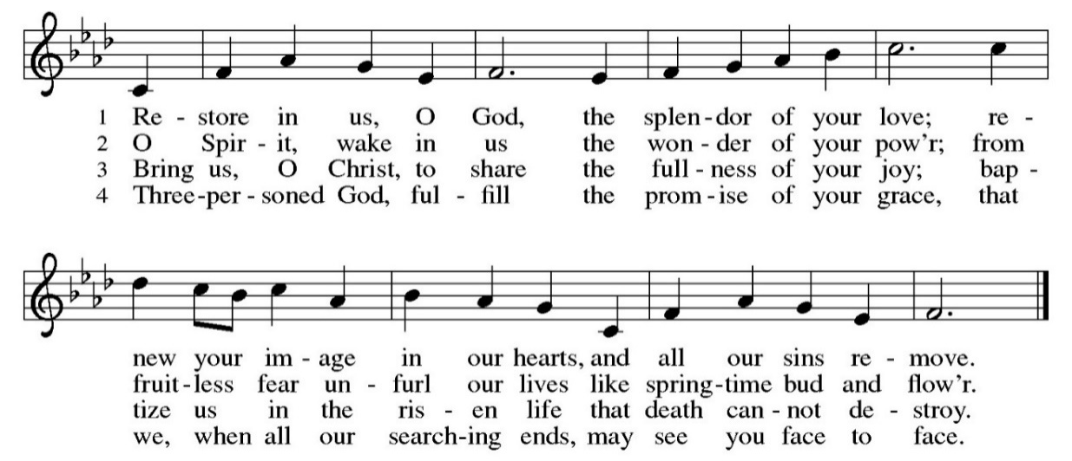
Gospel: John 9:1-41

P: The Gospel according to John C: Glory to you, O Lord
Jesus heals a man born blind, provoking a hostile reaction that he regards as spiritual blindness to the things of God.
P: The Gospel of Our Lord. C. Praise to you, O Christ.
CHILDREN’S MESSAGE
MESSAGE
HYMN OF THE DAY Amazing Grace, How Sweet the Sound ELW 779
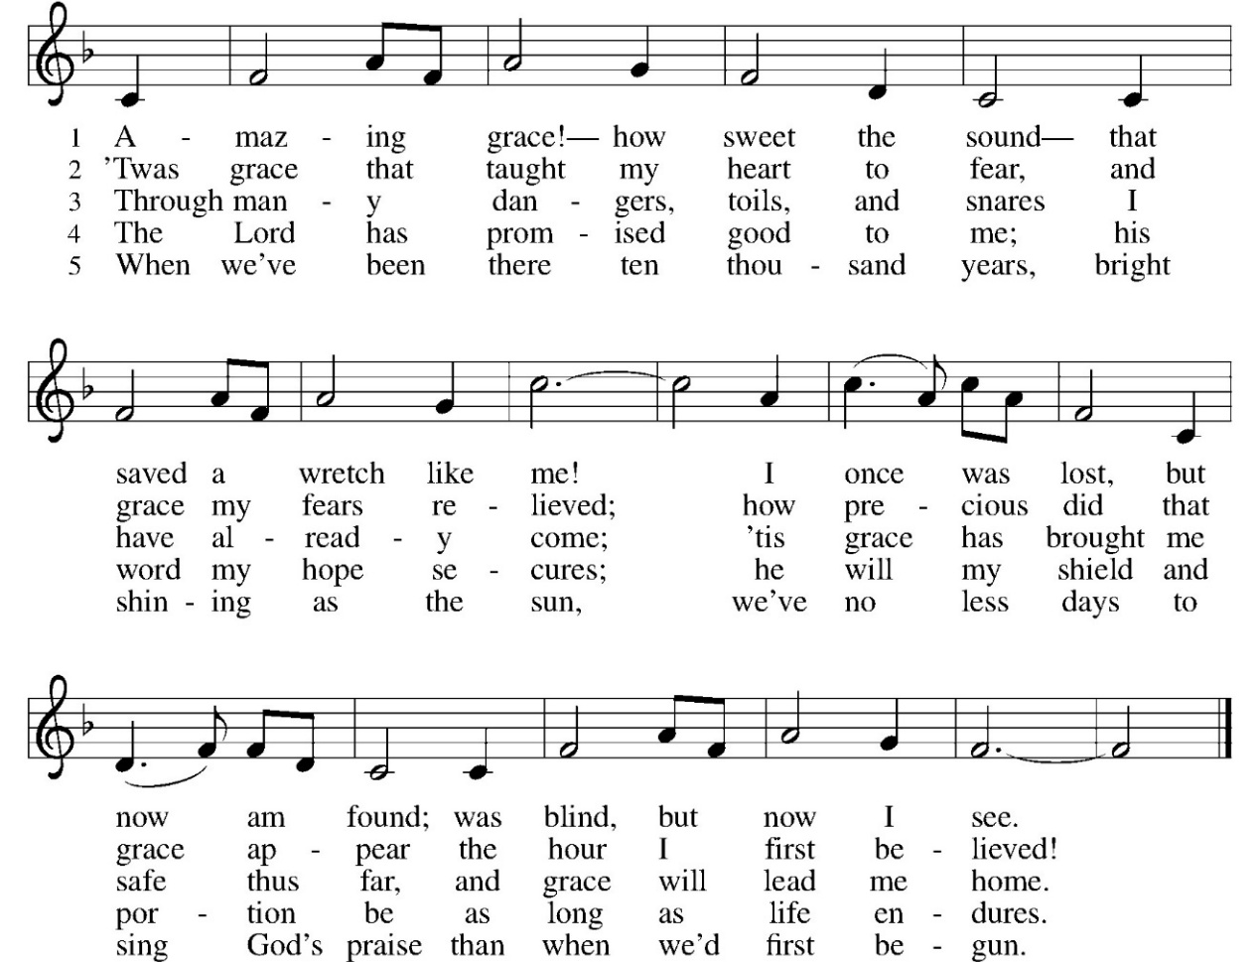

BAPTISM (SATURDAY ONLY)

Children of Samantha & Brandon Love
Aven Matthew Love Born May 12, 2024
God parent: Cody Schultz
Parker Jean Love Born: June 25, 2022
God parent: Cody Schultz
Kaison Lee Love Born: August 30, 2020
God Parents: Kyle & Jackie (Cahill) Dick

Children of Kyle Dick and Jackie Cahill
Sabrina Marie Dick Born: January 19, 2022
Holly Marie Dick Born: December 28, 2018
Abraham Anthony Dick Born: December 8, 2017
God Parents: Brandon & Samantha Love
Pastor: In holy Baptism our gracious heavenly father frees us from sin and death by joining us to the death and resurrection of our Lord Jesus Christ. We are born children of a fallen humanity; by God's command, water and the Holy Spirit we are reborn children of God and made members of the church, the body of Christ. Living with Christ and in the communion of saints, we grow in faith, love, and obedience in the will of God
Pastor: Who presents these children for the sacrament of Holy Baptism?
Sponsors: We present Aven Matthew, Parker Jean, Kaison Lee, Sabrina Marie, Holly Marie and Abraham Anthony for baptism.
Pastor: As you bring Aven Matthew, Parker Jean, Kaison Lee, Sabrina Marie, Holly Marie and Abraham Anthony to receive the gift of baptism, you are entrusted with responsibilities:
to live with them among God's faithful people,
bring them to the word of God and the holy supper,
teach them the Lord's Prayer, the Creed, and the Ten Commandments,
place in their hands the holy scriptures,
and nurture them in faith and prayer,
so that they may learn to trust God,
proclaim Christ through word and deed,
care for others and the world God made,
and work for justice and peace.
Pastor: Do you promise to help your children grow in the Christian faith and life?
Parents: Yes, and we ask God to help us.
Pastor: Sponsors, do you promise to nurture these children in the Christian faith as you are empowered by God's Spirit, and to help them live in the covenant of baptism and in communion with the church?
Sponsors: Yes, and we ask God to help us.
Pastor: Please stand as you are able. People of God, do you promise to support Aven Matthew, Parker Jean, Kaison Lee, Sabrina Marie, Holly Marie and Abraham Anthony and pray for them in their new life in Christ?
Congregation: We do and we ask God to help us.
Pastor: I ask you to profess your faith in Christ Jesus, reject sin, and confess the faith of the church, the faith in which we baptize.
Pastor: Do you renounce all the forces that deny God, the powers of this world that rebel against God, and the ways of sin that draw us from God?
Sponsors/parents: Yes, and we ask God to help us.
Pastor: Do you believe in God the Father?
All: I believe in God the Father Almighty, creator of heaven and earth.
Pastor: Do you believe in Jesus Christ, the Son of God?
All: I believe in Jesus Christ, his only Son, our Lord. He was conceived by the power of the Holy Spirit and born of the virgin Mary. He suffered under Pontius Pilate, was crucified, died and was buried. He descended into hell. On the third day he rose again. He ascended into heaven, and is seated at the right hand of God the Father. He will come again to judge the living and the Dead.
Pastor: Do you believe in the Holy Spirit?
All: I believe in the Holy Spirit, the holy catholic church, the communion of saints, the forgiveness of sins, the resurrections of the body, and the life everlasting. Amen.
Pastor: (Aven Matthew, Parker Jean, Kaison Lee, Sabrina Marie, Holly Marie and Abraham Anthony); I baptize you in the name of the Father, and of the Son, and of the Holy Spirit. Amen.
Let us pray. We give you thanks, O God, that through water and the Holy Spirit you give your daughters and sons new birth, cleanse them from sin, and raise them to eternal life. Pour out your Holy Spirit upon (Aven Matthew, Parker Jean, Kaison Lee, Sabrina Marie, Holly Marie and Abraham Anthony); the spirit of council and might; the spirit of knowledge and the fear of the Lord; the spirit of joy in your presence. All: Amen.
Pastor: (Aven Matthew, Parker Jean, Kaison Lee, Sabrina Marie, Holly Marie and Abraham Anthony )child of God, you have been sealed by the Holy Spirit and marked with the Cross of Christ forever.
Congregation Leader: Let your Light so shine before others that they may see your good works and glorify your heavenly Father.
Pastor: O God, the giver of life, look with kindness upon Aven Matthew, Parker Jean, Kaison Lee, Sabrina Marie, Holly Marie and Abraham Anthony’s families. Let them ever rejoice in the gift you have given them. Stir them to be teachers and examples of righteousness for their children. Strengthen them in their own Baptism so they may share eternally the salvation you have given through Jesus Christ, our friend and Lord.
All: Amen.
Congregation Leader: Through Baptism God has made us sisters and brothers in the priesthood we all share with Jesus Christ, that we may proclaim the praise of God and bear her creative and redeeming Word to all in the world.
Pastor: Let us welcome the newly baptized.
Congregation: We welcome you into the Lord's family. We receive you as a fellow member of the body of Christ, children of the same heavenly Father, and workers with us in the kingdom of God.
Pastor: The peace of the Lord be with you all.
All: And also with you.
Pastor: Let us share a sign of God's peace and welcome the newest member of Christ Lutheran Church.
PRAYERS OF INTERCESSION: (SUNDAY ONLY)
P: Hear us O God C: Your mercy is great.
PEACE
P: The peace of Christ be with you always.
C. And also, with you.
Meal: God feeds us with the presence of Jesus Christ.
OFFERING: Our offering is a significant act of worship; we worship God through our giving. The ministry of this congregation is completely dependent upon your partnership and generosity. Offering is collected as you enter worship on Saturday. We will pass the offering plate on Sundays. Online giving is available.
OFFERING HYMN: Create in Me ELW 186
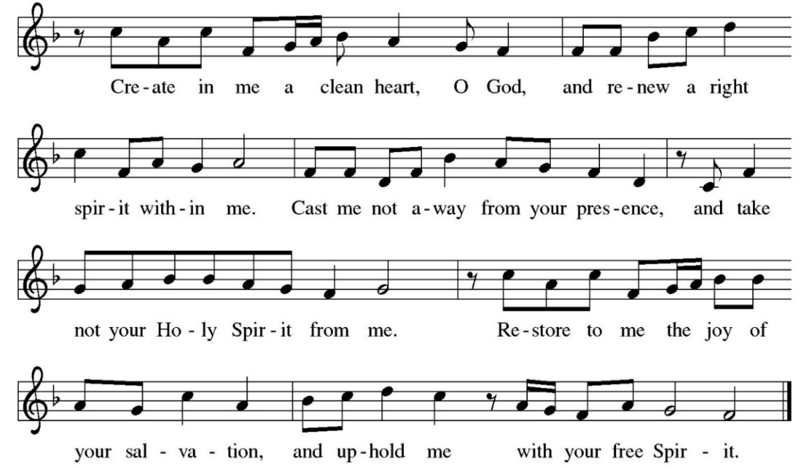

OFFERING PRAYER:
P: Let us pray together: O God, maker of heaven and earth, your steadfast love embraces all creation. You send rain and sunshine to nourish the earth and bring forth its bounty. Through these gifts of bread and wine, draw us into the death and life of your Son, who calls us to bear witness to his saving work We ask this in Jesus’ name. Amen.
COMMUNION LITURGY:
In the night in which he was betrayed, our Lord Jesus took bread, and gave thanks, broke it and gave it to his disciples, saying: take and eat; this is my body, given for you. Do this for the remembrance of me. Again, after supper, he took the cup, gave thanks and gave it for all the drink, saying: this cup is the new covenant in my blood, shed for you and for all people for the forgiveness of sin. Do this for the remembrance of me.
THE LORD’S PRAYER:
Our Father, who art in heaven, hallowed be thy name, thy kingdom come, thy will be done on earth as it is in heaven. Give us this day our daily bread; and forgive us our trespasses, as we forgive those who trespass against us; and lead us not into temptation but deliver us from evil. For thine is the kingdom, and power, and the glory, forever and ever. Amen
INVITATION TO COMMUNION:
P: Come to the table. Feast on God’s goodness and mercy.
Please come down the center aisle, take the bread, then receive a cup (wine is dark, juice is light, return to your seats via side aisle.) Those who prefer to take communion in your pews, we will take all together after all are served.
DISTRIBUTION OF COMMUNION:
P: This is the body of Christ given for you. (All take bread).
P: This is the blood of Christ shed for you. (All take the wine).

COMMUNION HYMN: There is a Balm in the Gilead ELW 614
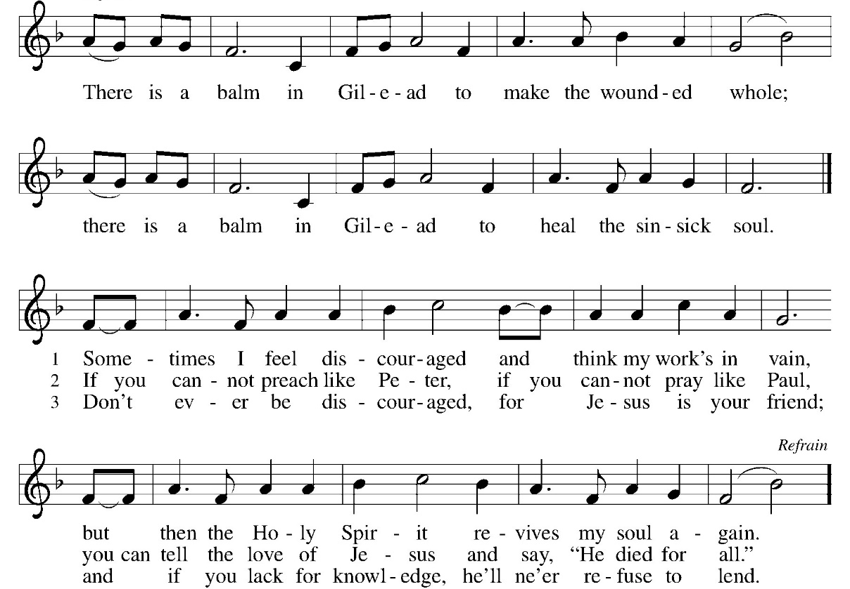
TABLE BLESSING:
P: May the body and blood of our Lord Jesus Christ strengthen you and keep you in God’s grace.
C: Amen.
PRAYER AFTER COMMUNION:
P: God of our salvation, C: we give you thanks for this meal that restores our souls, reconciles us to you, and strengthens us for the journey. Through the body and blood of your Son, may we become Christ’s body in the world, bearing witness to your love for all creation, through Jesus Christ, our Savior and Lord. Amen.
SENDING: God blesses us and sends us in mission to the world.
BLESSING:
P: Receive the blessing of the holy Trinity: God, who calls all things into existence, Jesus Christ, who redeems us, and the Holy Spirit, whose breath sustains creation, ☩ bless you now and always. C: Amen.

SENDING HYMN Be Thou My Vision ELW 793
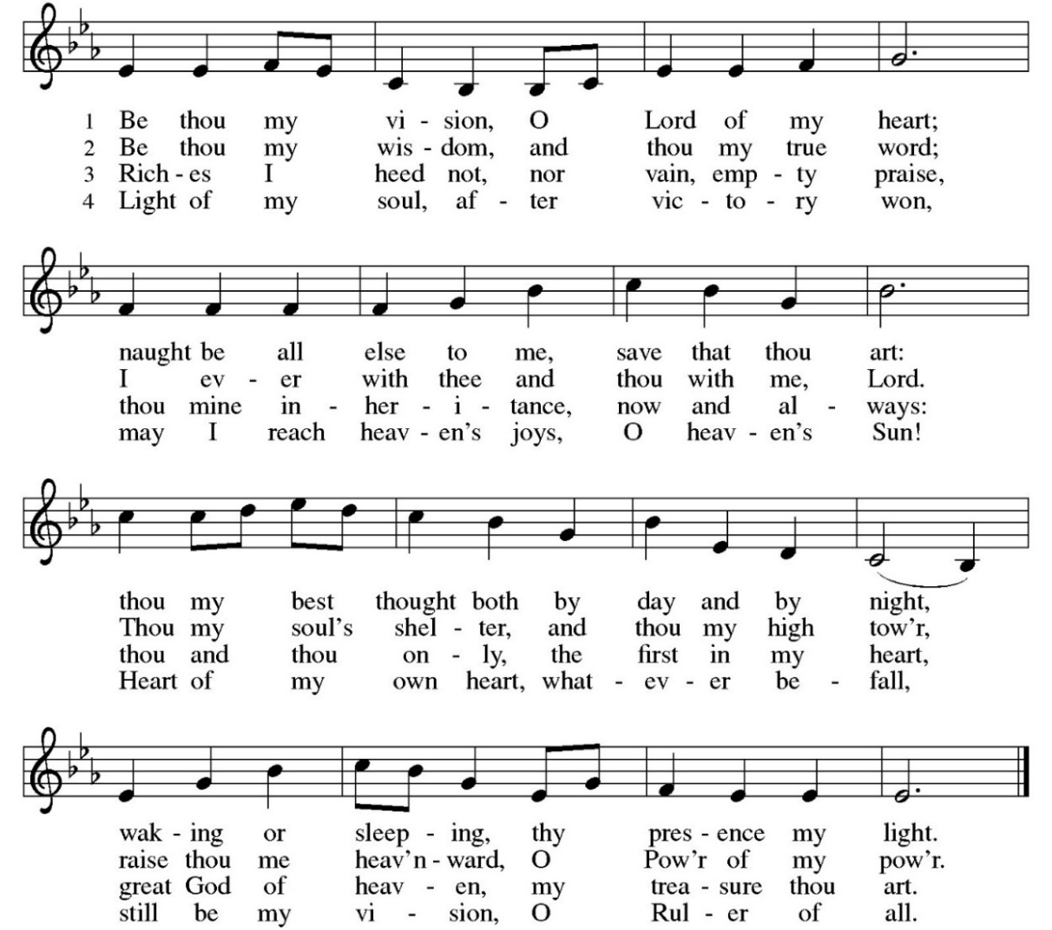
DISMISSAL:
P: Go in peace. Believe the good news.
C: Thanks be to God.
POSTLUDE

ONLINE GIVING: Your gift has a big impact on our ministries and those we serve. Scan this code or visit our website to give online today
IN OUR PRAYERS TODAY: Teresa Hesselbacher, Elaine Schlicting, Darlene and Walt Steffes, Bob Schreck, Delores Wampfler, Marge and Gerald Arnold, Don & Judy Brudi, Pat Lawfer, Nancy Dittmar, Karen Dick, Angie Broshous, Grayson Raab, Lisa Law , James Dieter, Christine Happ, Kay Hesselbacher, Mary Lou Bunker, Lillian Sefford, Cindy Kerchner, Russ Synder, Don Kunz, Johnny Blair, Jim Sullivan, John Becker, Cheri Broge To add someone to the prayer list please contact Pastor Chrissy
Anderson House Birthdays: Betsy’s birthday is April 8 Please mail cards or drop off at Anderson House 200 E King Ave. Stockton, IL 61085 or drop off in basket in the back of the church.
CELEBRATING BIRTHDAYS / ANNIVERSARIES: Tony Jones, Rachel Cook, Colin Dvorak, Tim Larsona, Jeremiah Luke, Randy Menzemer, Emily Curtiss
Thanks be to God for your gifts for the ministry of  Christ Lutheran Church *these numbers do not reflect online giving- only offering in worship |  |  |  | Offering/ Attendance  Sat March 7  Sunday March 8
Current Expense | $1,228.00 | Building Fund | $10.00 | March 7 | 21
Benevolence | $10.00 | Lent | $146.00 | March 8  Sunday School | No Worship
 |  | Total |  | Lent | 24
  $1,394.00
READINGS FOR NEXT WEEK: Ezekiel 37:1-14; Psalm 130; Romans 8:6-11; John 11:1-45
January Totals: As a way to improve communication around finances, we are sharing following information: *these numbers reflect online giving contribution
January
2026
 | January | Year to date
Offerings: | $6,430 | $6,430
Expenses: | $12,667 | $12,667
Overall Gain / Loss | ($6,237) | ($6,237)

ANNOUNCEMENTS
CONSIDERING BECOMING A MEMBER: Have you been attending worship and participating in the life of the church for a while? Have you considered joining and becoming a member of Christ Lutheran Church? It really is easy to transfer your membership or join us. For more information, please talk to Pastor Chrissy. New Member information class Sunday, March 15 11am.
LENTEN WEDNSDAY WORSHIP: A Conversation in the Wilderness
Our Lenten journey in the wilderness is just as Jesus did before he began to heal, teach, and gather his disciples. Jesus withdraws to the wilderness, being led by the Spirit, to be grounded before facing the questions about who he is and who God is. The tempter didn’t ask questions about what is right or wrong but about identity, purpose, and trust. As we journey together this Lenten season, you are invited into our own conversation with Jesus in the wilderness. What voices compete for our attention? What promises tempt us away from our calling as the body of Christ? What does it mean to trust God when the path forward is not an easy one or a clear one? Join us Wednesday evenings at 7 pm.
DONATIONS NEEDED FOR SOUP SUPPER: a sign-up sheet has been placed in the narthex of items needed for dessert. Items need to be in the kitchen by Sunday, March 22nd by noon.

AMAZON WISH LIST: did you know that everyday items used at the church are items you could contribute? Find our list here or on our Facebook page. Thank you!
EASTER LILY ORDERS: Due by March 27, 2026. Forms available in Narthex of church. Money and order form can be turned into Karen Brose or her mailbox. Cost is $16.00
COWORKERS IN THE GOSPEL: Consider being a part of one our leadership teams. As of this month, three teams will be helping connect council and congregation as we work together to do ministry together. Three teams have formed; Worship Team, Building Team and Education Team. If you are interested in being a part of one of the teams, please see Pr Chrissy or someone on the team.
- Worship team leader is Patsy Holland -anyone who is interested in serving in any area of worship, especially baking communion bread, communion set up, serving or clean up.
- The building team will access, and address issues related to the building. Please see Cory Haas, team leader, if you would like to help with the building.
- The Education Team over sees Confirmation, Sunday School and Vacation Bible School. Vacation Bible School is going to happen June 1-5 from 9-11:30. VBS meeting will be held March 8 after worship for those interested in helping. If you would like to be a part of the education team please see Leisa Hubb (team leader)

Upcoming Events
- March 14- 5:30pm Worship with Communion
- March 15- 9:00 am Sunday School
- March 15- 10 am Worship with Communion
- March 15- 11 am New Members Information Class
- March 16- 9 am Quilting
- March 17- 11:30 am Community table
- March 18- 9 am Bible Study
- March 18- 7 pm Midweek Lenten Service
- March 18- 7:30 pm Church Council
- March 21- 8 am Breaking Bread Together
- March 22- 8:30 am Confirmation Class
- March 23- 4:30-7 WELCA Soup Supper
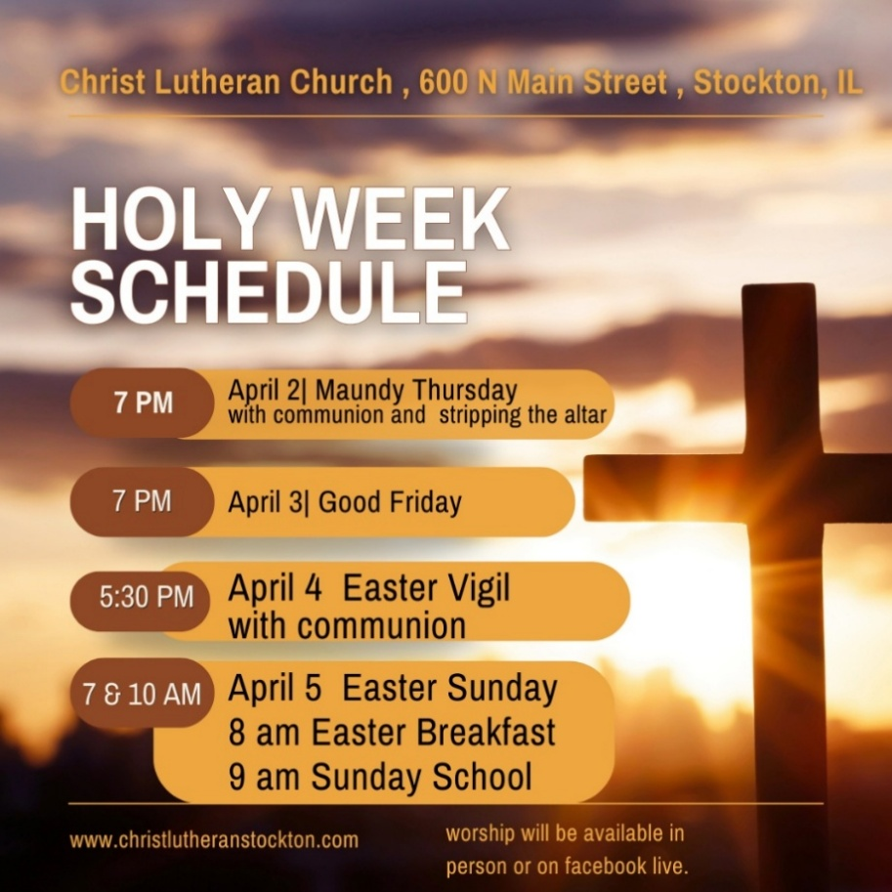
A Blessing for the Baptized (by Meta Herrick Carlson)
This is a blessing
That remembers your baptism
And tells the story
Even if your memory cannot.
It watched a community
Gather around you.
It heard the water poured
And felt the love expand.
This blessing will travel
Every distance with assurance
That baptism’s promise
Does not wear thin over time.
The gift is hardy and sure.
You could not break it if you tried.
Life has a firm grip on you,
Beloved One.
It is more than enough.
And so are you.
