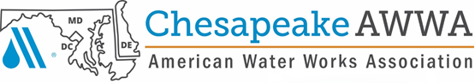

***2021 Tri-Association Conference***

***PRESENTS THE***

**“*Annual Water Taste Test Challenge”***

***At the Roland E Powell Convention Center***

## **4001 Coastal Highway**

## **Ocean City, MD**j0307436

## **September 2, 2021**

## **To Enter Bring only one (1) gallon of water, in a glass container, room temperature please!**

## **ONE entry per category, per treatment plant please.**

## **Label container with facility name and indicate Surface or Ground Water**

## **Samples must be received by 9:00 a.m. for judging**

## **Register now to put your water to the test!**

## **See you in Ocean City. Good luck!**

###### Registration Form for CSAWWA Water Taste Test Challenge

**_______ Surface ______ Ground**

**Water from ______________________________________________________**

***(Name of Facility)***

**Contact Person _______________________________ Phone No**. __________________

Questions or inquiries please contact CSAWWA Public Relations Chair: George Rest, 301-731-1162 (O) or 301-332-7557 (M) or email [george.rest@ramboll.com](mailto:george.rest@obg.com)