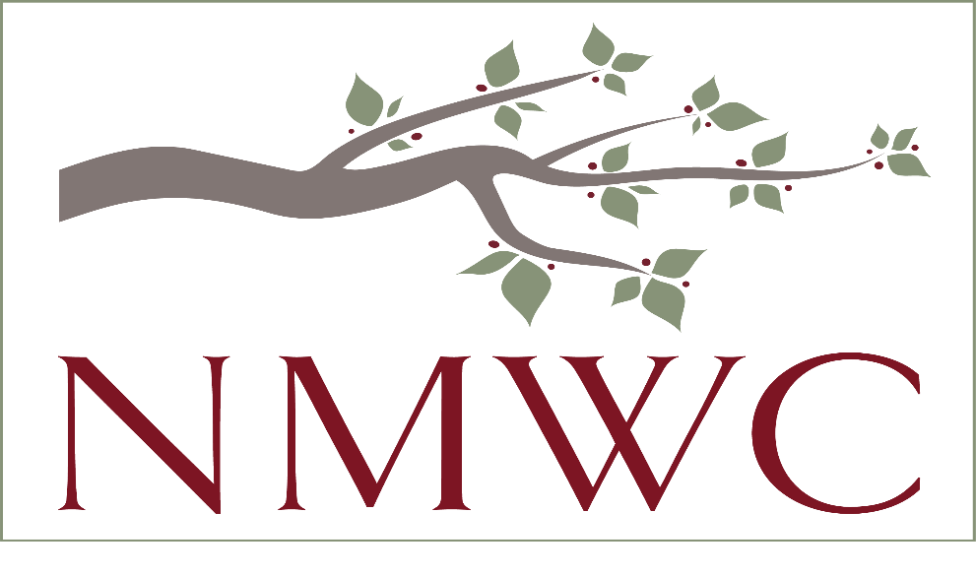

2022-23 NMWC CHARITABLE CONTRIBUTION REQUEST
North Mecklenburg Woman’s Club (NMWC) is organized to bring women together to promote and support social, educational, and civic progress in the community.

2022-23 APPLICATION REQUIREMENTS
Application cycle opens Wednesday, June 1, 2022, and closes Friday, July 15, 2022, at 11:59 pm ET.
Send to: Pam Schneider, charityrequest.nmwc@gmail.com

NMWC proudly announces an opportunity to apply for 2022-23 charitable contributions. NMWC members believe that in creating a better life for people in our communities, we create a better life for each other. NMWC solicits applications from programs and projects which serve women, children, and families in North Mecklenburg and surrounding counties represented by current membership.
To be considered for an award, applicant organizations for which funding is sought must operate in accordance with the NMWC mission of creating a better life for people in our community. Recipients of grants of $5,000 or more will be required to submit a Grant Status Report one year after receiving funds.
Eligibility Criteria
To be eligible for consideration, the following minimum requirements MUST be met:
- 501(c) (3) IRS determination and supporting social, healthcare, educational and civic progress in the community for women, children and families.
- Provide services in North Mecklenburg County and surrounding areas.
- May not discriminate based on race, color, religion, national origin, disability, or any other status protected under law. However, organizations which serve a specific population, (e.g., women) will be considered.
- The ability to demonstrate a significant demand for services and ability to respond.
- All information requested on the summary form and all the required attachments MUST be completed/submitted electronically by July 15, 2022 at 11:59 pm ET or the application will not be considered.
Checklist for Completion of Application
The NMWC application consists of the following components, which MUST be submitted: this checklist is provided to help ensure a complete proposal. If you’re missing a document, please explain why.
- NMWC Grant Summary with Narrative Questions. There is a three-page limit for this narrative using 12-point font.

- Required Attachments:
- Organization’s board approved operating budget for current year
- Project/Program Budget showing how grant requested funds will be used
- Organization’s current year financial statements.
- IRS 501(c)(3) Determination Letter
- Most current 990, 990Z or 990N in addition to most current Audit (if audit available)
- Board of Directors List with positions (include link to board member profiles if available online) and % of board making a financial contribution.
- Optional attachments (up to 2 accepted)
- This could be an annual report, letter of support from a community partner, brochure, reports for other grants, link to a video, etc., that will help us better understand who you serve, why, and how.
• Nondiscrimination Statement adopted by the Board of Directors
• Key Paid Staff (names and titles)
Thank you for your interest in the NMWC. Applicants will be notified of their application status in November 2022. Award dollar decisions based on annual fundraising totals and requested amounts will be made by the Board at their April 2023 meeting. Monies will be disbursed from the NMWC Treasurer to approved charities in May 2023.

