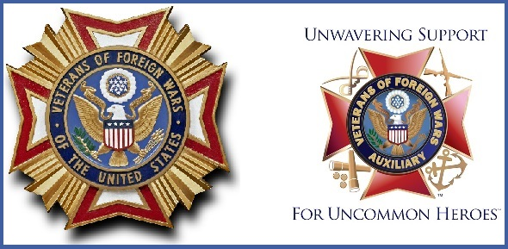
VFW POST 445 and AUXILIARY
September 2018 Newsletter

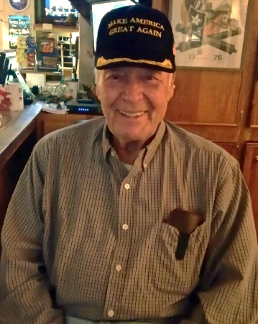
COMMANDER’S COMMENT
Comrades, Auxiliary and Supporters
There are several significant events in the month of September that we will be recognizing here in the Post. At our regular Membership meeting will be held at 7:00 pm on September 11 with a brief ceremony honoring those Americans whose lives were lost in a terrorist attack on the World Trade Center in New York. We will observe the 119th anniversary of the Veterans of Foreign Wars of the United States of America on September 28 at a special Dinner. Your participation at both events would be welcome. We are seeking participants in our annual Voice of Democracy and Patriots Pen contests Vice Commanders have applications and information for these programs please help if you can. We are continuing our search for new members as always, but we need to retain our current members and that means renewal of annual members if your anniversary is approaching we will be dropping a reminder in the mail. Comrades I am initiating a drive to promote Life Membership by introducing a drawing following our Membership Meetings the member whose number is called and is attending will be presented with a Life Membership or if that member is already a Life Member he or she will receive A Bronze Legacy Membership.
God Bless America and the VFW - Jim
MADAM PRESIDENT’S COMMENTS:
First of all, I would like to thank all of my officers and members for helping me in every way they could for the last two months to make our Auxiliary successful. Great job everyone - without you, I couldn’t have made it. Keep up the great work!
Just to let everyone know, our Auxiliary member Dennis Lemon is well on the way to recovery, but still has a ways to go. Thank you for all the support and prayers for him. Keep up the great progress, Dennis. We miss you! The fundraiser for him was a great turnout. Thanks to everyone who supported it.
Now – time to thank Kristen Halvorson for her great Sloppy Joe dinner night on August 12. Yummy! Danny Geer, your tater tots were delicious. Thanks to Angel for making the coleslaw and all her help with serving up the plates. Thanks to everyone who made it happen and a very good night for us!
Danny Geer and Montana have volunteered to make the Frogmore Stew for our dinner on September 21 and Barbara Barger has offered to prepare her delicious chopped salad.
Please remember to stop by the Post to buy your raffle tickets for the 55” TV drawing at our dinner on September 21. The bartender on duty has an envelope containing the tickets.
October 19 will be our next dinner night with ham and potluck dishes made by all that bring a dish. Please come out and support our Auxiliary dinners. I appreciate it so much.
As you all know, we had our District One President Donna Maria King at our August 9 Auxiliary meeting. Her visit was great and we enjoyed getting to know her following our meeting with snacks prepared by our Auxiliary members. Thank you, Madam President, for your visit. It was nice meeting you again. Thanks to all for the great attendance to welcome her.
Our annual Blood Drive in honor of Eileen Hadbavny will be held at the Post on October 6 from 9 a.m. to 2 p.m. Free donuts will be available in the morning followed by hot dogs at noon. Make your appointment by visiting www.redcrossblood.org and use sponsor code: VFW445, sign up on the sheet at the Post or call Tamme Suggs at 843-224-1039. Please spread the word so that we can have a successful drive.
Let’s continue to do what we’re here for – to support our Veterans and make our Post and Auxiliary one to be proud of. Many thanks to John Coy our Post Adjutant for all his help, especially getting our word out through the newsletter and Facebook posts.
God Bless you, our Military Past, Present and Future, and God Bless the United States of America!
Madam President
Joyce Simmons

