The Wilmington Sons & Daughters of Italy
&
Winchester Ladies Lodge
proudly present an Italian Heritage Dinner Show, featuring entertainer Luciano Sandro Russo

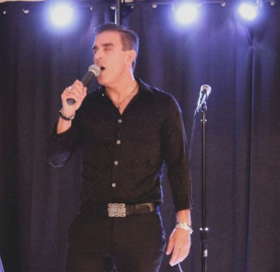

Saturday, October 11, 2025

Winchester Sons of Italy Hall
117 Swanton St., Winchester

Doors open 6:30 PM * Show begins 7:00 PM
family style Dinner served 7:30 PM
Cash bar
ticket price $60
For ticket info, call (978) 604-6437

**No tickets will be sold at door**

