5/24/2017 The Woman and the Eagle

The Woman Clothed with the Sun

Revelation chapter 12 tells us of a woman clothed with the sun who gives birth to a male child who will rule the earth with a rod of iron. After giving birth the woman is the given two wings of a great eagle to flee into the wilderness.

The Cherubim with Four Faces

About 2600 years ago the prophet Ezekiel was given a vision of angelic beings, each one have 4 faces.

Ezekiel 1:1 Now it came to pass in the thirtieth year, in the fourth month, in the fifth day of the month, as I was among the captives by the river of Chebar, that the heavens were opened, and I saw visions of Elohim.
2 In the fifth day of the month, which was the fifth year of king Jehoiachin’s captivity,
3 The word of YaHuWaH came expressly unto Ezekiel the priest, the son of Buzi, in the land of the Chaldeans by the river Chebar; and the hand of YaHuWaH was there upon him.
4 And I looked, and, behold, a whirlwind came out of the north, a great cloud, and a fire infolding itself, and a brightness was about it, and out of the midst thereof as the color of amber, out of the midst of the fire.
5 Also out of the midst thereof came the likeness of four living creatures. And this was their appearance; they had the likeness of a man.
6 And every one had four faces, and every one had four wings.
7 And their feet were straight feet; and the sole of their feet was like the sole of a calf’s foot: and they sparkled like the color of burnished brass.
8 And they had the hands of a man under their wings on their four sides; and they four had their faces and their wings.
9 Their wings were joined one to another; they turned not when they went; they went every one straight forward.
10 As for the likeness of their faces, they four had the face of a man, and the face of a lion, on the right side: and they four had the face of an ox on the left side; they four also had the face of an eagle.

The Cherubim Symbolism Embedded in the Heavens

The four faced cherubim of Ezekiel's vision have a counterpart in the heavens. Indeed, Ezekiel's vision may have been designed to be symbolic of living beings who can 'fly' through the heavens. The wings of the Cherubim denote the ability to fly through the air, but we know that there is no air 200 miles and further above the surface of the earth. The wings of a Cherub would not be needed to physically fly through space, or other dimensions beyond space-time. But the wings would impart a sense of the ability to fly to the mind of the person seeing the vision. In other words, Ezekiel was being shown an image that would be self explanatory without a word being said, an image that he could comprehend with the relatively limited scientific knowledge of his day.

Although the people of Ezekiel's time didn't know that air didn't extend from the earth to the stars, they did have knowledge of the Lion, the Ox, the Eagle, and the Man in the heavens.

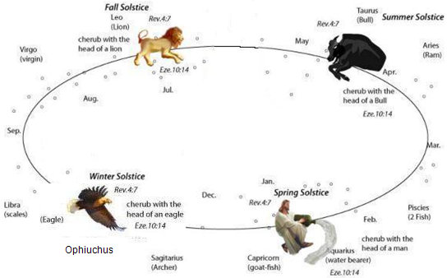
Above: The Lion, the Ox, the Eagle, and the Man in the heavens.

In one of Ezekiel's visions of the Cherubim, there was platform above the heads of the Cherubim with the figure of a man seated on a throne on the platform.

The information transferred to Ezekiel by the symbolism in the vision was that of YaHuWaH Elohim seated on a throne, separated (SET APART), from the universe, on a platform above the stars in the universe.

Ezekiel 1:26 And above the firmament that was over their heads was the likeness of a throne, as the appearance of a sapphire stone: and upon the likeness of the throne was the likeness as the appearance of a man above upon it.
27 And I saw as the color of amber, as the appearance of fire round about within it, from the appearance of his loins even upward, and from the appearance of his loins even downward, I saw as it were the appearance of fire, and it had brightness round about.
28 As the appearance of the bow that is in the cloud in the day of rain, so was the appearance of the brightness round about. This was the appearance of the likeness of the glory of YaHuWaH . And when I saw it, I fell upon my face, and I heard a voice of one that spake.
Ezekiel 2:1 And He said unto me, Son of man, stand upon thy feet, and I will speak unto thee.

The Beasts of Revelation Chapter 4

The Apostle John was taken into heaven and given visions of the throne of YaHuWaH Elohim and beasts and beings that surrounded the throne.

Revelation 4:6 And before the throne there was a sea of glass like unto crystal: and in the midst of the throne, and round about the throne, were four beasts full of eyes before and behind.
7 And the first beast was like a lion, and the second beast like a calf, and the third beast had a face as a man, and the fourth beast was like a flying eagle.

The four beasts in Revelation 4:7 above are the same types mentioned in Ezekiel's vision, the difference being that they are individual beasts in John's vision, not each individual being having four faces as in Ezekiel's vision. The symbolism being transferred to the seer in both Ezekiel's vision and John's vision are similar.

The Lion is the Lamb

Revelation 5:1 And I saw in the right hand of him that sat on the throne a book written within and on the backside, sealed with seven seals.
2 And I saw a strong angel proclaiming with a loud voice, Who is worthy to open the book, and to loose the seals thereof?
3 And no man in heaven, nor in earth, neither under the earth, was able to open the book, neither to look thereon.
4 And I wept much, because no man was found worthy to open and to read the book, neither to look thereon.
5 And one of the elders saith unto me, Weep not: behold, the Lion of the tribe of Judah, the Root of David, hath prevailed to open the book, and to loose the seven seals thereof.
6 And I beheld, and, lo, in the midst of the throne and of the four beasts, and in the midst of the elders, stood a Lamb as it had been slain, having seven horns and seven eyes, which are the seven Spirits of Elohim sent forth into all the earth.
7 And He came and took the book out of the right hand of Him that sat upon the throne.
8 And when He had taken the book, the four beasts and four and twenty elders fell down before the Lamb, having every one of them harps, and golden vials full of odours, which are the prayers of saints.
9 And they sung a new song, saying, Thou art worthy to take the book, and to open the seals thereof: for thou wast slain, and hast redeemed us to Elohim by thy blood out of every kindred, and tongue, and people, and nation;
10 And hast made us unto our Elohim kings and priests: and we shall reign on the earth.

Note that there is a symbolic "Lamb" in the heavens, the constellation Aires the ram, and also a Lion, the constellation Leo which signifies YaHuShua Messiah.

The Talking Beasts of Heaven

The beasts of the heavens invite John to "Come and see" when the seals are opened by the Lamb.

Revelation 6:1 And I saw when the Lamb opened one of the seals, and I heard, as it were the noise of thunder, one of the four beasts saying, Come and see.
2 And I saw, and behold a white horse: and he that sat on him had a bow; and a crown was given unto him: and he went forth conquering, and to conquer.
3 And when He had opened the second seal, I heard the second beast say, Come and see.
4 And there went out another horse that was red: and power was given to him that sat thereon to take peace from the earth, and that they should kill one another: and there was given unto him a great sword.
5 And when He had opened the third seal, I heard the third beast say, Come and see. And I beheld, and lo a black horse; and he that sat on him had a pair of balances in his hand.
6 And I heard a voice in the midst of the four beasts say, A measure of wheat for a penny, and three measures of barley for a penny; and see thou hurt not the oil and the wine.
7 And when He had opened the fourth seal, I heard the voice of the fourth beast say, Come and see.
8 And I looked, and behold a pale horse: and his name that sat on him was Death, and Hell followed with him. And power was given unto them over the fourth part of the earth, to kill with sword, and with hunger, and with death, and with the beasts of the earth.

The Lion Says "Come and See"

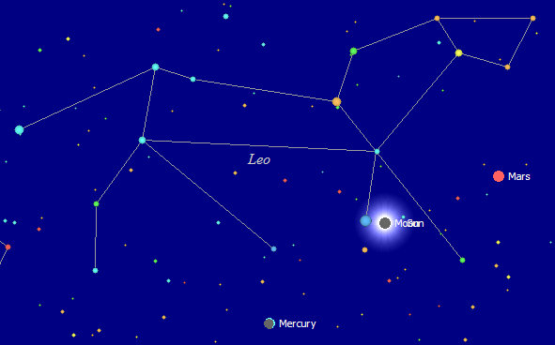

This is what the observers of the total solar eclipse of 8/21/2017 will see when it paints a stripe across the United States. The symbolism is self explanatory.

The 153 Fish

A special total solar eclipse occurred on 3/20/2015 that astronomers called a "once in 100,000 year eclipse". It ended precisely at the North Pole and on the Springtime equinox. To an observer standing at the North Pole, the eclipse ended precisely at 153 degrees local meridian and about 10 seconds later the 0 degree local meridian passed precisely over Regulus, the King Star symbolic of Israel's King, in the constellation of Leo symbolic of Israel's Messiah, the lion in the heavens. A quantity of 153 great fish is mentioned in John chapter 21.

The JoyBySurprise.com webpage on the 153 fish is here: http://www.joybysurprise.com/the-153-fish.html

The number 153 was commonly used in ancient Greek mathematics to denote the ratio of 265/153 which closely resolves the value of the mathematical cube root 1.732. The ratio was derived by using geometry and intersecting two identical circles in a certain way that looked like a fish symbol.

The number 153 became commonly identified in Greek culture with a fish, which then became identified with Christianity.

Well, the number 153 just happens to show up in the once in 100,000 years total solar eclipse of 3/20/2015 through the actions of our Creator Elohim, with the 0 degree local meridian being in the constellation Leo at the same time. The Lion in the heavens is saying to us "come and see".

The Woman Clothed with the Sun

On 9/23/2017 there will be a sign in the heavens known as The Woman Clothed with the Sun. It's a sign mentioned in Revelation chapter 12. The woman gives birth to a male child who will rule all nations with a rod of iron.

It happens that there are exactly 918 days from the total solar eclipse of 3/20/2015 to the sign of the Sun Clothed Woman on 9/23/2017. The number 918 happens to be exactly 6 x 153.

6 X 153

The number 153 is a special number in more ways than one. It is known as the 17th triangular number. If we make a triangle with 17 balls on each side, exactly 153 balls will completely fill the equilateral triangle.

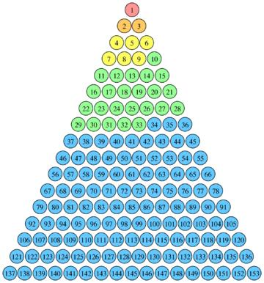

Above: 153 balls precisely fill a triangle with 17 balls on each side.

The 918 Days, 6 Sets of 153

If we want to represent the 918 days from 3/20/2015 to 9/23/2107, we will need 6 of the 153 "day" equilateral triangles.

Below: For several years I have been looking for the 7th set of 153 days, but have been unable to find it. It might be that there is no 7th set. This arrangement was given to me by YaHuWaH Elohim on 5/22/2017. We can arrange the six, 153 day triangles, symmetrically like this:

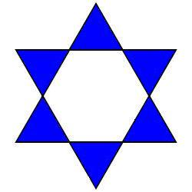
Above: A mathematical and geometrical representation of 6 x 153 days = 918 days

The Eagle Says "Come and See"

Below: Here's the position of the planet Saturn from 3/20/2015 to 9/23/2017 in the ancient constellation of the Eagle now known as Scorpio and Ophiuchus.

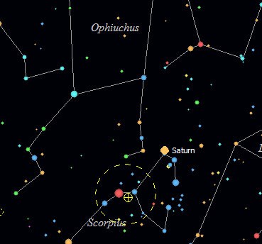
Above: Saturn's position in the Eagle constellation on 3/20/2015.

Below: Saturn's position in the Eagle constellation at the end of 6 x 153 days on 9/23/2017.

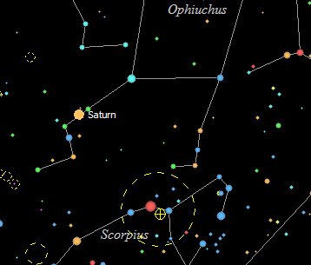
Above: Saturn's position in the Eagle on 9/23/2017
The Eagle Says "Come and See"

The planet Saturn is located within the ancient Eagle constellation during the entire 918 days from 3/20/2015 to 9/23/2017. We can accept the Eagle's invitation to "come and see".

Scientists were very surprised when they saw the first picture of Saturn's North Pole region, and wondered how the storm could exist in the form of a perfect hexagon. Some think the storm might exist for centuries more.

In 1981 a Voyager spacecraft sent the very first pictures of Saturn's North Pole.

Remember that 1981 began the 2520th year from the Handwriting on the Wall in ancient Babylon on 10/11/539 BC. The number 2520 is 70 x 36, with 36 being the number of gods recorded on the Babylonian Magic Square, whose numbers added up to 666.

1981 was the 36th anniversary year from the first atomic test of the Manhattan Project on 7/16/1945 that established the United States as the global superpower Babylon the great. 1981 was also the 36th year from the conception of Presidents Bill Clinton, George W. Bush, and Donald Trump, all conceived in 1945.

A later Cassini spacecraft sent this picture of Saturn's North Pole before being the first man made object to enter interstellar space on 8/25/2012.

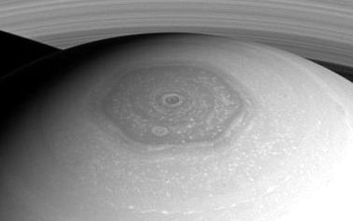
Above: The odd hexagonal storm at Saturn's north pole.
Photo courtesy NASA/JPL-Caltech/Space Science Institute

Summary

1. The 6 x 153 days = 918 days from 3/20/2015 to 9/23/2017 were completely filled by the 6 blue triangles above.

2. The Hexagonal storm on the planet Saturn, shown to us by the heavenly ancient Eagle constellation from 3/20/2015 to 9/23/2017, completes the geometrical figure formed by the 6 triangles.

Below: The two witnesses above identify the woman.



The two blue stripes on the flag above come from the command to have a thread of blue in the fringe, tzit-tzit, of our garment in order to help us to remember to keep the commandments of our heavenly Father, YaHuWaH Elohim. People were healed when they touched the tzit-tzit (hem) of YaHuShua's garment.

Revelation 12:12 Therefore rejoice, ye heavens, and ye that dwell in them. Woe to the inhabiters of the earth and of the sea! for the devil is come down unto you, having great wrath, because he knoweth that he hath but a short time.
13 And when the dragon saw that he was cast unto the earth, he persecuted the woman which brought forth the man child.
14 And to the woman were given two wings of a great eagle, that she might fly into the wilderness, into her place, where she is nourished for a time, and times, and half a time, from the face of the serpent.
15 And the serpent cast out of his mouth water as a flood after the woman, that he might cause her to be carried away of the flood.
16 And the earth helped the woman, and the earth opened her mouth, and swallowed up the flood which the dragon cast out of his mouth.
17 And the dragon was wroth with the woman, and went to make war with the remnant of her seed, which keep the commandments of Elohim, and have the testimony of YaHuShua Moshiach.

