.
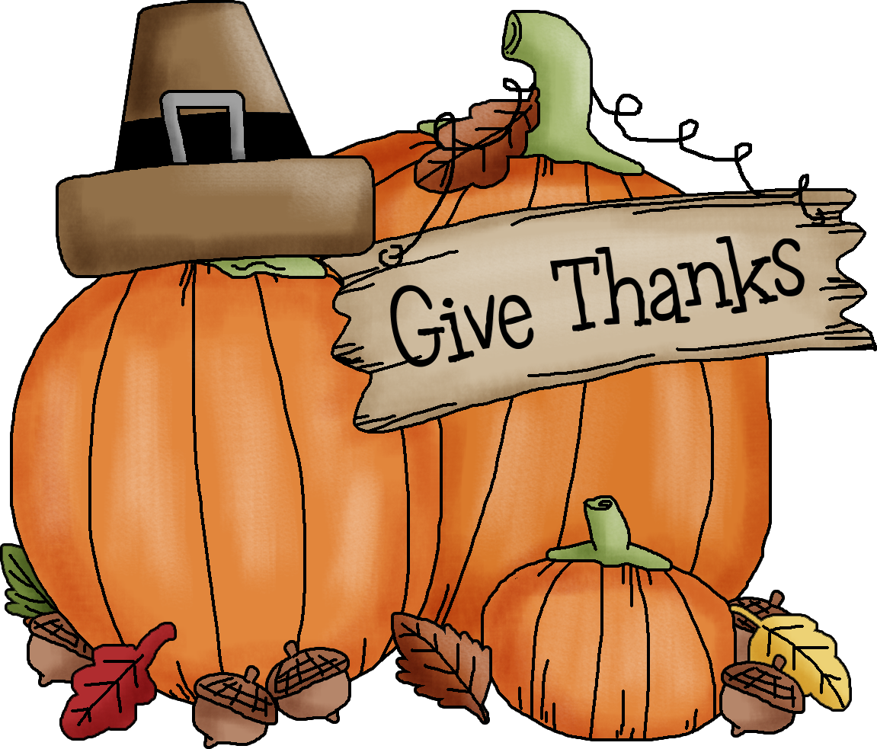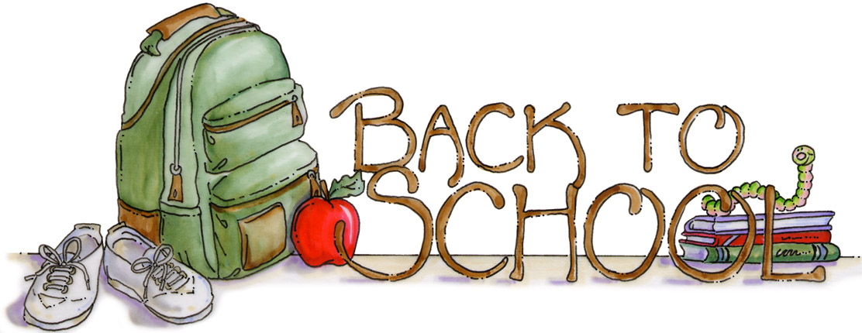  This Photo by Unknown Author is licensed under CC BY-NC-ND  This Photo by Unknown Author is licensed under CC BY-NC-ND  This Photo by Unknown Author is licensed under CC BY-NC-ND | December 2020
Sun. | Mon. | Tue. | Wed. | Thu. | Fri. | Sat.
 |  | 1 | 2 | 3 | 4 | 5
Week 10:  Being Safe |  | Taking a Walk, In a Car & Wheel Safety,  Introduce Pp,  Goldilocks & the Three Bears | Tub, Shower & Pool Safety,  List Pp Words, ASL Pp,  Goldilocks Story | Review Fire Safety, Introduce Stranger Safety, Introduce Final p,  Review a,b,n,p,s,t | Review Safety,  Review Aa, Ss, Pp,  Introduce Positional Words
6 | 7 | 8 | 9 | 10 | 11 | 12
Week 11:  Observing Weather | Introduce Weather,  Introduce I,  Who Likes the Rain | How Clouds are Formed,  Introduce Ll,  Cloud Experiments | Weather Cause & Effect,  List Ll Words, ASL Ll,  Rain,  Create Weather Patterns | Will the Wind Blow it Graph,  Introduce Final I,  Introduce Thermometers | Weather Riddles,  Match Initial Sounds,  Positional Words
13 | 14 | 15 | 16 | 17 | 18 | 19
Winter | Footprints in the Snow,  Winter Windows,  Marshmallow Math | Frozen Noses,  Shaving Cream Snow,  What Keeps Animals Warm | In the Snow,  Indoor Ice-Skating,  Snowman Number Matching | Snow Ice Melting Chart,  Cottonball Igloo | Snowballs,  Counting Snowballs,  Christmas Party  9:30 AM
20 | 21 | 22 | 23 | 24 | 25 | 26
Christmas Break | Christmas Book,  Make & Decorate a Christmas Tree | Christmas Book,  Make & Decorate an Ornament | Christmas Book,  Make & Decorate a Present | Closed  Merry Christmas | Closed  Merry Christmas
27 | 28 | 29 | 30 | 31
Winter Break | Teacher Choice | Teacher Choice | Teacher Choice | Teacher Choice

