NJ Motor Vehicle Commission Standard Statement
for Operators of a Motor Vehicle
N.J.S.A. 39:4-50.2(e) - Effective July 1, 2012
Below are written and spoken versions of the DUI statement made available in the ten languages in which the NJ Motor Vehicle Commission provides the driver's license test.
Language |  | Written Text  (pdf) |  | Spoken Audio  (mp3)
Arabic |  | Arabic Text |  | 1. Standard Statement  2. Additional Statement
Chinese | 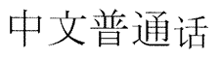 | Chinese Text |  | 1. Standard Statement  2. Additional Statement
English | 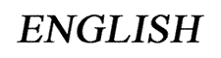 | English Text |  | 1. Standard Statement  2. Additional Statement
French | 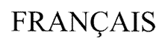 | French Text |  | 1. Standard Statement  2. Additional Statement
Japanese |  | Japanese Text |  | 1. Standard Statement  2. Additional Statement
Korean |  | Korean Text |  | 1. Standard Statement  2. Additional Statement
Polish | 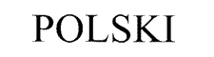 | Polish Text |  | 1. Standard Statement  2. Additional Statement
Portugese | 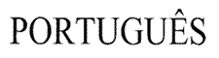 | Portugese Text |  | 1. Standard Statement  2. Additional Statement
Russian | 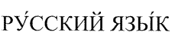 | Russian Text |  | 1. Standard Statement  2. Additional Statement
Spanish | 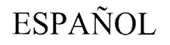 | Spanish Text |  | 1. Standard Statement  2. Additional Statement
Language |  | Written Text  (pdf) |  | Video  (mp4)
ASL | 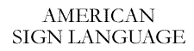 | English Text |  | 1. Standard Statement  2. Additional Statement

