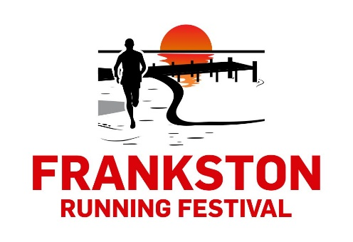
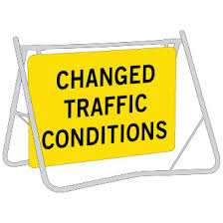
PUBLIC NOTICE: IMPORTANT INFORMATION
RUN EVENT IN FRANKSTON

When: Sunday 16 November 2025
What: Frankston Running Festival www.runthepen.com.au
As a result there will be:
- Approximately 2000+ athletes, supporters, family and friends in the area over this weekend
- Partial Road Closure of NEPEAN HWY northbound lane from Peir Promenade to Fletcher St, Frankston.
- Full Closure of NEPEAN HWY Northbound Lane only from Fletcher St Frankston to 697 Nepean Hwy, Carrum.
- We have worked closely with the Frankston City Council, VicRoads and our Traffic Management company (Miepol) to make sure there is as little impact to local residents as possible.
THE EVENT
The Frankston Running Festival will attract participants from all over Australia (+international visitors) and consists of a 5km Run/Walk, 10km Run, 15km and a Kids 1km Dash distances. This event will deliver a major economic benefit to the area and we are excited to be able to share this with the Frankston local community. Detailed maps and information can be viewed on the website www.runthepen.com.au
ROAD CLOSURES
Nepean HWY Southbound traffic will not be affected during this time other than a reduced speed zone.
NEPEAN HWY Northbound traffic changes
Stage 1 – NEPEAN HWY (Peir Promenade to Fletcher St, Frankston) NORTHBOUND only - Two lanes will be closed for runners and one lane open for local traffic from approx. 6:30am – 8:30am.
Stage 2 – NEPEAN HWY (Fletcher St, Frankston to 694 Nepean Hwy, Carrum) all Northbound lanes closed from approx. 6:30am – 9:30am

ACCESS IN AND OUT OF YOUR PROPERTY
Full Access in and out of all properties via the Nepean Hwy will be maintained during the event. All side roads will remain open and traffic controllers will be in place along the closure to assist you.

Please note : Residents along Nepean Hwy (Fletcher St to 694 Nepean Hwy, Carrum) only, you will only be able to turn left via your property onto Nepean Hwy during the event. To re-enter your property during these closure times you must turn onto Nepean Hwy via a northern street/road and turn left onto Nepean Hwy and head South to your property entrance.

Traffic controllers and volunteers will be present at all times to assist pedestrians and residents if and when required.

SHOW YOUR SUPPORT!
We encourage local residents and businesses to show their support to participants, so join us at Frankston Foreshore and along the course and cheer on participants as they complete this fun run.
MARSHALL OPPORTUNITIES
Want to get involved in our event? We are searching for vibrant, enthusiastic, friendly people to join our Volunteer Crew. No experience required. To find out more please contact us at info@eventpeople.com.au.
We thank you in advance for your cooperation and apologise for any inconvenience caused during this time. If you have any concerns about the traffic management or the event, please contact us: 0359884040 or info@eventpeople.com.au
Event People

