11/18/2016 Secrets Kept and Revealed and 1 Million Days from 721 BC

Topic 1

Governments have secrets.

When all enemies have been done away with, there will be no more need for secrets.

Fifty years ago, as a young man in the United States Air Force, I was stationed in a Middle Eastern country, having been awarded a Top Secret Cryptographic Cryptologic security clearance by the United States government. I held a position of trust, allowed to know only what I needed to know to accomplish my job, and cautioned not to divulge the secrets that I had been entrusted with on pain of death. Thousands upon thousands of men and women have shared my experience. I'm sure they wonder, as I do, as to why the apparent high level government security breaches are now manifest.

About a month ago, Benjamin Baruch, mentioned further below, sent an email from an undisclosed source that said that Hillary Clinton had sold above Top Secret computer software to some foreign governments via the Clinton Foundation. The above top secret software would allow the recipient foreign governments, most of whom were Islamic, to look into the most sensitive of our government's documents. The email also said that Bill Clinton would probably not live much longer. Thousands of us who have been entrusted with secrets, and threatened with death by our own government at our discharge from duty, are quietly waiting.

The Secrets of YaHuWaH Elohim

Unshared Secrets

Matthew 24:36 But of that day and hour knoweth no man, no, not the angels of heaven, but My Father only.
37 But as the days of Noe were, so shall also the coming of the Son of man be.

Shared Secrets

Psalms 25:14 The secret of YaHuWaH is with them that fear Him; and He will shew them His covenant.

Samson (Hebrew - Shimshon) had secrets regarding the anointing that rested upon him. When he revealed those secrets to Delilah, his enemies were able to remove his anointing (for a while).

Delayed Secrets

Over 2,500 years ago an angelic being told the prophet Daniel to seal up the words of the book Daniel was writing. Daniel was told that in the latter days the words would be understood.

Daniel didn't understand the information that was being given to him by the angelic messenger. Daniel didn't need to know. What Daniel needed to do was to write down the information that was being given to him in a book that would be read thousands of years later by those people in the latter days who would be in a position to need that information.

Daniel 12:8 And I heard, but I understood not: then said I, O my Lord, what shall be the end of these things?
9 And he said, Go thy way, Daniel: for the words are closed up and sealed till the time of the end.

Revelations

In the book of the Revelation of YAHUSHUA Messiah, we see revealed the judgments that are to be administered upon the earth by angelic beings. It is the Lamb of YaHuWaH Elohim, YAHUSHUA our Messiah, who has been found worthy to open the seals of the book. When He opens the seals, judgment begins.

The book of Revelation is a book of revealing, but there are still some unrevealed secrets in the book of Revelation.

Revelation 10:1 And I saw another mighty angel come down from heaven, clothed with a cloud: and a rainbow was upon his head, and his face was as it were the sun, and his feet as pillars of fire:
2 And he had in his hand a little book open: and he set his right foot upon the sea, and his left foot on the earth,
3 And cried with a loud voice, as when a lion roareth: and when he had cried, seven thunders uttered their voices.
4 And when the seven thunders had uttered their voices, I was about to write: and I heard a voice from heaven saying unto me, Seal up those things which the seven thunders uttered, and write them not.
5 And the angel which I saw stand upon the sea and upon the earth lifted up his hand to heaven,
6 And sware by him that liveth for ever and ever, who created heaven, and the things that therein are, and the earth, and the things that therein are, and the sea, and the things which are therein, that there should be time no longer:
7 But in the days of the voice of the seventh angel, when he shall begin to sound, the mystery of YaHuWaH should be finished, as He hath declared to His servants the prophets.

Topic 2

Transportation in the Kingdom of Heaven - Accounts of Translations

The account of Philip's translation:

Acts 8:38 And he commanded the chariot to stand still: and they went down both into the water, both Philip and the eunuch; and he baptized him.
39 And when they were come up out of the water, the Spirit of YaHuWaH caught away Philip, that the eunuch saw him no more: and he went on his way rejoicing.
40 But Philip was found at Azotus: and passing through he preached in all the cities, till he came to Caesarea.

The account of author Benjamin Baruch's translation related to me in our phone conversation in 2015:

Benjamin Baruch was hopelessly lost, walking on the back roads of Israel east of Tel Aviv, Israel, trying to find the house where he was to meet with some friends. The time for the meeting came. Benjamin prayed. Immediately he found himself on a porch, at the door of the house he needed to be at, right on time.

My translation on October 4, 1986:

I was translated part way up Illinois mountain while working as a Chief Engineer for TBN, the Christian Trinity Broadcasting Network. The television transmitter had gone off the air and I had to repair it. The TV station returned to the air at exactly 2:00 PM, precisely to the second, and the start of Pastor Chuck Smith's Calvary Chapel program from Costa Mesa, California. If I had not been translated part way up the mountain, the transmitter would have been returned to the air after the start of the program. Without my being translated, whoever needed that particular message at 2 PM that day would have missed it because the station would have still been off the air. As with Benjamin Baruch, my translation experience was instantaneous and painless.

Interestingly, Benjamin Baruch said that Chuck Smith's Calvary Chapel was his home church when he was first saved. Benjamin also told of having a prayer meeting with friends begin at 1 AM and after 5 minutes it was 7AM. These time shifting experiences are the norm in the presence of angelic beings and UFOs.

A more complete account of my translation experience is available in the article dated 04/20/2015 - Quantum Tunneling on this page http://www.joybysurprise.com/Articles.html

Topic 3

The End of the Dispersion

The ten northern tribes of Israel were dispersed by the Assyrians in about 721 BC. The dispersal had a time limit of 7 x 390 years = 2730 years. If we add 2730 years to 721 BC we arrive at the year 2010.

Here are some links to accurate BC to AD date calculators: http://keisan.casio.com/exec/system/1247118517 and http://keisan.casio.com/exec/system/1247127342

The Odd Events of 2010

Some strange things began to happen in 2010. Here's a partial list:

1/06/2010 - A strange "X" comet was discovered, Comet P/2010 A2 LINEAR
1/12/2010 - Haiti Earthquake, over 230,000 deaths
Early 2010 - Millions of Camels, Goats, Sheep, Cows, Yaks, and Horses die in Mongolia
3/23/2010- Obama Signs Obamacare into Law. It contains a provision for patient medical records tracking (RFID) devices.
12/2010 - 83,000 Drum fish dead along the Arkansas river
12/31/2010 - Just before midnight 3,000 to 5,000 Red Winged Blackbirds fall from the sky in Beebe, Arkansas
12/28/2010 to 1/3/2011 - 100 tons of dead fish wash ashore on the Brazil coast.
1/05/2011 - Hundreds of Turtle Doves found dead at Faenza, Italy.
1/8-9/2011 - 100 dead birds in one cluster in California, thousands of dead fish in Chicago harbor.
1/14/2011 - 200 cows found dead in a field in Stockton, Wisconsin
3/11/2011 - Great East Japan 9.0 earthquake and Tsunami spilling nuclear radiation into the ocean

The Fullness of Days

The quantity 10 in the bible denotes complete completeness. Multiples of 10 indicate more complete completeness.
If we add 1,000,000 days to 721 BC via the second date calculator mentioned above we arrive at late 2017 and most of 2018, depending on the starting date in 721 BC.
The fullness of the completion of the dispersal of the 10 northern tribes of Israel should begin arriving in late 2017.

Some Other Biblical Signs of 2017

A total solar eclipse revealing the King Star Regulus will cross the United States from northwest to southeast on 8/21/2017. Exactly 2422 days later another solar eclipse on 4/8/2024 marking Aviv 1 will cross the United States from southwest to northeast. These two solar eclipses will paint a "X", an ancient Paleo Hebrew "Tav" or "end mark", on the United States. They are part of a series of "Tavs" ordained to be placed upon the earth at this time by our Creator Elohim. Info: http://www.joybysurprise.com/The_Four_Tavs.html
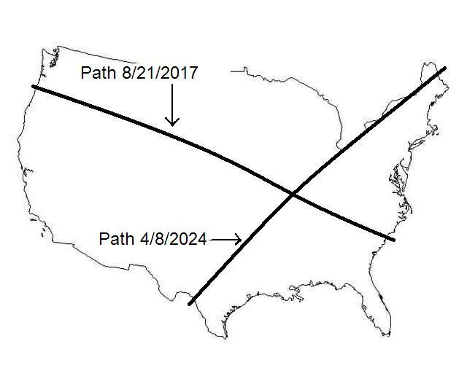

The sign of the Woman Clothed with the Sun of Revelation chapter 12 will occur on 9/23/2017. The man-child who will rule the nations with a rod of iron will be born at that time. The man-child will be taken (symbolically?) to the throne of YaHuWaH Elohim in heaven for dedication in the Temple about 40 days after 9/23/2017, at the completion of the cleansing of the woman according to Torah. http://www.joybysurprise.com/The_Sun_Clothed_Woman.html

The sign of the great red dragon will accompany the birth of the man-child. Perhaps there will be a comet in the sky at that time? This may be a reference to red communism, a godless and ruthless ideology, seeking to destroy the man-child who will rule the earth in the Name (authority) of YaHuWaH Elohim. Among the nations, China is known today as the Red Dragon.

