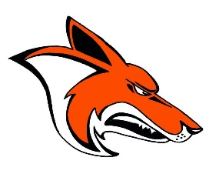
2018

WHS Coyotes Volleyball
Varsity
# | Name | Grade | Position
2 | Camberly Lerbakken | 12 | DS
4 | Emily Lux | 12 | OH
5 | Emily Jaeger | 11 | DS
6 | Jolyssa Marquart | 12 | DS/L
9 | Lauren Fearing | 12 | S
10 | Makia Remus | 11 | S/RH
12 | Nadine Barlow | 12 | RH
13 | Katherine Fearing | 12 | OH
15 | Emma Ward | 11 | MH/RH
20 | Rachel Anfinson | 11 | MH
22 | Brooklyn Douglas | 11 | MH
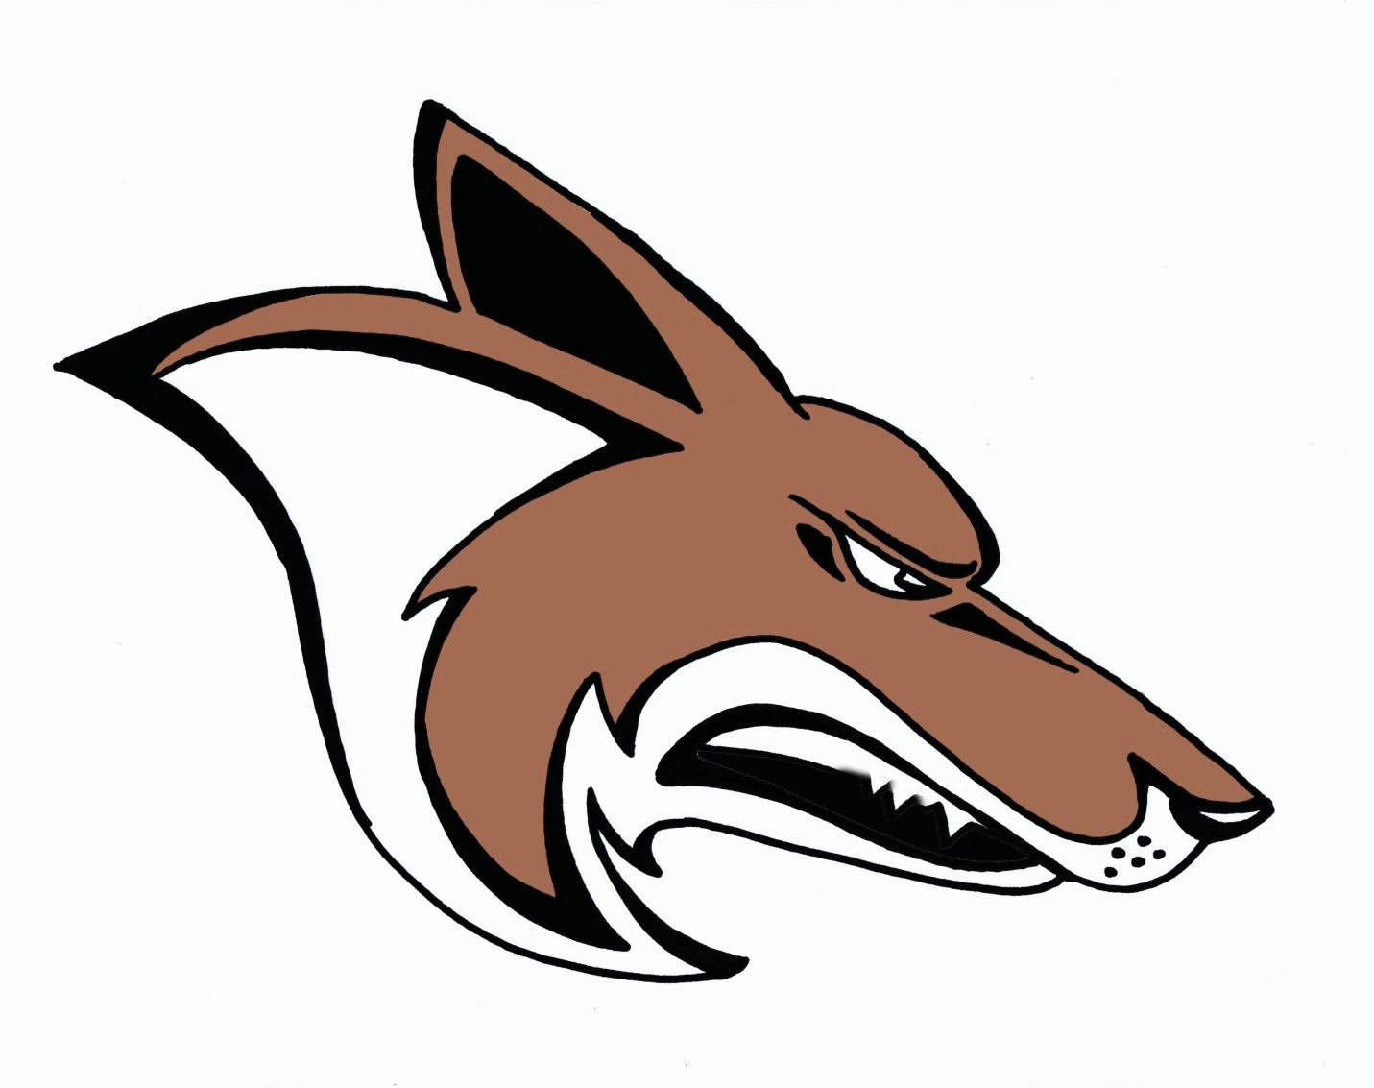
JV
# | Name | Grade
1 | Bryn Bratcher | 11
3 | Kiara McIvor | 11
5 | Emily Jaeger | 11
7 | Aniston Eslinger | 11
8 | Brooklyn Haug | 11
14 | Shelby Meyer | 9
15 | Emma Ward | 11
16 | Angelina Leija | 10
17 | Mackenzie Russell | 10

Sophomore A
# | Name | Grade
4 | Macenzie Russell | 10
7 | Brenna Ashby | 10
8 | Megan Shimko | 10
9 | Alicia Beuning | 10
10 | Anna Isom | 10
14 | Shelby Meyer | 9
15 | Kobee Gardner | 10
17 | Erin Powers | 10

Sophomore B
# | Name | Grade
1 | Emma Tong | 9
2 | Aaliyah Vondal | 10
5 | Mecayla Ralph | 10
8 | Jocelyn Nass | 9
9 | Kaelyn Sime | 9
10 | Hope Mettler | 10
11 | Kiara Melhoff | 10
13 | Savannah Douglas | 9
17 | Emma Solberg | 9

Head Coach: Rachael Hansana
Asst. Coaches Kenzi Mitchell, Kellee Black & Meagan Smith & Cami Collings
Managers: Jaylen Cymbaluk
Superintendent: Dr. Jeffrey Thake
Principal: Jason Germundson
Assistant Principals: Audrey Larson & Jonathan Abuhl
Athletic Director: David Mieure
Assistant Athletic Director: Colby Simonsen
School Song: Williston Fight Song
School Colors: Orange & Black

Freshman
# | Name | Grade
1 | Rylea Iverson | 9
2 | Chevella Abeyta | 9
3 | Samantha Schroeder | 9
11 | Haley Cote | 9
12 | Karly Elwess | 9
13 | Gabrielle Marks | 9
14 | Emry Kleven | 9
16 | Daniela Reeves | 9
26 | Zoe Lautenschlager | 9

www.wdasports.org
www.westerndakotaassociation.org

