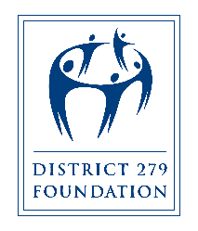

**GRANT REPORT PROCESS**

**DISTRICT 279 FOUNDATION**

**Grant Report Form**

Questions: [District279Foundation.org/classroom-grants](http://www.district279foundation.org/classroom-grants.html)

or contact the office at 763-391-7118 or foundation@district279.org

The Grant Report Form is due from the grantee within 30 days after the project is completed. This report is the primary tool for measuring the impact of the programs supported by the District 279 Foundation. Failure to submit a report could affect future funding for similar and/or repeated projects.

**CONTACT INFORMATION**

1. Name:
2. School/Site/Organization:
3. Title/Position:
4. Email address:
5. Telephone number:
6. List the name(s) of all school/site(s) benefiting from the project. If multiple schools, please indicate which school/site received the funds.
7. Date of Report:

**GRANT REPORT**

1. Project Title: (as stated in the application):

**Outcomes: Evaluate the project.**

1. When did the project take place?
2. How many scholars were served by this project?
3. What did you learn because of this project?
4. Provide an example of a success story from the project.

**Budget**

1. What was the amount of the grant awarded and how much was spent?

**Acknowledgement**

1. How was District 279 Foundation’s funding of this project acknowledged?

**GRANT REPORT SUBMISSION**

**Submit the following items to foundation@district279.org**

* This Grant Report Form Responses
* Digital Photographs. Gather digital photographs of the scholar(s) and/or the grant writer participating in the activities described in the project. Please ensure that any photos you submit comply with data privacy laws (including directory information opt outs). Contact your Principal/Site Leader if you have questions about data privacy.