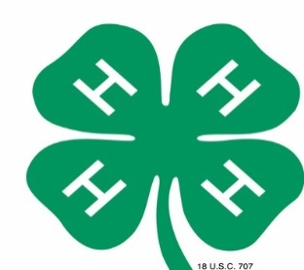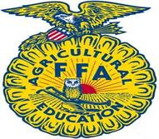
MANDATORY
4-H & FFA AGRICULTURE EXHIBITS
“AGRICULTURE IN FLAGLER COUNTY”

Each group entry should be based on the “Agriculture in Flagler County” theme on the topics listed below.
The following topics to choose from are:

Turpentine
Tymber
Cabbage
Potatoes
Cattle
Sod

Dive deep with your group and focus on one of the types of Agriculture listed above that are produced & grown right here in Flagler County, FL.
Rules:
- Entries may be submitted by 4-H & FFA groups ONLY.
- Entries will be judged and awarded Ribbons and Cash Prizes.
- Placing/Awards will be awarded as follows:
1st Place – Blue Ribbon & $100.00 Cash Reward
2nd Place – Red Ribbon & $50.00 Cash Reward
3rd Place – White Ribbon & $25.00 Cash Reward
- The decision of the judges will be final
- A 4’x8’ space with electricity WILL be available
  - Do not ask for more space
- Registration forms must be turned into Catie Cox by March 13th, 2026. You can email to flaglerctyfair@bellsouth.net or jonescatie15@gmail.com
- All exhibits will be on display at the fairgrounds during the upcoming Flagler County Fair & Youth Show
- Entrants shall assume all liability for table decorations placed on exhibits. The Flagler County Fair and its staff are not responsible for any damage or loss.

Judging Criteria: TOTAL POINTS = 100 POINTS
Educational Value
- Is the central theme of exhibit worthwhile, distinctive, significant and appropriate…20
- Does the story told around the central theme have unity, that is does each article, object, specimen and label contribute to the amplification of the central theme…25
- Is the booth free from error of thought – grammar, spelling, object use, label use, assumptions intended, figure of speech, etc…20
Power to Attract Attention & Hold Interest
- Exhibit presents an original, unusual or striking method of display…20
- Is the general appearance of the booth attractive, including background, good arrangement of objects, scale and balance, appearance of labels…15

Important Dates & Deadlines:
- April 11th, 2026 (2pm to 5pm) – Groups will be allowed to set their exhibits up
- April 13th, 2026 - Judging
- April 18th, 2026 at 9am – Take down exhibits

Contacts for this Competition:
Penny Buckles – Fair President (386) 931-6597
Catie Cox (386) 279-9792

FLAGLER COUNTY FAIR AND YOUTH SHOW, INC.

2026 4-H AND FFA AGRICULTURE EXHIBIT REGISTRATION FORM

THEME: “AGRICULTURE IN FLAGLER COUNTY”

NAME OF ORGANIZATION ______4H _______FFA
GROUP NAME______________________________________________________
CONTACT PERSON__________________________________________________
PHONE NUMBER___________________________________________________
ADDRESS_________________________________________________________

Signature :_________________________________________Date____________

Exhibit Space #_____________(fair use)

