**St. Luke’s Episcopal Church**

**The First Sunday of Advent**

**29 November 2020  10:00 A.M.**

**Holy Eucharist**

The Reverend Allison Caudill, *Celebrant*

The Reverend Michael L. Delk, *Preacher*

**THE WORD OF GOD**

**Prelude “Savior of the heathen, com” J. S. Bach**

**Matin Responsory “I look from afar” G. Palestrina**

I look from afar, and lo, I see a cloud covering the whole earth.

Go ye out to meet him and say,

Tell us, art thou he that shall come to reign over thy people Israel?

High and low, rich and poor, one with another.

Go ye out to meet him and say,

Hear, o thou Shepherd of Israel, thou that leadest Joseph like a sheep,

Tell us, art thou he that should come?

Stir up thy strength, O Lord and come to reign over thy people Israel.

Glory be to the Father, and to the son, and to the Holy Ghost.

*Words translated from the First Responsory of Advent Sunday*

*(early medieval Roman rite)*

**The Opening Acclamation Page 355**

***Celebrant*** Blessed be God: Father, Son, and Holy Spirit.

***People* And blessed be his kingdom, now and for ever. Amen.**

**The KyrieFrank W. Boles**

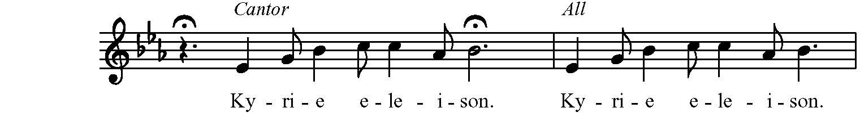

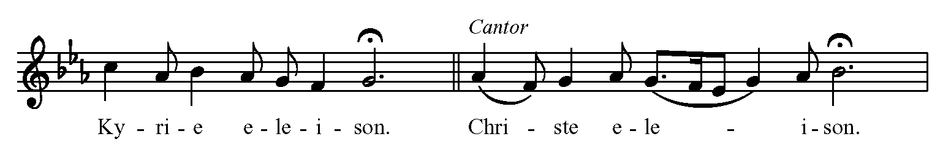

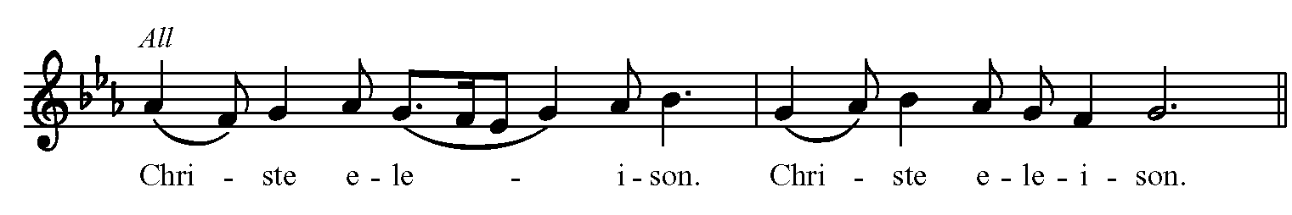

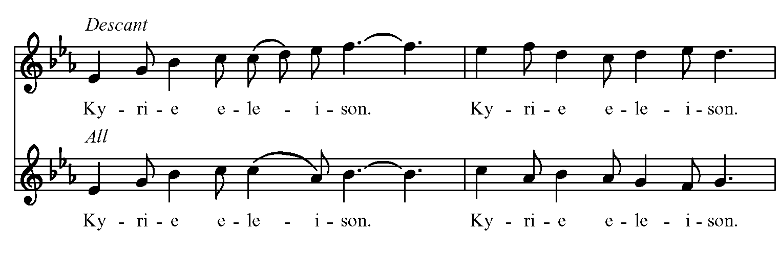

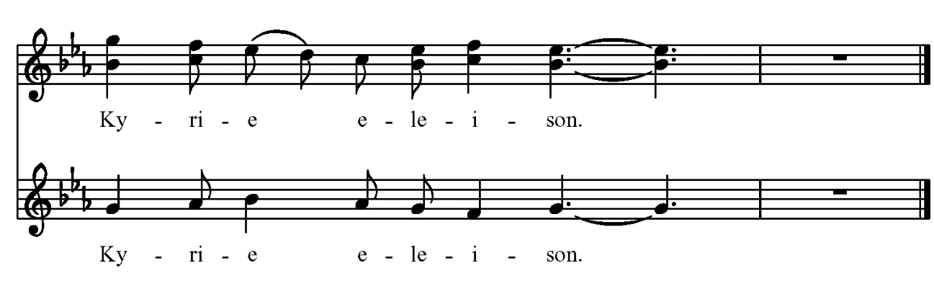



**The Salutation & Collect of the Day Page 357**

***Celebrant*** The Lord be with you.

***People* And also with you.**

***Celebrant*** Let us pray.

Almighty God, give us grace to cast away the works of darkness, and put on the armor of light, now in the time of this mortal life in which your Son Jesus Christ came to visit us in great humility; that in the last day, when he shall come again in his glorious majesty to judge both the living and the dead, we may rise to the life immortal; through him who lives and reigns with you and the Holy Spirit, one God, now and for ever. ***Amen.***

**The Lesson I Corinthians 1:3-9**

Grace to you and peace from God our Father and the Lord Jesus Christ. I give thanks to my God always for you because of the grace of God that has been given you in Christ Jesus, for in every way you have been enriched in him, in speech and knowledge of every kind-- just as the testimony of Christ has been strengthened among you-- so that you are not lacking in any spiritual gift as you wait for the revealing of our Lord Jesus Christ. He will also strengthen you to the end, so that you may be blameless on the day of our Lord Jesus Christ. God is faithful; by him you were called into the fellowship of his Son, Jesus Christ our Lord.

The Word of the Lord.

***People* Thanks be to God.**

**Psalm 80:1-7, 16-18 Plainsong**

1 Hear, O Shepherd of Israel, leading Joseph like a flock;  \*  
      shine forth, you that are enthroned upon the cherubim.

2 In the presence of Ephraim, Benjamin, and Manasseh,  \*  
      stir up your strength and come to help us.

3 Restore us, O God of hosts;  \*  
      show the light of your countenance, and we shall be saved.

4 O LORD God of hosts,  \*  
      how long will you be angered despite the prayers of your people?

5 You have fed them with the bread of tears;  \*  
      you have given them bowls of tears to drink.

6 You have made us the derision of our neighbors,  \*  
      and our enemies laugh us to scorn.

7 Restore us, O God of hosts;  \*  
      show the light of your countenance, and we shall be saved.

16 Let your hand be upon the man of your right hand,  \*  
      and son of man you have made so strong for yourself.

17 And so will we never turn away from you;  \*  
      give us life, that we may call upon your Name.

18 Restore us, O LORD God of hosts;  \*  
      show the light of your countenance, and we shall be saved.

**The Sequence “O come, o come, Emmanuel” Hymnal, 56**

**(vs. 1-2)**

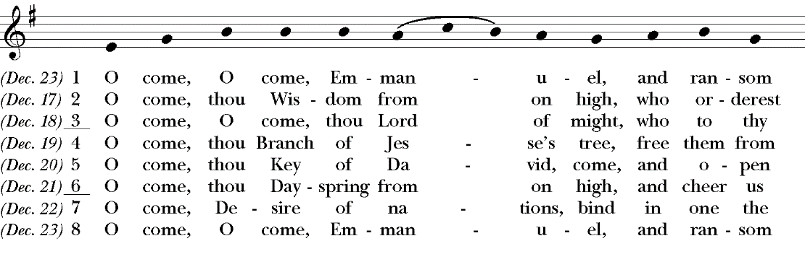

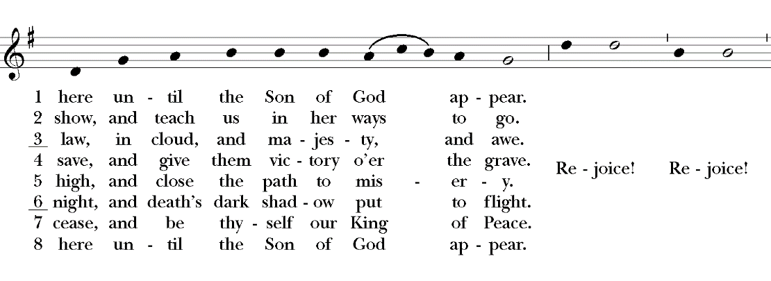

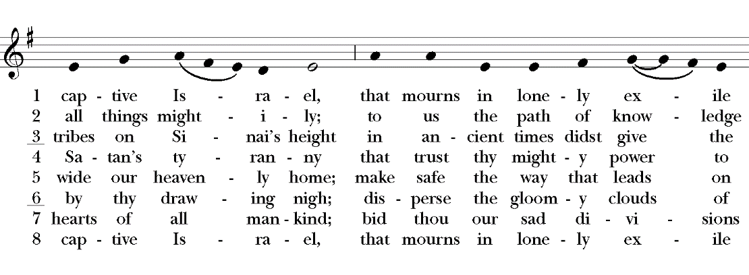

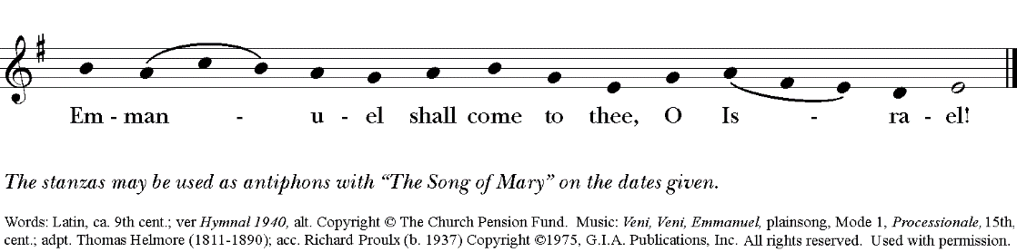

**The Holy Gospel Mark 13:24-37**

***The people remain standing. The Celebrant says***

The Holy Gospel of our Lord Jesus Christ according to Mark.

***People* Glory to you, Lord Christ.**

"But in those days, after that suffering, the sun will be darkened, and the moon will not give its light, and the stars will be falling from heaven, and the powers in the heavens will be shaken. Then they will see 'the Son of Man coming in clouds' with great power and glory. Then he will send out the angels, and gather his elect from the four winds, from the ends of the earth to the ends of heaven. "From the fig tree learn its lesson: as soon as its branch becomes tender and puts forth its leaves, you know that summer is near. So also, when you see these things taking place, you know that he is near, at the very gates. Truly I tell you, this generation will not pass away until all these things have taken place. Heaven and earth will pass away, but my words will not pass away. "But about that day or hour no one knows, neither the angels in heaven, nor the Son, but only the Father. Beware, keep alert; for you do not know when the time will come. It is like a man going on a journey, when he leaves home and puts his slaves in charge, each with his work, and commands the doorkeeper to be on the watch. Therefore, keep awake--for you do not know when the master of the house will come, in the evening, or at midnight, or at cockcrow, or at dawn, or else he may find you asleep when he comes suddenly. And what I say to you I say to all: Keep awake."

***After the reading, the Celebrant says***

The Gospel of the Lord.

***People* Praise to you, Lord Christ.**

**The Sermon**

**The Nicene Creed**

*Said by all, standing*

**We believe in one God, the Father, the Almighty, maker of heaven and earth, of all that is, seen and unseen.**

**We believe in one Lord, Jesus Christ, the only Son of God, eternally begotten of the Father, God from God, Light from Light, true God from true God, begotten, not made, of one Being with the Father. Through him all things were made. For us and for our salvation he came down from heaven: by the power of the Holy Spirit he became Incarnate from the Virgin Mary, and was made man. For our sake he was crucified under Pontius Pilate; he suffered death and was buried. On the third day he rose again in accordance with the Scriptures; He ascended into heaven and is seated at the right hand of the Father. He will come again in glory to judge the living and the dead, and his kingdom will have no end.**

**We believe in the Holy Spirit, the Lord, the giver of life, who proceeds from the Father and the Son. With the Father and the Son he is worshiped and glorified. He has spoken through the Prophets. We believe in one holy catholic and apostolic Church. We acknowledge one baptism for the forgiveness of sins. We look for the resurrection of the dead, and the life of the world to come. Amen.**

**The Prayers of the People, Form II Page 385**

*In the course of the silence after each bidding, the People offer their own prayers, either silently or aloud*.

I ask your prayers for God’s people throughout the world; Justin, the Archbishop of Canterbury, for Michael, our Presiding Bishop, Terry, our Bishop, for this gathering; for Michael, Allison, Anne, Art, and Jim, our clergy and for all clergy and people.

Pray for the Church***.***

*Silence*

I ask your prayers for peace; for goodwill among nations; and for the well‑being of all people. Pray for justice and peace.

*Silence*

I ask your prayers for the poor, the sick, the hungry, the oppressed, and those in prison. Pray for those in any need or trouble.

*Silence*

I ask your prayers for all who seek God, or a deeper knowledge of him. Pray that they may find and be found by him.

*Silence*

I ask your prayers for the departed, **. .** . Pray for those who have died.

*Silence*

I ask your prayers for **Al, Allen, Amy, Ann, Annie, Beecher, Bethann, Bill, Braxton, Bud, Calvin Riley, Carol, Charles, Christy, Dave, David, Diana, E.J., Eleanor, Elizabeth, Gene, Hugh, Ira, Jackie, Jen, Jenni, Jerry, Jim, Joan, Joe, John, Joyce, Karen, Kelly, Ken, Lauren, Lee, Linda, Lisette, Liz, London, Lynn, Martha, Mary, Matt, Meg, Mike, Milo, Monica, Nancy, Nina (Nine-ah), Patricia, Paul, Phil, Rob, Ronald, Sandy, Stefanie, Steve, Sue, Susan, Susie, Terry, Tim, Tracy, Trent, Trish, Ursula, Vicki, Walt, Whitney, Wynn; for the men and women of our armed forces, especially Alex, Bianca, Casey, Christian, Griffin, Pat, Seth, Sinclair, Steve.**

*Silence*

Praise God for those in every generation in whom Christ has been honored.

Pray that we may have grace to glorify Christ in our own day.

*Silence*

***The Celebrant adds a concluding Collect.***

**Confession of Sin Page 360**

Celebrant Let us confess our sins against God and our neighbor.

**All Most merciful God, we confess that we have sinned against you in thought, word, and deed, by what we have done, and by what we have left undone. We have not loved you with our whole heart; we have not loved our neighbors as ourselves. We are truly sorry and we humbly repent. For the sake of your Son Jesus Christ, have mercy on us and forgive us; that we may delight in your will, and walk in your ways, to the glory of your Name. Amen.**

**The Absolution**

**The Peace**

***Celebrant*** The peace of the Lord be always with you.

***People* And also with you.**

**THE HOLY COMMUNION**

**Offertory Anthem “Prayer of the Venerable Bede” Richard Prouix**

Christ is the morning light,

Who when the night of this world is past,

He gives to his saints the promise of the light of life,

And opens everlasting day.

**The Great Thanksgiving: Eucharistic Prayer B Page 367**

*S120a*

*Celebrant* It is right, and a good and joyful thing, always and everywhere to give thanks to you, Father Almighty, Creator of heaven and earth, because you sent your beloved Son to redeem us from sin and death, and to make us heirs in him of everlasting life; that when he shall come again in power and great triumph to judge the world, we may without shame or fear rejoice to behold his appearing.

Therefore we praise you, joining our voices with Angels and Archangels and with all the company of heaven, who for ever sing this hymn to proclaim the glory of your Name:

*Celebrant and people*

**Sanctus “Conditor alme siderum” Frank W. Boles**

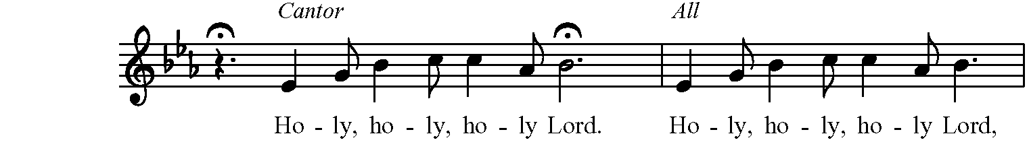

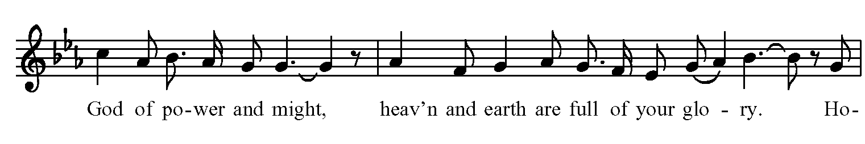

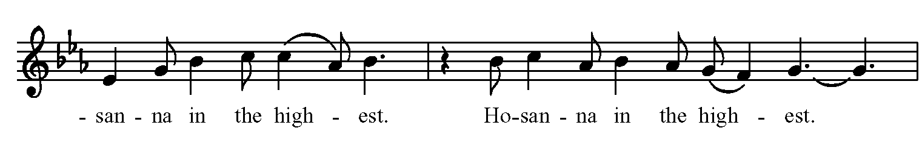

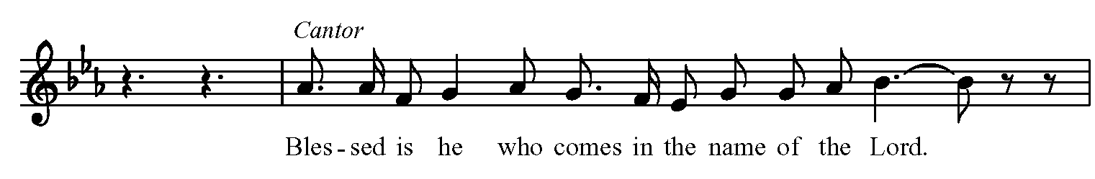

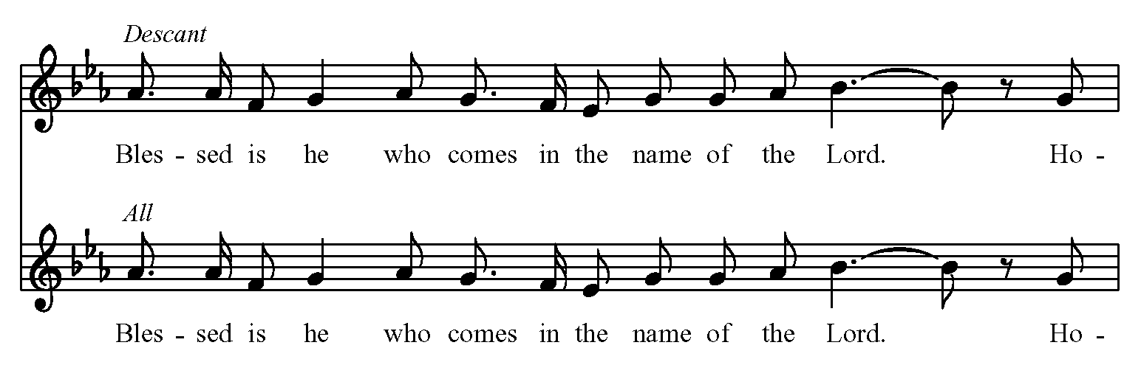

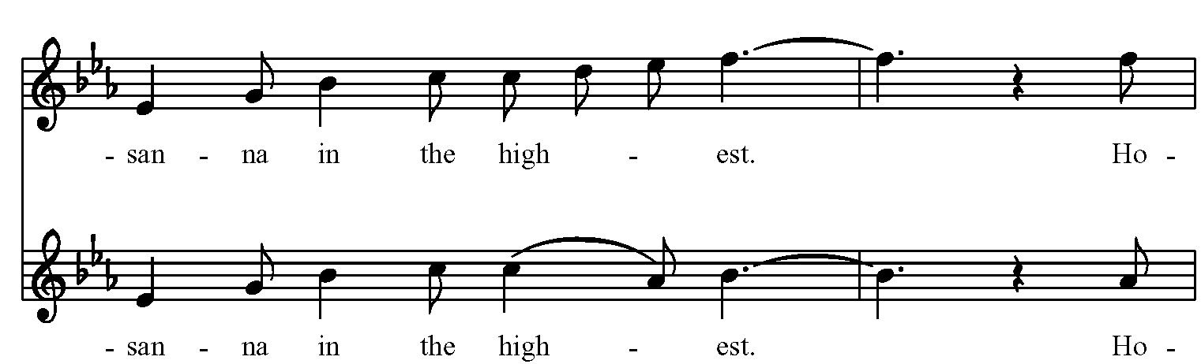

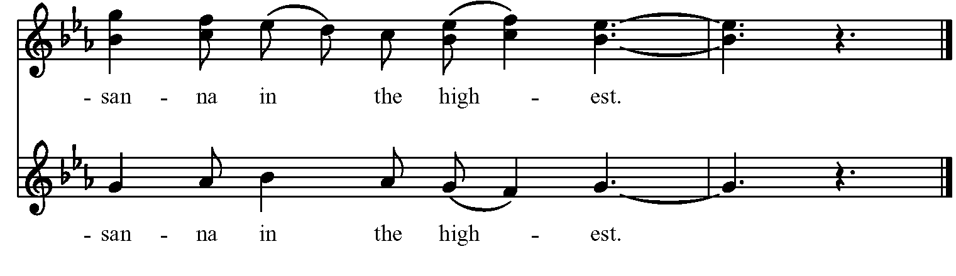



*The people stand or kneel.*

*Then the Celebrant continues*

We give thanks to you, O God, for the goodness and love which you have made known to us in creation; in the calling of Israel to be your people; in your Word spoken through the prophets; and above all in the Word made flesh, Jesus, your Son. For in these last days you sent him to be incarnate from the Virgin Mary, to be the Savior and Redeemer of the world. In him, you have delivered us from evil, and made us worthy to stand before you. In him, you have brought us out of error into truth, out of sin into righteousness, out of death into life.

On the night before he died for us, our Lord Jesus Christ took bread; and when he had given thanks to you, he broke it, and gave it to his disciples, and said, "Take, eat: This is my Body, which is given for you. Do this for the remembrance of me."

After supper he took the cup of wine; and when he had given thanks, he gave it to them, and said, "Drink this, all of you: This is my Blood of the new Covenant, which is shed for you and for many for the forgiveness of sins. Whenever you drink it, do this for the remembrance of me."

Therefore, according to his command, O Father,

*Celebrant and People*

**We remember his death.**

**We proclaim his resurrection.**

**We await his coming in glory.**

*The Celebrant continues*

And we offer our sacrifice of praise and thanksgiving to you, O Lord of all; presenting to you, from your creation, this bread and this wine.

We pray you, gracious God, to send your Holy Spirit upon these gifts that they may be the Sacrament of the Body of Christ and his Blood of the new Covenant. Unite us to your Son in his sacrifice, that we may be acceptable through him, being sanctified by the Holy Spirit. In the fullness of time, put all things in subjection under your Christ, and bring us to that heavenly country where, with [St. Luke, \_\_\_\_\_\_\_\_ and] all your saints, we may enter the everlasting heritage of your sons and daughters; through Jesus Christ our Lord, the firstborn of all creation, the head of the Church, and the author of our salvation.

By him, and with him, and in him, in the unity of the Holy Spirit all honor and glory is yours, Almighty Father, now and forever. ***Amen****.*

And now, as our Savior Christ has taught us, we are bold to say,

**The Lord’s Prayer**

**Our Father, who art in heaven, hallowed be Thy Name. Thy kingdom come, Thy will be done, on Earth as it is in heaven. Give us this day our daily bread, and forgive us our trespasses, as we forgive those who trespass against us, and lead us not into temptation, but deliver us from evil, for thine is the kingdom and the power and the glory, for ever and ever. Amen.**

**The Fraction Anthem**

*Celebrant* Alleluia. Christ our Passover is sacrificed for us.

***People* Therefore let us keep the feast. Alleluia.**

**Communion Anthem “Come to us, home to us” Daniel Kantor**

Lord, only this longing weighs upon us,

Waiting for a savior to bring us peace and comfort.

Weary eyes, tearful people cry out to your silence.

Lord of love, Lord of life, we seek you.

***Come to us, Home to us Child,***

***Dawn of unending light.***

***Embrace our night with your light!***

Lord, offer your people, peaceful refuge.

Towering above us, you guide us through til daybreak. Bring to us, with your loving Son promise of slumber.

Guide this journey to peaceful closing.

***Come to us, Home to us Child,***

***Dawn of unending light.***

***Embrace our night with your light!***

Child, born of an evening’s cold unwelcome.

Lingering above us a star of hope, of morning.

Gentle eyes of this loving Son gaze upon us.

Word unspoken shall soon be spoken.

***Come to us, Home to us Child,***

***Dawn of unending light.***

***Embrace our night with your light!***

**The Post-Communion Prayer Page 365**

*After the celebrant receives, the congregation prays*

***All* Eternal God, heavenly Father, you have graciously accepted us as living members of your Son our Savior Jesus Christ, and you have fed us with spiritual food in the Sacrament of his Body and Blood. Send us now into the world in peace, and grant us strength and courage to love and serve you with gladness and singleness of heart; through Christ our Lord. Amen.**

**The Blessing**

**Final Hymn “Watchman, tell us of the night” Hymnal, 640**

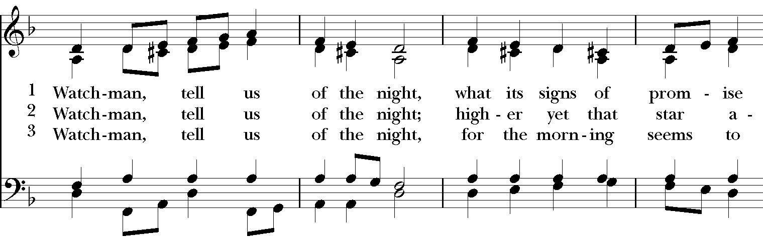

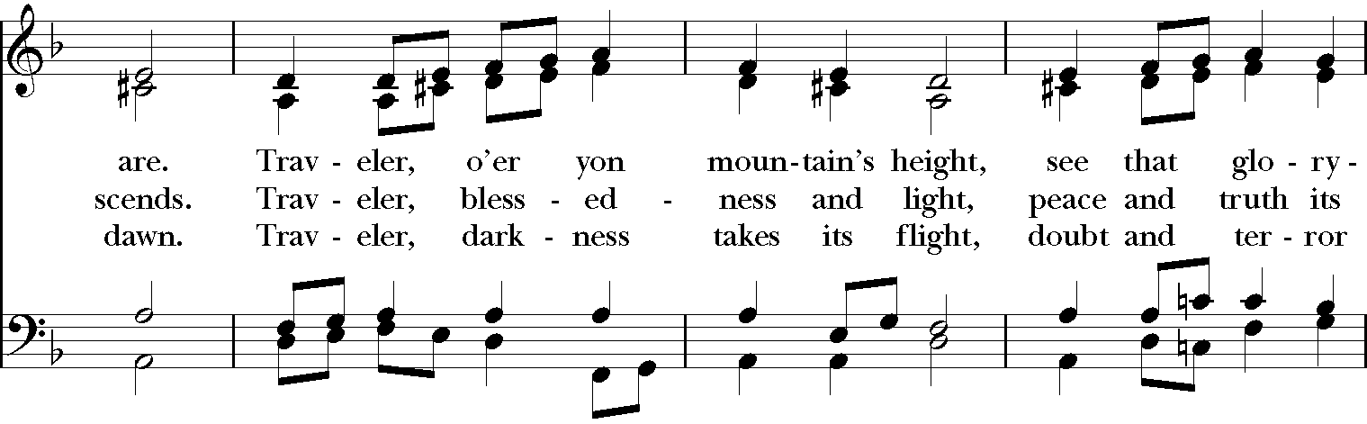

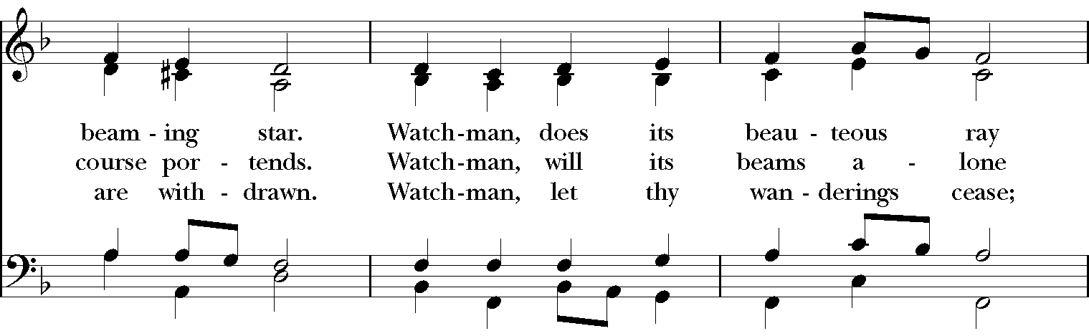

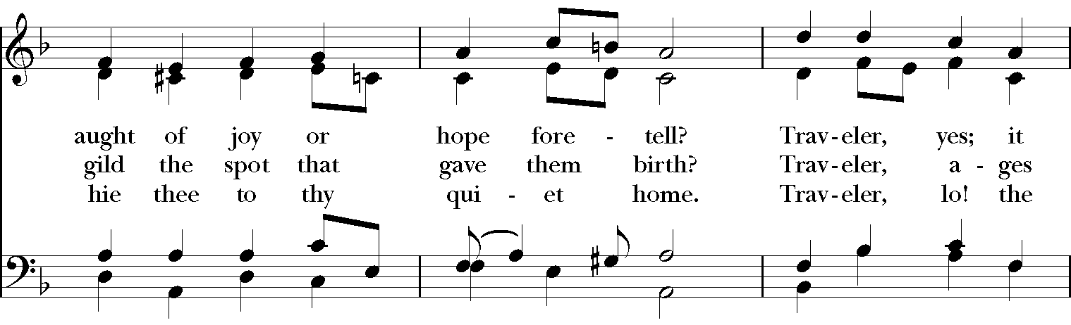

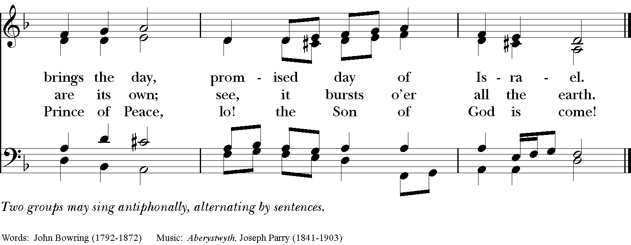

**The Dismissal**

***People* Thanks be to God.**

**Postlude “Savior of the heathen come” Hugo Distler**

(1908-1942)

Permission to reprint, podcast, and/or stream the music in the service obtained from ONE LICENSE # A-736775. All rights reserved.

**Christmas Eve and Christmas Day services** are still being planned, please watch your email and our Facebook Page for more information!

If you do not receive St Luke's emails, please contact Dawn at [admin@stlukesanchorage.org](mailto:admin@stlukesanchorage.org) to be added to our email list.

Hold Control and hover Left Mouse button

over green button to activate link.

Do you have questions about the Christian faith or the Episcopal Church?

Join us this Sunday at 11:15 AM for a FaceBook meeting where you can share your questions. Go to: [**https://www.facebook.com/StLukesAnchorage**](https://www.facebook.com/StLukesAnchorage)

To see our video go to :

[**https://www.facebook.com/StLukesAnchorage/videos/246044036847885**](https://www.facebook.com/StLukesAnchorage/videos/246044036847885)

**ANNOUNCEMENTS**

**St. Luke’s Upcoming Music  
St. Luke’s Music Series is pleased to** **present Dr. Stephen Price in a** **virtual recital of Advent organ music on December 13 at 3:30 pm**.   Dr. Price recently joined Seven Eight Artists, and his upcoming recital will be his first since joining their management.  Music of Nicholas Bruhns, Johannes Brahms, J. S. Bach, Hugo Distler and Aldophus Hailstork.

**Lisa Lewis and Friends will present a Virtual Christmas concert of sacred and secular carols on December 20 at 3:30 pm**. Along with some traditional organ selections, Doug Murray will sing some of your favorite Christmas songs, organ arrangements of dances from “The Nutcracker”, and perhaps a zany encore with organ and piano duet and percussion!  Wear your favorite Christmas sweater, light the fire and pour your favorite Christmas beverage and prepare to be entertained!

**Christmas Outreach for 2020**

This year, instead of hosting an Angel Tree to sponsor individual children and youth at Bellewood & Brooklawn, we have been invited to do something a little different! In your email and on our Facebook page, you will find a list of requests for items needed in the cottages of the children and youth, as well as items needed by the young people who will be transitioning into independent living in 2021. While this list does not include the usual toys and games that we are used to giving, it is a great honor to be asked to provide for the needs of these young people who are preparing to enter adulthood during this tumultuous season. Our family of St Luke's will be a part of easing that transition and ensuring their new homes are well-stocked and comfortable. A donation drop-off will be set up on the porch of Lyman House (the church office) and collected items will be brought to Bellewood during the entire season of Advent.

If you would still like to sponsor a child or make your purchases online, there is more information here: <https://bellewoodandbrooklawn.org/wp-content/uploads/Wish-List-2020_Holidays-page-001.jpg>

We hope you will consider making a donation!

**Christmas Memorials**

We continue our tradition of decorating the church for Christmas with memorial poinsettias and large wreaths, as well as memorializing loved ones through contributions for special Christmas music. Due to COVID, we sent out an email that you can respond to, or you can email her at [**admin@stlukesanchorage.org**](file:///C:\Users\Michael\AppData\Local\Microsoft\Windows\INetCache\Content.Outlook\XCMZ2MCD\admin@stlukesanchorage.org). Please indicate if it is **in MEMORY of** or **in THANKSGIVING of** someone and list their names clearly. **The deadline to receive all memorials is the end of Sunday, December 6.**

***Poinsettia Memorials*** – the cost for poinsettias is $9 per plant with the deadline for ordering is Sunday, December 6.

***Wreath Memorials*** – We will again be hanging large wreaths inside the church on the stone walls between the windows. The cost for each wreath is $100. We hope parishioners will help subsidize this decorating effort by donating for a wreath, or part of one, in memory of a loved one or in thanksgiving. The deadline for this memorial is Sunday, December 6.

***Music Memorials*** – Give to our wonderful music program as God plants in your heart. You may give throughout the year to the music program, but in order to get your memorial in print, the deadline is Sunday, December 6.

**Thursday Night Bible Study**

The Basics of the Bible Study continues on Thursday evenings with Mother Allison! We are using The Path to guide our study, but all you need is a Bible and access to the internet to join us. We are gathering every Thursday evening from 6:45-7:45 on Zoom to discuss the foundational stories of our faith and to explore how these stories connect to our own journeys. Please follow this link on Thursdays at 6:45 to join us!

**Advent Study of Mary the Mother of Jesus!**

**Beginning December 3rd and running through December 17, Thursday nights from 6:45-7:45 via Zoom**, please join Mother Allison for an Advent study of Mary the Mother of Jesus! This study will cover Mary's appearances in scripture, art, and music as well as how we, as Episcopalians, interact with her as part of the Great Cloud of Witnesses. All are welcome to join this study, for one week or for all three Thursdays as part of your preparation for Christmas. Follow the link below on Thursday nights for prayer and conversation, and invite your friends!

[**https://us02web.zoom.us/j/284582639**](https://us02web.zoom.us/j/284582639)

Meeting ID: 284-582-639  
If prompted to enter a password, please enter our parish office phone number - 2458827

**Wednesday Morning Bible Study**

Our Wednesday morning Bible study Zoom, starting at 9:45, we begin on The Gospel of Matthew, led by Father Michael. Please check your email for the invite.

**[https://us02web.zoom.us/j/284582639](https://us02web.zoom.us/j/284582639" \t "_blank)**

Meeting ID: 284-582-639  
If prompted to enter a password, please enter our parish office phone number - 2458827

**Contemporary Anglican Theologians – Sunday 9am Class**

Please join us Sunday mornings, 9:00, as we have begun a new series.

There are several Anglican (including many Episcopalian) theologians who have written during our lifetime, most of them are still working.  They have written some fascinating ideas that enrich our understanding of God, Jesus, the Church and spirituality. Their work has added clarity, insight and depth to Anglican Christianity. We will be spending the next couple of months discussing these theologians and their ideas.

For more information, email Dave Kirchinger at [**episcopaliandave@gmail.com**](mailto:episcopaliandave@gmail.com).

The link to the class is:

[**https://us02web.zoom.us/j/85144530030**](https://us02web.zoom.us/j/85144530030) / Meeting ID: **851 4453 0030**

If prompted to enter a password, please enter our parish office phone number - 2458827

**Centering Prayer**

Centering Prayer is TWICE a month, every 2nd and 4th Tuesday. Join us on **December 8th and 22nd from 6 – 7pm** on ZOOM until we can all join back in the Lyman Office.

Link to Centering Prayer Group: <https://zoom.us/j/85280543522>

Meeting ID: 852 8054 3522

If prompted to enter a password, please enter our parish office phone number – 2458827

**Birthdays & Anniversaries**

**If you've had a birthday or anniversary over the past several weeks, or have one coming up in the weeks ahead,** please let Dawn know, [admin@stlukesanchorage.org](mailto:admin@stlukesanchorage.org).  Let her know your birthday, or the date of your wedding anniversary and how many years you've been married, and we will offer a blessing over you during our recorded worship.

***The Flowers on the Altar*** are given by Margaret Dry and family in loving memory of the best dad and gummy ever. We miss you and love you!

**In our prayers** ... **Al, Allen, Amy, Ann, Annie, Beecher, Bethann, Bill, Braxton, Bud, Calvin Riley, Carol, Charles, Christy, Dave, David, Diana, E.J., Eleanor, Elizabeth, Gene, Hugh, Ira, Jackie, Jen, Jenni, Jerry, Jim, Joan, Joe, John, Joyce, Karen, Kelly, Ken, Lauren, Lee, Linda, Lisette, Liz, London, Lynn, Martha, Mary, Matt, Meg, Mike, Milo, Monica, Nancy, Nina (Nine-ah), Patricia, Paul, Phil, Rob, Ronald, Sandy, Stefanie, Steve, Sue, Susan, Susie, Terry, Tim, Tracy, Trent, Trish, Ursula, Vicki, Walt, Whitney, Wynn**; and our men and women serving in our armed forces and their families. We offer prayers of blessing and thanksgiving for all men and women serving in the armed services, especially these persons known to us: **Alex, Bianca, Casey, Christian, Griffin, Pat, Seth, Sinclair, Steve**. We pray that they have safe journeys and know the loving concern of friends and family. May God watch over them and grant them strength and courage to face perils which beset them.

**Readings for:**

**December 6: Isaiah 40:1-11; Psalm 85:1-2, 8-13;**

**Advent II** **II Peter 3:8-15a; Mark 1:1-8.**