

**SUMMER 2025 SEASON**

**9th July 2025**

**PRECISION SHOOTING CUP**

15 Players took part this year, with some new players taking part which is good to see.

Five separate disciplines are undertaken in the Precision Shooting with a maximum available score of 100 points, although the world record is 67 achieved by Christophe Sevilla in July 2011.

After Round 1 the scores were as follows:

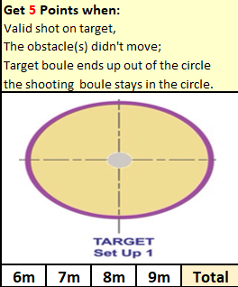

|  |  |
| --- | --- |
| Alan Oliveira | 0 |
| Andrew Bellamy-Burt | 6 |
| Branden De La Haye | 0 |
| Brian Harris | 3 |
| Callum Stewart | 1 |
| Daniel Deveau | 3 |
| Gary Cowburn | 0 |
| James Gennoe | 0 |
| Jean Stewart | 0 |
| Keith White | 0 |
| Ross Churchill | 4 |
| Ross Payne | 6 |
| Toby Northern | 1 |
| Tommy Walsh | 0 |
| Wendy Ritzema | 0 |

The best starts for Andrew and Ross with 6 points, but shows the importance of starting off well with several players failing to score.

|  |  |
| --- | --- |
| Alan Oliveira | 1 |
| Andrew Bellamy-Burt | 1 |
| Branden De La Haye | 0 |
| Brian Harris | 0 |
| Callum Stewart | 3 |
| Daniel Deveau | 0 |
| Gary Cowburn | 7 |
| James Gennoe | 9 |
| Jean Stewart | 0 |
| Keith White | 0 |
| Ross Churchill | 5 |
| Ross Payne | 1 |
| Toby Northern | 3 |
| Tommy Walsh | 0 |
| Wendy Ritzema | 3 |

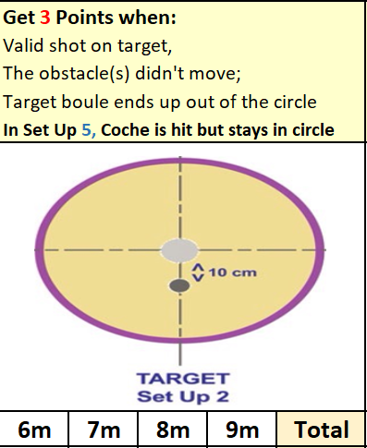

Some good scores from Gary and James in this round helping move them into contention with a much more difficult shot required.

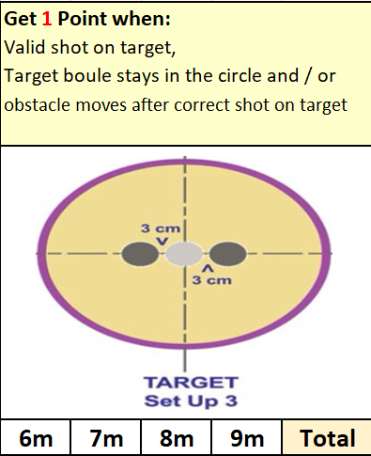

|  |  |
| --- | --- |
| Alan Oliveira | 0 |
| Andrew Bellamy-Burt | 3 |
| Branden De La Haye | 0 |
| Brian Harris | 1 |
| Callum Stewart | 0 |
| Daniel Deveau | 3 |
| Gary Cowburn | 0 |
| James Gennoe | 3 |
| Jean Stewart | 0 |
| Keith White | 0 |
| Ross Churchill | 3 |
| Ross Payne | 0 |
| Toby Northern | 1 |
| Tommy Walsh | 0 |
| Wendy Ritzema | 0 |

After three rounds Ross Churchill, James Gennoe lead the way.

|  |  |
| --- | --- |
| Alan Oliveira | 3 |
| Andrew Bellamy-Burt | 3 |
| Branden De La Haye | 0 |
| Brian Harris | 0 |
| Callum Stewart | 0 |
| Daniel Deveau | 0 |
| Gary Cowburn | 3 |
| James Gennoe | 3 |
| Jean Stewart | 0 |
| Keith White | 1 |
| Ross Churchill | 3 |
| Ross Payne | 3 |
| Toby Northern | 3 |
| Tommy Walsh | 0 |
| Wendy Ritzema | 0 |

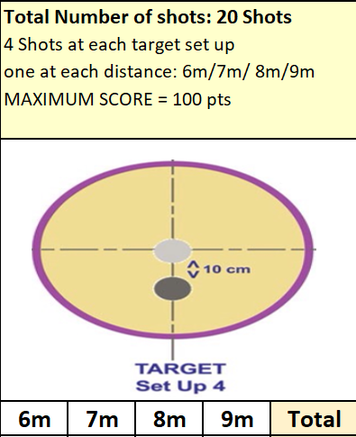

Probably the most difficult one of the five disciplines saw low scores.

|  |  |  |
| --- | --- | --- |
|  | Round 5 Score | Total |
| Alan Oliveira | 0 | 4 |
| Andrew Bellamy-Burt | 3 | 13 |
| Branden De La Haye | 0 | 3 |
| Brian Harris | 3 | 7 |
| Callum Stewart | 0 | 4 |
| Daniel Deveau | 5 | 11 |
| Gary Cowburn | 0 | **10** |
| James Gennoe | 0 | 15 |
| Jean Stewart | 0 | 0 |
| Keith White | 3 | 4 |
| Ross Churchill | 3 | 18 |
| Ross Payne | 10 | 20 |
| Toby Northern | 5 | 13 |
| Tommy Walsh | 0 | 0 |
| Wendy Ritzema | 0 | 3 |

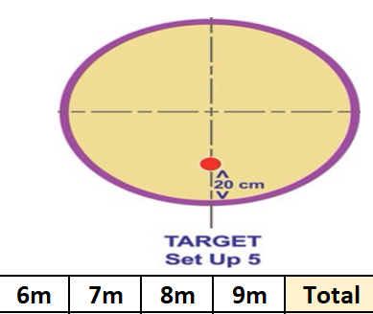Ross Payne was the Jack master hitting 10 points to score very well in this round and go through. Ross Churchill’s three points put him through to play Ross Payne in the final as the only players scoring 16 points or more.

Some disappointing scores though with 13 players all surprisingly failing to get the minimum required. Several players one hit away from getting through though.

In the final Ross Payne took the lead 9 – 6 after round 1. This remained unchanged after Round 2.

Mr Payne extended the lead to 12 – 8 after Round three and that unfortunately was the final score with neither player scoring in the final two rounds.

**Winner – Ross Payne**

Huge thank you to Gary Cowburn and Wendy Ritzema for helping run the event, very much appreciated by all those taking part.

**NEXT WEEK - SINGLES LEAGUE**

Club email address - [liberationpc@gmail.com](mailto:liberationpc@gmail.com)

Club Website - [www.liberationpetanque.co.uk](http://www.liberationpetanque.co.uk)

Kind Regards

Toby Northern

Chairman

Liberation Petanque Club