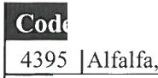
Restaurant Name: Date: ) } Location :
_ Email your order to: Mytoddsorder@toddstomatoes.com

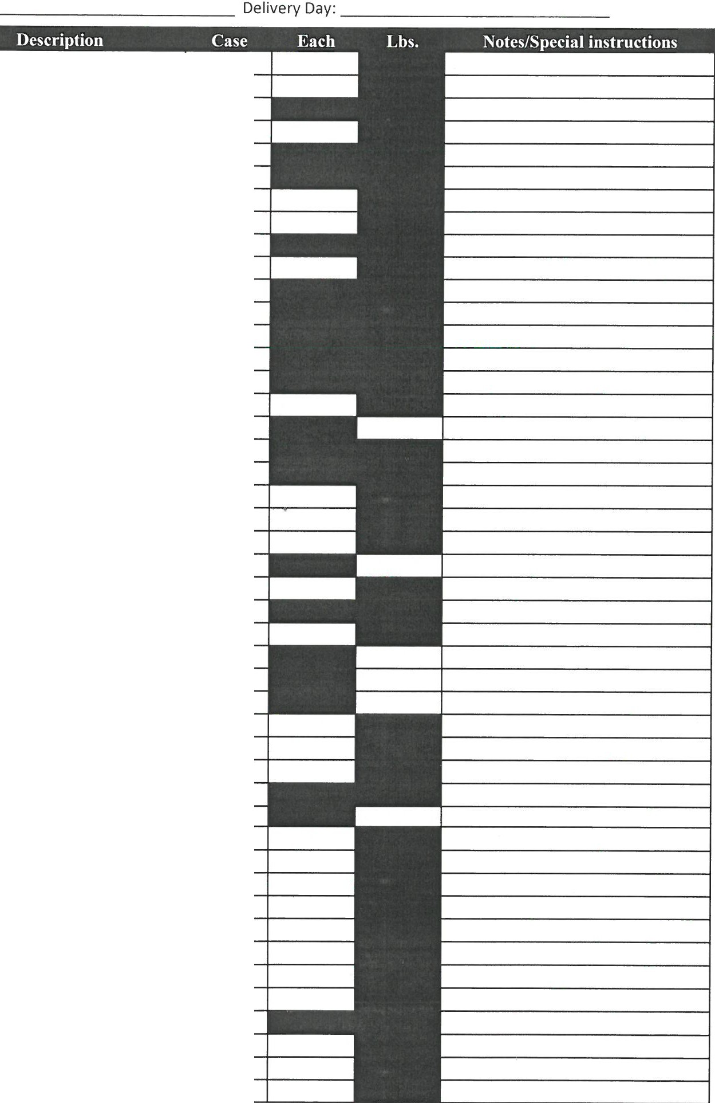
 | Sprouts Cups 4oz.
2360  505  190  210  265  235  400  445  3296  3189  2445  2410  2440  2415  555  585  5035  2486  2480  640  635  4955  2520  2530  2540  2585  4965  2610  5623  5620  1215  1202  2665  2715  2685  2675  2655  2725  2775  2830  2780  5060  5585  5080  5512 | Anise, (Fennel) 20# Apples, Sliced I0012oz  Apples, Golden Del. 72/88 Apples, Golden Del.l 25's Apples, Granny Smith l 25's Apples, Granny Smith 88ct Apples, Red 80/88  Apples , Red Del. l 25's Arcadian Harvest 4/3# Arugula, Baby 3# Asparagus, Jumbo I l # Asparagus, Large I I# Asparagus , Small 11# Asparagus, Standard 11# Avocados , Hass 60ct Bananas #1 40 # Basil, I#  Beans, Haricot Vert #5 Beans, Snipped 2/5# Blackberries 1216oz Blueberries l 2ct  Bok Choy 30# Broccoli, California 14's Broccoli, Crowns #20 Broccoli, Florets 4/3#  Cabbage, Green Crt. 50# Cabbage, Nappa 30#  Cabbage, Red 50#  Cabbage, Red Chopped 4/5# Cabbage, Red Shredded 4/5# Cantaloupes l 2ct Cantaloupes, Cubed 1/5# Carrots, Loose 50#  Carrots, Mini Peeled 30/1# Carrots, Shredded 4/5# Carrots, Slim Peeled 4/5# Carrots , Sticks 4/5# Cauliflower, l 2ct.  Celery, 24's Celery, Diced 4/5# Celery, Sticks 4/5# Chives, 1#  Chopped Salad W/Color 4/5# Cilantro 30ct  Cole Slaw, Diced 4/5#

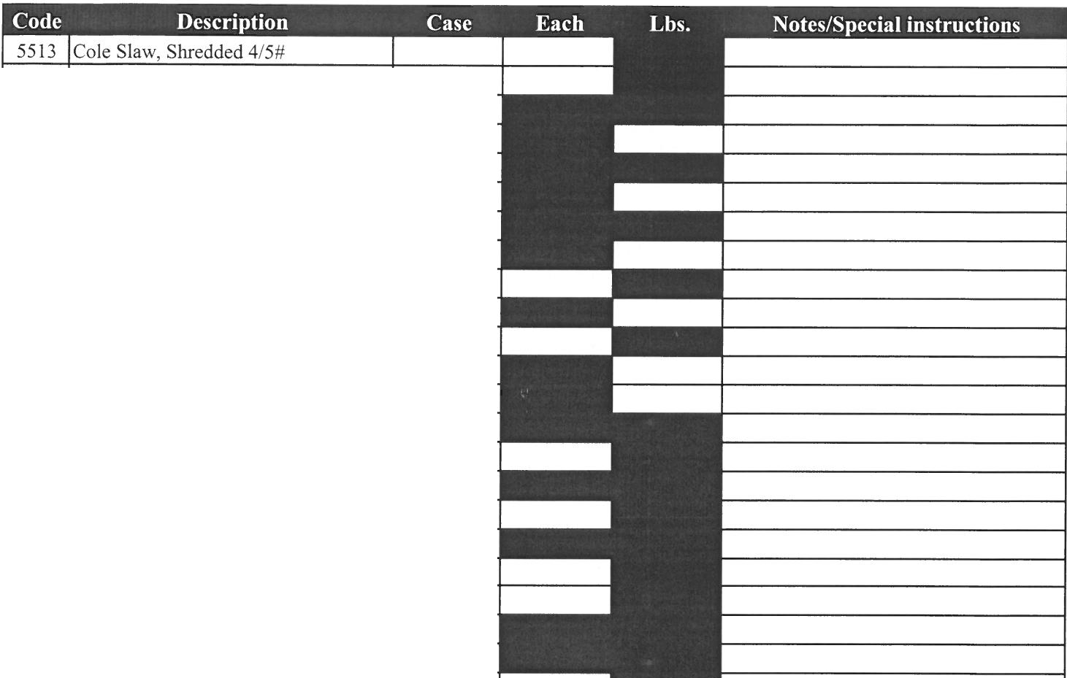
2860 Com, Cob Crate 50ct
2920 Cukes, Euro l 2ct
2930 Cukes, Select 40#
5090 Dill, 1#
2960 Eggplant
5530 Fruit Mix 1/5 #
3015 Garlic, 30#
3040 Garlic, Peeled 4/5#
3065 Ginger, 30#
910 Grapefruit , Red 32ct
855 Grapes, Green Seedless #18
860 Grapes, Red Seedless #18
3295 Green Leaf Washed & Trim 2/5#
1280 Honeydew Melons 6ct
1298 Honeydew, Cubed 1/5#
3165 Kale, 24's
3170 Kale, Flowering 24ct
990 Kiwi 36/39ct
3175 Leeks 12c t
1035 Lemons l l 5ct
1065 Lemons 200ct
1045 Lemons, 140's
1055 Lemons, 165's Fancy
3240 Lettuce, Cello 24's
3285 Lettuce, Green Leaf 24ct
3230 Lettuce, Iceberg 24's
5625 Lettuce , Shredded 4/5#
1135 Limes, 200's
1150 Mangos 9ct
5125 Mint, 1#
3446 Mushroom, Crimini 5#
3405 Mushroom, Gourmet Buttons 10#
3410 Mushroom , Jumbo 10#
3415 Mushroom, Medium I0#
3475 Mushroom, Portabella 5# Med
3485 Mushroom, Portabella Large
3505 Mushroom, Shitake 3#
3535 Mushroom, Silver Dollar #10
3540 Mushroom, Sliced 5#
3500 Mushroom, Sliced Tubs 2/5#
3725 Onions, Diced 3/8" 4/5#
4325 Onions, Green 48's
3655 Onions, Red 25#
3640 Onions, Slive red 4/5#
3680 Onions, Spanish 50#
3685 Onions , Sweet 40#
5795 Orange Juice 4/1 Gal
1600 Oranges, Florida 100ct
1610 Oranges, l l 3ct

Sold by dozen for each
Sold by dozen for each

Sold by dozen for each

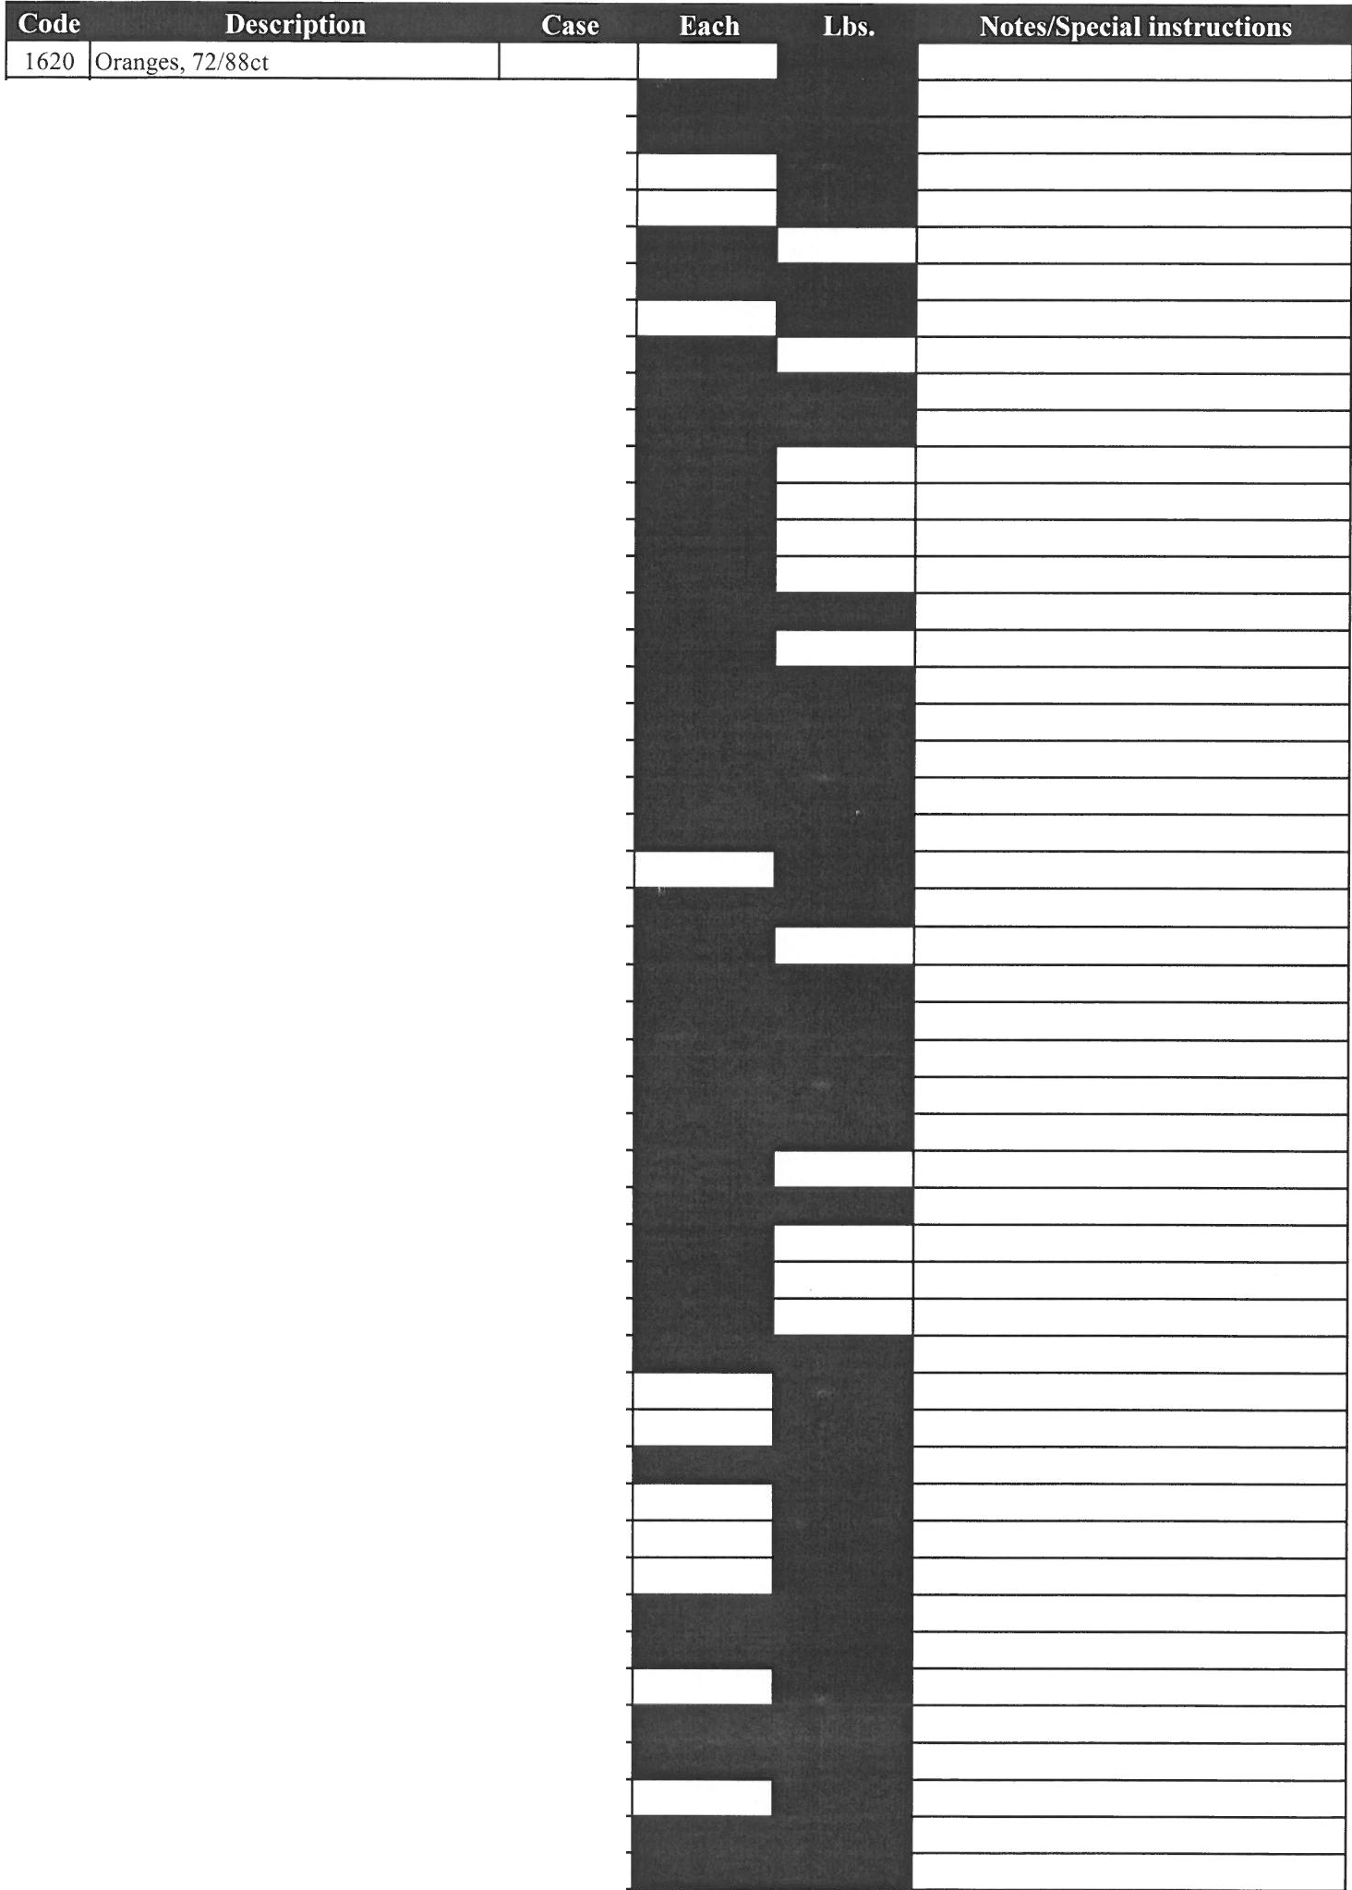5135 Oregano, I#
1745 Papaya 9's
3735 Parsley, Curley Bunch 60ct 3745 Parsley, Italian 30ct
3760 Parsnips 20#
2015 Pears, 120/135ct 1965 Pears, 70-l20ct
3845 Peppers, Green I 1/9 BU. 25# 3861 Peppers, Green Diced 1/5# 3900 Peppers, Green Slivered 1/5# 3865 Peppers, Habanero 8#
3890 Pep ers, Jalapeno I 0 # 3915 Peppers, Poblano 25#
3920 Peppers, Red I 1/9 BU. 25# 3926 Peppers, Red Diced 1/5#
3876 Peppers, Yellow 1 1/9 BU. 25# 6230 Pickles, Chips Cross Cut 5/16 6390 Pickles, Spears Kosher 5 Gal. 9371 Pickles, Whole 80ct
6370 Pickles, Whole Kosher 50ct 2230 Pineapple, Golden 6's 2235 Pineapple, Golden 7's
224I Pineapples, Cubed 1/5# 4075 Potatoes , C hef #!
4140 Potatoes, Idaho 100ct
4145 Potatoes, Idaho I 20ct 4100 Potatoes, Idaho 50ct 4110 Potatoes, Idaho 60ct 4115 Potatoes, Idaho 70ct. 4 I 20 Potatoes, Idaho 80ct 4125 Potatoes, Idaho 90ct 40IO Po tatoes, Red A 50# 4030 Potatoes, Red B 50#
4235 Potatoes, Sweet #1 40#
4200 Potatoes, Yukon Gold 50# 4280 Radishes, Cello 14/1#
655 Raspberries I 2ct
335 1 Romaine Hearts 48ct. Bulk 3335 Romaine , California 24ct. 3360 Romaine, Chopped 6/2# 3350 Romaine, Heart s 12/3's 5150 Rosemary, 1#
5200 Sage, I#
4345 Shallots, Peeled 4/1 Gal 4360 Spinach, 4/2.5#
4940 Spinach, Baby 3#
4375 Spinach, Cello 12/ I0 o z. 5615 Spring Mix 3#
4435 Squash, Acom 50#

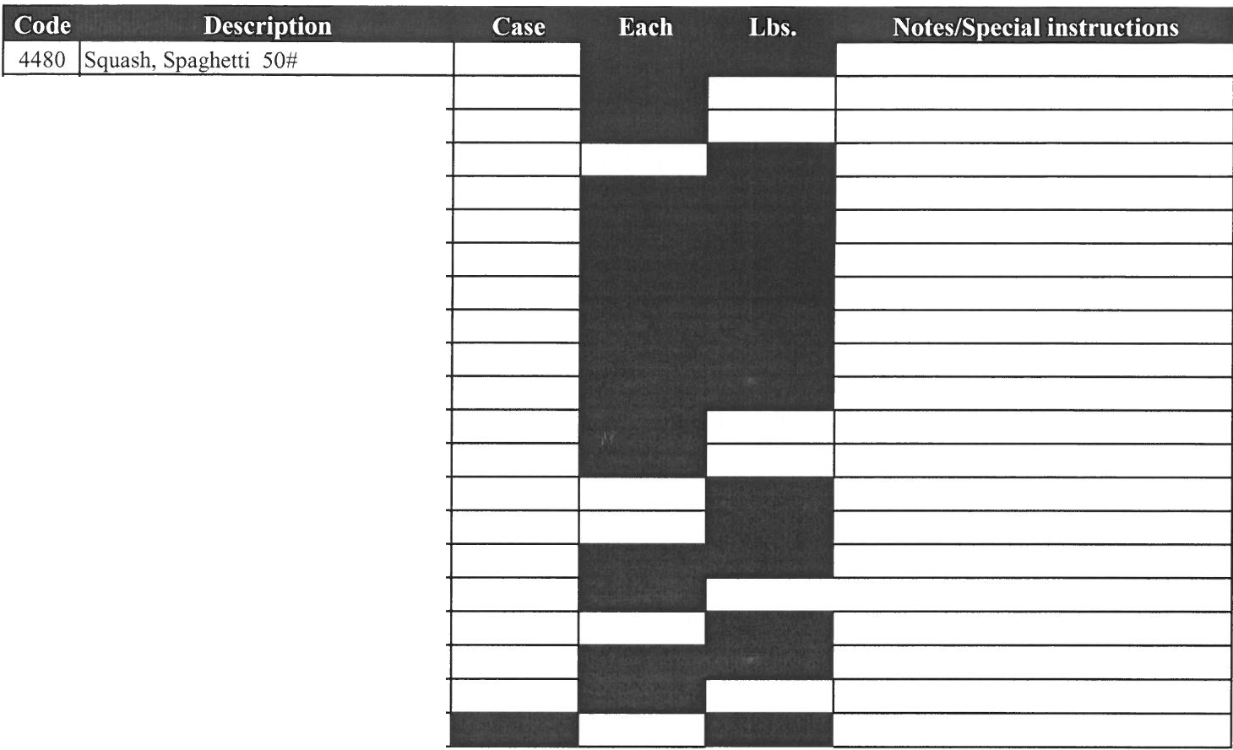
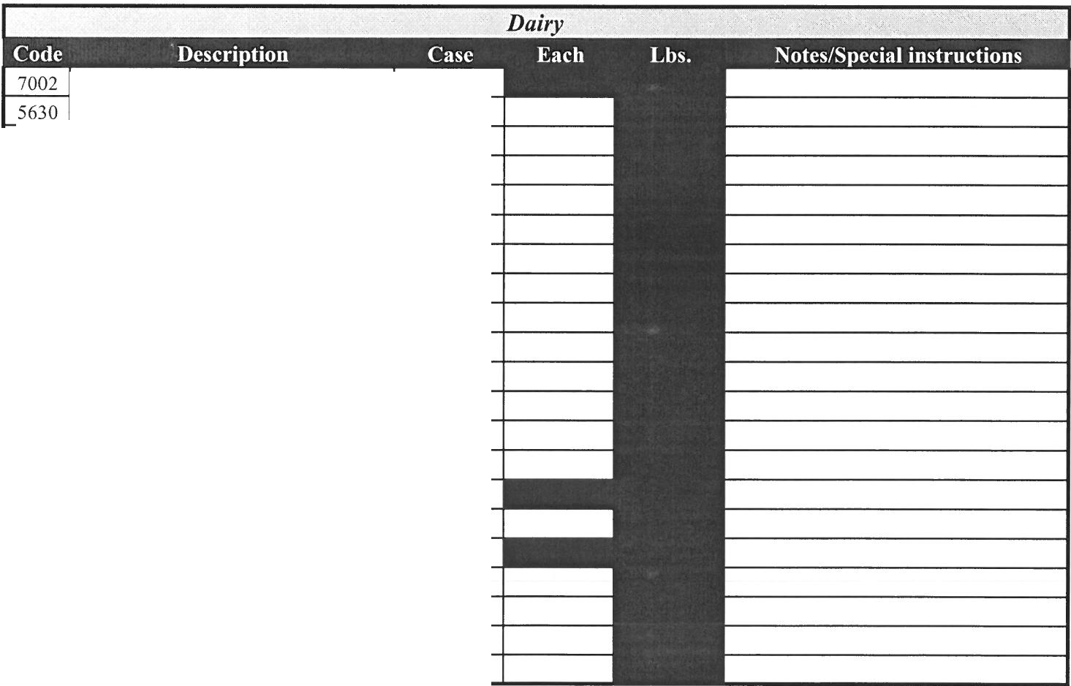

4500 | Squash, Yellow 18#
4525 | Squash, Zucchini 18#
690 | Strawberries, Drisco ll Set
5210 | Tarragon, I #
5235 | Thyme I#
4565 | Tomatillos 10#
4735 | Tomatoes 4x5 Single layer 10#
4610 | Tomatoes 5x6 Single layer 10#
4615 | Tomatoes 6x6 Single layer 10#
4700 | Tomatoes, 4X5 Large 25#
4595 | Tomatoes, 5x6 25#
4630 | Tomatoes, 6x6 25#
4650 | Tomatoes, Cherry l 2ct
4670 | Tomatoes, Grape 12ct
4765 | Tomatoes, Green 25#
4730 | Tomatoes, Plum 25#
4750 | Tomatoes, Sundried 4/5#
4770 | Tomatoes, Vine Ripe 5x6 25#
4830 | Turnips 25#
1415 | Watermelon, Seedless Each

 | Butter, Unsalted 36/ l #
 | Buttermilk 9- 1/2 Gal
8010 | Cheese, American White 160 4/5#
8000 | Cheese, American Yellow 160 4/5#
8096 | Cheese, Bleu Crumbles 4/5#
8291 | Cheese, Cheddar Sharp Shred 4/5#
8289 | Cheese, Feta Crumbles 2/5#
8088 | Cheese, Jack & Cheddar Shred 4/5#
8090 | Cheese, Monterey Shred 4/5#
8295 | Cheese, Mozzarella Shred 6/5#
8012 | Cheese, Parmesan Grated 2/5#
8013 | Cheese, Parmesan Shredded 2/5#
8050 | Cottage Cheese 4/5#
8060 | Cream Cheese, 10/3#
5660 | Half & Half 390ct PC
5661 | Half & Half, 12/ 1 Quarts
8300 | Margarine, Solid 30/1#
6180 | Mayo, Heavy Duty 4/1 Gal
8282 | Milk, 2% 4/1 Gal.
5633 | Milk, Whole 4/1 Gal.
8020 | Sour Cream, 4/5#

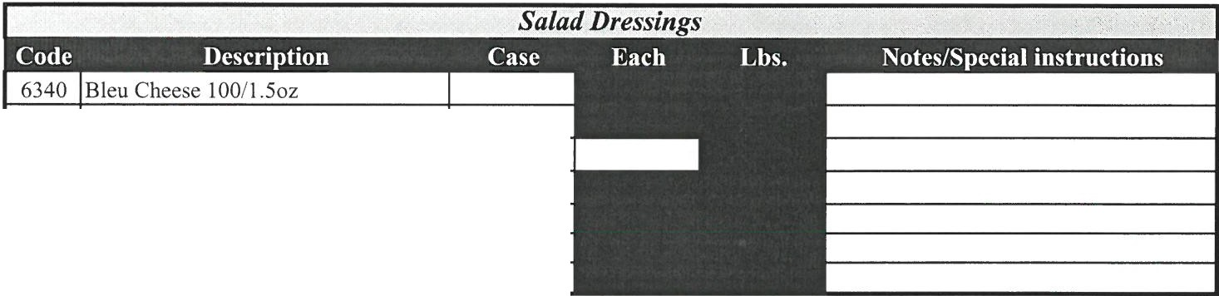
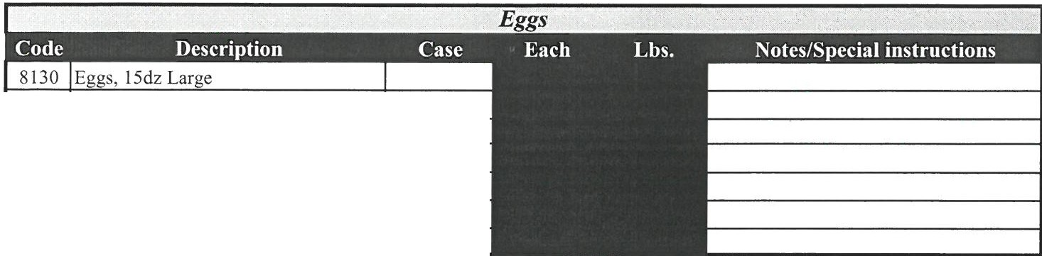

8150 | Eggs, 15dz Medium
81 10 | Eggs, 15dz X-large
8120 | Eggs, 30dz Large
8100 | Eggs, 30dz X-large
8180 | Eggs, Hard Boiled 20#
8190 | Eggs, Liquid 15/2#

6329 | Caesar 100/ I.oz
6170 | Cole Slaw Dressing 4/1 Gal.
6351 | Fat Free Italian I0011.5oz
6310 | Honey French I00/1.502
6113 | Buttermilk, Ranch I0011.5oz
6360 | Lite Ranch 10011.5oz

Additional Comments:

