RSAI Position Paper Extend State Penny for School Infrastructure:
A 2017 Legislative Priority

Background: The State Penny for School Infrastructure, established in 2008, expires on Dec. 31, 2029. The original 20-year timeframe matched the typical bonding period for property-tax backed construction projects. State penny has helped schools address the age-old problem of equity and adequacy for school facilities. Use of the local option tax from 1998-2008 and the state penny sales tax for school infrastructure since have together:
- Funded technology expansions in districts (such as 1:1 initiatives)
- Elevated student learning (science labs, STEM, CTE and the arts, to name a few)
- Upgraded fields/facilities to encourage student/community participation and connection to school
- Resulted in fewer days lost due to extreme temperatures
- Returned saved energy dollars to the educational program
- Purchased items otherwise requiring PPEL levy increases or new Bond Issues
- Improved condition of otherwise aging bus fleet
- Reduced property taxes
- Provided additional property tax equity through dedication of use tax to property tax relief.

Current Reality: Nine years later, schools are feeling the pinch of a shortened bonding period:
- With only 12 years, a shortened bonding stream has left approximately $700 million of borrowing capacity on the table, compared to a full 20-year period.
- With low interest rates and unmet needs, this is the wrong time to turn to property taxes rather than sales taxes to continue facilities repair and construction.
- The replacement cost of Iowa schools is estimated to be $16.4 billion (July 1, 2014). The state penny provides an annual investment of 2.55%, a reasonable amount to maintain and update Iowa schools, including funding for technology, equipment, buses and additional property tax relief.
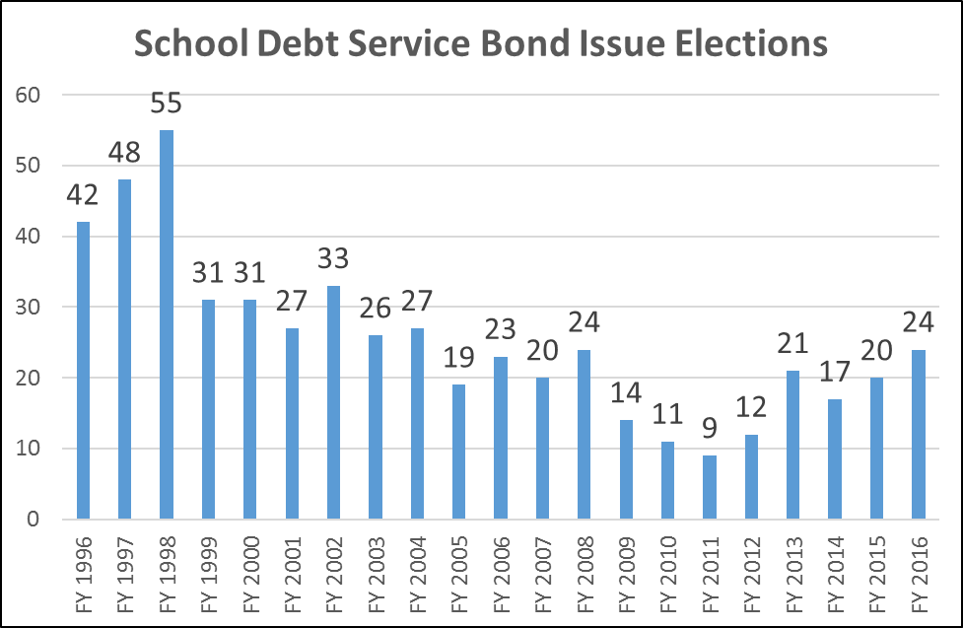
- Fallback will always be property taxes. Inequity in valuations means that some districts will utilize PPEL/Debt Service property taxes bearing no relationship to enrollment or need. Iowa will return to the infrastructure mess we were in with inadequate school facilities and unequal student resources.
History of the number of bond issues approved by voters annually proves the point: fewer bond issues have been passed every year since the start of the state penny. That track record will continue if the penny can be bonded against for the full 20 years. Absent that action, as the time frame shortens, the number of bond issues backed by property taxes will escalate.
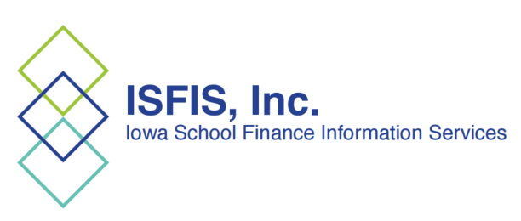

RSAI calls on the Iowa Legislature to extend or repeal the sunset of the state penny for school infrastructure. Since voters in Iowa’s 99 counties approved the sales tax for public schools, any change in use of the revenue in the extension should be dedicated to educational purposes.
School Infrastructure Local Option Taxes were first available to districts in FY 1999. The State Penny was passed in the 2008 Session.

