Present needs and levels (NOW)
Things I want people to know about my learning and my disability ( what I am good at, what I struggle with, what my learning style is)
__________________________________________________
__________________________________________________
__________________________________________________
__________________________________________________
Modifications
(things that I believe help me to be successful at school and with tests)
__________________________________________________
__________________________________________________
__________________________________________________
Extracurricular (activities I do, in and out of school)
__________________________________________________
__________________________________________________
__________________________________________________
Planning for Next Year

Services I will need to support me at school next year.
__________________________________________________
__________________________________________________
__________________________________________________

Goals I have for next year on my IEP
___________________________________________________
___________________________________________________
___________________________________________________

Modifications that I will need for next year to be successful
__________________________________________________
__________________________________________________
__________________________________________________
IEP Planning Brochure
For My CSE meeting
“Nothing about me without me”
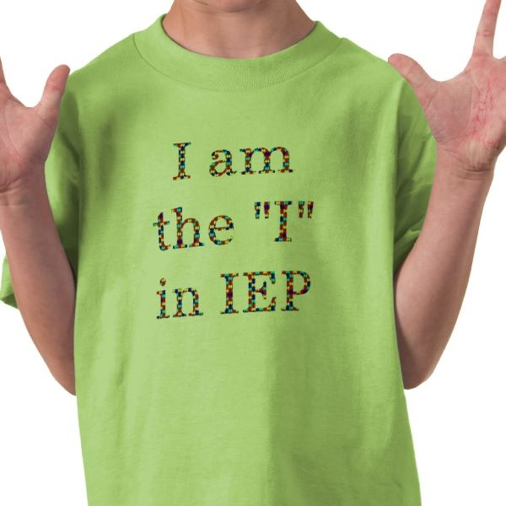

CSE meeting date: _______________
CSE meeting time: _______________
CSE meeting location: _____________

People invited to my CSE meeting
______________________________________
______________________________________
______________________________________
______________________________________
Employment

Post Secondary Measurable Goals/ My plans for when I leave Shenendehowa
Jobs I plan to have after finishing high
school?
____________________________________________
___________________________________________

My long term career goal[s]?

_____________________________________________
_____________________________________________

Education/Learning

What kind of educational experiences and /or training would I like to have after High School?

____________________________________________________
____________________________________________________

____________________________________________________

Options for learning after High School

- Attending a 2 or 4 year College/University

- Taking one course at a college
- Taking a GED course at a college
- Trade school
- Career and technical school
- Taking Community Ed courses
- Participating in on the job training
Community Living
After High School I plan to live:
______________________________________________
______________________________________________
(dormitory, parents house, apartment, group home)

After High School I plan to use
_______________________________________________
for transportation
(car, bus, taxi, bicycle, walking)
