September Songs for Back to School
The More We Get Together
The more we get together, together, together (play, sing, laugh)
The more we get together, the happier we’ll be (with James, and Peter, and Lucy and etc.)
For your friends are my friends and my friends are your friends.
The more we get together, the happier we will be.

The Itsy Bity Spider
The itsy bitsy spider went up the water spout
Down came the rain and washed the spider out
Out came the sun and dried up all the rain
And the itsy bitsy spider went up the spout again
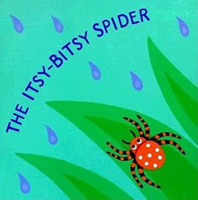
Oh, look out, here he comes again
The itsy bitsy spider went up the water spout
Down came the rain and washed the spider out
Out came the sun and dried up all the rain
And the itsy bitsy spider went up the spout again

Twinkle Twinkle Little Star
Twinkle, twinkle, little star,
How I wonder what you are.
Up above the world so high,
Like a diamond in the sky.
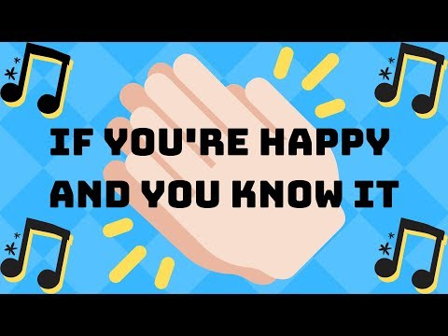
If You Are Happy and You Know It
If you are happy and you know it, clap your hands.
If you are happy and you know if, clap your hands.
If you are happy and your know it,
Then your face will surely show it.
If you are happy and you know it clap your hands.
(repeat with stomp your feet, shout hooray, do all three)

If You Want to See a Star
Sung to the tune of If You Are Happy and You Know It

If you want to see a star, look at me, look at me, look at me
I am special you will see, there is no one quite like me
If you want to see a star, look at me.

Open Shut Them
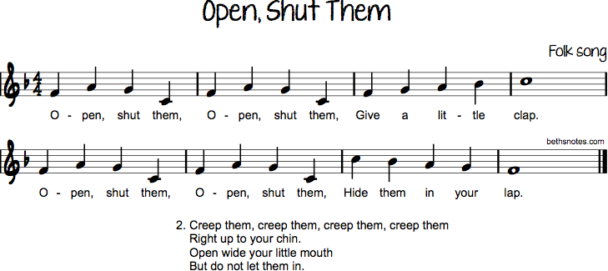
Open shut them, open shut them, give a little clap
Open shut them, open shut them, put them in your lap
Creep them, creep them, right up to your chin
Open up your little mouth, but do not let them in.

The Doors of the School
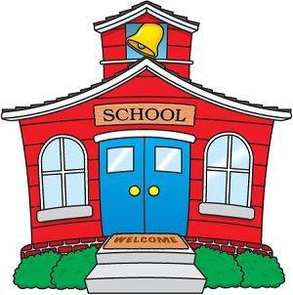
Sung to the Tune of the Wheels on the Bus
The doors of the school go open and shut, open and shut, open and shut
The doors of the school go open and shut every single day.

The teachers at the school say, “Come on in. Come on in. Come on in.”
The teachers at the school say, “Come on in” every single day.

The mommies at the school say, “Be back soon. Be back soon. Be back soon.”
The mommies at the school say, “Be back soon” every single day.

The children at the school say, “We’ll have fun. We’ll have fun. We’ll have fun.”
The children at the school say, “We’ll have fun” every single day.

The Fingerband
The fingerband is coming to town(3x) (hands moving from behind back to front)
The fingerband is coming to town so early in the morning.

This is the way they march and march(3x) (stretch out legs and march hands on legs)
This is the way they march and march so early in the morning.

This is the way they play their drums(3x) (open arms wide and clap hands together)
This is the way they play their drums so early in the morning.

This is the way they wear their hats(3x) (pointy fingers together above the head)
This is the way they wear their hats so early in the morning.

The fingerband is going away(3x) (hands move behind the back)
The fingerband is going away so early in the morning.

The fingerband has gone away(3x) (whisper)
The fingerband has gone away so early in the morning.

ABC Song
A - B - C - D - E - F - G
H - I - J - K - L - M - N - O - P
Q - R - S - T - U- V,
W - X - Y and Z.
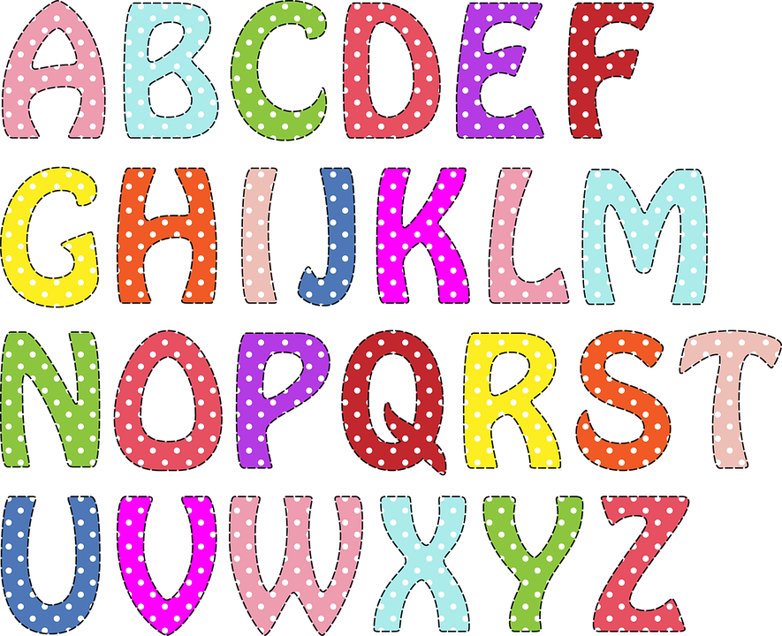
Now I know my ABC's
Next time won't you sing with me.

COLOR WEEKS
Each fall BHPCNS celebrates a color a week. We sing songs, have special snacks, play games, do crafts, to celebrate and learn our colors. Each color gets its own week and we focus on that color all week. At the end of the week the children wear that week’s color to school. They love to see all their classmates and teachers wearing the same color shirt. Here are the songs that we sing to accompany our color celebrations.

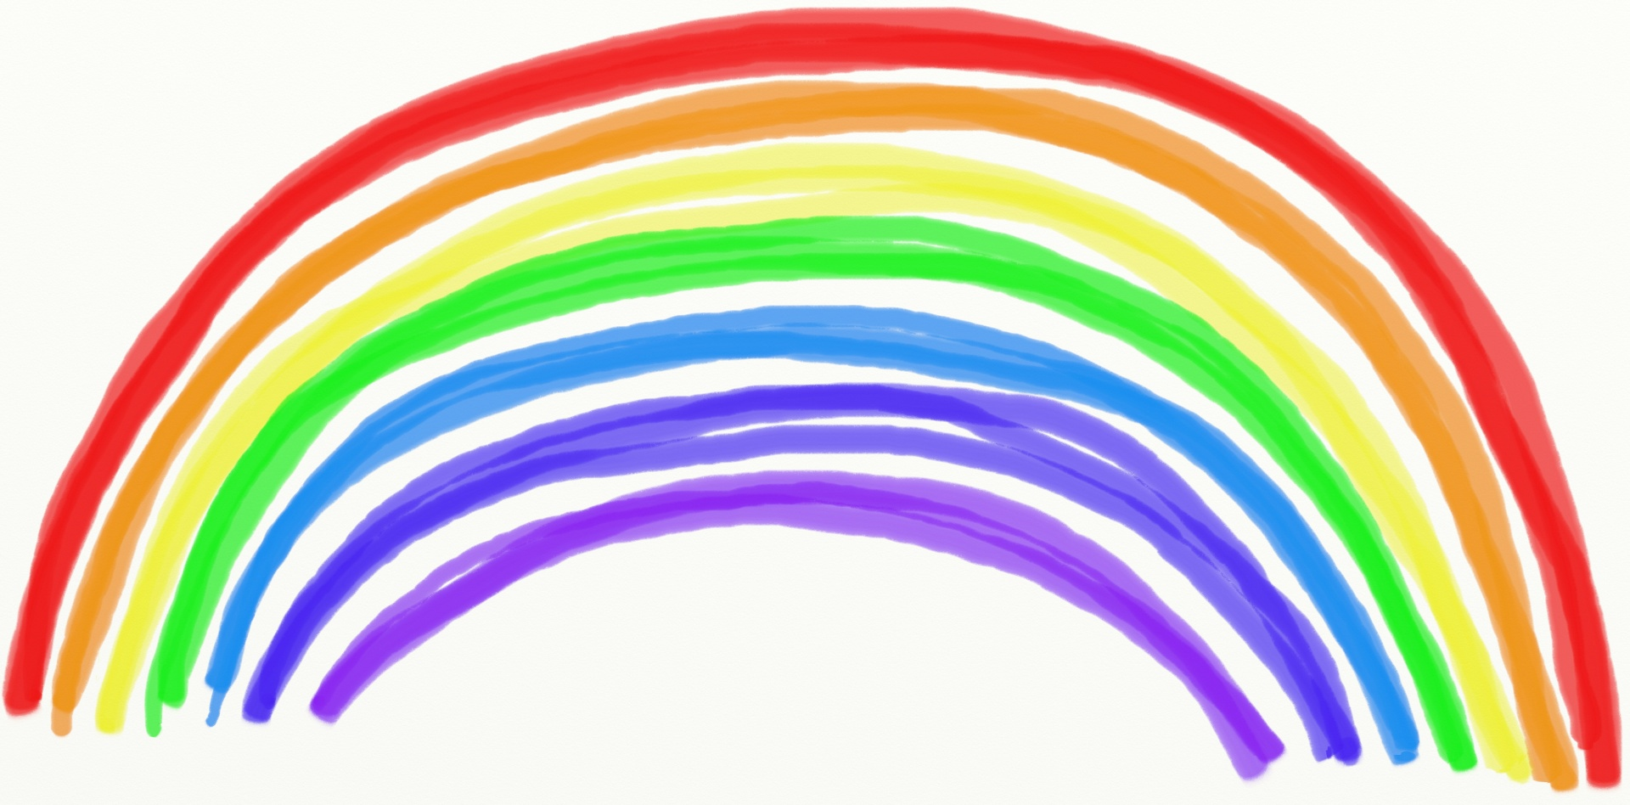
YELLOW Song
Sung to the Tune of If You’re Happy and you Know It
Y-E-L-L-O-W spells yellow
Y-E-L-L-O-W spells yellow
Like the early morning sun
When the day has just begun
Y-E-L-L-O-W spells yellow

BLUE Song
ORANGE Song
Sung to the Tune of Ten Little Indians
O-r-a-n-g-e
O-r-a-n-g-e
O-r-a-n-g-e
Orange is what that spells.
Jack-o-lanterns are always orange.
Carrots are always orange.
Oranges are always orange.
O-r-a-n-g-e

RED Song
Sung to: "Three blind mice"
R-E-D
R-E-D
Red is the word.
Red is the word.
Apples & Strawberries both are red.
Tomatoes & Cherries are also red.
R-E-D
R-E-D

Sung to the Tune of Are you Sleeping
B-L-U-E
B-L-U-E
That spells Blue
That spells Blue
Blueberries are Blue
Eyes & Skies are too
Blue, Blue, Blue

GREEN Song
Sung to the Tune of BINGO
There is a color that I know
and Green is its name-o
G-R-E-E-N
G-R-E-E-N
G-R-E-E-N
And Green is its name-o

PURPLE Song
Sung to the Tune of This Old Man
P-U-R-P-L-E
Spells the color Purple
Like the grapes on a vine,
Or flowers in the field
P-U-R-P-L-E

