# Eclipses and Yods May Validate the Time of Birth

### by Marguerite dar Boggia

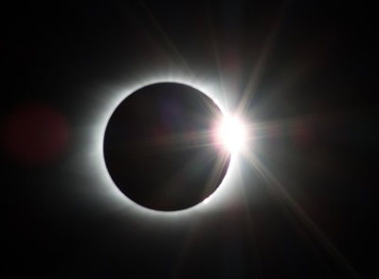 Many astrologers put up charts without giving the source of the data.  Was it from the parent, or letters or notes, or biography or from birth certificate?  Lois Rodden brought this to the attention of astrologers and did something about it. She created the AstroDatabank program which gave a rating to the data, according to the source of the information.  If the data was from the birth certificate, the rating was AA. Where there was dirty data, she sometimes supplied the alternative data.

I began to notice in death charts of friends and family, that there was an eclipse on the natal or the progressed MC/IC several years prior to the death.  The orb of the eclipse degree was not more than 4 degrees from the MC/IC.  I found that the effect of an eclipse can occur **three months before the eclipse date** and at least a year and a half to two years later.  If there are children in the family, many times the eclipse will occur on their MC/IC several years before the date of death or even three months before the death.

If there was no eclipse at all on the MC/IC, there was **a finger of god** **aspect** called a ‘yod’.  A yod is the tenth letter of the Hebrew Language. The aspect relates to destiny, or an important event and death certainly falls into that category.

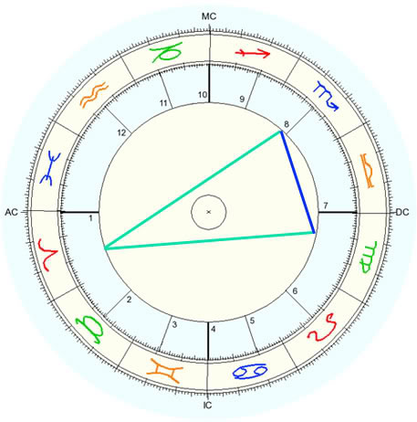The yod aspect is formed by two sextile planets with both quincunxing a third planet at the apex.  It forms a “V”. A yod is easier to find if there are additional meridians such as the equatorial ascendant and the vertex.  The equatorial ascendant is formed by the prime vertical meridian crossing the celestial equator.  The Vertex is formed by the prime vertical crossing the ecliptic.  The computer program gives this pertinent information.

You can use the midpoint of two planets to complete a yod. For instance, in my chart, I have Sun at 10 Capricorn and Mercury at 24 Capricorn.  To find the midpoint, just add the degrees of the two planets and then divide by 2. The midpoint of 10 Capricorn and 24 Capricorn, when added together and divided by 2, is 17 Capricorn.  17 Capricorn forms the apex of a yod with my natal Neptune (17 Leo) sextile Moon (17 Gemini); however, unless an eclipse aspects or a progressed planetary factor (planet, angle, node) conjoins one of the planets, nothing happens.

When my first husband died on Jan. 11, 1976 my progressed Venus was 17 Capricorn, at the apex of the yod.  Venus signifies partner, spouse or lover, the Moon denotes ‘end of life’. There was an eclipse on 1/30/72 (9:36 Leo) on my natal MC (9:22 Leo) approximately **three and a half years** before his date of death.

At the time of this writing, my progressed ascendant is 17 Capricorn, and that yod is again activated. How does one interpret the yod? What does Neptune and Moon rule in my chart? This is how a determination is made.  Neptune rules the 5th house of creativity. It is in the 10th house of work. Moon rules the 9th house of publication. It is in the 8th house of transformation. Suddenly New-Age Magazines have been publishing my articles.   
My second husband was Bennett Peterson, the former Treasurer of ISAR and of UAC.  He did not know his time of birth.  His parents had died before he became interested in astrology.  He found the time of his birth by sending through the mail a drop of his blood to someone who advertised in a publication.  The time he received was 9:49 PM, giving him a 220 Cancer ascendant.   He could not believe that this was correct; but it was.

At the time of his death on 6/21/1992, the lunar eclipse of 12/21/91 (29:08 Gemini) was on his **progressed** MC (28:41 Gemini).  He also had a finger of god aspect:  Progressed No. Node (20:56 Leo) was sextile to progressed Pluto (21:01 Gemini) and natal Pluto (22:31 Gemini) and both quincunxed progressed Moon (21:26 Capricorn). The Moon as ruler of the 4th house, signifies ‘end of life.’ Pluto relates to death and the Nodes have something to do with destiny.

In his daughter’s chart, the solar eclipse of 6/30/92 (8:56 Cancer) was on her progressed IC (8:59 Cancer).  She also had a yod: Progressed Mars (9:27 Leo) sextiled the midpoint of Sun (5:45 Gemini) and Mercury (12:18 Gemini) which midpoint is 9:01 Gemini. Progressed MC (8:59 Capricorn) was at the apex of the yod. Midheaven signifies parent. Mars rules her Scorpio MC. Mercury rules the 8th house of death.  He was very close to his daughter. His ascendant is on her descendant.

In his oldest son’s chart, the lunar eclipse (29:08 Gemini) aspected his natal IC (29:33 Gemini).  He also had a yod: natal Venus (29:47 Cancer) sextiled progressed Moon (28:04 Taurus) and both quincunxed natal MC (29:33 Sag.) (parent).

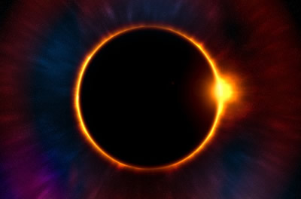In his younger son’s chart, there was an eclipse (23:30 Libra) on April 14, 1987 on the natal MC (21:29 Libra) **within five years** of the date of death.  There was a yod: Natal MC (21:29 Libra) sextiled progressed descendant (22:22 Leo) and both quincunxed natal Mercury (21:27 Pisces).  Mercury is co-ruler of the 8th house of death. MC relates to parent. There was an eclipse on 6/27/91 (5:07 Capricorn) that activated a yod involving the progressed No. Node (3:01 Gemini) sextile natal Saturn (2:45 Leo) with both quincunx natal ascendant (2:37 Capricorn). Saturn relates to Father. The ascendant applies to himself.

In my chart the lunar eclipse of 1/30/91 (9:43 Leo) was on my natal MC (9:22 Leo). The eclipse of 6/30/92 (8:56 Cancer) was on my Pluto (10:09 Cancer). Every eclipse on an MC also effects the IC,  which signifies family and/or the ‘end of life’. There was a change in the family relationship.

I wondered if this would demonstrate with grandchildren and great grandchildren.  Bennett had two grandchildren and two great grandchildren.   
For the older grandchild, the eclipse was on her natal IC. The eclipse of 7/11/91 was 18:59 Cancer. Her natal IC is 18:18 Cancer.

For the younger grandchild, the eclipse of 8/17/89 at 24:12 Aquarius was on his MC (25:51 Aquarius).

For the older great grandchild, the eclipse of 3/29/87 at (8:18 Aries) was on her progressed IC (4:49 Aries). She had a yod. Declination antiscia Jupiter (6:02 Virgo) sextiles natal Pluto (7:09 Scorpio) and both quincunx natal No. Node of the Moon (7:23 Aries).  Pluto signifies death.

For the younger great grandchild, the eclipse of 12/21/91 (29:08 Gemini) was on his progressed MC 28:02 Gemini.  He also had a yod with natal IC (25:51 Leo) at the apex of a yod, quincunx the declination antiscia1 Mercury (24:41 Capricorn) sextile to declination antiscia Venus (25:48 Pisces). Mercury rules the Gemini ascendant, which signifies the grandparent. There was a solar eclipse (25:20 Capricorn) on 1/15/91 on Mercury.

Planets form parallel aspects when they share the same degree of declination north or south of the celestial equator. A declination equivalent planet, is when the planet’s degree of latitude above or below the celestial horizon is converted into a degree of longitude along the ecliptic.  This also applies to a declination antiscia planet. Computer software will do this for us.

All of the charts were configured by solar arc secondary progression to 6/21/92, the date of Bennett’s death. All of the charts had an eclipse prior to the date of death. The eclipse may occur even five or six years before the death.

When you think of all the aspects and degrees of the planets and how they correlate to life events, you have to marvel at the wisdom of the Creator of the Universe and to love astrology.

**Note**:  
1Christen, Gary  Important Points in a Chart, Essentials of Intermediate Astrology, 1995 USA by NCGR, Inc.  Antiscia p.107

**Chart data and sources**:  
**Bennett Peterson**, October 28, 1905 9:49 PM, time zone 06:00(CST) Minneapolis, Minnesota (93W18’06”; 44N59’48”) time from drop of blood. Ascendant 22:18 Cancer.  
**Daughter**, May 26, 1940 11:02 PM, time zone 06:00 (CST), Minneapolis, Minnesota (93W18’06”; 44N59’48) from birth certificate; (Ascendant 21:36 Capricorn)  
**Oldest Son**, June 07, 1943 2:12 AM, time zone 05:00 (CWT) Minneapolis, Minnesota (93W18’06”; 44N59’48”) from birth certificate; (Ascendant, 29:04 Pisces)  
**Younger Son**, March 04, 1947, 2:28 AM, time zone 08:00 (PST) Santa Monica, California, (118W29’12”; 34N01’30”) from birth certificate. (Ascendant 02:37 Capricorn)  
**Marguerite dar Boggia**, January 1, 1923, 02:03’32” AM, time zone 05:00 (EST) New York City, NY, (73W59’30”; 40N45) from Mother for 2 AM, then rectified to 2:03:30 AM. Ascendant 3 Scorpio  
**Granddaughter,** March 26, 1962, 6:58 AM, time zone 08:00 (PST) Glendale, California (118W15’18”; 34N09’54”) from birth certificate.  Ascendant 29:45 Aries.  
**Grandson,** November 6, 1964 6:41 PM, Van Nuys, California, time zone 08:00 (PST) (118W28’12”; 34N10’36”) from birth certificate. Ascendant 15:49 Gemini.  
**Older Great Granddaughter,** July 10, 1987, 5:43 PM, Santa Paula, California, time zone 07:00 (PDT) (119W04’; 34N21’) from birth certificate. Ascendant 14:52 Sagittarius.    
**Great Grandson**, July 09, 1989 11:30 AM, Santa Maria, California, time zone 07:00 (PDT) (120W23’30”; 34N55’06”) from birth certificate.  Ascendant 25:38 Virgo.

**Image sources**:  
Yod: Richard Vetter, AstroWiki  
Eclipses: CC0 Creative Commons license, via pixabay.com

**Author:**  
**Marguerite dar Boggia** formerly served as Membership Secretary for ISAR, the International Society for Astrological Research. She was past Secretary and Director of ISAR and Publisher of Kosmos, the ISAR journal. She was a co-founder of UAC and its past Secretary and Director. She can be contacted at her website which she created at the age of 90: [www.FreePythagorasTeachings.com](http://www.FreePythagorasTeachings.com/)