As indicated in the updated graphic below, we are now arriving at the culmination of events involving Pluto, the Moon, Jupiter, Eclipse Sequences, Atomic Energy, Islam,and end times Babylon the Great.

Ancient Babylon was conquered in one night by King Cyrus the Persian. The name "Cyrus" means "like the sun", which is a description of an exploding nuclear device. The ancient Persia of King Cyrus is now modern day Iran, and modern Babylon the Great is currently being set up for destruction by the descendants of ancient Persia using a weapon that is "like the sun". Bible prophecy tells us that modern Babylon the Great will be destroyed by fire in one hour.

A nuclear agreement between certain World Powers and Iran has been reached today 7/14/2015, after bargaining for about 7 years since 2008. That fact coupled, with the New Horizons spacecraft flying past the planet Pluto (for which the element plutonium was named) also on 7/14/2015 after flying through space for 9 1/2 years, reveals an alarming coincidence. Both of these important events, culminating on the same day after many years, have rightly captured the attention of the global media. The attention given them indicates the status of their importance. These events exhibit the precise timing and "coincidence", to the very day, that only an Almighty Sovereign, our heavenly Father, can supply. I believe they were ordained by our heavenly Father to coincide at this time for a reason, as a sign and a warning to the nations. These, and other related events, are now coming to culmination as indicated in the timeline below.

Here's an updated graphic that illustrates some similarities between the Hebrew calendars in the 1st and 7th months and this current Roman calendar 7th month of July.

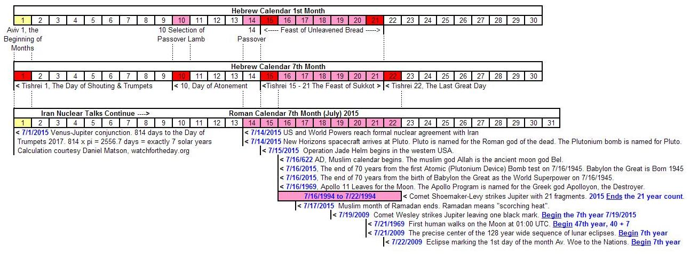

Note that there's a 7th one year period year that begins next week for four of the items at the bottom of the list. The king of ancient Babylon was given one year warning to repent of his sins of arrogance before he was judged by heaven and went insane like a beast for 7 years. - Daniel Chapter 4

NASA is having its' closest look at the planet Pluto as the New Horizons spacecraft flys by the planet today, July 14, 2015. The planet Pluto is named after the Roman god of the dead. Pluto's largest moon Charon is named after the Greek demon that ferried people to the underworld. This sets the mood for what's coming.

July 16, 2015, marks the 70th anniversary of the successful test of the first atomic device, which was a plutonium device. Of the two devices dropped on Japan, one was a uranium device, the other was plutonium. The Trinity Test in Nevada marked the birth of Babylon the Great as the World Superpower. Babylon the Great is also reaching maturity at 70 years of age on July 16, 2015.

I don't think Iran could currently by itself destroy the entire USA, but allied with Russia and China it might.

From the "Handwriting on the Wall" episode of ancient Babylon and Daniel, Persia took the city of Babylon without a fight. That might happen to Babylon the Great (NYC) in the future by the use of only a few nuclear devices and blackmail. It only took 2 cities for Japan to surrender. Two or three cities gone in this country and our government would probably surrender to Sharia Law, and perhaps Islamic taxation. I don't know that the real Christians would surrender to Sharia, but most people probably would just to save their lives.

However, the book of Revelation says that Babylon the Great will be completely destroyed in one hour by fire by missiles coming from the north (over the north pole). Jeremiah 50:9 says the arrows will come from the north to destroy Babylon and none will fail, perhaps from Russia, China, North Korea, or Iran if it has a capable missile. Jeremiah 50:14 says the arrows will come from all around Babylon (perhaps from submarines, etc.). Jeremiah 50 has to be referring to endtimes Babylon because ancient Babylon was taken without a fight.

Drew Simmons has settled upon 6/5/2016 for the destruction of NYC. Coincidentally, 6/5/2016 is also the center date of the inner eclipses of the Four TAVs solar eclipses that have to do with Russia, the United States, and nuclear energy part way down this page: http://www.joybysurprise.com/Sign_of_Messiah_s_Return.html

The Four TAVs information indicates that Russia is the one to destroy Babylon.

These are all indications from the Bible and signs that point to what might be coming. I'm not a prophet. I just hope to hear from YaHuWaH Elohim, warn others, and get out of the way.

