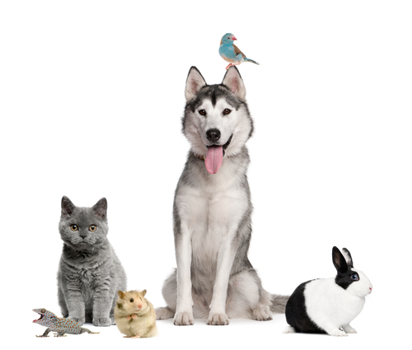
Tail Waggin Good Pet Services
“Happy Pets…One Tail at a Time”

Veterinary Release Agreement

In the event that any of my pets appears to be ill, injured, or at significant risk of experiencing a
medical problem at the start of service, or while in the care of Tail Waggin Good Pet Services L.L.C.., I give permission to Tail Waggin Good Pet Services L.L.C.. to seek veterinary service from a veterinarian or a veterinary clinic. My preferred veterinary services are listed on each individual Pet Information Disclosure. Other veterinarians or emergency care clinics chosen by the pet sitter are acceptable.

I ask Tail Waggin Good Pet Services L.L.C. to inform the attending clinic or veterinarian of my requested total diagnosis and treatment limit of $_____________ per pet / all pets (most common values are $200, $1000, or unlimited). I understand that efforts will be made to contact me regarding any treatments, illness, injury, or potential problems as soon as the condition is deemed not life threatening and/or contact is possible. I understand that Tail Waggin Good Pet Services L.L.C. care providers work hard to prevent accidents and injuries, and that such problems may occur no matter how well a pet is cared for. I agree to allow Tail Waggin Good Pet Services L.L.C. care providers to use their best judgment in handling these situations, and I understand that Tail Waggin Good Pet Services L.L.C.. and its staff assume no responsibility for the actions and decisions of the veterinary staff, the health, or death of my pet(s).

I will assume full responsibility for the payment and/or reimbursement for any and all veterinary services rendered, including but not limited to diagnosis, treatment, grooming, medical supplies, and boarding. Such payments will be made within 14 days of the initial incident. I also agree to be responsible for all Special Service fees assessed by Tail Waggin Good Pet Services L.L.C. for emergency transportation, care, supervision, or hiring of emergency caregivers, and will pay such fees within 14 days of each incident.

I further authorize Tail Waggin Good Pet Services L.L.C. and my primary veterinarian(s) to share all of the medical records of all of my animals with veterinary clinics in an emergency in the interest of providing the best care for my ill or injured animal(s).

Every dog or cat, at the site of service will be current (per my veterinarians recommendations) on its rabies vaccinations prior to the arrival of any caregiver. I will also make arrangements to guarantee that each animal will remain current on its rabies vaccinations throughout each service visit period.

I agree to notify Tail Waggin Good Pet Services L.L.C. of any signs of injury or possible illness before any visit as soon as the condition appears. Tail Waggin Good Pet Services L.L.C. reserves the right to cancel service at any location where a pet with a potentially infectious condition exists. Tail Waggin Good Pet Services L.L.C. strives to provide clean, safe service to each of our clients. In doing so, Tail Waggin Good Pet Services L.L.C. strongly recommends that each pet be vaccinated, de-wormed, and protected from harmful insects according to veterinarian recommended standards.

This agreement is valid from the date below and grants permission for future veterinary care without the need for additional authorization each time Tail Waggin Good Pet Services L.L.C.. cares for one or more of my pets. I understand that this agreement applies to all of the pets within Tail Waggin Good Pet Services L.L.C. care. In signing this contract, I agree that I have the sole authority to make health, medical, and financial decisions regarding the animals that will be scheduled to receive service.

Client Signature: _________________________________________ Date: _________________

