Mars UP Church

Apostles’ Creed
I believe in God the Father Almighty, Maker of heaven and earth; and in Jesus Christ His only Son our Lord; who was conceived by the Holy Ghost, born of the Virgin Mary, suffered under Pontius Pilate, was crucified, dead and buried; He descended into hell; the third day He rose again from the dead; He ascended into heaven, and sitteth on the right hand of God the Father Almighty; from thence He shall come to judge the quick and the dead. I believe in the Holy Ghost, the holy catholic church; the communion of saints; the forgiveness of sins; the resurrection of the body; and the life everlasting. Amen.

Gloria Patri
Glory be to the Father, and to the Son, and to the Holy Ghost. As it was in the beginning, is now and ever shall be,
world without end.
Amen. Amen.

Come Holy Spirit, Come
Before the Service – Speak to God!
During the Service – Let God speak to you!
After the Service – Speak to each other!

(*Please stand, if able)
Welcome and Mars Messages

Prelude

*The Call to Worship
Leader: I was glad when they said to me, “Let us go to the
house of the living God.”
People: This is the day when we rejoice in God’s act of
creation.
Leader: This is our Sabbath, when we rejoice in the
resurrection of Jesus the Christ.
People: We give thanks that once more, God has brought
us together, that we might be refreshed in him.
Leader: Peace to all who enter here, blessing to all who go
from here on their way, let us worship God!

*Hymn 705
“It is Well with my Soul”

Call to Confession

Prayer of Confession
Merciful God, You call us to be salt of the earth and light of the world. We confess that our witness is often bland and gloomy. Forgive us when we fail to be an influence for good, and when we condone or do what is wrong in Your sight. Help us to flavour the earth with righteousness and to reflect the light of Your love in a dark world; through Jesus Christ, the Light of the world.

The
Lord’s Prayer

Our Father,
who art in heaven,

hallowed be Thy
name,

Thy kingdom come,
Thy will be done,
on earth
as it is in heaven.

Give us this day
our daily bread;

and forgive us
our debts,
as we forgive
our debtors;

and lead us not
into temptation,
but deliver us
from evil.

For Thine
is the kingdom,
and the power,
and the glory,
forever. Amen.

The Doxology

Praise God
from whom
all blessings flow;
praise Him
all creatures
here below;
praise Him above,
ye heavenly host;
praise Father, Son,
and Holy Ghost.
Amen.

Assurance of Pardon

Gloria Patri
Children’s Chat

Scripture Micah 6:1-8

Morning Message Rev. Brian Hauser
“Talking and Walking”

*Hymn Insert
“Morning Has Broken”

Prayers of the People and Lord’s Prayer

Offering
Offertory
*Doxology
*Offering Prayer

*Hymn 562
“Be Thou My Vision”

*Benediction

*Postlude
Today we welcome Michelle Manukas, our music accompaniment for worship.

Originally from Mars, Pennsylvania, Michelle Manukas is currently a senior at Duquesne University studying flute performance under Pittsburgh Symphony Orchestra’s piccolos, Rhian Kenny. Her first two years of undergraduate study began at Penn State University studying under Dr. Naomi Seidman.
She has played most recently in the Duquesne Symphony Orchestra as well as in the Duquesne Chamber Orchestra - most notable of this year’s highlights were performing Prokofiev's Symphony No.5, Franck's Symphony in D minor, and The Sorcerer's Apprentice by Dukas. In 2021, Michelle branched out her skills into social media and digital marketing through a work study position and is now incorporating this avenue into her career.
Church Staff
Rev. Brian Hauser
Pastor
pastor@mars-up.org
724-689-3412

Mrs. Shelly Bocheff
Administrative Assistant
marsup@mars-up.org

AV TEAM
Alma Staskiewicz, Lisa Barbour, Marie Matthews, Bill Guesman, John Ivory, Mike Bocheff, Herb Wellman

Mars United Presbyterian Church

232 Crowe Ave
PO Box 805
Mars, Pennsylvania 16046
724-625-1365
www.mars-up.org
marsup@mars-up.org

Church Office Hours:
Mon -Thurs from 9 a.m. -2:30 p.m.

MUP Session

Class of 2025 Class of 2024 Class of 2023
John Ivory Alma Staskiewicz Lisa Barbour
Susan Cox Louise Fox Mary Ann Croop
Jay Wilson Marie Matthews Don Lewis
Herb Wellman

Clerk of Session: Herb Wellman

MUP Deacons

Class of 2025 Class of 2024 Class of 2023
Jill Cooper Steve Martin Sharon Gibbs
Robyn Beckwith Marge Nicklas Carol Kopar
Missy Wells Pat Auld Alice Leonberg

Moderator: Steve Martin

Morning Worship:
10:00 am

4th Sunday after the Epiphany

Prayer of Preparation
Lord, we come to you today with so many things on our hearts.

You call us to be in relationship of trust and love with you and you offer healing to us for those portions of our lives that are broken and injured.

Help us to be open to your mercy and healing love. For we ask this in Jesus’ Name.
AMEN.

Mars United Presbyterian Church
Welcome!

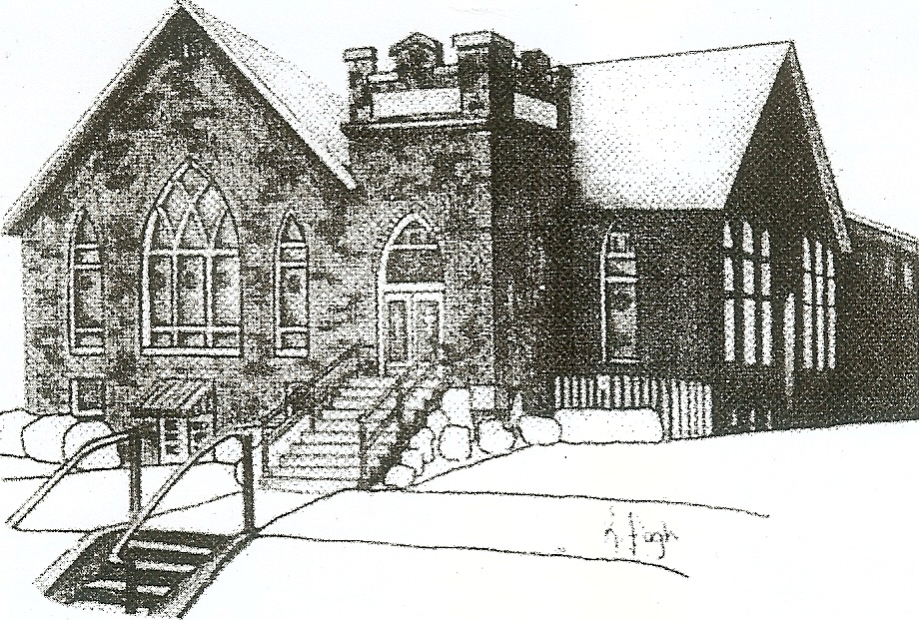
We are your hometown church: Faithful to Tradition, Loving in Fellowship, & Reaching for Tomorrow!

January 29, 2023

We welcome you and we are glad you’ve chosen to Worship with us today!

CALENDAR: January 29th – February 5th

Church Office Hours: Monday -Thursday from 9 a.m. – 2:30 p.m.

Today, January 29, 2023
VOLUNTEERS☺

LAST SUNDAY’S In-House ATTENDANCE: 59

LAST SUNDAY’S OFFERING:
Operating Funds: $2645.00
Kindness: $50.00
Mission: $60.00
Per Capita: $262.85
Total: $3017.85

Tarry N Talk Hosts
Stewardship Committee

9:00 am Sunday School Hour
10:00 a.m. THE MORNING WORSHIP SERVICE
Monday, January 30, 2023
9:00 am Kitchen Cleaning Day
Tuesday, January 31, 2023
9:00 am A team
7:00 pm AA
Wednesday, February 1, 2023
9:00 am Material Girls
Thursday, February 2, 2023
Friday, February 3, 2023
6:30 pm Family Game Night
Saturday, February 4, 2023
Sunday, February 5, 2023
9:00 am Sunday School Hour
10:00 am THE MORNING WORSHIP SERVICE
11:15 am Congregational Meeting- Annual Report
11:15 am Deacon Meeting
1:00 pm Youth Group

Welcome to all who are Worshiping with us today!

Guests
We sincerely hope our service is a blessing to you. We ask that our guests please take a few minutes to complete one of the Connect Cards found in the pew holder.

Should you have questions regarding any aspect of our church, including membership, please contact Pastor Brian or the church office during the week at 724-625-1365. Thank you for being with us today.

PRAYER – JOYS & CONCERNS
Lou Beckwith Paige Lauten
Paige Barbour (daughter of Andrew and Steph Barbour) Sandy Wahl
Reid Christopher Hall (June Stirling’s nephew)
Lindy McCartney (Lisa Barbour’s Sister)

ANNOUNCEMENTS
Bulletins are printed Thursday mornings; let us know if you have an announcement
…
2022 GIVING STATEMENTS are available in Tarry N Talk. To help defray mailing costs please take your copy with you. Thank You
PER CAPITA ASSESSMENT
It is that time of year, our individual Per Capita Assessment is due to the Butler Beaver Presbytery. We are requested to pay $43.77 to them per member of congregation of confirmation age and older. You can place your assessments in the offertory and ear mark it for your Per Capita Assessments. The BBP help provide support in negotiating salaries, insurances and pensions with our pastors and employees. Most importantly they provide a resource for us to tap into when we are in need of guidance. Please consider paying your Per Capita Assessment as soon as possible as we partner with our Presbytery to become stronger, smarter and more cohesive. As always, we give thanks for your generosity and support.
KITCHEN CLEANING DAY It has been quite a while since the church kitchen has had a good cleaning. The Deacons have decided to meet on Monday, January 30th at 9am to clean and organize the church kitchen. They are hoping to only need a couple of hours to make the kitchen sparkling new again. Hope to have many hands to help. All welcome!!
GAME NIGHT Calling our Mars UP Church family! Join us for a night of building relationships over games and fun. Whether you’re young or young at heart, we’ve got a space for you. This game night come ready to play cards, board games, Cornhole, or even Pictionary! See you on Friday, February 3rd at 6:30 pm in the Fellowship Hall
CONGREGATIONAL MEETING There will be a Congregational meeting on February 5th, 2023 after worship to discuss the annual report from 2022.
MSPS It’s that time again for those early preschool Sign-ups! Early registration is available for MUP church members and those MOPS members. Registration will be held on Monday, February 6th from 1:30 to 2:00pm. Questions? Please contact Heidi Beahm at 724-272-9911
MUP SKI TRIP It’s that time again! Time for Mars UP Church to take to the slopes for an exciting day of fun and fellowship together at Peak N Peak Ski Resort! The date of the ski trip will be Saturday, February 11th. This event is open to all!!! We will leave the church at 7:00am and ski/snowboard for the day. Watch for more details to follow or talk to Pastor Brian.

