***Louisiana Strawberry Fundraiser Order Form***

*Carona Farms*

*Independence, LA*

***We are hoping to create a traffic "JAM" with this EASY and DELICIOUS fundraiser!***😂😂😂

Mandeville High Band musicians are selling delicious flats of strawberries to help fund the MHS Skipper Band.

🍓Strawberries are sold in **whole 8-pound flats** for $**35**, and they are DEEE-licious!

🍓**Orders *with payment* are due on Thursday, April 24**.

🍓Each band member will pick up their complete order on Saturday, May 3 between 10:00-noon at the MHS parking lot near ticket building. We recommend you deliver them to your customers immediately following the pickup.

🍓We ask that payments in the form of cash or check payable to SKIPPER BAND BOOSTERS.

🍓We are asking each band member to sell at least one flat.

We thank you and appreciate your commitment so much!

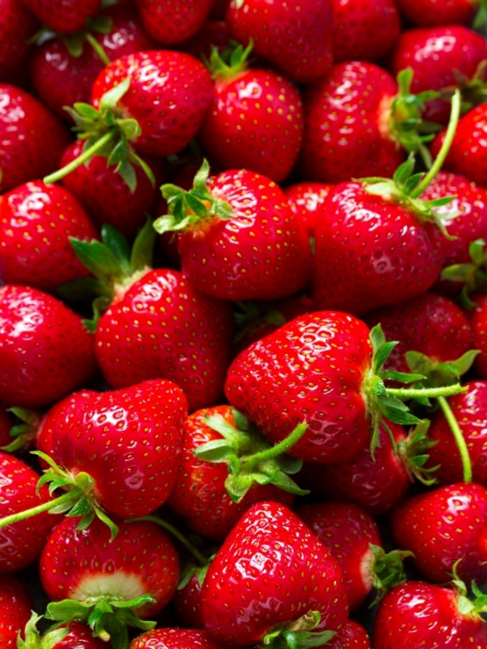

***Louisiana Strawberry Fundraiser Order Form***

*Carona Farms*

*Independence, LA*

|  |  |  |
| --- | --- | --- |
| **Customer Name & Phone Number** | **# of flats** | **Amount Collected** |
|  |  |  |
|  |  |  |
|  |  |  |
|  |  |  |
|  |  |  |
|  |  |  |
|  |  |  |
|  |  |  |
|  |  |  |
|  |  |  |
|  |  |  |
|  |  |  |
|  |  |  |
|  |  |  |
|  |  |  |
|  |  |  |
|  |  |  |
|  |  |  |
| **Totals** |  |  |

**# of flats Amount collected**

\***Orders/payment due on Thursday, April 24. Band members pick up orders on Saturday morning, May 3 between 10:00-noon at MHS parking lot nearest ticket booth.**