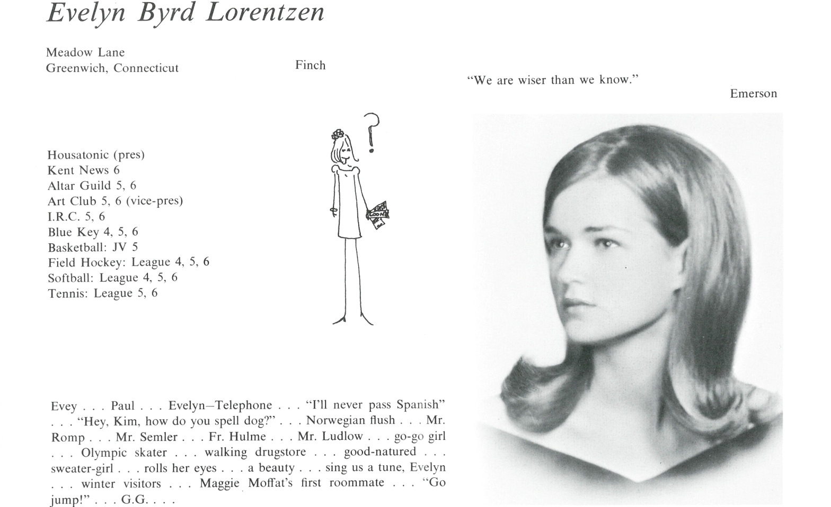

Evelyn B. Lorentzen Bell

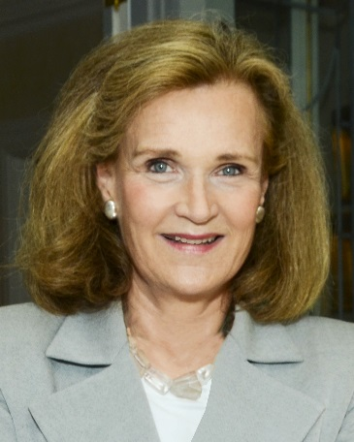I have done a lot since I graduated from Kent. Had a career in textiles and special events while working for Harper’s Bazaar, Hoechst Celanese Corporation, Marshall Fields, and Merchandize Mart. Volunteered for great philanthropic institutions and had my own jewelry and interior design businesses. Currently, I am a photography judge with Garden Club of America. I enter my photography in competitions, lecture and teach photography all over the country.

My daughter, Byrdie Bell, is an actress living in Los Angeles. I have lived in New York, Chicago, and London. At present I live in Greenwich, Ct and New York City.

Upon reflection, my years at Kent were “Happy Days” because of all of you. It has been such fun to connect with many of you. I often think of those I have not seen since graduation. We have not aged but only become wiser, more experienced.



______________________________________________________________

______________________________________________________________ ______________________________________________________________ ______________________________________________________________ ______________________________________________________________ ______________________________________________________________ ______________________________________________________________ ______________________________________________________________ ______________________________________________________________

Attach Picture in .jpg Format

______________________________________________________________

______________________________________________________________

___________________________________________________________________________________ _________________________________________________________________________________________________________________________________________________________________________________________________________________________________________________________________________________________________________________________________________________________________________________________________________________________________________________________________________________________________________________________________________________________________________________________________________________________________________________________________________________________________________________________________________________________________________________________________________________________________________________________________________________________________________________________________________________________________________________________________________________________________________________________________________________________________________________________________________________________________________________________________________________________________________________________________________________________________________________________________________________________________________________________________________________________________________________________________________________________________________________________________________________________________________________________________________________________________________

___________________________________________________________________________________