ROADMAP TO CAA CERTIFICATION  Certified Athletic Administrator | 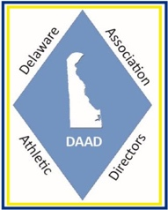  DAAD
