 **Triple T Sports Center**

**Summer School Age Sports Day Camp**

**2023 Registration**

|  |  |  |  |  |  |  |  |  |  |  |  |  |
| --- | --- | --- | --- | --- | --- | --- | --- | --- | --- | --- | --- | --- |
|  | **SB** | **WK 1** | **WK 2** | **WK 3** | **WK 4** | **WK 5** | **WK 6** | **WK 7** | **WK 8** | **WK 9** | **WK 10** | **WK 11** |
| **CAMP WEEKS** | **APRIL 10-14** | **June 19-23** | **June 26- June 30** | **July 3-7** | **July 10-14** | **July 17-21** | **July 24-28** | **July 31- Aug 4** | **Aug 7-11** | **Aug 14-18** | **Aug 21-25** | **Aug 28- Sep 1** |
|  |  |  |  |  |  |  |  |  |  |  |  |  |
| **Mon** | F | F | F | X | F | F | F | F | F | F | F | F |
|  |  |  |  |  |  |  |  |  |  |  |  |  |
| **Tues** | F | F | F | F | F | F | F | F | F | F | F | F |
|  |  |  |  |  |  |  |  |  |  |  |  |  |
| **Wed** | F | F | F | F | F | F | F | F | F | F | F | F |
|  |  |  |  |  |  |  |  |  |  |  |  |  |
| **Thrs** | F | F | F | F | F | F | F | F | F | F | F | F |
|  |  |  |  |  |  |  |  |  |  |  |  |  |
| **Fri** | F | F | F | F | F | F | F | F | F | F | F | F |
|  |  |  |  |  |  |  |  |  |  |  |  |  |

**Triple T Sports Center Summer Sports Day Camp Open to Ages 4-12**

**\*Full Day Camp Hours 6:00am-6:00pm**

**\*Late fee will be charged if campers are not picked up on time, $10, and $5 each additional 15 mins.**

**Full Day Campers Brings 2 Snacks & Lunch**

I hereby authorize the staff of Triple T Sports Center to act for me according to their best judgment in any emergency requiring medical attention and hereby waive & release owners, agents, volunteers, and staff of Triple T Sports Center from any and all liability for any injuries or illnesses incurred while at camp. I understand that participation in gymnastics and other sports/activities involves motion and as such carries with it the risk of injury or death. Triple T and camp staff are not responsible for personal items that are lost, stolen or damaged. All medical expenses as a result of injury or illness during all camp activities are the responsibility of the parent or guardian of registered camper. In lieu of medical certificate signed by a medical doctor, I have no knowledge of any physical or mental impairment that would be affected by the named camper’s participation in the camp program. I also understand and agree that camp retains the right to use any photographs, videotapes, motion picture recordings, or any other record of this event for publicity, advertising, or any legitimate purpose.

Child’s Name__________________________________ M/F Age___________ DOB______________

Medical Conditions/Allergies __________________________________________________________________________

Primary Guardian Name ______________________________________________________________________________________

Home Phone (____) ______-_______Cell Phone (____) _____-______Work Phone (___) ______-_________

EMAIL: __________________________________________________________________________________

***Camp Registration Fee and $35 Deposit (each week) Required at Registration-**No Refunds on Camp Registration or deposit\*\****

I understand that camp balances are due the Wednesday prior to camp week each week.

______________________________________________ ____________________

Signature Date

*This is a legal document and must be signed by parent or legal guardian only. By signing above, you are stating that you fulfill this requirement.

Total Paid ____________ Form of Payment ___________ Date ____________ Rec’d by __________ Forms Complete ______

Shirt Size______ Extra Shirts $(20x # shirts) $_____ T-shirt(s) rec’d **___________ Fieldtrip Fee ____**

**Required Forms: Birth Certificate ________ Shot Record _______ Most Recent Physical ________**

**Medication Forms: __________** **Medication (in original container with prescription on it): _________**

Triple T Sports Center

619 E. Constance Rd Suffolk, VA 23434

WAIVER AND RELEASE OF LIABILITY

DISCLAIMER: TRIPLE T GYMNASTICS SPORTS CENTER IS NOT RESPONSIBLE FOR ANY INJURY (OR LOSS OF PROPERTY) TO ANY PERSON WHILE PRACTICING, TRAINING, TAKING CLASS, PARTICIPATING IN OPEN GYM, CAMP, BIRTHDAY PARTIES, TUMBLEBUS, SPECIAL EVENTS, FIELD TRIPS, DEMONSTRATIONS OR SHOWS, OR IN ANY OTHER WAY INVOLVED IN GYMNASTICS, CHEERLEADING, TUMBLE, NINJA, DANCE, TAEKWONDO, PRESCHOOL, OR TEAM AT TRIPLE T CLUB FOR ANY REASON WHATSOEVER, INCLUDING ORDINARY NEGLIGENCE ON THE PART OF TRIPLE T, ITS OWNERS, OFFICERS, AGENTS, OR EMPLOYEES.

In consideration of my participation, I hereby release and covenant not-to-sue Triple T Sports Center , LLC, the Triple T Parent’s Association, or any of their employees, teachers, coaches, or agents, from any and all present and future claims resulting from ordinary negligence on the part of Triple T Sports Center, LLC or others listed for property damage, personal injury, or wrongful death, arising as a result of my engaging in or receiving instruction in gymnastics, cheerleading, or any other activities incidental thereto, wherever, whenever, or however the same may occur. I hereby voluntarily waive any and all claims resulting from ordinary negligence, both present and future, that may be made by me, my family, estate, heirs, or assigns.

Further, I am aware that gymnastics, karate, dance, ninja, and cheerleading are vigorous sporting activities involving height and rotation in a unique environment and as such they pose a risk of injury. I understand that gymnastics, cheerleading, and related activities always involve certain risks, including but not limited to, death, serious neck and spinal injuries resulting in complete or partial paralysis, brain damage, and serious injury to virtually all bones, joints, muscles, and internal organs, and that the mats, pits, and other safety equipment and apparatus provided for my protection, including the active participation of a coach or teacher who will spot or assist in the performance of certain skills, may be inadequate to prevent serious injury. The risk of harm may be limited by all of the safety equipment and trained coaches, but never eliminated. I understand that participation in gymnastics and related activities involves activities incidental to active participation in gymnastics, including moving from event to event, conditioning, stretching, and other activities which may leave me vulnerable to the reckless actions of other participants who may not have complete control over their actions or who may not see other students in the gym. Student is voluntarily participating in this activity with knowledge of the risks involved and hereby agree to accept any and all inherent risks of property damage, personal injury, or death.

Participation includes possible exposure to and illness from infectious diseases including but not limited to MRSA, influenza, and COVID-19. While particular rules and personal discipline may reduce this risk, the risk of serious illness and death does exist; and,

I willingly agree to comply with the stated and customary terms and conditions for participation as regards protection against infectious diseases. If, however, I observe any unusual or significant hazard during my presence or participation, I will remove myself from participation and bring such to the attention of the nearest staff member immediately; and,

I, for myself and on behalf of my heirs, assigns, personal representatives and next of kin, further agree to indemnify and hold harmless Triple T Sports Center and all others listed for any and all claims arising as a result of my engaging in or receiving instruction in Triple T Sports Center LLC, activities or any activities incidental thereto, whenever, whatever, or however the same my occur.

I understand that this waiver is intended to be as broad and inclusive as permitted by the laws of the state of Virginia and agree that if any portion is held invalid, the remainder of the waiver will continue in full legal force and effect. I further agree that the venue for any legal proceedings shall be within the state of Virginia.

I affirm that I am of legal age and am freely signing this agreement. I have read this form and fully understand that by signing this form, I am giving up legal rights and or remedies, which may be available to me for the ordinary negligence of Triple T Sports Center, LLC, or any person listed below.

I also consent to the use, by Triple T Sports Center, or anyone it authorizes, of any and all photographs, tapes, or other representations, and any reproductions thereof for the purpose of promotion (including sale, publication, display and exhibition) without compensation. The member further consents to the use of the member’s name in connection with such materials, and agrees that such materials and negatives shall constitute Triple T Sports Center property, with full right of distribution.

__________________________________ _________________________________ ______________

* (Signature of Parent or Legal Guardian) Printed Name Date

*This is a legal document and must be signed by parent or legal guardian only. By signing above you are stating that you fulfill this requirement.

______________________________________

(Printed Name of Participant)

**Triple T Sports Center**

**Day Camp Medical Release Form**

**(All Information Very Important-Please Fill Out Completely)**

Child’s Name

______________________________________ DOB ___________ Age __________

Medical Conditions / Restrictions / Allergies: (all medicines kept at TTT require med admin form – if prescription needs to be completed by physician) _____________________________________________________________________

_____________________________________________________________________

Medications: __________________________________________________________

Special Instructions: _____________________________________________________________________

_____________________________________________________________________

**Physician ___________________________________ Telephone # (_____) _______-_________**

**Dentist _____________________________________ Telephone # (_____) _______-_________**

**Primary Email: __________________________________________________________________**

Father: ______________________________________________________________

Address ______________________________________________________________

City _____________________________________State__________ Zip___________

Home (____) ______-______ Cell (____) _____-______ Work (____) _____-______

Mother: ______________________________________________________________

Address (if different) ________________________________________________________

City _____________________________________State__________ Zip___________

Home (____) ______-______ Cell (____) _____-______ Work (____) _____-______

**Code Word ______________________________________________________________**

(This word is used to verify your authorization for them to pick up your child when you cannot. Persons other than parent will be required to produce driver’s license as identification)

Insurance (Copy of Insurance Card—Front and Back Required)

I certify that my child is up to date on all state required immunizations.

I am fully aware of and appreciate the risks of catastrophic injury, paralysis and even death, as well as damages and losses, associated with participation in gymnastics and other sports. I further agree that Triple T Sports Center, corporations, employees, agents, officers, and directors shall not be liable for any losses or damages occurring as a result of camper’s participation in the “Summer Sports Day Camp.”

I hereby give consent for Triple T to provide customary medical/athletic attentions, transportation, and emergency medical services as warranty in the course of my child’s participation at Triple T. I will maintain and uphold up-to-date primary medical health insurance during the entire camp enrollment at Triple T Sports Center.

_____________________________________________________ ______________________________

Parent/Legal Guardian Signature Date

**Triple T Sports Center**

***Summer Sports Day Camp***

**Day Camp Registration Fee:** $50 / $35 add’l children (includes camp t-shirt required for field trips, additional shirts may be purchased at registration if available for $20 each)

**Non-Member Registration:** $65.00 / $50.00 Additional Children

**Day Camp Rates:** 5 Day Full Day $160 / $185 Non-Member

**3 Day Full Days** $115 / $130.00 Non-Member

**5% Discount for each sibling,** if one child is a member and sibs are not then will do member rate without sibling discount.

**Cash, Check, Debit Cards, MasterCard, Visa, Discover Accepted**

**Camp Hours 6:00am – 6:00pm**

**Deposit:** A $35 nonrefundable deposit is due upon registration to hold your child’s space in each camp week. This is applied to the total due for the week. Balances must be paid on the Wednesday before each week they are attending. You are required to have a credit card on file with Brightwheel for payments. If payment is not received by Friday, your child will not be able to attend camp until payment is made. You will be responsible for full payment of that week regardless of attendance. ***Full balance each week reserved will be due unless camp withdrawal form with 3-week notice has been received to release the spot. ***

**Licensed/Non-Licensed Areas**: I understand that there are licensed and non-licensed areas of Triple T Sports Center. The licensed areas include the lobby, kitchen/party room, dance room, and back TaeKwonDo room. I give Triple T staff my permission to sign my child in and out of licensed and non-licensed areas during camp based on the activities they are participating in.

**Campers will not be allowed to participate if tuition is not current.**

**Payment must be received by the Wednesday before your child’s camp for each week. A guaranteed form of payment in the form of a credit card for day camp is required to be added to Brightwheel Account. You will be responsible for payment of the time registered for regardless of attendance.**

**Very Important: Health screen must be received daily prior to drop off, this is done on the Brightwheel App. You will scan the QR code to sign your child in to camp. Only the parent or authorized person is permitted to pick up. If a person comes to pick up that is not on your approved pick up list then we will not release the child without written permission from the parent or correct code word is given.**

**I have read and understand the Triple T Camp policies and agree that camp balances will be paid on the Wed prior to camp week. A $15 late fee will be charged each thrs until payment is received.**

**Signature Date**

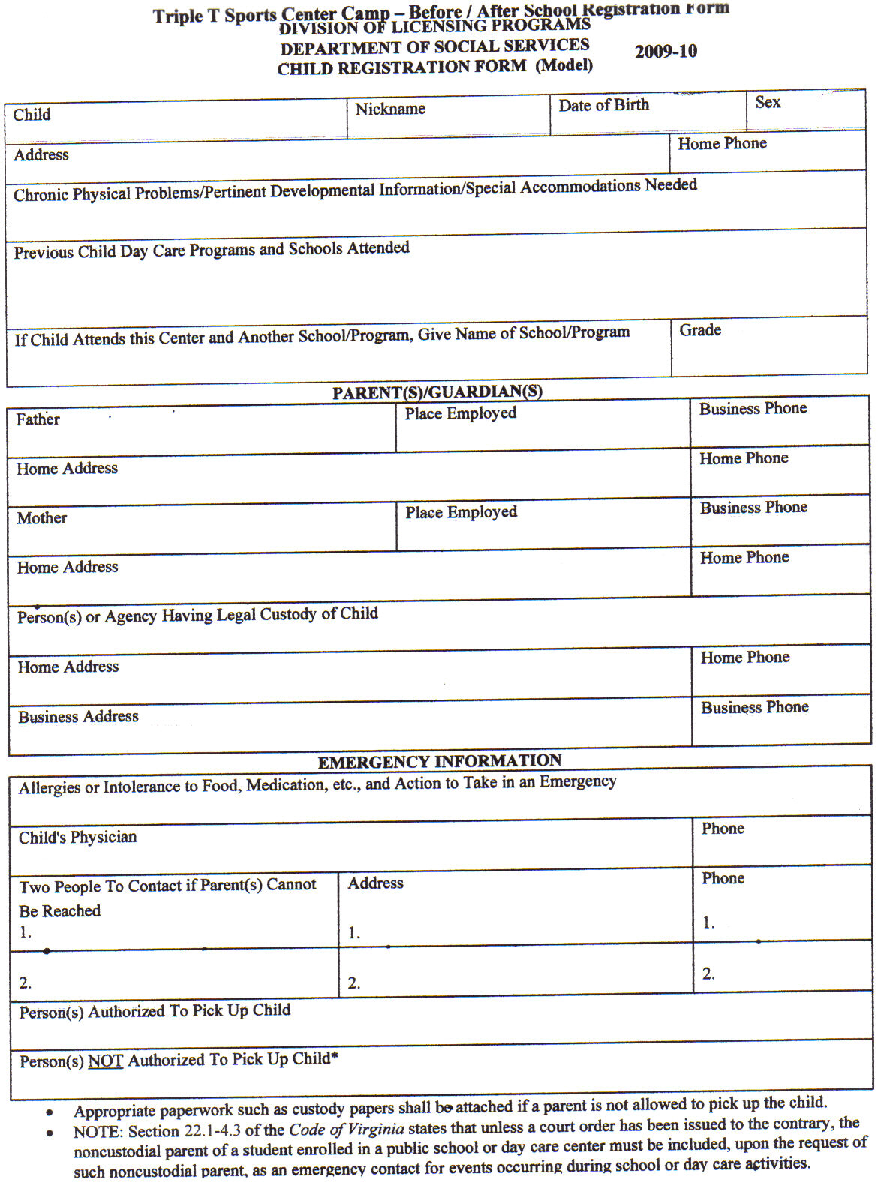

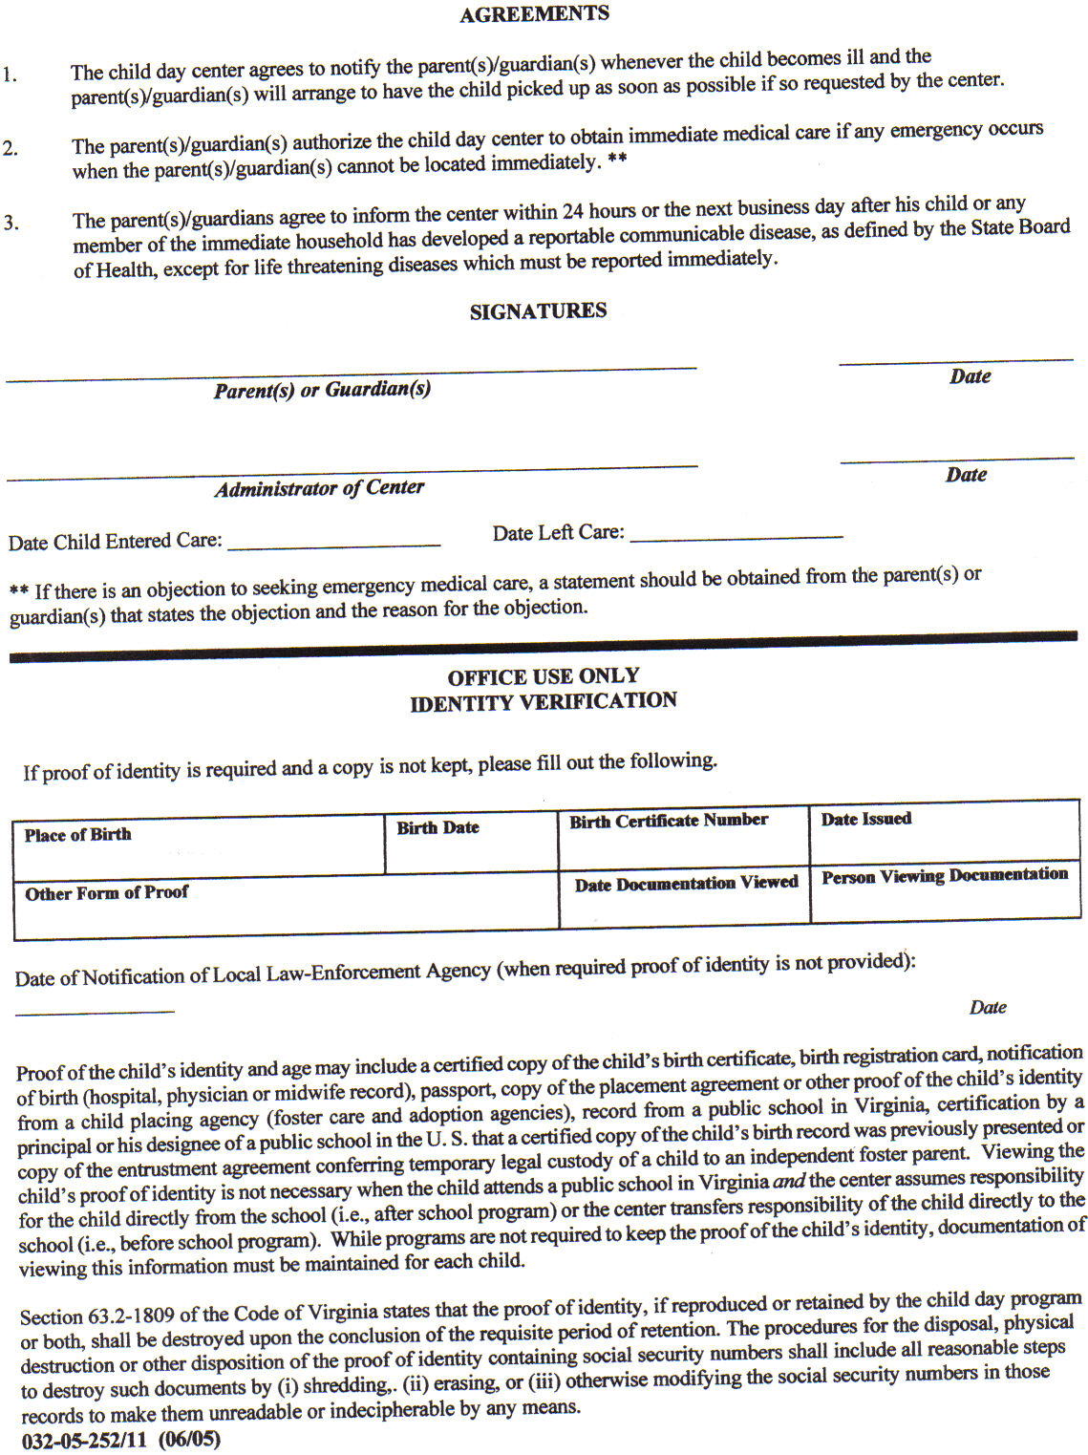

**Triple T Sports Center**

**Summer Sports Day Camp Policies & Procedures**

**1. Sign In-Sign Out**

Signing your child IN & OUT of day camp is very important. The child is not allowed to sign themselves in or out. Only the parent or authorized person is permitted to pick up. If a person comes to pick up that is not on the authorized persons list, we will not release the child without written permission of the parent or verification of code word by the person picking up.

**2. Structured Camp Activities 8:30am-5:00pm, extended care 6am-6pm is included**

**3. Parent Notices:**  Brightwheel program is the primary communication tool for childcare – pictures and videos are also shared using this app. You will be required to sign your child in and out on this app as well.

For your convenience we also post needed information on the neon flashing sign in the lobby. Good communication requires both the giving and receiving of information. Please help us keep you informed by reading information posted.

**4. Pick Up**

Pick up for full day is 6:00pm

**5. A Late Fee of $15 for late pick-ups after 6:00pm, $5 each additional 15 mins.**

**6. Day Camp Forms**

Please make sure that all forms are fully completed upon registration for day camp. Partially completed forms will not be accepted. This includes shot record, physical, birth certificate, day camp release form, rules and policies sheet, and the camper information forms. Please be sure to fully complete all pages to insure your child’s space in the camp. Space in camp is reserved upon receipt of registration forms and payment of deposit. No spaces will be held prior to forms being submitted.

**7. What is a member**

Members are children enrolled in a class (gymnastics, tumbling, ninja, tkd, cheer, or dance) for a minimum of 3 months or enrolled in our before and after school program throughout the school year.

**8. What to wear**

Most activities require no shoes. Bare feet are recommended. Sport shorts and t-shirts are recommended. (Please no zippers or snaps) No Jean Shorts please. No Tank tops.

If your child is younger and prone to bathroom accidents, please make sure the child has an extra set of clothing with them each day or we may have to call you to pick up your child early if your child has a potty accident. We have lockers available to store the spare set of clothes if you prefer to leave them here at the gym.

Also, girls with shoulder length hair or longer need to have hair tied back – NO balls ties please.

**9. Lunch & Snacks**

Full day campers bring lunch, 2 snacks and drinks. Mark all items clearly with camper's name and date. Our camp consists of non-stop sports, games and activities; therefore, each child needs to have a healthy lunch and snacks for the energy they need. Please refrain from junk food to help your child have the energy they need each day. They must have a refillable water bottle each day. We are not allowing them to drink from the fountain however can refill their bottles.

**10. Medication**

If your child will require medication to be administered while they are at Triple T, then you will be required to fill out medication forms that may require your doctor’s signature. All medication must be given to the office staff with directions and completed medication form. Leaving any medication with the child is strictly forbidden and could be hazardous for other children. This includes all over the counter medications like cough drops, Tylenol, etc.

**11. Procedures for sick children**

The staff will have the child to sit out for a while to see if they start feeling better. Sometimes a child will say they do not feel well if they are unsure of the activity. After they watch for a while and feel comfortable, they will join the activity. If they are truly sick, we will contact the parent to pick the child up. It is recommended that arrangements be pre-set for your child to be picked up by someone else if it is impossible for you to leave work. We will not accept children that are visibly sick into camp. Children with a fever, diarrhea or vomiting need to be picked up within the hour. Child must be symptom free for 24 hours without medication before returning to the care.

**12. Accidents**

Due to the nature of our day camp accidents do sometimes happen. Our staff is trained to handle accidents. We will contact you to advise you of any accidents/injuries.

**13. Celebrating Birthdays**

If your child would like to celebrate their birthday it is recommended you bring cake, cupcakes or cookies. Please also bring all the paper goods needed. Boxed drinks are permitted. You may contact us for the number of campers we expect on the day you wish to celebrate your child’s birthday. We will celebrate birthdays during snack time.

**14. Missed Days:**

Camp tuition covers the week registered for – due to limited space, campers are not allowed to make up missed days in a different camp week. ECC card users, you are responsible for keeping your attendance up to date daily. This includes marking children absent if they do not attend on a day they are registered for. Copays are due at the beginning of the month.

**15. Payment Policy**

A guaranteed form of payment in the form of a credit card for day camp is required. Child will not be able to attend until payment is received, including late fee if applicable. You will be responsible for the week regardless of attendance.

**16. Field Trips**

We will be scheduling field trips during camp this summer. The field trip schedule is posted in the lobby and on our website at tttgym.com. Please keep the field trip schedule provided handy as a reminder of what days the fieldtrips will be so your child will be prepared. Children that do not go on the field trip will remain at the gym for regular scheduled activities. If your child is not going to be participating, please notify the office staff in writing by end of the day on Monday of that week so we can staff appropriately. Parents are welcome to come on the field trips with the campers for an add’l fee. Please let us know if you wish to attend so arrangements can be made. Campers will be assigned to a camp staff person and constant supervision will be given by the camp staff person; parents will not be responsible for supervision. You cannot take your child out of the group during the fieldtrip. Field trips are a privilege and will be taken away if child does not behave properly or comes without proper attire which includes camp T-shirt and closed toe shoes. This is for their safety and exceptions will not be made.

**17. Behavior Procedures**

In an effort to provide the best environment for the Triple T Summer Sports Day Camp, behavior procedures have been implemented to ensure that each and every child has the best possible experience at the Triple T Day Camp. Behaviors such as: using bad language repeatedly, not following instructions that will result in harm to themselves or others, fighting, continuous disrespect to staff, etc.

The following behavior procedures will be enforced.

1st Offense Time Out

2nd Offense Parent will be notified of the situation by camp staff at pickup or via phone call if necessary.

3rd Offense Meeting with the child, parent, and childcare management.

4th Offense Dismissal from further participation in the Triple T Summer Sports Day Camp if staff and management feel harm will come to the child and or/others if participation in camp continues.

**18. Video / Quiet Play Time**

The full day camper will be watching an age-appropriate theme related movie from approximately 1:30-2:30pm. With the amount of physical activity in camp this time provides a chance for the children to rest between AM and PM activities. Campers will also be allowed to play passive games, such as: board games, checkers, puzzles, etc if they do not want to watch the movie. Electronics are permitted however no social media is allowed. No recording of other campers. All content accessed needs to be appropriate for all ages within the group (5-12) If electronic is used to access inappropriate sites, then electronic will be taken away until it is time to go home.

**19. Group Divisions**

We have 3 age groups that children are separated into. Ages 3-4, 5-7, and 8-12. This is to allow each group to participate in age-appropriate games and activities. Please do NOT request for certain campers to be together or separated. The only exception that will be made is if an older child is not behaving correctly and may be temporarily moved to a younger group. Preschool group (ages 3-4) will have nap time from 12:15-2:15.

**20. Teacher/Student Ratios**

Teacher/Student ratios vary depending on the activity. Gymnastics classes are 8/9 students to teacher ratio. For sports, games and dance the ratio can be 15 and higher because the sports and games usually require a larger number of students and dance/karate/cheer class will range from 15-20 depending on the age. Ratios of staff to children during care: Preschool (ages 3-4) 1:10, School Age (5-12) 1:18 are the state mandated ratios however due to the structured activities that are done at Triple T our school age ratio is generally closer to 1:12.

**21. Triple T Contact Info**

619 E Constance Rd Suffolk, VA 23434

(757) 923-5150

[tttgym@gmail.com](mailto:tttgym@gmail.com) Email

tttgym.com website

Cheryl Burks (757) 839-9108 Owner/Childcare Administrator

**Triple T Sports Center Summer Day Camp Policies**

Parent/ legal guardian must initial next to each statement verifying that they have been informed of the following policies.

__________ I understand that a $35 non- refundable deposit is due upon registration for each week reserved.

__________ I understand a 3-week written notice is required to remove my child from summer camp. If notice is not given the balance in full will be due for the remaining weeks including any late or collection fees. I understand that if notification is not received, I will be liable for the balance as well as payment of fees associated with collecting on the account. Deposits are nonrefundable.

__________ I give permission for my child to participate in all regularly scheduled fieldtrips. However, I understand that fieldtrips are a privilege and not a right, even if additional fee is charged. Campers will be kept from participating in the fieldtrip if they are not dressed appropriately (camp t-shirt and closed toe shoes) or not behaving appropriately. Triple T wants all campers to participate however if it presents a safety hazard to themselves others they will not be allowed to attend. The field trips that require an additional fee are purchased far in advance and we cannot get a refund if the child does not attend. (Ocean Breeze, Apex, VA Living Museum) If child does not bring an appropriate lunch (non - microwavable on fieldtrip days) & one must be provided you will be charged a $10 fee. Some trips are divided by age. I understand this is the age on the day of the fieldtrip. This is for the safety of the children - no exceptions will be made.

__________ Registration includes 1 camp t-shirt. If you would like to order additional shirts upon registration the cost is $20 per shirt. T-shirts are ordered based on the students registered, a limited number of additional shirts are ordered. However, we cannot guarantee that there will be any available for purchase if you forget yours on field trip day. Please plan ahead and be sure your child’s shirt is clean and available on fieldtrip day, days are listed on the fieldtrip schedule.

__________ Notices and reminders will be posted on the Lighted Neon sign in the front lobby – please read these daily as the notices will provide information needed for campers.

__________ Unfortunately, when large numbers of children get together there may be times that arguments, fights, or hurt feelings will occur. Our staff is trained to handle these situations when they arise. You will be notified if your child is involved in any incident. We will not discuss the other children with you, and you are strictly forbidden to approach any child (includes CITs) other than your own to address any issue directly. If your child is having a problem with another child or staff member please report the issue to Cheryl Burks, Administrator/Owner and the problem will be addressed in whatever manner needed. If issue cannot be resolved with the children, then both sets of parents will be called in for a conference with Cheryl Burks.

_________­­­­­­ Electronic devices such as iPods, DS, or other games can be brought to camp. The students have certain times of day to play with these, during quiet play times. The rest of the day the device is locked in a locker. I understand that bringing them is a privilege and if my child argues about putting them away or begging to play with them then they will no longer be allowed to bring them. I also understand that bringing any device is at my own risk and that Triple T is not responsible for any loss or damage done to the device. Cell phones are not permitted in camp. If you need to contact your child, please call the gym at 923-5150 or Cheryl Burks directly at 839-9108.

__________ It is my responsibility to be sure and pack a full, healthy lunch, drinks, and 2 snacks for my child. Snack Accounts are optional for campers however office is not always open and cannot be counted on to purchase snacks. Any money left with the camper is not Triple T’s responsibility if lost, stolen, or misplaced. See the front desk for details on how to open an account for your child.

__________ I understand there are licensed and unlicensed areas of Triple T Sports Center and give my permission for the staff to sign my child(ren) in and out of these areas.

__________ Parents using ECC cards, you are responsible for swiping your child in and out daily and put your receipt in the black gym tuition box. Failure to maintain accurate attendance may result in loss of childcare benefits.

I have read the above statements and fully understand the policies and procedures of Triple T.

___________________________________ __________________

Signature of Parents or Legal Guardian Date

***Triple T Sports Center***

***Summer Camp 2023***

**June 19th-Sept 1st**

**Register now for the entire summer or for only the weeks you would like your child to attend.**

Our coaches will be teaching Gymnastics, Taekwondo, Dance, and Cheer along with several school teachers and counselors that will be helping with the educational activities, arts & crafts, computer skills, field trips, games, and more!! Space is limited to 50 campers per week (5 summer preschool spots for 3-4 yr. old's), 24 Before / After Spots for those attending school over the summer. Spots fill quickly - so sign up early to save your child’s spot. We do offer a 5% sibling discount on childcare. Membership is enrollment in regular class.

**Week # Date Theme Fieldtrip**

1 June 19-23 School’s Our for Summer Bowling – APEX*

2 June 26-30 Spirit Week King Neptune’s Mini Golf / Top Golf*

3 July 3-7 Americana Cookout @ Triple T

4 July 10-14 Lost in Space VA Air & Space Museum

5 July 17-21 Splish Splash Ocean Breeze*

6 July 24-28 When I Grow Up Children’s Museum of Virginia

7 July 31-Aug 4 Animal Planet Virginia Living Museum *

8 Aug7-11 Around the World Smithfield Skating Rink

9 Aug 14-18 Camp Kindness JB’s Rattles Reptile Show

10 Aug 21-25 Art Mania Art Ventures **

11 Aug 29-Sept 2 Operation Relaxation End of Summer Celebration

Fieldtrips are planned though will depend on Covid restrictions. We will have alternative activities if the regular field trip is not able to be done. Fieldtrips are subject to change. *$20 Additional Fieldtrip Fee* Before/After Summer School Care 6am-6pm Cost $90 per week 5 days(member) $100 5 days (non-member). If virtual we will not be able to provide care due to Summer Camp activities being too disruptive.

Structured Camp Hours 9am-5pm, extended care included 6am-6pm

Registration Fee $65 Non-members, $50 Members (includes camp T-shirt for field trips)

5 full days $185 Non-members, $160 Members (enrolled in regular class at TTT)

3 days: $130 Non-Members, $115 Members, $20 add’l fee for field trips

Field trips are usually on Wednesdays unless otherwise posted.

TTT camp shirts & closed toe shoes are required for all fieldtrips!!

** All regular classes will be held as scheduled **

***Spring Break – Mario Mania April 10th-14th***

Fieldtrip: Super Mario Bros. Movie @ AMC

619 E. Constance Rd. Suffolk, VA 23434

(757)923-5150; [tttgym@gmail.com](mailto:tttgym@gmail.com)

**WAIVER/RELEASE FOR COMMUNICABLE DISEASES INCLUDING COVID-19 ASSUMPTION OF RISK / WAIVER OF LIABILITY / INDEMNIFICATION AGREEMENT**

**Participants Names:__________________________________________________________**

In consideration of being allowed to participate on behalf of TTT Sports Center and related events and activities, the undersigned acknowledges, appreciates, and agrees that:

1. Participation includes possible exposure to and illness from infectious diseases including but not limited to MRSA, influenza, and COVID-19. While particular rules and personal discipline may reduce this risk, the risk of serious illness and death does exist; and,

2. I KNOWINGLY AND FREELY ASSUME ALL SUCH RISKS, both known and unknown, EVEN IF ARISING FROM THE NEGLIGENCE OF THE RELEASEES or others, and assume full responsibility for my participation; and,

3. I willingly agree to comply with the stated and customary terms and conditions for participation as regards protection against infectious diseases. If, however, I observe any unusual or significant hazard during my presence or participation, I will remove myself from participation and bring such to the attention of the nearest staff member immediately; and,

4. I, for myself and on behalf of my heirs, assigns, personal representatives and next of kin, HEREBY RELEASE AND HOLD HARMLESS TTT Sports Center, their officials, agents, and/or employees, other participants, sponsoring agencies, sponsors, advertisers, and if applicable, owners and lessors of premises used to conduct the event (“RELEASEES”), WITH RESPECT TO ANY AND ALL ILLNESS, DISABILITY, DEATH, or loss or damage to person or property, WHETHER ARISING FROM THE NEGLIGENCE OF RELEASEES OR OTHERWISE, to the fullest extent permitted by law.

I HAVE READ THIS RELEASE OF LIABILITY AND ASSUMPTION OF RISK AGREEMENT, FULLY UNDERSTAND ITS TERMS, UNDERSTAND THAT I HAVE GIVEN UP SUBSTANTIAL RIGHTS BY SIGNING IT, AND SIGN IF FREELY AND VOLUNTARILY WITHOUT ANY INDUCEMENT.

Parent signature: ________________________________________________

Parent Name Printed: ____________________________________________

Date signed: _____________

MASKS/COVID: If your family is highly concerned about coronavirus or has immunocompromised family members, then our programs may not be a good fit for your family. TTT Sports Center (TTT) has always had a thorough daily cleaning schedule and follows all childcare licensing protocols for cleanliness, sanitizing, and hand washing. Parents will be required to submit the regular daily health check prior to bringing their child to the program (temperature, symptoms, etc..). Per executive order children 4 and older are required to wear masks during childcare. Coaches, staff, and parents/guardians are required to wear masks while inside the building.



**Center Name:** Triple T Sports Center

**Participation Agreement**

**To email and publish my child’s work, photographs, or videos via Brightwheel**

To: Parent / Legal Guardian

Please read this page carefully as it includes information about safety and security issues associated with privacy and behavior:

In the interest of safety and security we require parent permission for the publishing of children’s work, photographs or videos through a software program called Brightwheel (the “Program”). By signing this form, you grant for us to photograph or video your child for the purposes of sharing this information with you through the Program. You will also receive updates and information about your child through the Brightwheel app.

Note that sometimes other children in the center may feature in photos, videos or stories of your child. By giving your consent, you agree not to share photos or videos of any child, other than your own, outside the Program without permission.

Please complete, sign, and return this form to the center if you wish to participate. We encourage you to contact us if you have any questions.

My Child’s Name: ___________________________________________________________

Additional Children: _________________________________________________________

My Name: __________________________________________________________________

My Email: ___________________________________________________________________

Signature: ______________________________________ Date: ______________________