**Halloween-Decorated Yard of the Month**

The winner was Mary Pichette of 2416 Eagleview Circle. Mary’s yard had a variety of seasonal displays and looked good in daylight and phenomenal at night! The larger side of the yard to the right of the driveway (street perspective; photo on right) had fall décor such as scarecrows, pumpkins, witches, a gravestone, ghoul, skeletons, and black pumpkin planters, including one with a black spider feeding from it. A recessed illuminated Dracula guarded the front door. Skeletons and flying witches appeared inside the front left windows. There was a lot of movement in the yard at night, with an inflatable witch arising periodically from a burning cauldron on the right, two kinetic laser light displays (moon with flying witches, and spider web with swirling spiders) on the garage and adjoining part of the house, and another inflatable, a pirate ship with 3 ghosts (photo on left), to the left of the garage. Mary says, “Halloween is such an exciting holiday. I enjoy sharing it with family, friends, and neighbors.”.

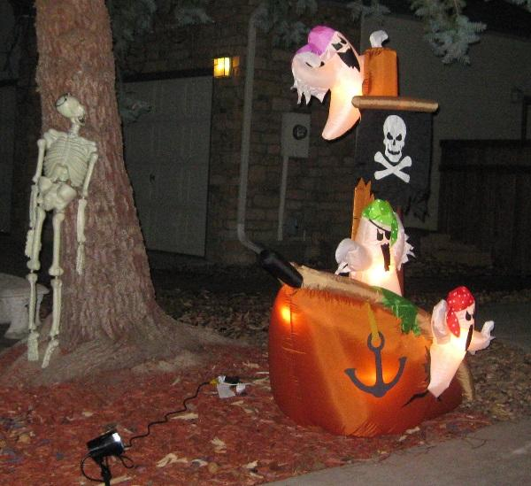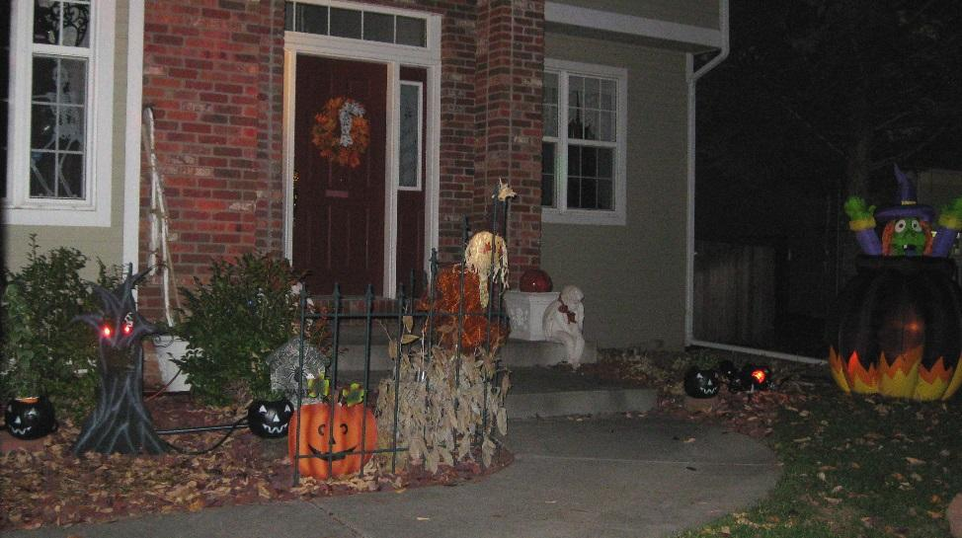

**Yard of the Month Contest Continues**

The contest for December will recognize holiday decorations.

**Social Committee and Yard of the Month Volunteers Needed for Next Year**

Note that Roz Weller will no longer be serving as chair of the social committee or yard of the month committee after December, so volunteers are needed next year for these programs to continue. Email the board at hoa@fachoa.org or [soc@fachoa.org](mailto:soc@fachoa.org) to volunteer or get more information about the positions.

**Fence Maintenance**

Pending board approval, minor repairs to the HOA-owner perimeter fence behind homes bordering Plateau and Sunset, as well as fences between FAC and Watersong. will be made over the next month. We will attempt to let the homeowners know when the repair team will be in their yard. Please contact FAC HOA maintenance manager, Bernie Newcomb @ 303-588-3299 or maint@fachoa.org if you self-identify perimeter fence repairs that need to be done or if you have any questions. Homeowners can see what outside fence repairs are being made by looking for orange flags marking repair areas.