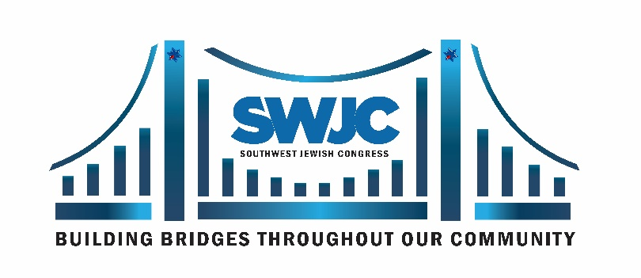 | P.O. Box 700116  Dallas, Texas 75370  Tel: 214-361-0018  Cell: 214-404-8114  Email: susan@swjc.org  Website: www.swjc.org

2022 TEXAS SIZED EVENT AWARD NOMINATION FORM
Please submit by January 15, 2022

ELIGIBILITY:
• Involved in exemplary achievements in community service
• Agree with the principles and mission of the Southwest Jewish Congress
• Biography and photo required at a later date for further consideration

Date Submitted:

Choose one:
❑ Audrey Kaplan Inspiring Women
❑ Stan Golden Men of Action
❑ Future Inspiring Women and Future Men of Action
• Nominee must be 14-21 years of age and have parental or guardian approval.
Age: Grade: Parents names: Parent’s phone:

Nominee’s Information (submit what information you can)
Name:
Address:
School:
Cell:
Email:

Nominee’s community involvement, your recommendations and comments. (attach resume if possible) Use back if more room needed.

Your Information: Name:
Address:
Cell: Email:
Submit this nomination form via email to susan@swjc.org or mail to:
Ms. Susan Myers, Southwest Jewish Congress, P.O. Box 700116, Dallas, Texas 75370

