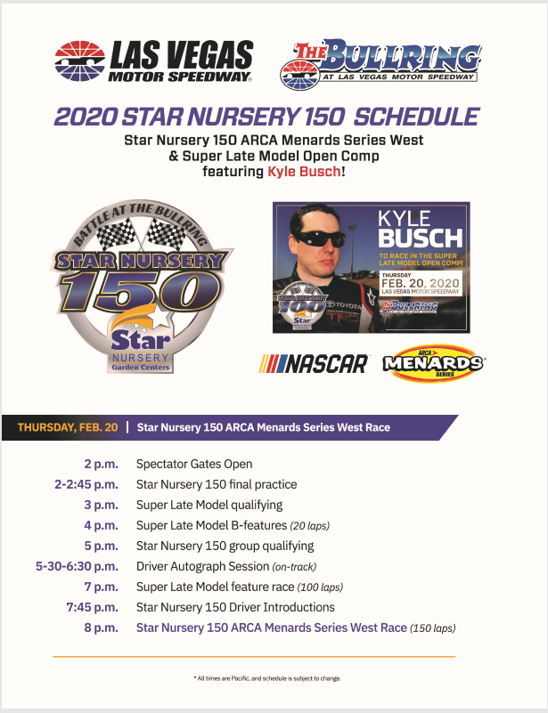

STAR NURSERY 150
The NASCAR weekend racing lineup will begin on Thursday, Feb. 20, 2020, with the Star Nursery 150 ARCA Menards Series West race at The Bullring at LVMS. The addition of the ARCA event gives LVMS four consecutive days of racing and brings the newly merged series – previously known as the NASCAR K&N Pro Series West – to the 3/8-mile paved oval for the first time since 2012.
The Star Nursery 150 ARCA Menards Series West race will be accompanied by the Star Nursery 100 Super Late Model Open Comp featuring Kyle Busch. The feature races will be preceded by an on-track autograph session featuring all ARCA Menards and Open Comp drivers.
For ticket purchases call 800-644-4444 or go on line to https://www.lvms.com/tickets/nascar/pennzoil-400/tickets/#starnursery150tickets.
Please Note: Discounted tickets are available for current 2020 NASCAR ticket holders, RVers and Military personnel. Please call the LVMS Ticket Office at 800.644.4444 for more details. Kids 12 and under are FREE with a ticketed adult.* Ticket prices increase on Monday, February 17, 2020.
Please RSVP to me if you are going.
Departing place and time TBD. Doug Rosa

