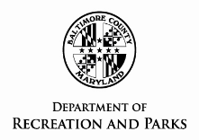
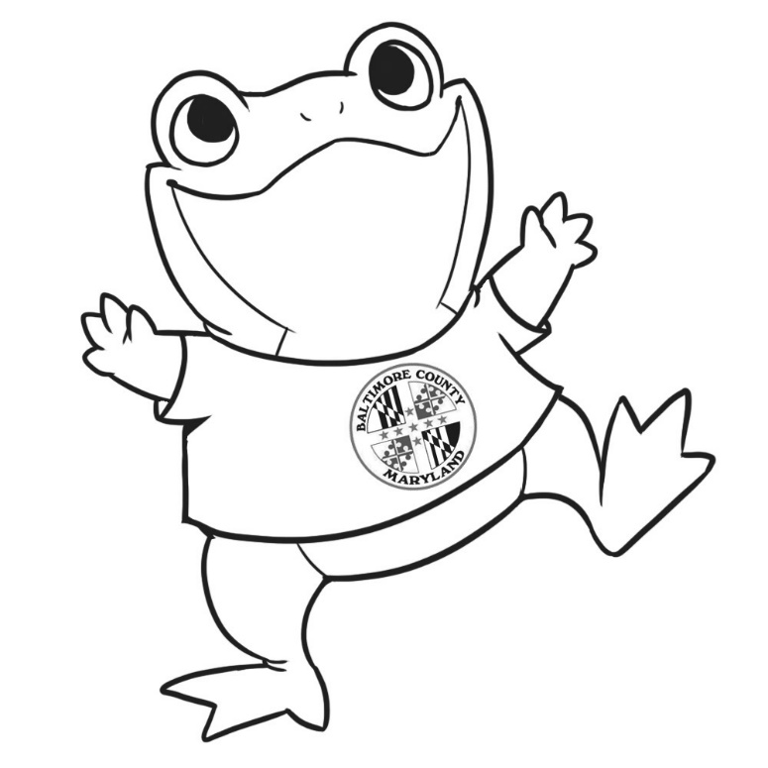
* Print your very own Parker the Frog and bring with you on your adventures!

* Take a selfie with PARKER at a Baltimore County Park to be eligible for a prize.

* Prizes awarded to the participant whom visits the most Baltimore County Parks each month and submits a selfie to Parker@baltimorecountymd.gov.

* One entry is valid per park per e-mail address.

* Include #inmyownparkyard when sharing to social media to add to the fun!

Should you require special accommodations (i.e. sign language interpreter, large print, etc.) please give as much notice as possible by calling the Recreation Office at 410-887-5194 or the Therapeutic Office at 410-887-5370 (voice) or 410-887-5319 (TT/Deaf).
In accordance with any current public health guidelines, please practice *Social Distancing* and wear a mask (when social distancing is not possible) whenever you are enjoying Baltimore County’s Parks.

Presenting…
Parker the Frog!
How many Baltimore County Parks has PARKER explored?
That is up to YOU!

