Saturday & Sunday,
January 17 & 18, 2026
Epiphany of our Lord
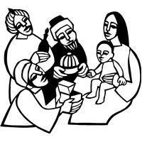
Christ Lutheran Church
“A Place Where You are Always Welcome”
Services: Saturday 5:30 pm and Sunday 10:00 am
Sunday School: 9:00 am (September- May)
600 North Main Street, Stockton, IL 61085 Office: 815-947-2033
Email: christlutheranchurch70@gmail.com http://www.christlutheranstockton.com
Ministers: ALL members of the congregation
Pastor: Rev. Chrissy Salser chrissytherev@att.net 815-988-9450
From Sundays and Seasons.com. Copyright 2017 Augsburg Fortress. All rights reserved. Reprinted by permission under Augsburg Fortress Liturgies Annual License #40643.New Revised Standard Version Bible, copyright 1989, Division of Christian Education of the National Council of the Churches of Christ in the United States of America. Used by permission. All rights reserved.
WELCOME: Thank you for joining us for worship today. We are glad you are with us. Communion will be served in the aisle or in your pew. All are welcome to share this meal. Jesus is our host and invites everyone. Those who would like to come forward, bread and wine will also be available in the front. When directed by the usher, come forward down the center aisle, Pr Chrissy will give you bread (she will be masked and wearing cloves) and then you will take a cup of wine (grape juice) from the tray. After taking communion, you will return to your seat by the side aisle. For those who are unable to come forward, communion elements can be found as you entered worship. At that part of the service, you are invited to take the bread and wine (or grape juice) when Pr. Chrissy leads. On Saturday’s offering is collected as you enter or leave worship. On Sunday we will pass the plate as a response to God’s grace. Online giving is available. Please see QR code on back of bulletin or visit our website.

Introduction: The feast of Epiphany (“manifestation”) concludes the Christmas season with a celebration of God’s glory revealed in the person of Jesus Christ. In Isaiah and Ephesians, that glory is proclaimed for all nations and people. Like the light of the star that guided the magi to Jesus, the light of Christ reveals who we are: children of God who are claimed and washed in the waters of baptism. We are sent out to be beacons of the light of Christ, sharing the good news of God’s love to all people.

Gathering: The Holy Spirit calls us together as the people of God.
PRELUDE
WELCOME AND ANNOUNCEMENTS
DIALOGUE
P: The star shone bright in the Bethlehem sky.
C: We too have a star to guide us.
P: The shepherds ran to see the babe.
C: We too have a star to guide us.
P: The magi knelt at the child’s feet.
C: We too have a star to guide us.
P: Christ shines with God’s own truth and light.
C: We too have a Star to guide us.

GATHERING HYMN Jesus, the Light of the World ASC 914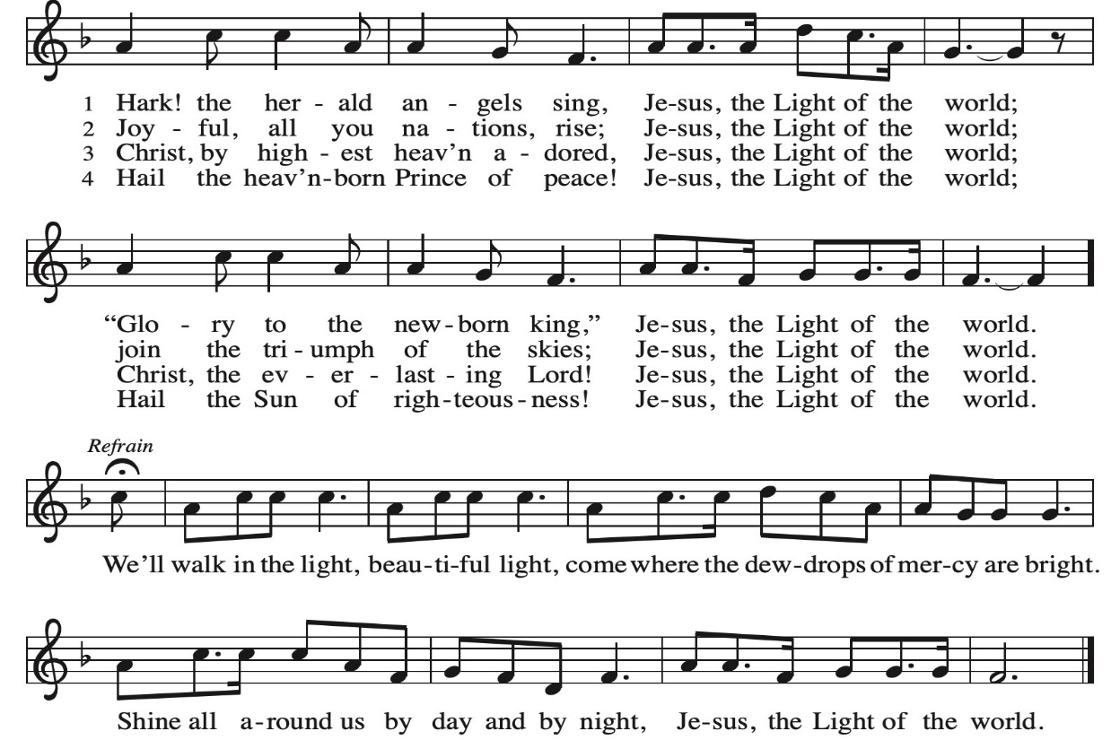
Greeting:
P: The grace of our Lord Jesus Christ, the love of God, and the communion of the Holy Spirit be with you all.
C. And also, with you.
PRAYER OF THE DAY:
P: Let us pray: O God, on this day you revealed your Son to the nations by the leading of a star. Lead us now by faith to know your presence in our lives and bring us at last to the full vision of your glory, through your Son, Jesus Christ our Lord, who lives and reigns with you and the Holy Spirit, one God, now and forever. Amen.

Word: God speaks to us in scripture reading, preaching, and song.

First Reading: Isaiah 60:1-6

Jerusalem is assured that nations will make a pilgrimage to her because the light of God’s presence is in her midst. The bountiful food of the sea and the profits of international trade will come streaming to Jerusalem and thereby declare God’s praise.

¹ Arise, shine, for your light has come, and the glory of the Lord has risen upon you. ² For darkness shall cover the earth and thick darkness the peoples, but the Lord will arise upon you, and his glory will appear over you. ³ Nations shall come to your light and kings to the brightness of your dawn.
⁴ Lift up your eyes and look around; they all gather together; they come to you; your sons shall come from far away, and your daughters shall be carried in their nurses’ arms. ⁵ Then you shall see and be radiant; your heart shall thrill and rejoice, because the abundance of the sea shall be brought to you; the wealth of the nations shall come to you. ⁶ A multitude of camels shall cover you, the young camels of Midian and Ephah; all those from Sheba shall come. They shall bring gold and frankincense and shall proclaim the praise of the Lord.

Psalm: Psalm 72:1-7, 10-14
¹ Give the king your justice, O God, and your righteousness to the king’s son;
² that he may rule your people righteously and the poor with justice;
³ that the mountains may bring prosperity to the people, and the hills, in righteousness.
⁴ Let him defend the needy among the people, rescue the poor, and crush the oppressor.
⁵ May he live as long as the sun and moon endure, from one generation to another.
⁶ Let him come down like rain upon the mown field, like showers that water the earth.
⁷ In his time may the righteous flourish; and let there be an abundance of peace till the moon shall be no more.
¹⁰ May the kings of Tarshish and of the isles pay tribute, and the kings of Sheba and Seba offer gifts.
¹¹ May all kings bow down before him, and all the nations do him service.
¹² For the king delivers the poor who cry out in distress, the oppressed, and those who have no helper.
¹³ He has compassion on the lowly and poor, and preserves the lives of the needy.
¹⁴ From oppression and violence he redeems their lives, and precious is their blood in his sight.
Second Reading: Ephesians 3:1-12
What had been hidden from previous generations is now made known through the gospel ministry of Paul and others. In Christ both Jews and Gentiles participate in the richness of God’s promised salvation.
¹ This is the reason that I, Paul, am a prisoner for Christ Jesus for the sake of you gentiles, ² for surely you have already heard of the commission of God’s grace that was given me for you ³ and how the mystery was made known to me by revelation, as I wrote above in a few words, ⁴ a reading of which will enable you to perceive my understanding of the mystery of Christ. ⁵ In former generations this mystery was not made known to humankind, as it has now been revealed to his holy apostles and prophets by the Spirit: ⁶ that is, the gentiles have become fellow heirs, members of the same body, and sharers in the promise in Christ Jesus through the gospel.
⁷ Of this gospel I have become a servant according to the gift of God’s grace that was given me by the working of his power. ⁸ Although I am the very least of all the saints, this grace was given to me to bring to the gentiles the news of the boundless riches of Christ ⁹ and to make everyone see what is the plan of the mystery hidden for ages in God, who created all things,
¹⁰ so that through the church the wisdom of God in its rich variety might now be made known to the rulers and authorities in the heavenly places. ¹¹ This was in accordance with the eternal purpose that he has carried out in Christ Jesus our Lord, ¹² in whom we have access in boldness and confidence through faith in him.
R: The Word of the Lord. C: Thanks be to God.
GOSPEL ACCLAMATION Joy to the World ELW 267 verse 1
Joy to the world, the Lord is come! Let earth receive her king;
let ev'ry heart prepare him room and heav'n and nature sing,
and heav'n and nature sing, and heav'n, and heav'n and nature sing.

Gospel: Matthew 2:1-12

P: The Gospel according to Matthew C: Glory to you, O Lord
God’s promise shines bright in the night as magi follow a star to honor a new king. Strangers from a faraway land, they welcome the long-awaited messiah of Israel.
¹ In the time of King Herod, after Jesus was born in Bethlehem of Judea, magi from the east came to Jerusalem, ² asking, “Where is the child who has been born king of the Jews? For we observed his star in the east and have come to pay him homage.” ³ When King Herod heard this, he was frightened, and all Jerusalem with him, ⁴ and calling together all the chief priests and scribes of the people, he inquired of them where the Messiah was to be born. ⁵ They told him, “In Bethlehem of Judea, for so it has been written by the prophet:
⁶ ‘And you, Bethlehem, in the land of Judah, are by no means least among the rulers of Judah, for from you shall come a ruler who is to shepherd my people Israel.’ ”⁷ Then Herod secretly called for the magi and learned from them the exact time when the star had appeared. ⁸ Then he sent them to Bethlehem, saying, “Go and search diligently for the child, and when you have found him, bring me word so that I may also go and pay him homage.”
⁹ When they had heard the king, they set out, and there, ahead of them, went the star that they had seen in the east, until it stopped over the place where the child was. ¹⁰ When they saw that the star had stopped, they were overwhelmed with joy. ¹¹ On entering the house, they saw the child with Mary his mother, and they knelt down and paid him homage. Then, opening their treasure chests, they offered him gifts of gold, frankincense, and myrrh. ¹² And having been warned in a dream not to return to Herod, they left for their own country by another road.
P: The Gospel of Our Lord. C. Praise to you, O Christ.
CHILDREN’S MESSAGE
MESSAGE
HYMN OF THE DAY Christ be Our Light ELW 715 (next page)
APOSTLES’ CREED:
I believe in God, the Father almighty, creator of heaven and earth.
I believe in Jesus Christ, God’s only Son, our Lord, who was conceived by the Holy Spirit, born of the virgin Mary, suffered under Pontius Pilate, was crucified, died, and was buried; he descended to the dead. On the third day he rose again; he ascended into heaven, he is seated at the right hand of the Father, and he will come to judge the living and the dead.
I believe in the Holy Spirit, the holy catholic church, the communion of saints, the forgiveness of sins, the resurrection of the body, and the life everlasting. Amen
PRAYERS OF INTERCESSION:
P: Hear us, O God. C: Your mercy is great.
PEACE
P: The peace of Christ be with you always. C. And also with you.

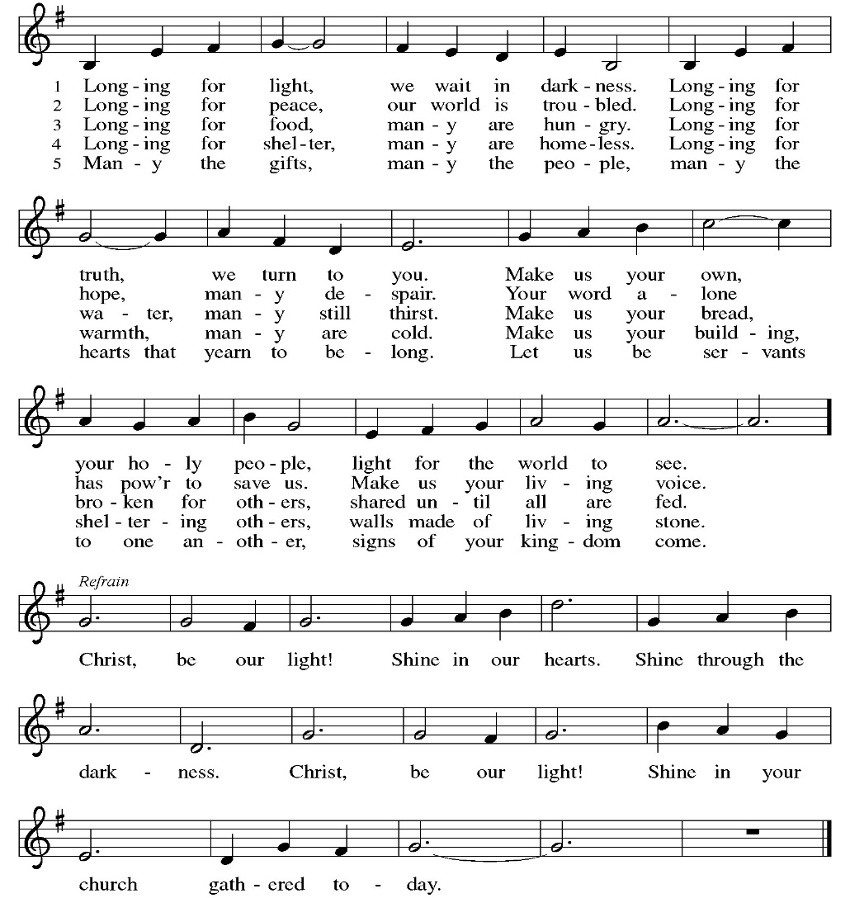
OFFERING: Our offering is a significant act of worship; we worship God through our giving. The ministry of this congregation is completely dependent upon your partnership and generosity. Offering is collected as you enter worship on Saturday. We will pass the offering plate on Sundays. Online giving is available.
OFFERING HYMN: What Child is This ELW 296 verse 3
So bring him incense, gold, and myrrh; come peasant, king, to own him.
The King of Kings salvation brings; let loving hearts enthrone him.
Raise, raise, the song on high, the virgin sings her lullaby;
Joy, joy, for Christ is born, the babe, the son of Mary!
OFFERING PRAYER:
P: Lord of the harvest, C: we return to you a portion of what you have given to us. Turn us to set our hope not on the uncertainty of riches, but on you, who richly provides for us Multiply what we have gathered to bless all who are suffering and in need, through Jesus Christ our Lord. Amen.
COMMUNION LITURGY:
In the night in which he was betrayed, our Lord Jesus took bread, and gave thanks, broke it and gave it to his disciples, saying: take and eat; this is my body, given for you. Do this for the remembrance of me. Again, after supper, he took the cup, gave thanks and gave it for all the drink, saying: this cup is the new covenant in my blood, shed for you and for all people for the forgiveness of sin. Do this for the remembrance of me.
THE LORD’S PRAYER:
Our Father, who art in heaven, hallowed be thy name, thy kingdom come, thy will be done on earth as it is in heaven. Give us this day our daily bread; and forgive us our trespasses, as we forgive those who trespass against us; and lead us not into temptation but deliver us from evil. For thine is the kingdom, and power, and the glory, forever and ever. Amen
INVITATION TO COMMUNION:
P: Jesus welcomes sinners and eats with them. Come to this meal of mercy.
Please come down the center aisle, take the bread, then receive a cup (wine is dark, juice is light, return to your seats via side aisle.) Those who prefer to take communion in your pews, we will take all together after all are served.
DISTRIBUTION OF COMMUNION:
P: This is the body of Christ given for you. (All take bread).
P: This is the blood of Christ shed for you. (All take the wine).
COMMUNION HYMN: We Three Kings of Orient WOV (Blue book) 646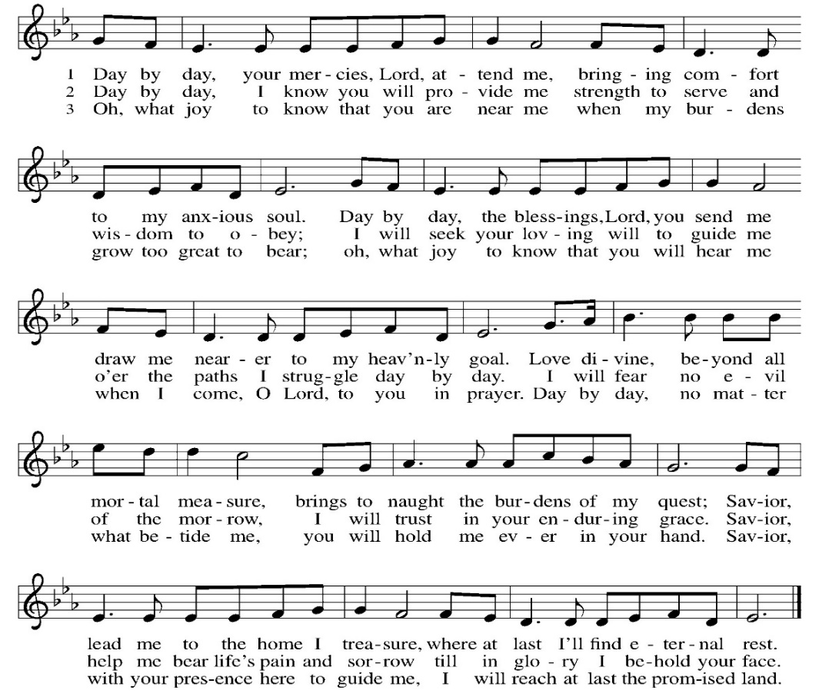
TABLE BLESSING:
P: May the body and blood of our Lord Jesus Christ strengthen you and keep you in God’s grace. C: Amen.
PRAYER AFTER COMMUNION:
P: O God, C: through this meal you have strengthened us and appointed us to be your servants. Send us to do good and to share our possessions with all in need. We ask this in Jesus’ name. Amen.
SENDING: God blesses us and sends us in mission to the world.
BLESSING:
P: The God of righteousness, who gives justice to the oppressed, who gives food to the hungry, who sets the prisoners free, ☩ bless you now and forever. C: Amen.
SENDING HYMN Let Justice Flow Like Streams ELW 717
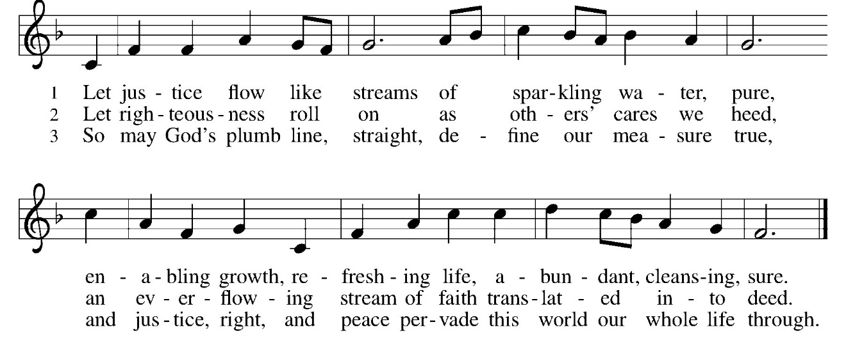
DISMISSAL:
P: Go in peace. Do not lose heart.
C: Thanks be to God.
POSTLUDE
IN OUR PRAYERS TODAY: Teresa Hesselbacher, Elaine Schlicting, Darlene and Walt Steffes, Bob Schreck, Delores Wampfler, Marge and Gerald Arnold, Don & Judy Brudi, Pat Lawfer, Nancy Dittmar, Karen Dick, Grayson Raab, Larry Goebel, James Dieter, Christine Happ, Kay Hesselbacher, Mary Lou Bunker, Lillian Sefford, Judy Wilson, Russ Synder, Don Kunz, Johnny Blair, Jim Sullivan, Joe Karr, John Becker , the family and friends of June Dittmar To add someone to the prayer list please contact Pastor Chrissy
CELEBRATING BIRTHDAYS / ANNIVERSARIES: Maci Lou Arnold, Miley Arnold, Payton Kay Haas, Teresa Tesmer, Dirk Harbach, Tammy Millerschone, Tom Wright
Thanks be to God for your gifts for the ministry of  Christ Lutheran Church *these numbers do not reflect online giving- only offering in worship |  |  |  | Offering/ Attendance  Sat Jan 10  Sunday Jan 11
Current Expense | $2,148.00 | Building Fund | $10.00 | Jan 10 | 16
Benevolence  Community Dinner | $10.00  $100.00 |  |  | Jan 11  Sunday School | 44  6
 |  | Total
  $2,268.00.00

ONLINE GIVING: Your gift has a big impact on our ministries and those we serve. Scan this code or visit our website to give online today

December Totals: As a way to improve communication around finances, we are sharing the following information: *these numbers reflect online giving contribution
2025
 | December | Year to date
Offerings: | $13,503 | $120,115
Expenses: | $10,797 | $122,527
Overall Gain / Loss | $2,706 | ($2,412)

